ANNEXES

Annex 1: Presentation of the assessment criteria
Name of the criterion | Description of the criterion | Elements evaluated ? | Proposed classes
Relevance (general) | The measure addresses a major general issue identified by independent experts. | Level of relevance of the measure | High  Intermediate  Low  Absent
Relevance (societal) | The measure responds to a major societal challenge : mention of the measure's challenge in the SNB3 consultations, mention of the measure's challenge in the various targets of the CBD, the EU, the IUCN, the various national strategies, etc. | Level of relevance of the measure | High  Intermediate  Low  Absent
Relevance (scientific) | The measure responds to a major scientific challenge. | Level of relevance of the measure | High  Intermediate  Low  Absent
Motivated | The description of the measure allows for an understanding of how the activation of the measure is likely to induce transition dynamics and how the trajectories for solving the targeted problems would evolve. It clearly and precisely identifies the problems, their causes, and the policy options for leveraging measures to address them. This criterion defines whether the measure has a proven positive impact on biodiversity, whether it will lead to a real transition dynamic. | Level of motivation for the measure | Well established  Poorly documented  Absent
Effective | The measure is likely to actually produce the expected results, to have a positive impact contributing to the resolution of the problem. The effectiveness criterion defines whether or not the measure is capable of producing the results expected in its definition. | Level of certainty of the measure's impact | Strong and well established  Medium but well established  Strong but speculative  Medium but speculative  Weak
Global | The measure responds to one or more societal issues and sustainable development goals. | Number of SDGs affected by the measure | Number of SDGs
Independent | The measure is not proposed by parties who would benefit from its implementation at the expense of another more ambitious, but more effective and relevant measure. This criterion includes two aspects/steps: intra-measure dependence (during the development of the measure) and inter-measure dependence (proposal by stakeholders of a measure that would be less ambitious than another measure concerning them present within the strategy). | The measure is not a watered down version of a more ambitious measure, it is independent . If the measure is not independent: is the lack of independence a problem or is it a result of an improvement in the feasibility of the measure? | Yes  No but not problematic  No and problematic
Acceptable | The measure is accepted and acceptable, i.e. it is the result of an iterative process and is refined and revised on the basis of stakeholder input, new knowledge and emerging trends. We analyse the acceptability of the measure to the actors and stakeholders directly affected by it. | Degree/risk of acceptability of the measure | Accepted  Accepted with minor modification  Substantially modified  Rejected by stakeholders  Lack of constraint and/or ambition
Robust | The measure is not likely to be opposed by lobbying from interest groups. This criterion looks at whether or not there are stakeholders who might oppose the measure once the strategy is published. This criterion concerns society as a whole, not just the actors directly concerned by the implementation of the measure. | The measure does not conflict with the particular interests of a group of stakeholders | Yes  Risk of opposition  Lack of constraint and/or ambition
Understandable | Accessible to the target audience(s). For this criterion, there are two levels of understanding of the measure: understanding the issues and expected results, and understanding the mechanics of the measure. The mechanics of the measure do not need to be understandable by the whole of society, only by the actors directly concerned. | Degree of understanding of the measure by the actors involved. | Very understandable  Almost understandable  Moderately understandable  Not very understandable  Not understandable
Persistent | The measure can be implemented before it is too late and has permanent effects after the investment resources needed to implement it have stopped. | Sufficient time of the effect during and after the implementation of the measure | Yes  Almost yes  Almost no  No
Resilient | The measure is adaptable and transformable (even reversible or revocable): can the measure be easily modified to evolve? The resilience of the measure concerns its possible impact on biodiversity, not its impact on other aspects of society (economy etc.). | Ease of adapting the measure to the changing context | Yes  Almost yes  Almost no  No
Scientifically credible | The content of the measure is supported by the available scientific knowledge, and in particular, the understanding of the problem and the mechanics of the lever, of its cause and effect relationships. | The content of the measure is supported by the scientific literature  This criterion was assessed by expert opinion.  For some measures, a search of the Web of Science database was conducted. The number of publications from the search is reported. This number is displayed as an indication and does not by itself define whether or not the measure is scientifically credible. | Yes  Almost yes  Almost no  No
Consensual (scientifically) | The measure is a consensus in the scientific field. | Presence of a consensus within the scientific field. | Yes  Almost yes  Almost no  No
Realistic (resources) | Each measure has clearly identified financial resources. | Definition of the financial means necessary for the implementation of the measure. | Yes  Almost yes  Almost no  No
Realistic (timetable) | Each measure has a clearly identified timetable outlining the major steps in implementing the measure to achieve the target objective. | Definition of a timetable specifying the stages of implementation of the measure | Yes  Almost yes  Almost no  No
Realistic (technics, knowledge) | Each measure has a corresponding knowledge and techniques available to be implemented in order to achieve the targeted objective. | Definition of the knowledge, expertise, techniques, regulatory adjustments for the implementation of the measure | Yes  Almost yes  Almost no  No
Measurable (implementation) | Each measure has a corresponding result indicator that allows us to evaluate the degree to which the objective has been achieved | Presence of one or more result indicators to measure the degree of achievement of the target objective | Yes  Almost yes  Almost no  No
Measurable (biodiversity) | Each measure has a corresponding outcome indicator, where relevant, to assess the state of the biodiversity concerned by the measure. | Presence of one or more indicators to assess the state of biodiversity | Yes  Almost yes  Almost no  No
Targeted | The measure identifies the actors who are expected to implement it and those who will be directly or indirectly, positively or negatively impacted. | Precise identification of the actors in charge of implementing the measure, of the stakeholders impacted | Yes  Almost yes  Almost no  No

Annex 2: Scores associated with the analysis classes
Name of the criterion | Proposed classes | Scores
Relevance (general) | High  Intermediate  Low  Absent | 3  2  1  0
Relevance (societal) | High  Intermediate  Low  Absent | 3  2  1  0
Relevance (scientific) | High  Intermediate  Low  Absent | 3  2  1  0
Motivated | Well established  Poorly documented  Absent | 3  1  0
Effective | Strong and well established  Medium but well established  Strong but speculative  Medium but speculative  Weak | 4  3  2  1  0
Global | Number of SDGs | Number of SDGs
Independent | Yes  No but not problematic  No and problematic | 2  1  0
Acceptable | Accepted  Accepted with minor modification  Substantially modified  Rejected by stakeholders  Lack of constraint and/or ambition | 4  3  2  1  0
Robust | Yes  Risk of opposition  Lack of constraint and/or ambition | 2  2  0
Understandable | Very understandable  Almost understandable  Moderately understandable  Not very understandable  Not understandable | 4  3  2  1  0
Persistent | Yes  Almost yes  Almost no  No | 3  2  1  0
Resilient | Yes  Almost yes  Almost no  No | 3  2  1  0
Scientifically credible | Yes  Almost yes  Almost no  No | 3  2  1  0
Consensual (scientifically) | Yes  Almost yes  Almost no  No | 3  2  1  0
Realistic (resources) | Yes  Almost yes  Almost no  No | 3  2  1  0
Realistic (timetable) | Yes  Almost yes  Almost no  No | 3  2  1  0
Realistic (technics, knowledge) | Yes  Almost yes  Almost no  No | 3  2  1  0
Measurable (implementation) | Yes  Almost yes  Almost no  No | 3  2  1  0
Measurable (biodiversity) | Yes  Almost yes  Almost no  No | 3  2  1  0
Targeted | Yes  Almost yes  Almost no  No | 3  2  1  0

Annex 3: Extract from Promethee software, axis n°5, societal scenario
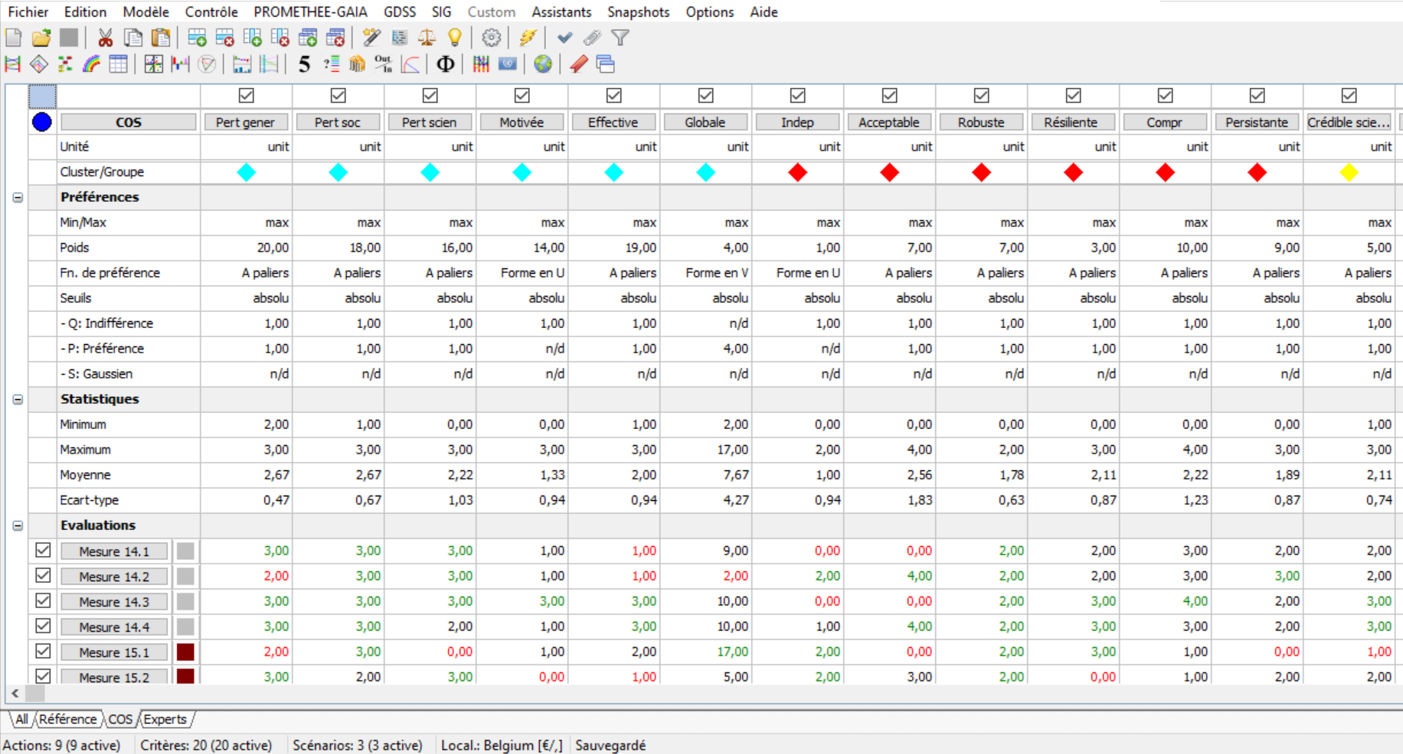

Annex 4: Organisation and measures of the national strategy for biodiversity
Axis 1 - Protected, restored and resilient ecosystems
Objective 1 - Strengthen policies to protect and restore biodiversity | 1.1 - Continue the dynamic of extension of the protected areas network
 | 1.2 - Know and protect the marine environment
 | 1.3 - Develop a national strategy for soil protection and restoration
 | 1.4 - Accelerate the protection and restoration of ecosystems
 | 1.5 - Strengthen the protection of endangered species, particularly in overseas territories
 | 1.6 - Better manage invasive alien species and enhance local species
 | 1.7 - Consolidate a system of adaptive management of species
Objective 2 - Ensure the protection and restoration of ecological continuity | 2.1 - Develop and strengthen the integration of ecological frameworks in land use planning
 | 2.2 - Resolve the priority black spots identified at the regional level
 | 2.3 - Continue the restoration of aquatic continuity
 | 2.4 - Deployment of a marine and coastal network
 | 2.5 - Fighting against light pollution and setting up a black grid to protect nocturnal biodiversity
Objective 3 - Fight against all types of pollution, giving priority to reducing them at the source | 3.1 - Strengthen the fight against pollution
 | 3.2 - Strengthen the regulatory assessment of chemical products with regard to their impact on biodiversity, particularly in agrosystems and the marine environment
 | 3.3 - Take into account the impacts on biodiversity when regulating the supply, sale, labeling and advertising of consumer products
 | 3.4 - Improve the effectiveness of police actions against pollution and environmental damage
 | 3.5 - Fight against water and aquatic environment pollution
Objective 4 - Increase the resilience of territories and fight against soil artificialisation | 4.1 - Mobilize communities to strengthen the resilience of territories, in particular by encouraging the use of nature-based solutions
 | 4.2 - Generalize the creation of communal or inter-communal biodiversity atlases before drawing up urban planning documents
 | 4.3 - Better protect biodiversity by mobilizing the "Avoid-reduce-compensate" sequence on land and at sea
 | 4.4 - Access to nature and its resources
 | 4.5 - Protecting biodiversity on land belonging to the State or to a public establishment
Axis 2 - Sustainable and equitable use of natural resources and ecosystem services
Objective 5 - Promote biodiversity-friendly economic activity | 5.1 - Aligning EU trade with the need to preserve biodiversity at the global level
 | 5.2 - Supporting the transition of fishing and aquaculture towards practices compatible with the preservation of biodiversity, particularly multi-trophic aquaculture
 | 5.3 - Strengthen the consideration of biodiversity protection issues in energy production facility projects
 | 5.4 - Ensure the sustainable use of genetic resources and the equitable sharing of benefits arising from their use
Objective 6 - Promote the agro-ecological transition of agricultural production methods and food systems | 6.1 - Strengthen the "biodiversity" dimension of agricultural, fishing and food labels and consolidate their economic models
 | 6.2 - Guarantee the contribution of the HVE standard to agro-ecology and the preservation of biodiversity
 | 6.3 - Deploy the intervention strategy of the national strategic plan of the Common Agricultural Policy 2023 related to biodiversity and to encourage experimentation of production systems favorable to biodiversity
 | 6.4 - Promote the diversification of seeds, crops and animal breeds and species in order to preserve biodiversity
 | 6.5 - Consolidate information systems on the biodiversity of agricultural environments
 | 6.6 - Strengthen the resilience of forest ecosystems, preserve biodiversity and the services provided by forests
Objective 7 - Integrate biodiversity into business strategies | 7.1 - Strengthen the biodiversity dimension of labels or standards in economic sectors
 | 7.2 - Integrate biodiversity into reporting and investment choices
 | 7.3 - Support companies in sustainable procurement and biodiversity-friendly practices
 | 7.4 - Encourage better consideration of biodiversity in ICPE projects
 | 7.5 - Integrate biodiversity issues into the construction industry
 | 7.6 - Supporting innovation in biodiversity and nature-based solutions
Axis 3 - A society that is aware, trained and mobilised
Objective 8 - Mobilize citizens, communities and businesses | 8.1 - Recognize, value, encourage and report on individual and collective voluntary commitments
Objective 8 - Mobilize citizens, communities and businesses | 8.2 - Better connect young people to nature
Objective 8 - Mobilize citizens, communities and businesses | 8.3 - Encourage knowledge and experience of nature, particularly through participatory science
Objective 8 - Mobilize citizens, communities and businesses | 8.4 - Take into account biodiversity in sports, cultural and tourist practices
Objective 8 - Mobilize citizens, communities and businesses | 8.5 - Inform and raise awareness on the ability to act on a daily basis
Objective 9 - Educate and train on biodiversity | 9.1 - Strengthen the training of students (school, college, high school) in the preservation of biodiversity, including the connection to nature
Objective 9 - Educate and train on biodiversity | 9.2 - Integrate the protection of nature and the fight against climate change and adaptation to climate change in initial and continuing education
Objective 9 - Educate and train on biodiversity | 9.3 - Promote biodiversity professions (ecological engineering, ecologist, lawyer, finance, protected area manager, farmers, etc.)
Axis 4 - Cross-functional, results-oriented management
Objective 10 - Strengthen and enhance knowledge on biodiversity | 10.1 - Consolidate the acquisition of knowledge (metropolitan and overseas) and support research on biodiversity
 | 10.2 - Support the ecological transition of economic activities through the development of knowledge on biodiversity
 | 10.3 - Promote knowledge of biodiversity to society as a whole
 | 10.4 - Develop research-action on workshop areas in an interdisciplinary and inclusive framework
Objective 11 - Make public policies consistent with national biodiversity objectives | 11.1 - Strengthen the integration of biodiversity issues in territorial planning and development
 | 11.2 - Taking biodiversity into account in development aid
 | 11.3 - Taking biodiversity into account in climate policies
 | 11.4 - Integrate the "one health" approach in public policies and in the territories
 | 11.5 - Fight against all types of erosion of imported biodiversity, and in particular imported deforestation
 | 11.6 - Strengthen the consideration of biodiversity and in particular continuity in transport policies
 | 11.7 - Create regular events on biodiversity and other sectoral policies
Objective 12 - Mobilise a governance system and a framework to guarantee the full implementation of the SNB over the long term | 12.1 - Establishment, by each ministerial pole, of strategies or roadmaps on biodiversity
 | 12.2 - Establish, jointly between the State and regional executives, with the support of their national association, a regular dialogue to ensure synergy between the SNB and the SRB (regional biodiversity strategies)
Objective 13 - Guarantee the implementation of measures through a monitoring-evaluation and accountability system | 13.1 - Adopt a set of indicators for the monitoring and evaluation of each level of the SNB
 | 13.2 - Clarify competences and responsibilities in the implementation of the SNB
 | 13.3 - Guarantee transparent access to monitoring and evaluation results for citizens and stakeholders
Axis 5 - Financing at the service of biodiversity policies
Objective 14 - Improve the relevance and efficiency of existing budgetary and fiscal tools | 14.1 - Define the methods of financing public biodiversity policies and strengthen the implementation of the polluter-pays principle
 | 14.2 - Clarify and adapt the methods and responsibilities for implementing biodiversity funding
 | 14.3 - Develop and implement a reduction plan to move towards the elimination of biodiversity harmful public spending
 | 14.4 - Mobilize the results of the Green Budget process and new wealth indicators in favor of biodiversity
Objective 15 - Facilitate the financial contribution of private actors | 15.1 - Mobilize private funding for biodiversity-friendly activities
 | 15.2- Mobilize voluntary funding from businesses to support biodiversity-friendly projects
 | 15.3 - Promote the low carbon label
 | 15.4 - Progressively deploy ecological accounting
 | 15.5 - Optimize the articulation of financing implemented at the regional level

