Supporting information for:
Reversible Anisotropic Wet Adhesion Enabled by Rigid Amphiphiles
Tongyue Wu¹, Shuitao Gao¹, Hongxin Zhao¹, Cheng Ma¹, Lingxiang Jiang², Jianbin Huang¹, Yun Yan^{1*}

¹Beijing National Laboratory for Molecular Sciences (BNLMS), College of Chemistry and Molecular Engineering, Peking University, Beijing 100871, China
²South China Advanced Institute for Soft Matter Science and Technology, School of Emergent Soft Matter, South China University of Technology Guangzhou 510640, China
Email: yunyan@pku.edu.cn

1. Phase diagram for glycyrrhizic acid of pH and concentration.
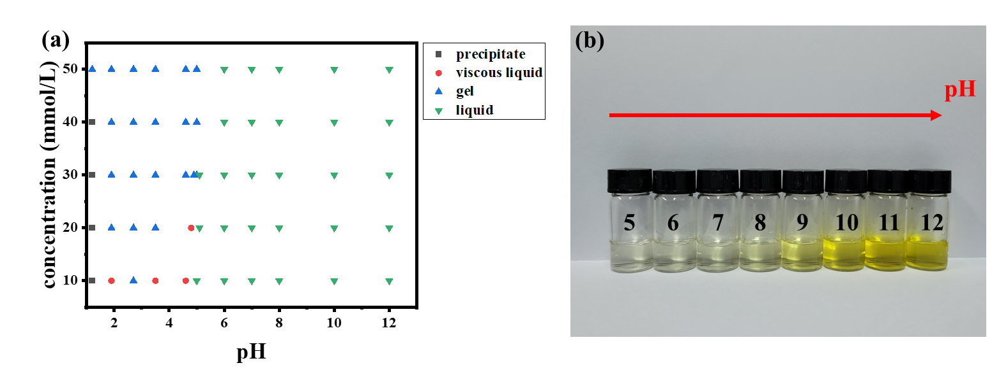
Figure S1. (a) Phase diagram of glycyrrhizic acid (b) Photos of glycyrrhizic acid with different pH.

2. Phase diagrams of the GA-PDDA mixture with different ratio at pH = 12.
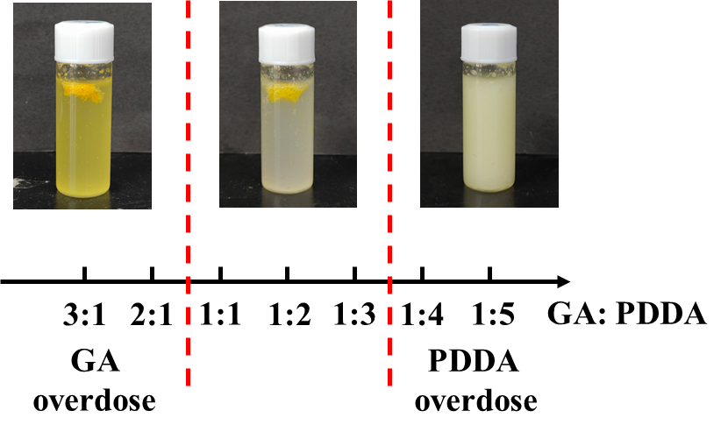
Figure S2. Phase diagrams of the GA-PDDA mixture with different ratio at pH = 12. The precipitation is most complete when the charge is balanced.

3. IR analysis for the formation of GA-PDDA coacervates

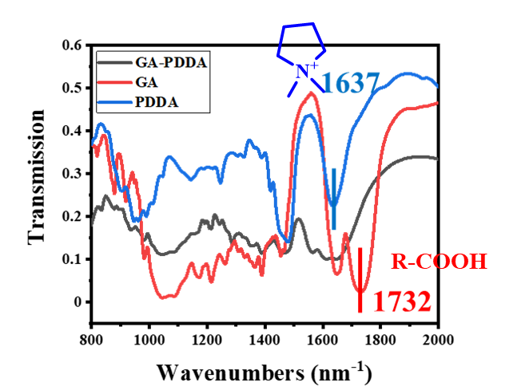
Figure S3. IR analysis for GA-PDDA coacervates

4. Viscosity of the newly prepared GA-PDDA coacervate.
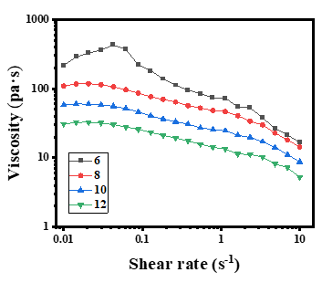
Figure S4. Viscosity of the newly prepared GA-PDDA coacervate with different pH.

5. Molecular size of glycyrrhizic acid
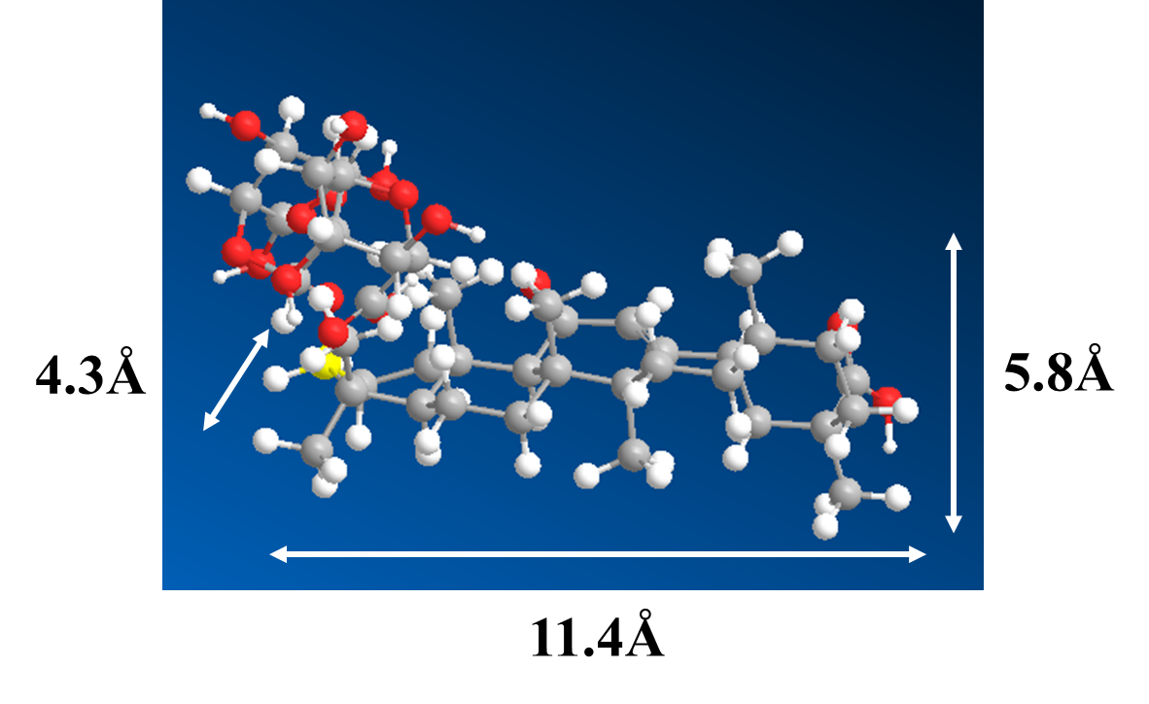
Figure S5. Molecular size of glycyrrhizic acid in different direction.

6. GA-PDDA adhesives have hydrophilic regions
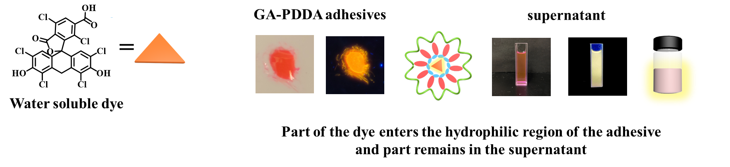
Figure S6. Hydrophilic dye staining experiment confirmed that GA-PDDA adhesives have hydrophilic regions

7. Molecular structure of sodium cholate (SC) and sodium deoxycholate.
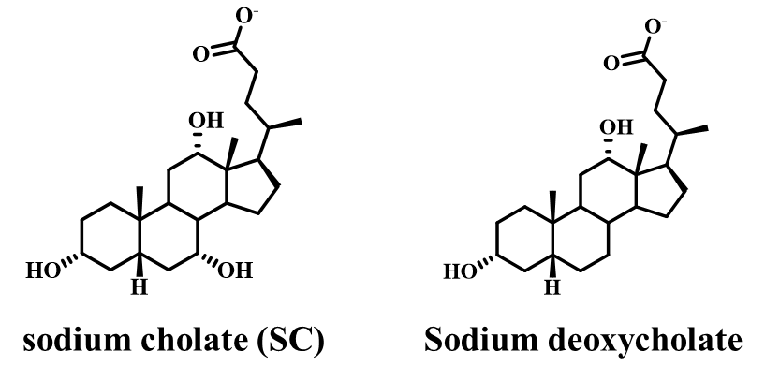
Figure S7. Molecular structure of sodium cholate (SC) and sodium deoxycholate.

8. Anisotropic characteristic of CS-PDDA coacervates.
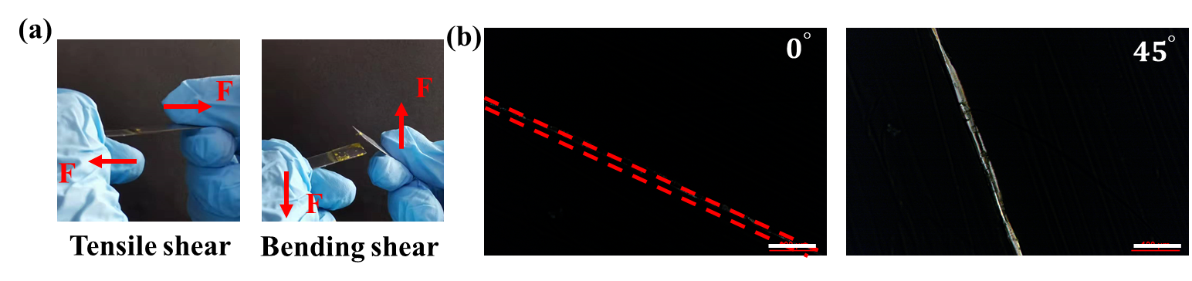
Figure S8. (a) Strong tensile shear strength (Left) and weak bending shear strength (weak) of SC-PDDA coacervates on iron flake. (a) POM result of CS-PDDA coacervates.

Table S1. The water content of the newly prepared wet adhesive GA-PDDA with different pH
pH | Water content (%)
6 | 63.2
8 | 65.2
10 | 63.1
12 | 65.5

Table S2. Elemental analysis result of GA-PDDA coacervates
 | N (%) | C (%) | H (%)
PDDA | 11.1 | 76.2 | 12.7
GA | 0 | 61.5 | 7.2
Coacervate | 3.23 | 55.8 | 9.61
It can be calculated that in G-PDDA coacervates, the molecular ratio of PDDA:GA is 3.46:1.

Table S3. Adhesives strength of GA-PDDA adhesive and commercial adhesives
Material | GA-PDDA Adhesives | 502 | AB-glue
Marble | 1.9MPa | 3.1MPa | 6.8MPa
Wood | 7.2MPa | 2.5MPa | 2.8MPa

Table S4. Adhesion strength with different preparation pH
 | 6 | 8 | 10 | 12
Zinc | 0.87MPa | 1.4MPa | 1.6MPa | 1.6MPa
Iron | 2.7MPa | 2.5MPa | 2.3MPa | 3.0MPa
304 stainless | 2.4MPa | 1.6MPa | 1.4MPa | 2.3MPa

Table S5. Adhesion strength of between different surfaces
Materials | Adhesion strength (MPa)
Cu-Zn | 1.8
Cu-steel | 2.0
Zn-steel | 0.7
Glass-Zn | 1.4
Glass-Cu | 1.1
Glass-steel | 1.9
Concrete-Zn | 2.2
Concrete-Cu | 3.1
Concrete-steel | 2.1
Concrete-marble | 2.3
Marble-Cu | 1.7
Marble-Zn | 1.7
Marble-steel | 1.1

Table S6. Isotropic adhesion for polyelectrolyte-alkyl surfactants
 | Tensile shear strength (MPa) | Bending shear strength (MPa) | Anisotropic/isotropic
PAE-SDS | 0.20 | 0.20 | Isotropic
PHMB-SDBS | 0.25 | 0.24 | Isotropic
Note：The above tests are conducted on PTFE surface.

