Supporting information

Tumor-targeted AIE polymeric micelles mediated immunogenic sonodynamic therapy inhibits cancer growth and metastasis
Kai Deng^{a,d,1*}, Yi-Feng Yu^{b,1}, Yong Zhao^{b}, Jia-Mi Li^{d}, Kun-Heng Li^{d}, Hong-Yang Zhao^{d}, Meng Wu^{c,*}, Shi-Wen Huang^{d,e*}
ªDepartment of Radiology, Zhongnan Hospital of Wuhan University, Wuhan University, Wuhan 430071, China.
^{b}Department of Orthopedic Trauma and Microsurgery, Zhongnan Hospital of Wuhan University, Wuhan 430071, China.
^{c}Department of Ultrasound, Zhongnan Hospital of Wuhan University, Wuhan University, Wuhan 430071, China.
^{d} Key Laboratory of Biomedical Polymers of Ministry of Education, Department of Chemistry, Wuhan University, Wuhan 430072, China.
^{e}Wuhan Research Center for Infectious Diseases and Cancer, Chinese Academy of Medical Sciences, Wuhan 430071, China.
¹These authors equally contributed to this work.
∗ Corresponding authors.
E-mail address: deng-k@whu.edu.cn (K. Deng); wb00713@whu.edu.cn (M. Wu); swhuang@whu.edu.cn (S.W. Huang).

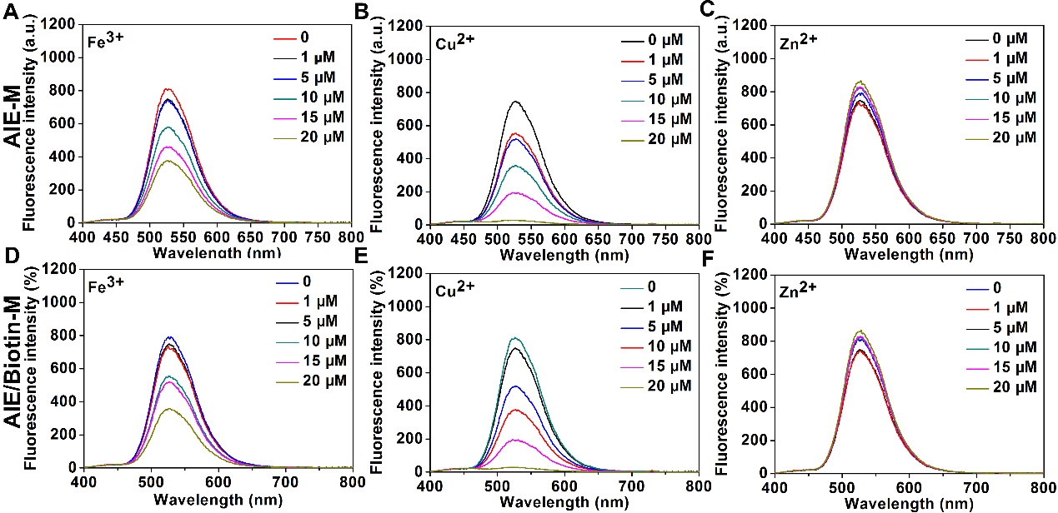

Figure S1. Fluorescence spectra of AIE-M (A-C) and AIE/Biotin-M (D-F) in a solution containing different concentration of metal ions.

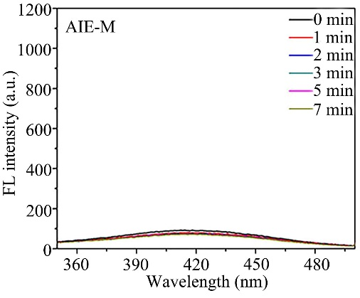
Figure S2.The generation of ·OH by AIE-M with US irradiation for different time quantitatively determined by the fluorescence intensity of TAOH.
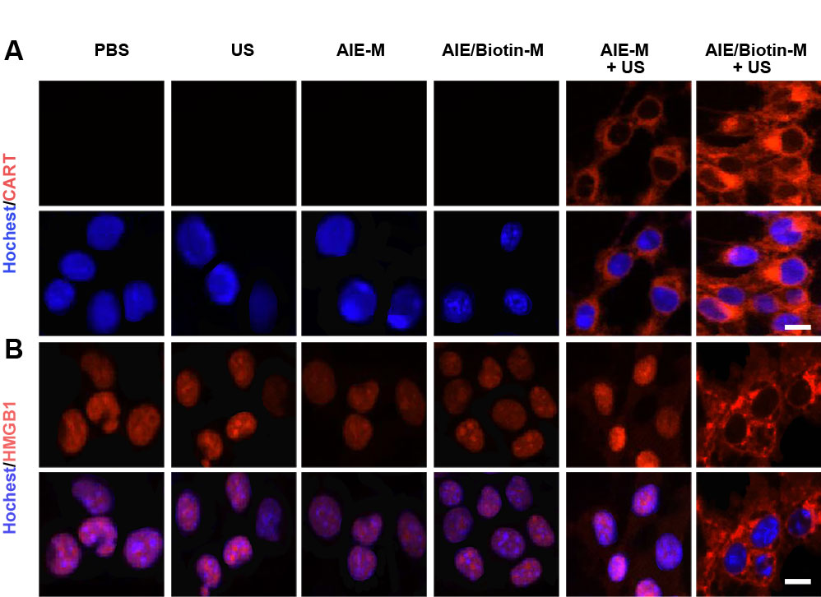
Figure S3. CLSM images of CART (A) and HMGB1 (B) released from 4T1 cells in vitro after uptake of AIE-M and AIE/Biotin-M plus treated without US or with US (1.0 MHz, 2 Wcm⁻², 50% duty cycle) for 3 min (scale bar = 25μm).

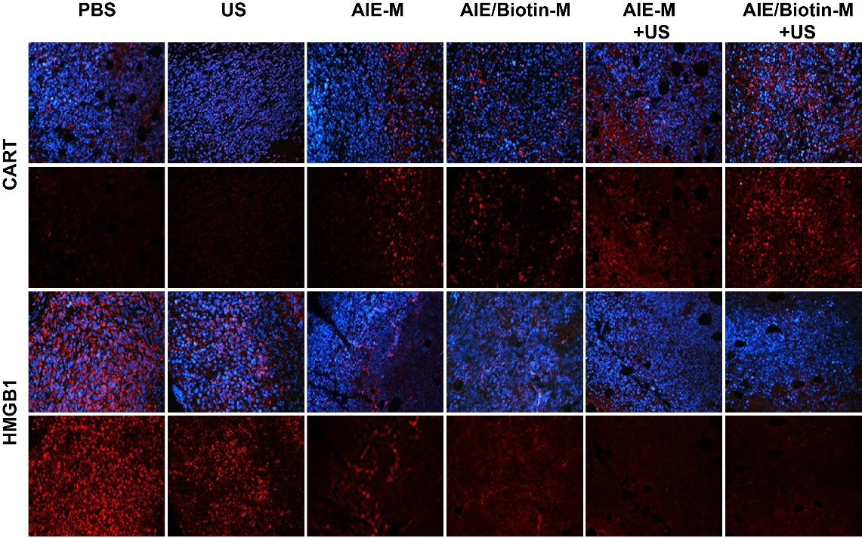

Figure S4. In vivo AIE/Biotin-M mediated SDT to induce DMAPs release. 4T1 tumor-bearing mice were i.v. separate injection of AIE-M and AIE/Biotin-M once every 3 day for three times, and then treated without or with US (1.0 MHz, 2 Wcm-2, 50% duty cycle) irradiation at 2 h post-injection for 5 min. The exposure of CART and release of HMGB1 in 4T1 tumors of BALB/c mice at 6 h after last US irradiation.

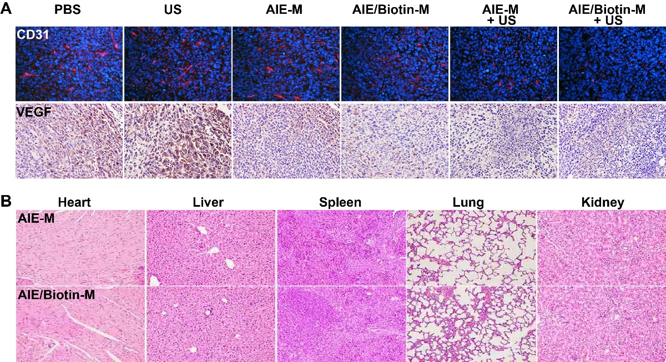

Figure S5. (A) The tumor tissue immunofluorescence staining for CD31 and immunohistochemical staining for VEGF after various treatments for 16 day. (B) H&E staining of heart, liver, spleen, lung and kidney after tumor-free mice were i.v. separate injection of AIE-M and AIE/Biotin-M for 16 days.

