Mitochondrial accumulation of Apurinic/Apyrimidinic Endonuclease 1 protein in early stages of hepatocellular carcinoma enhances mtDNA repair rate, contributing to cell proliferation and mitochondrial functionality.

Veronica Bazzani¹, Arianna Barchiesi¹, Dorota Radecka¹, Riccardo Pravisani², Antonio Guadagno^{3,4}, Carla Di Loreto³, Umberto Baccarani² and Carlo Vascotto*¹

SUPPLEMENTARY INFORMATION

Supplementary Figure 1. Uncropped Western blot images for Fig. 1D.

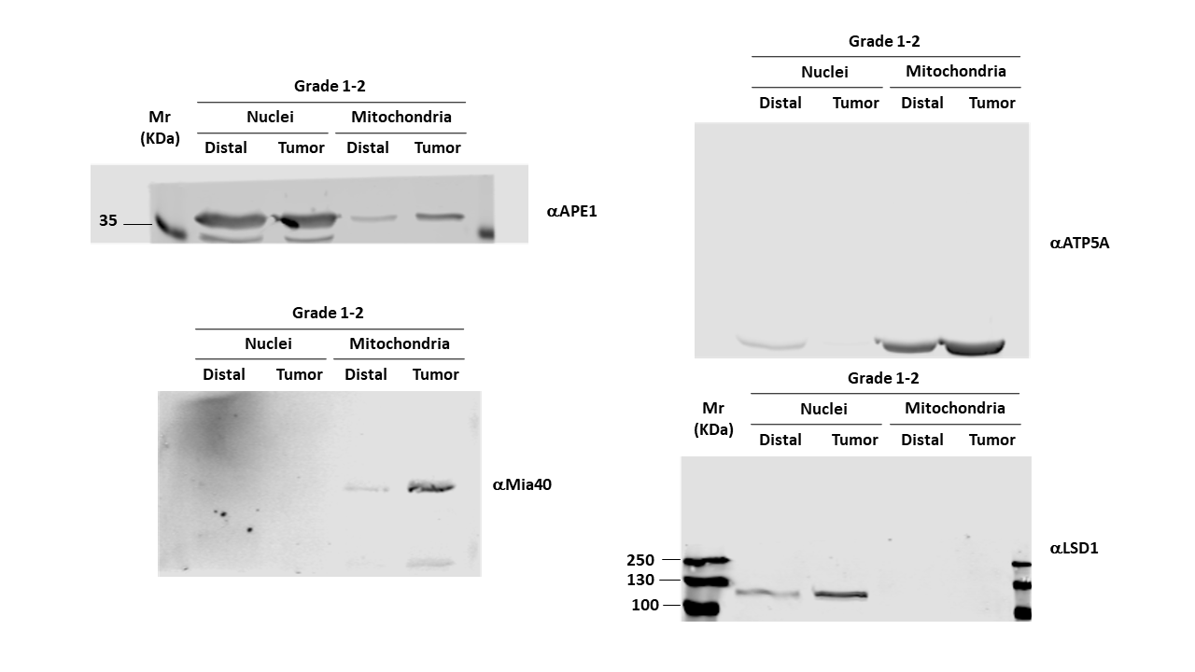

Supplementary Figure 2: Uncropped Western blot images for Fig. 2A.

