Supplementary Information

Thermal behavior, reaction pathways and kinetic implications of using a Ni/SiO₂ catalyst for waste tire pyrolysis
Paula Osorio-Vargas^{1,2*}, Ileana D. Lick², Felipe Sobrevía¹, Daniela Correa-Muriel³, Tamara Menares¹, Raydel Manrique¹, Monica L. Casella², Luis E. Arteaga-Pérez^{1,4**}
¹Laboratory of Thermal and Catalytic Processes (LPTC-UBB), Wood Engineering Department, Universidad del Bio-Bio, Concepción, Chile
²CINDECA (CCT La Plata-CONICET, UNLP), Universidad Nacional de La Plata, Facultad de Ciencias Exactas, 47 N◦257, 1900 La Plata, Argentina
³Grupo de investigación en Fotocatálisis y Estado Sólido, Facultad de Tecnología, Escuela de Química, Universidad Tecnológica de Pereira, Pereira, Colombia.
⁴Universidad de Concepción, Unidad de Desarrollo Tecnológico, Coronel, Chile.
*Corresponding authors:
Paula Osorio-Vargas
Universidad del Bio Bio, Escuela de Ingeniería Química, Chile
Tel: (+5641) 311 1161
e-mail: posorio@ubiobio.cl

Luis E. Arteaga-Pérez
Universidad del Bio Bio, Escuela de Ingeniería Química, Chile
Tel: (+5641) 311 1691
e-mail: larteaga@ubiobio.cl

Table S1. Expressions for the most common reaction mechanisms in solid state reactions.
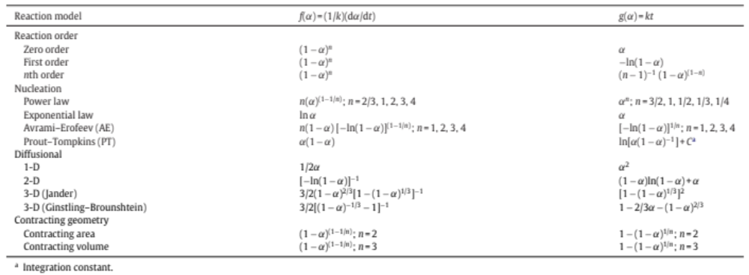
Additionally, the Random Scission model proposed by Sánchez-Jiménez et al.[1] was used. This model states that the conversion function is determined by the fraction of broken bonds (x) and the length of the polymeric unit (L). Then, it proposes the following law to describe the conversion:
$f\left(α\right)=L\left(L-1\right)∙x∙{\left(1-x\right)}^{L-1}$ (1)
This expression takes the form $f\left(α\right)=2\left(α^{1/2}-α\right)$ for L = 2. However, for L ≠ 2 no symbolic solution can be obtained, and the equation should be solved numerically for specific α-values by applying the following equation:
$α=1-{\left(1-x\right)}^{L-1}\left[1+x\left(L-1\right)\right]$ (2)
The other alternative used was the truncated Sestak–Berggren model (SB) represented in eq. 3:
$f\left(α\right)=α^{m}{(1-α)}^{n}$ (3)

Table S2. Identified compounds by Py–GC/MS during waste tire pyrolysis
t_{R} (min) | Compound
 | Alkenes
2.1 | Isoprene
3.2 | Cyclohexene
4.4 | 3-methylcyclohexene
4.8 | 1,4-cycloheptadiene
5.1 | 2,6-dimethyl-1,4,6-heptatriene
5.3 | 1-methyl-1,3-cyclohexadiene
5.5 | 1,3,5-heptatriene
7.6 | 4-ethenylcyclohexene
11.7 | 2,6-dimethyl-1,3,6-heptatriene
12.2 | 1,5,5,6-tetramethyl-1,3-cyclohexadiene
14.0 | 4-ethenyl-1,4-dimethyl cyclohexene
15.0 | 5-ethyl-1,5-dimethyl-1,3-cyclohexadiene
15.2 | 3,7-dimethyl 2,4,6-octatriene
15.4 | 2,6-dimethyl-1,6-octadiene
15.6 | 3,7-dimethyl-2,6-octadiene
15.8 | 3,7-dimethyl-1,3,6-octatriene
16.5 | D,L-limonene
16.7 | α-Terpinene
16.9 | 2,4,6-trimethyl-1,3,6-heptatriene
17.2 | p-cymene
17.5 | γ-Terpinene
18.2 | Terpinolene
19.0 | 2,6-dimethyl-2,4,6-octatriene
19.8 | 2,6-dimethyl-1,3,5,7-octatetraene
 | Aromatic compounds
3.4 | Benzene
5.9 | Toluene
11.5 | Xylenes
13.3 | Styrene
17.0 | p-cymene
17.4 | 1,2,3-trimethyl benzene
18.0 | Isopropylbenzene
18.5 | 4-Ethyltoluene
18.8 | 4-Allyltoluene
19.0 | p-cymenene
 | Additives
6.4 | Methyl isobutyl ketone
15.2 | Cyclohexanone
18.7 | Aniline
22.0 | 2-Methoxy-4-methylphenol
23.1 | Benzothiazole
23.9 | 4-Ethyl-2-methoxyphenol
25.4 | 4-(2-Propenyl)-2-methoxyphenol
26.1 | 2,6-Dimethoxyphenol
26.7 | 2,4-Dimethylquinoline
27.1 | 1,2-dihydro-2,2,4-trimethylquinoline

Table S3. Main functional groups identified by FTIR during thermogravimetric analysis
Wavenumber | Functional group/ Vibration | Pyrolysis product
1500 and 1600 cm⁻¹ | C=C stretch | Aromatic ring
740-690 cm⁻¹ | C-H out-of-plane bend | Aromatic ring
1600-1670 cm⁻¹ | C=C stretch | Alkenes and Conjugated Dienes
3000-2840 cm⁻¹ | C-H stretch | Alkyls
1330 -1500 cm⁻¹ | C-H bend | Methyl and Methylene
690 cm⁻¹ | (ρCH₂). | Methylene rocking vibrations
1650 and 1750 cm⁻¹ | C=O stretch | Carbonyl groups
2320 and 2360 cm⁻¹ | C=O stretch | CO₂
3014 cm⁻¹ | C-H stretch | CH₄
1460 cm⁻¹ | S=O stretch | Sulfur species

Fig. S1 FTIR of evolved gases of thermal decomposition of waste tire for (a) non-catalyzed and (b) catalyzed reaction.

Fig. S2 Temperature effect on formation of aromatics and alkenes during waste tire decomposition for uncatalyzed and catalyzed reaction followed by absorbance.

Fig. S3 Effect on product distribution of catalytic support (SiO₂) during waste tire pyrolysis carried out at 400 °C.

References
1. Sánchez-Jiménez, P.E., Pérez-Maqueda, L.A., Perejón, A., Criado, J.M.: A new model for the kinetic analysis of thermal degradation of polymers driven by random scission. Polym. Degrad. Stab. 95, 733–739 (2010). https://doi.org/10.1016/j.polymdegradstab.2010.02.017

