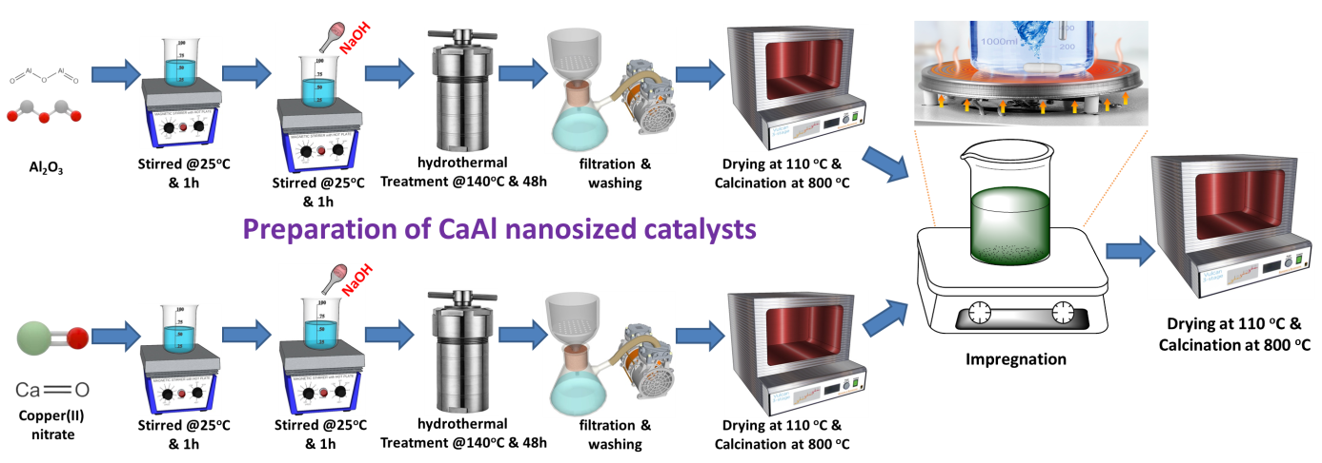
Figure S1: Synthesis procedure of Ca, 2Ca2Al, and 2Ca3Al nano-sized catalysts

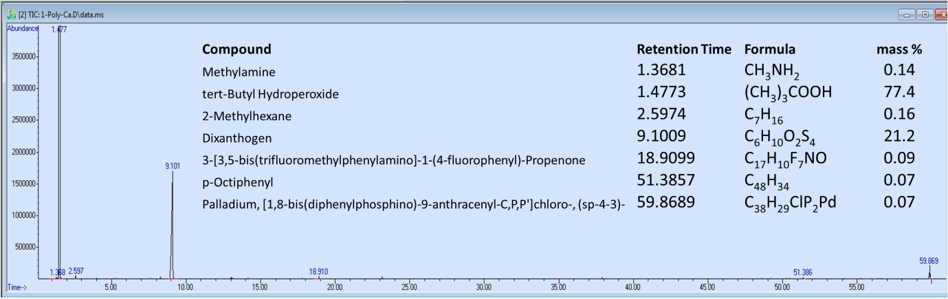
Figure S2: GCMS data of pyrolytic products

