Supplementary materials for “Do Fires Discriminate? Socio-Economic Disadvantage, Wildfire Hazard Exposure and the Australian 2019–20 ‘Black Summer’ Fires”
SM 1 List of variables included in SEIFA 2016
Dimension | Index of Relative Socio-Economic Disadvantage (IRSED) | Index of Relative Socio-Economic Advantage and Disadvantage (IRSEAD) | Index of Economic Resources (IER) | Index of Education and Occupation (IEO)
Income | Income low | Income low | Income low
 |  | Income high | Income high
Education | 12 years or lower  No education  Certificate | 12 years or lower  No education  Certificate University  Diploma  Degree |  | 12 years or lower  No education  Certificate  University  Diploma  Degree  At school
Employment | Unemployed | Unemployed | Unemployed (all) | Unemployed
Occupation | Labourer  Drivers  Low skilled  Low skill sales | Labourer  Drivers  Low skilled  Low skill sales  Professionals  Managers |  | Skill level 1  Skill level 2  Skill level 4  Skill level 5
Housing | Low rent  Overcrowded  Few beds | Low rent  Overcrowded  4+ bedrooms  High rent  High mortgage  Own house  Spare bedroom | Low rent  Overcrowded  Mortgage  4+ bedrooms  High rent  High mortgage  Own house
Other | Child & joblessness  One parent  No car  Disability (<70)  Poor English  Separated or divorced  No internet | Child & joblessness  One parent  No car  Disability (<70)  Poor English  Separated or divorced  No internet  3+ cars | Unincorporated enterprise  One parent  No car  Group occupied  Lone occupied

Source: (Australian Bureau of Statistics 2018b)

Description of variables in alphabetical order:
- 12 years or lower=% people aged 15 years and over whose highest level of education is up to Year 11.
- 3+ cars=% occupied private dwellings with three or more cars (adv)
- At school=% people aged 15 years and over who still attend secondary school.
- Certificate=% people aged 15 years and over whose highest level of education is a Certificate III or IV qualification.
- Child & joblessness=% families with children under 15 years of age who live with jobless parents.
- Degree=% people aged 15 years and over whose highest level of education is Bachelor degree or higher qualification (adv)
- Diploma=% people aged 15 years and over whose highest level of education is a Diploma qualification.
- Disability (<70)=% people aged under 70 who have a long-term health condition or disability and need assistance with core activities.
- Drivers=% employed people classified as Machinery Operators and Drivers.
- 4+ bedrooms=%occupied private dwellings with four or more bedrooms.
- Group occupied=% occupied private dwellings that are group-occupied private dwellings.
- High mortgage=% occupied private dwellings paying mortgage greater than $2,800 per month.
- High rent=% occupied private dwellings paying rent greater than $470 per week.
- Income high=% people with stated annual household equivalised income greater than or equal to $78,000 (approx. 9th and 10th deciles) (adv)
- Income low=% people with stated annual household equivalised income between $1 and $25,999 (approx. 1st and 2nd deciles)
- Labourer=% employed people classified as 'labourers'.
- Lone occupied=% occupied private dwellings that are lone person occupied private dwellings.
- Low rent=% occupied private dwellings paying rent less than $215 per week (excluding $0 per week)
- Low skilled sales=% employed people classified as Low Skill Sales.
- Low skilled=% employed people classified as Low Skill Community and Personal Service Workers.
- Managers=% employed people classified as Managers.
- Mortgage=% occupied private dwellings owning dwelling (with a mortgage)
- No car=% occupied private dwellings with no cars.
- No education=% people aged 15 years and over who have no educational attainment.
- No internet=% occupied private dwellings with no internet connection.
- One parent=% one parent families with dependent offspring only.
- Overcrowded=% occupied private dwellings requiring one or more extra bedrooms (based on Canadian National Occupancy Standard).
- Own house=% occupied private dwellings owning dwelling without a mortgage.
- Poor English=% people who do not speak English well.
- Professionals=% employed people classified as Professionals.
- Separated or divorced=% people aged 15 and over who are separated or divorced.
- Skill level 1=% employed people who work in a Skill Level 1 occupation.
- Skill level 2=% employed people who work in a Skill Level 2 occupation.
- Skill level 4=% employed people who work in a Skill Level 4 occupation.
- Skill level 5=% employed people who work in a Skill Level 5 occupation.
- Spare bedroom=% occupied private dwellings with one or more bedrooms spare (based on Canadian National Occupancy Standard)
- Unemployed (all)=% people aged 15 years and over who are unemployed.
- Unemployed=% people (in the labour force) unemployed.
- Unincorporated enterprise=% occupied private dwellings with at least one person who is an owner of an unincorporated enterprise.
- University=% people aged 15 years and over at university or other tertiary institution.

SM 2 Sources of data for the key variables
Variables | Name of the dataset | Source
Remoteness | Australian Statistical Geography Standard (ASGS): Volume 5 - Remoteness Structure, July 2016 | Australian Bureau of Statistics (2018c)
Size of forests | Forests of Australia (2018) | Department of Agriculture, Water and the Environment (2019b)
IRSED | Socio-Economic Indexes for Areas (SEIFA), Australia, 2016 | Australian Bureau of Statistics (2018a)
Fire extent | National Indicative Aggregated Fire Extent (NIAFE) | Department of Agriculture, Water and the Environment (2020)
Area of SA1 | Statistical Area Level 1 (SA1) ASGS Edition 2016 in .csv format | Australian Bureau of Statistics (2016)
History of fire exposure | Fires in Australia's forests 2011–16 (2018) | Department of Agriculture, Water and the Environment (2019a)
Population | Socio-Economic Indexes for Areas (SEIFA), Australia, 2016 | Australian Bureau of Statistics (2018a)
Fire stations, Total number of business | Australian Exposure Information Platform (AEIP), Statistical Areas Level 1 (SA1) exposure information | Geoscience Australia (2020)

SM3 Tobit regression results of the correlation between alternative measures of socio-economic disadvantage and wildfire hazard exposure in Australia in 2019–2020
 | Wildfire hazard exposure indexª
IRSEAD | (1) | IER | (2) | IEO
IRSEAD_r decile 2^{b} | −29.410 | IER_r decile 2^{c} | 12.960 | IEO_r decile 2^{d} | 44.170
 | (45.800) |  | (19.980) |  | (31.170)
IRSEAD_r decile 3^{b} | 24.940 | IER_r decile 3^{c} | 42.180** | IEO_r decile 3^{d} | 61.930**
 | (46.020) |  | (20.100) |  | (30.560)
IRSEAD_r decile 4^{b} | 54.390 | IER_r decile 4^{c} | 49.100** | IEO_r decile 4^{d} | 70.270**
 | (44.990) |  | (21.090) |  | (30.890)
IRSEAD_r decile 5^{b} | 27.600 | IER_r decile 5^{c} | 33.920* | IEO_r decile 5^{d} | 69.140**
 | (44.940) |  | (20.150) |  | (30.550)
IRSEAD_r decile 6^{b} | 46.460 | IER_r decile 6^{c} | 51.270** | IEO_r decile 6^{d} | 59.790*
 | (45.560) |  | (22.400) |  | (30.980)
IRSEAD_r decile 7^{b} | 45.150 | IER_r decile 7^{c} | 70.110*** | IEO_r decile 7^{d} | 78.740**
 | (45.290) |  | (24.130) |  | (31.850)
IRSEAD_r decile 8^{b} | 60.720 | IER_r decile 8^{c} | 40.290 | IEO_r decile 8^{d} | 74.210**
 | (46.140) |  | (30.170) |  | (32.400)
IRSEAD_r decile 9^{b} | 53.530 | IER_r decile 9^{c} | 130.100*** | IEO_r decile 9^{d} | 83.910**
 | (47.840) |  | (36.300) |  | (34.420)
IRSEAD_r decile 10^{b} | 117.700** | IER_r decile 10^{c} | 77.140** | IEO_r decile 10^{d} | 92.430**
 | (49.800) |  | (38.650) |  | (36.730)
Control variables | Y |  | Y |  | Y
SA3 fixed-effects | Y |  | Y |  | Y
Observations | 1,655 |  | 1,655 |  | 1,660
Notes:
ªThe interaction of fire extent (i.e. total burnt area as a percentage of the total size of a SA1) and proximity of fire to settlements.
^{b}IRSEAD_r stands for the Index of Relative Socio-Economic Advantage and Disadvantage (recoded). A high value of the IRSEAD-r means a high proportion of relatively disadvantaged and a low proportion of relatively advantaged population in an area. Base level=decile 1.
^{c}IER_r stands for the Index of Economic Resources (recoded). A high value of the IER-r means a low access to economic resources. Base level=decile 1.
^{d}IEO_r stands for the Index of Education and Occupation (recoded). A high value of IEO-r indicates that an area is characterized by a high proportion of low skilled and/or unemployed population. Base level=decile 1.
Robust standard errors in parentheses
*** p<0.01, ** p<0.05, * p<0.1
Analysis is conducted at SA1 level. Analysis sample contains only fire affected SA1s. Excluded areas are all SA1s of Northers Territory, SA4 Outback (North) of Western Australia, SA3 Gascoyne, Goldfields and Mid-West of Western Australia, SA3 Outback (North and East) of South Australia, and SA3 Far North and Outback (North and South) of Queensland.

SM 4 Regression results of the correlation between socio-economic disadvantage and alternative measures of wildfire hazard exposure in Australia in 2019–2020
 | (1) | (2)
 | Fire extentª | Proximity^{b}
IRSED_r decile 2^{c} | 6.645 | 0.285
 | (4.305) | (0.257)
IRSED_r decile 3^{c} | 9.883** | 0.621***
 | (4.011) | (0.239)
IRSED_r decile 4^{c} | 8.991** | 0.360
 | (4.045) | (0.236)
IRSED_r decile 5^{c} | 9.967** | 0.393*
 | (3.984) | (0.239)
IRSED_r decile 6^{c} | 11.790*** | 0.593**
 | (3.982) | (0.239)
IRSED_r decile 7^{c} | 9.701** | 0.469*
 | (4.035) | (0.241)
IRSED_r decile 8^{c} | 13.700*** | 0.622**
 | (4.157) | (0.249)
IRSED_r decile 9^{c} | 12.100*** | 0.583**
 | (4.327) | (0.259)
IRSED_r decile 10^{c} | 18.210*** | 0.815***
 | (4.737) | (0.286)
Control variables | Y | Y
SA3 fixed-effects | Y | Y
Observations | 1,655 | 1,655
Notes:
ª Tobit regression model coefficients. Fire extent is measured as the percentage of an SA1 burnt.
^{b} Ordered probit regression model coefficients. Proximity is an ordinal variable which measures proximity of fires to settlements. A higher value of proximity means shorter distance.
^{c} IRSED-r stands for the Index of Relative Socio-Economic Disadvantage (recoded). A high value of the IRSED-r means a high proportion of relatively disadvantaged population in an area.
Robust standard errors in parentheses. *** p<0.01, ** p<0.05, * p<0.1
Analysis is conducted at SA1 level. Analysis sample contains only fire affected SA1s. Excluded areas are all SA1s of Northers Territory, SA4 Outback (North) of Western Australia, SA3 Gascoyne, Goldfields and Mid-West of Western Australia, SA3 Outback (North and East) of South Australia, and SA3 Far North and Outback (North and South) of Queensland.

SM 5 The spatial distribution of 2019-2020 wildfire hazard in Australia
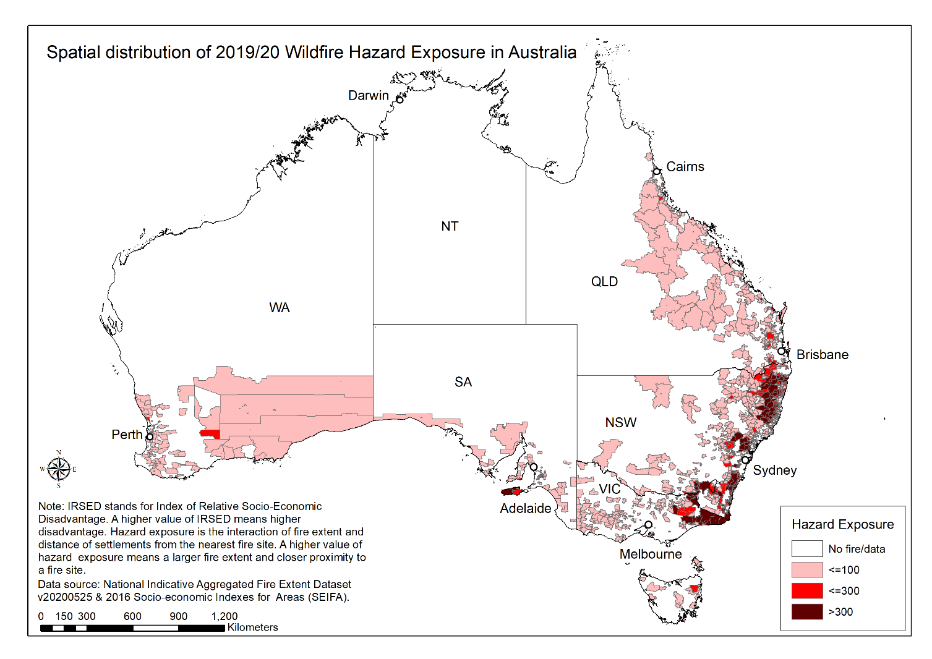

SM 6 The spatial distribution of 2019-2020 wildfire hazard in New South Wales and Victoria, Australia
