Supplementary material for the paper:
“When Macro Critical Climate Risk Comes True. Environmental Destruction and House Prices in Mar Menor, Spain”
Section 1: News about Mar Menor
Section 1.1. Structural Break tests with unknown break point
Calling the number of news (or the proportion of news containing Mar Menor over Murcia excluding sports) $y_{t}$ we estimate the model:
$$y_{t}=α+ϕy_{t-1}+ε_{t}$$
and we test for the stability of the parameters $α$ and $ϕ$.
Andrews (1991, 1993), Andrews and Ploberger (1994), and Bai and Perron (1998), (2003a), (2003b) propose different methods to test for parameter instability when the break point is unknown. The seminal proposed test by Andrews is simply the maximum of the F-statistics of the null hypothesis of no-break assuming that the break point is in each of the possible dates of the sample (leaving at least 10% of the observations in each side of the subsamples). The proposed statistics is then:
$$Max F={Max}_{τ_{1}<t<}τ_{2} F(t)$$
Where $F(t)$ is the F statistic of the null hypothesis of no break for all t between $τ_{1}$ and $τ_{2}$
The results reject the null hypothesis of no break with a p-value of 0.02 and the estimated break point, for the available sample, 2000-2021 is 2015. When we allow for multiple break points using Bai and Perron specification, we find only one significant (at 5% confidence interval) break that also coincides with 2015. The dynamics of the period 2000-2015 are different that the dynamics of the period 2016-2021, which can be clearly seen in Figure 2 top graphs of the main text.
The results are comparable when we use the proportion of news with the word “Mar Menor” over the news including “Murcia Region” after excluding sports news.

Section 1.2. Change in topics about Mar Menor
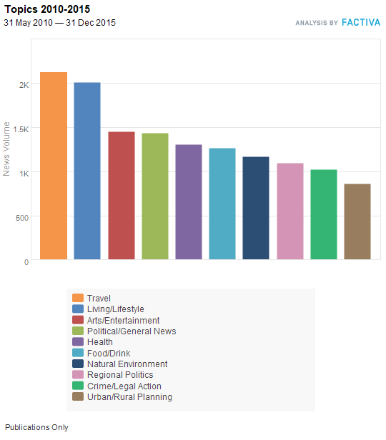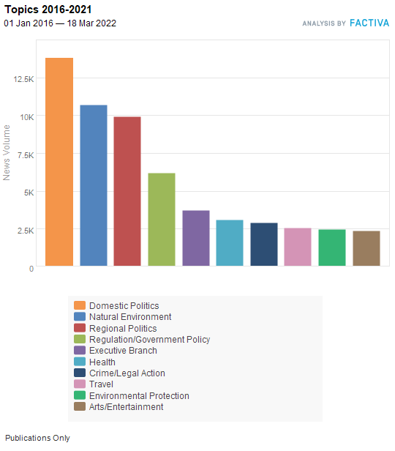
Figure A.1.1 News about Mar Menor by subject
As it is shown in the Figure A.1.1, there is a substantial change in the subjects about Mar Menor. Before the break, we observe that news about travel, living/lifestyle, general news, arts/entertainment and food/drink are the more important ones, but after the break, politics, regulation, and natural environment are the ones that make news. Therefore, not only the dynamics of the news are different, as shown in the previous section, the content of the news is also very different.
Section 2. Tweets about Mar Menor
Section 2.1 Extracting and classifying the tweets about Mar Menor
All the codes can be found in:
https://gitfront.io/r/manolopy/51SqTCY8jckn/Twitter-Mar-Menor/
This section provides guidance to use the codes to create a database with tweets about Mar Menor and perform a sentiment analysis to study how contamination affected the evolution of public opinion.
#First step: Generate database with mar_menor.py
This code includes snscrape library, which requires to use the interpreter Python 3.8 to run. Previous versions cannot run this code. Posterior versions may lead to errors.
Snscrape is a library to perform web scraping from the historical of social media programs such as Twitter, Facebook, Instagram, Reddit, etc. In this application, we focus on Twitter.
The code performs a search in twitter of all the tweets containing the words “Mar Menor” that have been posted in given day. This process is repeated in a loop for every day from 1st January 2010 to 18th March 2022.
We can modify the parameters to change the maximum number of tweets that we want to get per day, the starting date, and the ending date of the extraction. This code stores the date, the text and the username of every tweet filtered by the search. It creates one separated .xlsx by each year. We have three reasons to do this:
First, the code takes a long time to run. If there is any interruption in the execution, at least we conserve the database until the last completed year before the interruption, such that we only need to run this code for the remaining years instead of starting from the beginning.
Second, textual information weights a lot. If we store everything in one dataframe within python, the probability that it is going to run out of memory is very high.
Third, splitting the sample in different files have several computational advantages. We can perform parallel computing if we want to build or analyse the database faster , using many computers or threads at the same time.
#Second step: Classify the tweets with Sentiment_analysis.py
This code uses as input the files generated in the previous step. It runs a loop which analyses in each iteration all the tweets about Mar Menor in a given year, and generates a new .xlsx file with the sentiment data for that year, which contain the daily number of positive, negative, neutral and total tweets about Mar Menor.
First, it detects the language of the tweet with the library langdetect. Then we classify the subjective polarity of the tweets. This program can filter Spanish and English tweets.
To work with the Spanish tweets, we used the sentiment-spanish python library, created by Hugo J. Bello (https://pypi.org/project/sentiment-analysis-spanish). It uses convolutional neural networks to predict the probability of Spanish text being positive. We classified a tweet as positive, negative, or neutral if this probability is >0.6, <0.4 or between 0.4-0.6 respectively. This machine learning model was trained using over 800000 reviews of users of the pages el tenedor, decathlon, tripadvisor, filmaffinity and ebay. This model has a validation accuracy (accuracy over fresh data, no used for training) of 88%.
The algorithm for English tweets is VADER (Valence Aware Dictionary for Sentiment Reasoning), which is available in the NLTK python Library. It is a lexicon (LEX) and rule-based model which has shown to outperform other rule-based and machine learning models previously used in the literature (Hutto and Gilbert, 2014). One of the variables of the VADER polarity score algorithm is called compound, and its sign tell us if the tweet is positive, negative, or neutral (compound >0, <0, =0 respectively).
Henriquez, Guzman, & Santamaria (2016) found that ML models work better for Spanish text, but Hutto and Gilbert (2014) reached the conclusion that LEX rule-based models are more efficient in classifying English textual data. These different results may be due to the differences in the training samples and linguistic resources available in both languages.
#Third step: We merge the sentiment data into a single .xlsx with merge.py
Once we have all the sentiment data, we merge all the sentiment data in an unique .xls
Then we group by week, adding up all the number of positive, negative, neutral and total tweets within each week. We do this to reduce the noise of the data, because high frequency data is very noisy. This way, the graphs are easier to interpret.
To group by week we use pseudo_week_transformation.py. The first 3 pseudo weeks comprehend 7 days; but the last one comprehend from the day 22 until the end of the month. We do this to make every month have always 4 pseudo weeks, which is standard in the economics literature, see, for example, Lewis et al. (2020). Otherwise, some months would have 4 weeks and other months would have 5 weeks, which creates problems when using this data into mathematical or statistical models.
Section 2.2 Testing for breaks in the tweets about Mar Menor
We repeat the procedure of section 1.1 of this supplementary material, where the variable $y_{t}$ is the difference between the positive and negative tweets containing the word Mar Menor. We take a 4 weeks moving average of the data, to avoid extreme volatile observations, and we estimate the model
$$y_{t}=α+{ϕ_{1}y}_{t-1}+{ϕ_{2}y}_{t-2}+…{ϕ_{8}y}_{t-8}+{ϕ_{9}y}_{t-9}+ε_{t}$$
Where we increase the number of lags with respect to the specification in 1.1 because we have higher frequency of data. We test for the joint stability of the parameters using the previously explained test of Andrews (1993) and the Bai and Perron test for multiple breaks. We find only one significant break, with a p-value of 0.01 in the second week of June 2016, coinciding with the reactivation of visitors in the area and their first-hand experience of visiting a deteriorated ecosystem.

Section 3. A tale of two cities. Cointegration analysis.
K time series, $y_{1,t}….y_{k,t}$ are integrated of order “d”(are non-stationary and need “d” differences to become stationary). If there is a linear combination across then than is integrated of order “d-1” these series are cointegrated.
Cointegration was introduced by the Nobel Prize Winners, Robert Engle and Clive Granger in their seminal work, Engle and Granger (1987). In economics, usually refers to non-stationary series (usually random walks, d=1) which are strongly dominated in their signal by their stochastic trend, but a combination of these series is stationary (d=0). Engle and Granger (1987) also show that if K series are cointegrated, in the evolution of ${∆y}_{i,t} (i=1…K)$, the residual of the cointegration relation (called the Error Correction Term) is statistically significant.
In the example that we are analyzing, we have two time series, $y_{1,t}$ the log prices in San Pedro (the area of San Pedro adjacent to Pilar de la Horadada a district called Lo Pagan) and $y_{2,t}$the log prices in Pilar de la Horadada.
Before summer of 2015, (sample 2010.01-2015.06), applying Johansen (1991) test, we find cointegration between these two price series (we reject no cointegration with a p-value of 0.03. Therefore, growth rates of prices in San Pedro (${∆y}_{1,t})$ and growth rate of prices in Pilar de la Horadada (${∆y}_{2,t})$ are driven by its own past and a measure of the divergences between these two prices because their levels cannot be far away from each other. This divergence between these two prices is called error correction term. The estimated model is then:
$\left(\begin{matrix}{∆y}_{1,t} \\ {∆y}_{2,t}\end{matrix}\right)$ =$\left(\begin{matrix}c_{1} \\ c_{2}\end{matrix}\right)+\left(\begin{matrix}∅_{1}(L) & ∅_{2}(L) \\ ∅_{3}(L) & ∅_{4}(L)\end{matrix}\right)\left(\begin{matrix}{∆y}_{1,t-1} \\ {∆y}_{2,t-1}\end{matrix}\right)+\left(\begin{matrix}d_{1} \\ d_{2}\end{matrix}\right)\left(y_{1,t}-c-∝y_{2,t}\right)+\left(\begin{matrix}ε_{1} \\ ε_{2}\end{matrix}\right)$
$L$ represents the lag operator that indicates the number of lags of the variables included in the specification. $\left(y_{1,t}-c-∝y_{2,t}\right)$ is the formal definition of the error correction term. The coefficients $d_{1}$and $d_{2}$ have the expected sign (negative for $d_{1}$and positive for $d_{2}$) which is indicative that, when prices is San Pedro are too high (low) with respect to prices in El Pilar de la Horadada $(\left(y_{1,t}-c-∝y_{2,t}\right)$is very positive), they have the tendency to go down (up), prices in El Pilar will have the tendency to go up (down). Also, as suggested by Engle and Granger (1987) at least one of them is significant. $d_{1}=-0.02 (0.03)$, $d_{2}=0.17 (0.07)$. Therefore, if prices in San Pedro drift positively (negatively) from prices in Pilar de la Horadada, prices in San Pedro will decrease (increase) in the following period and prices in Pilar de la Horadada will increase (decrease) to catch up with San Pedro prices. Associated to this specification and for L=6, we obtain the impulse response functions represented in figure A.3.1. Impulse response functions represent how one shock in one unit in the growth rate of the price in one location is transmitted to its own dynamics and in the dynamics of the of the other variable.
Figure A.3.1 Impulse response function. The graphs plot how a surprise of 1% in the growth rate of prices in each location is transmitted through the growth rates of the next 12 months to each of the two locations. The X axis contains the number of months after the shock, the Y axis is the variation in the growth rate of the prices in each location due to each particular shock. Figures are represented with 68% standard deviations bands.
As can be seen, shocks in San Pedro have a positive effect in housing prices in El Pilar de la Horadada (bottom left graph) and viceversa (upper right graph). These two series move together in the long run, therefore shocks in the short run produce the same kind of movement in both series. Actually, it is remarkable how, after one year, shocks in El Pilar have bigger effect on the growth rate of prices in San Pedro than shocks in San Pedro on itself. (two bottom graphs).
However, none of these results hold for the full sample (2010.01 2022.03). Johansen (1991) test accept the null of no cointegration (p-value 0.17) and there is no significant transmission of shocks from one location to the other.
Nevertheless, one variable can explain the drift between these two price series. We introduce the difference between positive and negative tweets about Mar Menor (we transform the series to monthly frequency using the average of the weeks of a given month). The null of no cointegration using Johansen (1991) is rejected at 10%, p-value 0.06). It seems that there is a long term relation between $y_{1,t}$ the log prices in San Pedro, $y_{2,t}$the log prices in Pilar de la Horadada and $y_{3,t}$ the sentiment about San Pedro´s coastal area measured by the difference between positive and negative tweets. The estimated equation is now:
$\left(\begin{matrix}{∆y}_{1,t} \\ {∆y}_{2,t} \\ {∆y}_{3,t}\end{matrix}\right)$=$\left(\begin{matrix}c_{1} \\ c_{2} \\ c_{3}\end{matrix}\right)+\left(\begin{matrix}∅_{1}(L) & ∅_{2}(L) & ∅_{5}(L) \\ ∅_{3}(L) & ∅_{4}(L) & ∅_{6}(L) \\ ∅_{7}(L) & ∅_{8}(L) & ∅_{9}(L)\end{matrix}\right)\left(\begin{matrix}{∆y}_{1,t-1} \\ {∆y}_{2,t-1} \\ {∆y}_{3,t-1}\end{matrix}\right)+\left(\begin{matrix}d_{1} \\ d_{2} \\ d_{3}\end{matrix}\right)\left(y_{1,t}-c-α_{1}y_{2,t-}α_{2}y_{3,t}\right)+\left(\begin{matrix}ε_{1} \\ ε_{2} \\ ε_{3}\end{matrix}\right)$
The results of the cointegration tests are confirmed because, as suggested by Engle and Granger (1987), at least one of the three parameters of interest is significant and with the appropriate sign, $d_{1}=-0.023 (0.010)$ and $d_{3}=0.126 (0.053)$. The coefficient $d_{1}$ reflects that in prices in San Pedro separates positively (negatively) of what it is expected from the sentiment and the prices in Pilar de la Horadada, they will go down (up) in the next period and $d_{3}$ implies that if the prices in San Pedro increases (decreases) with respect to its expected value, it will imply that positive (negative) sentiment will appear in the future to explain this price gap. The associated impulse response function for this specification is represented in figure A.3.2.

Figure A.3.2 Impulse response function. The graphs plot how a surprise of 1% in the growth rate of prices in each location (or an increase in 1 unit in the difference between the proportion of positive and negative shocks) is transmitted through the growth rates of the next 12 months to each of the two locations. The X axis contains the number of months after the shock, the Y axis is the variation in the growth rate of the prices in each location due to each particular shock. Figures are represented with 68% standard deviations bands.
As can be seen in the graphs, in addition to the transmission mechanism plotted before, we have to add that sentiment variable affects the growth rate of prices in San Pedro. Good (bad) news about Mar Menor increases (decreases) the growth rate of prices in San Pedro (top left graph) as can be expected. Therefore, there are two transmission channels to the price in San Pedro, prices in El Pilar and sentiment variables
Section 4. Estimation of the number of houses and the wealth of changing from dry-farming to crop-irrigation.
Section 4.1 Number of houses.
Cadastral statistics provide information about the number of houses built by municipality. Four municipalities have access to Mar Menor shores, the municipalities of San Javier, San Pedro del Pinatar, Los Alcazares and Cartagena, but the proportion of houses at the shore of Mar Menor in these municipalities is not the same. However, in the web page where owners put their houses up for sale (idealista.com) we have information of the number of houses for sale with a map that allows us to calculate the proportion of houses for sale in the sea shore with respect to the total number of houses for sale in the municipality. With this proportion, we can infer the proportion of total houses in the shore. Details of these calculations are shown in table A.4.1
Table A.4.1 shows the input for these calculations.
These numbers represent a lower bound to the number of houses because we are not considering the houses in the 20 Km strip of land called La Manga. Even though we exclude this area from the analysis, because, as we said in the main text, it is only partially affected by the catastrophe (it has two shores, Mar Menor and Mediterranean) it experiments during the period a very mild increase in price, less than 10%, that imply that it is also affected by the ecological catastrophe. If we include this area, even assuming that only half of the properties are affected, the impact would be of more than €6,250 million.
Section 4.2 Wealth of changing from dry-farming to crop-irrigation.
The purpose of this section is to calculate the wealth generated from dry-farming to crop-irrigation in the surrounding area to Mar Menor.
There are no specific data on the number of hectares with crop-irrigation in that area. We have some snapshot references, as the one quoted in the main text (Perni et al 2020), but it is not clear how has been the evolution over the years. In order to address this question, we estimate an upper bound for this wealth based on the data from National Accounting and the official survey from the Ministry of Agriculture on the use and return from land in Spain (2021).
Our calculations heavily rely on the numbers displayed in Table A.4.2. We calculate in each period of time how many hectares have been put into production (irrigated-crop) with respect to the first year that we have data (2011) in the whole Region of Murcia. Let us denote this number with $∆X_{t}=\left(X_{t}-X_{2011}\right)$, with $X_{t}$ being the number of hectares in irrigation in year “t”. We will assume that all the $∆X_{t}$ in Murcia region is done in the Mar Menor area. This is clearly un upper bound, because this is not the case, but, given that we do not have specific data about that particular area, we will estimate an upper bound to make sure that we do not underestimate the gains from irrigated-crops.
Given that $∆X_{t}$ is the increase in hectares of irrigation, if we calculate the returns per hectare, we can calculate the contribution of the decision of increase the irrigated area to GDP.
The returns per hectare is also calculated as an upper bound. Being $Y_{t}$ the GDP in the agricultural sector in the Region of Murcia in period “t”, we can define$R_{t}=\frac{Y_{t}}{X_{t}}$ . $R_{t}$represents an upper bound to the returns in irrigation because not all agricultural GDP has been generated with irrigation (actually only 39% of crops in Murcia are irrigation).
With these arguments in mind, $G_{t}=∆X_{t}*R_{t}$ represents the increase in GDP from the base year in period t of putting $∆X_{t}$hectares into production (an upper bound).
The aggregation of all these $G_{t}$is the upper bound for the wealth generated by irrigation (443 million Euros) , orders of magnitude smaller than the loss of wealth in housing.
Additionally, we could calculate the gains from changing crops by measuring the increase in the value of the land of changing from dry-farming to irrigation. Figure A.4.1 shows the evolution of the number of hectares in irrigation in Murcia Region since the first period for which data are available. Trying to calculate an upper bound to the wealth accumulated by the farming sector in the surrounding of Mar Menor for changing the type of land, we consider as the initial amount of land in irrigation the one that correspond to the minimum of the time series (year 2010). We then assume that all the variation from the last period of the sample to the minimum is associated with increase in irrigation land in Mar Menor (183,477 in 2021 minus 162,790 in 2010 =16864 Ha). Therefore, we assume that the increase in irrigation of more than 16 thousand only comes from the Mar Menor surroundings. Now we value how much gain in wealth this increase in irrigation has produced. In order to do that, we compare (at 2021 prices) the value of these additional 16 thousand Ha as irrigation land with its value at dry-farming. The price of irrigation land is 37,126 Euros/Ha and the price of dry-farming 4,690 Euros/Ha. The increase in price per Ha of changing the use of land is 32,436 Euros/Ha.
Therefore, the increase in wealth from changing the use of land is 32,436 X 16,864= 547 million Euros. As can be seen, this is in the same order of magnitude than the amount previously calculated with the summation of the GDP (443 million) and it is again around 10 times smaller than the destruction of wealth in the housing sector.

Figure A.4.1. Number of Hectares in irrigation in Murcia Region.

Section 5. Difference in Difference
Section 5.1 Baseline model. Estimation coefficients
We use the datasets of the Spanish Association of Registrars to carry out this analysis. We cover the universe of house transactions in this area, although we exclude government-subsidized housing and houses purchased by legal entities since price determinants in these operations could be different. Our sample is made up of 13,260 properties sold during the period 2013-2021 (October) in the control area and 8,842 properties in the Mar Menor area. We use the DD estimator proposed extensively in the literature of treatment effects. The estimated model is

$$y_{i}=α+B_{2013}{Treat(Mar Menor)}_{i}+\sum_{t=2014}^{t=2021}{γ_{t}{Time}_{t,i}+}\sum_{t=2014}^{t=2021}{β_{t}{Time}_{t,i}*}{Treat(Mar Menor)}_{i}+δ_{k}{X_{i,k}+ε}_{i}$$
Where:
- $y_{i}=$ Log of Price per square meter for house i
- ${Treat(Mar Menor)}_{i}$= Dummy value 1 if House i belongs to Mar Menor
- ${Time}_{t,i}$= Dummy value 1 if House i is sold in period t
- $X_{i,k}$ Control variables
The model is estimated using OLS techniques, with homoscedastic standard errors but, for robustness, we also allow for heteroscedasticity consistent standard errors (and clustered standard errors that takes into account that different subgroups of houses might have their own source of uncertainty. In our case, we allow for different variance by zip code and by housing size. We have then 10 zip codes times five type of houses, creating 50 different variances.

In our specification we include the following:

- $X_{i,1}$ Control for the type of house. Three dummies depending on the type, terraced house, isolated house, flat, flat with storage
- $X_{i,2}$ House size: Four dummies, four cut points, 54, 64, 76, 94 sq meters.
- $X_{i,3}$ Construction status: Two dummies. Under construction, New, Second hand
- $X_{i,4}$Buyer nationality: One dummy. Spanish or Foreign
- $X_{i,5}$Seller nationality: One dummy. Spanish or Foreign
- $X_{i,6}$Seller legal status: One dummy: Legal entity or individual

To check for robustness, we also include zip dummies. The results are robust. All the estimated coefficients from the different specifications are displayed in Table A.5.1

Section 5.2 Repeated houses. Estimation coefficients
As explained in the main text, the estimation with repeated houses, addresses the possibility that, even though houses sold in both areas are equal and the trends before the HAB were equal, the houses listed during the period 2016-2021 might be very different even when controlling for our set of explanatory variables. In order to address this possibility, we repeat the previous exercise but we only use houses that are sold more than once in the period under study, just to make sure that the set of dwellings is completely homogeneous over time (e.g., before and after the HAB). The results, for the variables of interest are displayed in Figure A.5.1 where we use the same format that the one used in Figure 6 of the main text with the same three possible specifications for the variance.

Figure A.5.1 Differential effect of housing prices in Mar Menor vs control area. OLS estimation (left), heteroscedasticity consistent standard errors (middle), and cluster errors (right). Estimation with repeated houses.
The coefficient estimates are displayed in Table A.5.2. Obviously, in this case, all the coefficients related with dummies that do not change over time cannot be estimated.

Section 5.3. Enlarging control group.
Murcia Region has other potential control areas that we could use in our analysis. South of the Mar Menor is clearly not comparable, because a big city with an important port, Cartagena, is located, and, clearly the price dynamics of such a different area are not comparable with Mar Menor. However, further south, in the same region, some other areas are potentially comparable (vacation houses, second residences, tourist destination). We include these areas and we repeat the analysis developed in the main text. Our control area has now, instead of 13,260 houses, 18,456.units Figure A.5.3 show the map of the extended control and the treated area.
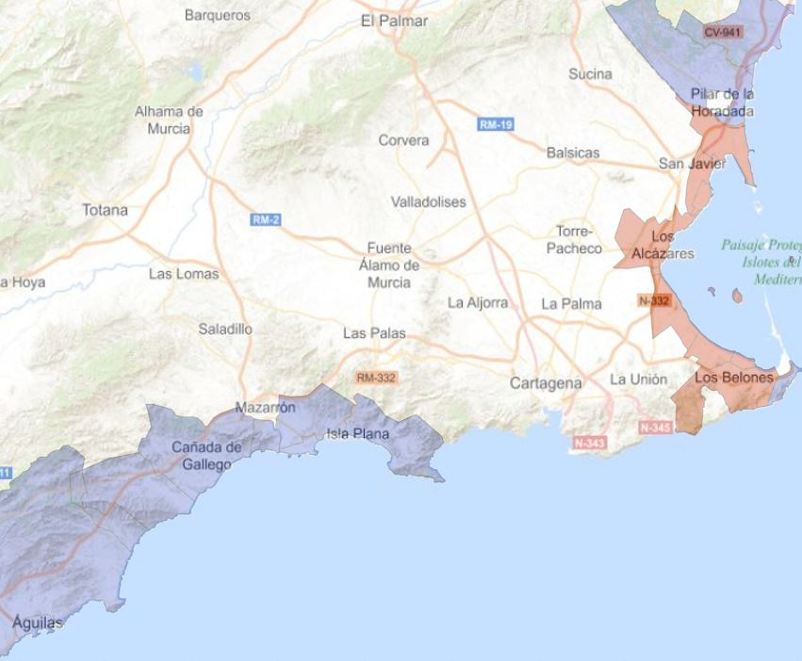
Figure A.5.3 Red area is the one affected by the ecological deterioration (Mar Menor). Blue area is the enlarged control group.

The results are comparable, and the relevant coefficient are plotted in Figure A.5.3. As can be seen in the figure, as a difference of the control area used in the main text, even though the additional area apparently shares the characteristics of the Mar Menor, the new control area does not satisfy the strict requirements of the DD estimation. Even though the parallel trend assumption seems to marginally hold, (we do not reject the null hypothesis that the coefficients in 2014 and 2015 are equal to 0), we clearly reject the homogeneity of the control and treated area in the base year (the coefficient of the treatment in the base year is positive and significant; prices in Mar Menor are higher than in the new control area). Even with this caveat, just as an illustration, looking at the figure, it is clear that prices in Mar Menor decreased during the treatment period in comparison with prices in the new enlarged control area. Our results are robust, although a word of caution should be added with respect to the statistical validity of our enlarged analysis.

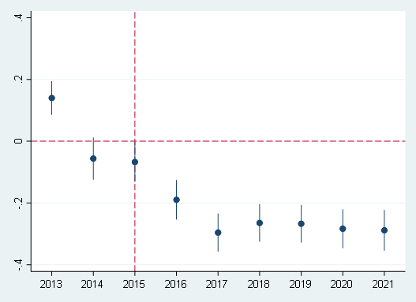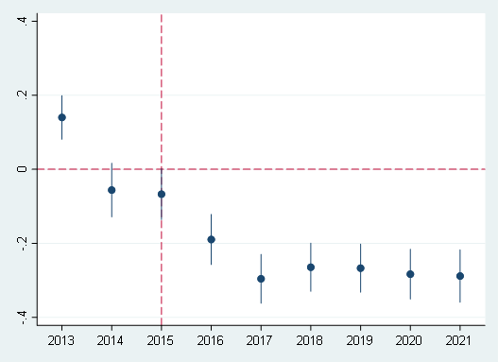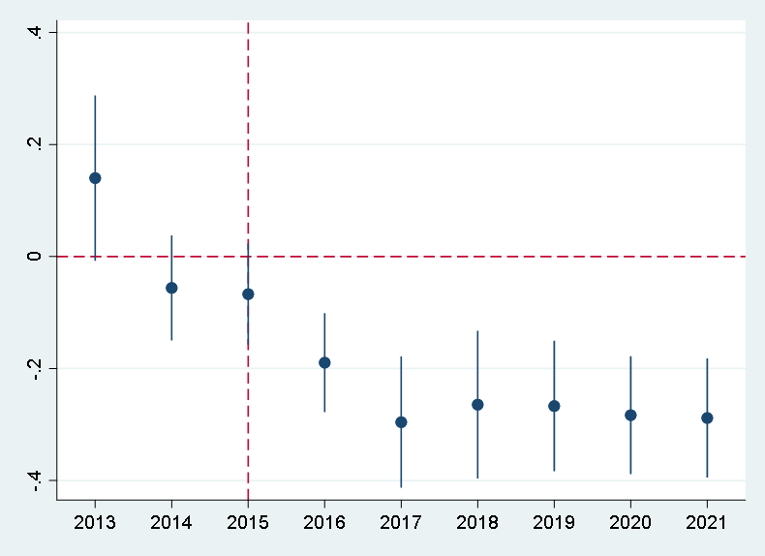
Figure A.5.3 Differential effect of housing prices in Mar Menor vs control area. OLS estimation (left), heteroscedasticity consistent standard errors (middle), and cluster errors (right). Estimation with enlarged control area.

References of Section 1
Andrews D., “Heteroskedasticity and Autocorrelation Consistent Covariance Matrix Estimation,” Econometrica 59(3) (1991), 817–58.
———, “Tests for Parameter Instability and Structural Change with Unknown Change Point,” Econometrica 61(4) (1993), 821–56.
———, “End-of-Sample Instability Tests,” Econometrica 71(6) (2003), 1661–94.
———, and Ploberger, W., “Optimal Tests When a Nuisance Parameter Is Present Only under the Alternative,” Econometrica 62(6) (1994), 1383–414.
Bai, J., and P. Perron, “Estimating and Testing Linear Models with Multiple Structural Changes,” Econometrica 66(1) (1998), 47–78.
———, and ———, “Computation and Analysis of Multiple Structural Change Models,” Journal of Applied Econometrics 18(1) (2003a), 1–22.
———, and ———, “Critical Values for Multiple Structural Change Tests,” Econometrics Journal 6(1) (2003b), 72–8
References of Section 2
Henriquez Miranda, C. N., Guzman, J., & Santamaria, R. (2016). A review of Sentiment Analysis in Spanish. TECCIENCIA, 12(22), 40–47. Retrieved from https://revistas.ecci.edu.co/index.php/TECCIENCIA/article/view/320
Hutto, C., & Gilbert, E. (2014, May). Vader: A parsimonious rule-based model for sentiment analysis of social media text. In Proceedings of the international AAAI conference on web and social media (Vol. 8, No. 1, pp. 216-225).
Lewis, D. J., Mertens, K., Stock, J. H., & Trivedi, M. (2022). Measuring real activity using a weekly economic index. Journal of Applied Econometrics, 37(4), 667-687.
References of Section 3
Engle, R. and Clive Granger (1987). Co-integration and Error correction: Representation, estimation and testing. Econometrica, Vol 55 No 2 March 1987, pages 251-276
Johansen, Søren (1991). "Estimation and Hypothesis Testing of Cointegration Vectors in Gaussian Vector Autoregressive Models". Econometrica. 59 (6): 1551–1580

References of Section 4
Perni A., M.-P. J., Barreiro-Hurle J. When policy implementation failures affect public preferences for environmental goods: Implications for economic analysis in the european water policy. Ecol. Econ. 169, 1–12, DOI: https://doi.org/10.1016/j.ecolecon.2019.106523 (2020).
Encuesta sobre Superficies y Rendimientos de Cultivos en España, ESYRCE, (2021). Gobierno de España. Ministerio de Agricultura, Pesca y Alimentación. Subsecretaría de Agricultura, Pesca y Alimentación, Subdirección General de Análisis Coordinación y Estadística.

We choose Summer 2015 because the summer of 2015 coincides with the first phytoplankton proliferation episode documented and, given the proximity of these towns, prices seems to react a few months earlier than in the whole treatment area.

