Appendix A: Final Logic Model
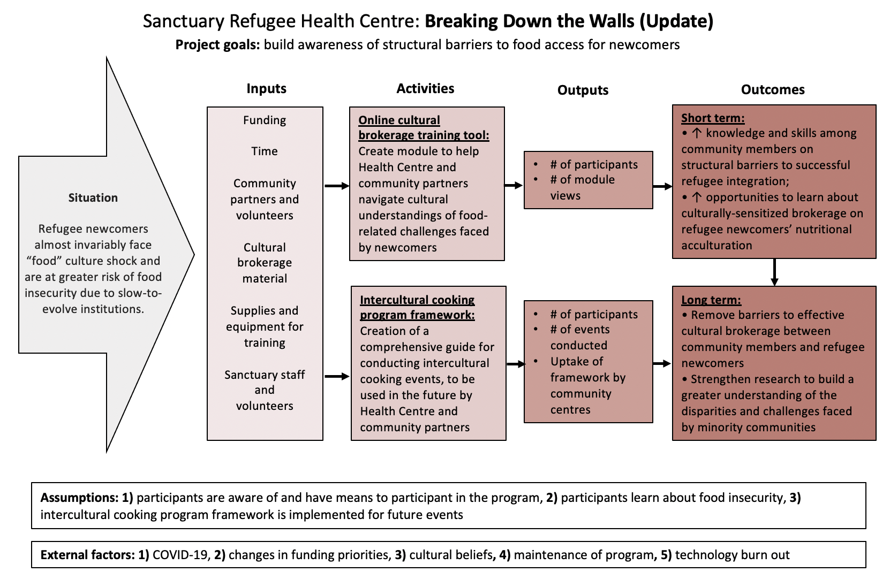
Figure II: Logic model developed for the original implementation of the BDTW pilot program

Appendix B: Final Evaluation Tools
Building Cultural Bridges Through Food Feedback Form

Start of Block: Default Question Block

Q14 Congratulations on completing the "Building Cultural Bridges Through Food" training module!
We would appreciate your help in improving this program by completing this quick survey. Thank you in advance for your feedback!

Q3 Please rate the following aspects of the training:
 | Very Poor (1) | Poor (2) | Neutral (3) | Good (4) | Very Good (5)
Quality of information (1)
Clarity of information (2)
Visuals (3)
Interactivity (4)
Overall experience (5)

Q14 How did you feel about the amount of information presented in this module?
- Too little (1)
- About right (2)
- Too much (3)

Q7 Following completion of the module, how has your knowledge surrounding the following concepts shifted?
 | I am more confused (1) | My knowledge has remained the same (2) | My knowledge has somewhat increased (3) | My knowledge has greatly increased (4)
Food insecurity (1)
Impact of culture on food insecurity (2)
Food traditions of other cultures (3)
Strategies to support refugee families (4)

Q5 To what extent did your perceptions of food-related barriers faced by refugees change following completion of this module?
- My perceptions changed a lot, refugees face more barriers than I thought (10)
- My perceptions changed a little, refugees face more barriers than I thought (5)
- My perceptions did not change (1)
- My perceptions changed a little, refugees face less barriers than I thought (9)
- My perceptions changed a lot, refugees face less barriers than I thought (6)

Q8 How confident do you feel volunteering with refugees in your community after having participated in this module?
- Very unsure (1)
- Somewhat unsure (2)
- Neutral (3)
- Somewhat confident (4)
- Very confident (5)

Q11 Is there anything that you wished you had learned during this module?
________________________________________________________________

Q12 Do you have any final feedback?
________________________________________________________________

End of Block: Default Question Block

Semi-structured interview guide
Intro: My name is ___ and I am a PhD student at the University of Waterloo, working on the evaluation team for the Breaking Down the Walls project. My colleague, ______, is also here just to take notes during our conversation, but if she flags anything she would like you to expand on she might chime in a bit too. Over the next 30 minutes I will be asking you questions about your role on this project, as well as your thoughts and experiences related to the development and implementation of the project.

Consent to Record: Before we start, we are hoping to record this session so that we can refer back to it and fill in any gaps we might miss when taking notes. Would that be alright with you?

Consent: Lastly, if there are any questions you are not comfortable answering, please let us know. Your participation in this is completely voluntary, and you can refuse to answer any questions and can end the interview at any time. We only have 6 questions to review with you today so please feel free to take your time and think about your answers and don’t feel pressured to answer quickly.

Technology: If at any point you have trouble hearing me, please let me know.

Interview Questions and Prompts:

- Can you briefly explain your role on the Breaking Down the Walls project?
- To what extent is the Breaking Down the Walls program being implemented as originally planned? To what extent has the program changed?
  - How does the current project implementation compare to the original project plan?
  - How has the intended population for the program changed?
- When you think back to the development and implementation of this project, what challenges did you and your team face?
  - What external factors influenced the development and implementation? (e.g., COVID-19, experience with partnerships, funding)
  - What internal factors influenced the development and implementation? (e.g., organizational structure, communication, etc.)
- Can you describe some of the facilitators to successful implementation?
  - What external factors supported the development and implementation? (e.g., experience with partnerships?)
  - What internal factors supported the development and implementation?
  - Can you think of a time where you and your team had a big success? Or when things were running quite smoothly for this project? Were there any factors that stood out to making this time successful?
- How might you have approached things differently?
  - What additional resources might have been beneficial (e.g., funding, time, partnerships, staff)?
  - (try to facilitate connection between answers from Q3 to this question if the participants don’t naturally make that connection)
    - You mentioned earlier that ___ was a barrier, if you were to start this project over again, how might you have done things differently so that this barrier might not have had such a big impact?
- What impact do you think this program (as it is now) will have on cultural brokerage?
  - Has the potential for impact changed with the program changes? How so?

