Supplementary Information for Permittivity Boosting by Induced Strain from Local Doping in Titanates from First Principles

Alex Kutana, Yuho Shimano, Ryoji Asahi

The parent compound for substituted perovskites is a paraelectric calcium titanate CaTiO₃ (mineral perovskite) that crystallizes into an orthorhombic Pnma (62) phase at low temperatures;¹ the observed high temperature phases include tetragonal I4/mcm (140), and a cubic Pm$\underline{3}$m (221) phase for T>1580 K.^{2,3} The breaking of the ideal cubic Pm$\underline{3}$m symmetry occurs by a⁻a⁻c⁺ tilting of the TiO₆ octahedra. Our calculated average ionic dielectric constant for this material at PBEsol lattice constant is 124, in the range of previously reported theoretical values⁴ ~93-268, which varied depending on whether a theoretical (LDA) or experimental value of the lattice constant was used. The Ruddlesden-Popper phases^{5,6} Sr₂TiO₄ and Sr₃Ti₂O₇ have the I4/mmm (139) symmetry, and TiO₂ rutile has the P4₂/mnm (136) symmetry.

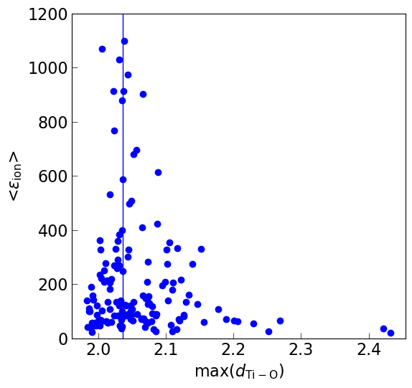
Figure S1. Ionic part of the dielectric constant, ε_{ion}, as a function of max(d_{Ti-O}), the maximum length of the Ti-O bond in co-doped TiO₂ rutile. The vertical line at max(d_{Ti–O})=2.036 Å is drawn to guide the eye.

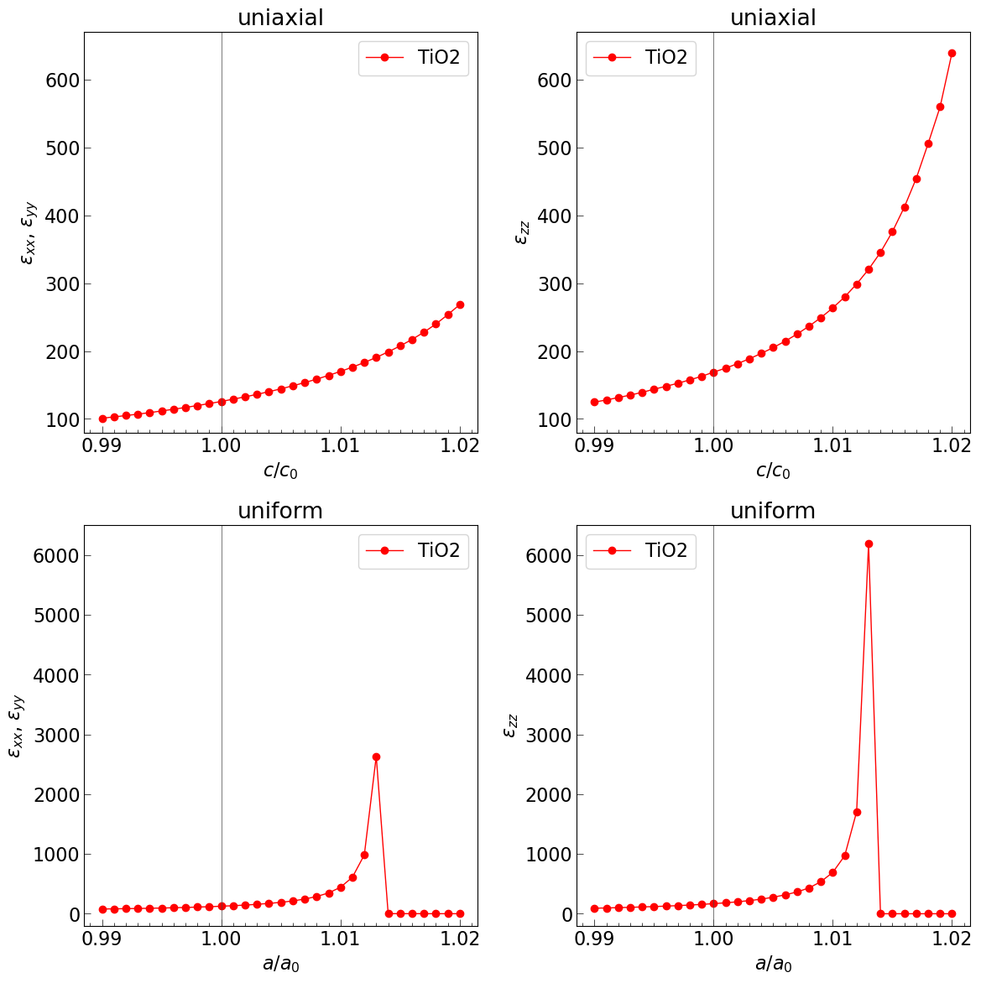
Figure S2. ε_{ion} of TiO₂ rutile as a function of uniaxial and uniform strain.

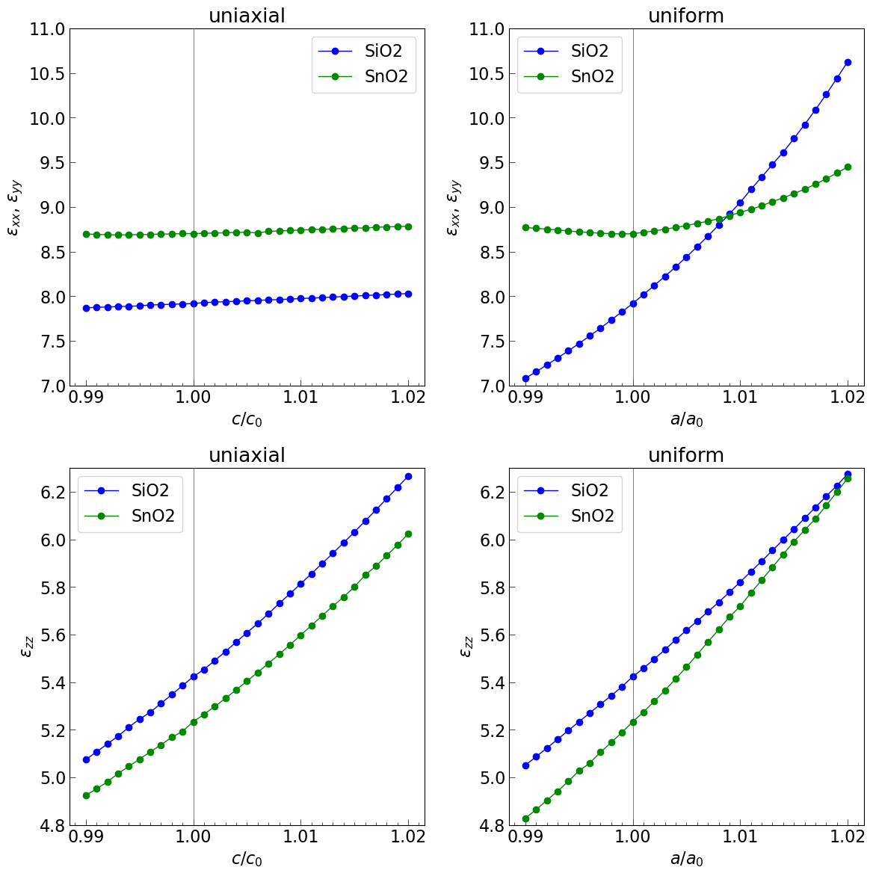
Figure S3. ε_{ion} of SiO₂, SnO₂ rutile structures as a function of uniaxial and uniform strain.

Table S1. Phonon modes of Pnma CaTiO₃ contributing to dielectric constant.

 | ν (THz) | ε_{partial} | mode #
εxx
 | 3.828 | 109.1 | 6
 | 5.026 | 19.9 | 12
 | 6.379 | 2.5 | 21
εyy
 | 4.021 | 96 | 7
 | 5.222 | 24.1 | 14
 | 9.172 | 2.6 | 31
 | 15.56 | 2.2 | 53
εzz
 | 3.599 | 22.4 | 5
 | 4.432 | 55.0 | 9
 | 5.668 | 26.3 | 16
 | 15.90 | 2.5 | 55

Table S2. Ionic part of the dielectric tensor in substituted and co-doped titanates shown in Fig. 2.

compound | ε_{xx} | ε_{yy} | ε_{zz}
CaTiO₃ | 136.0 | 126.9 | 108.2
Ba₂Sr₂Ti₄O₁₂ | 697.0 | 407.2 | 9015.2
Ba₂Ca₂Ti₄O₁₂ (α) | 92.8 | 53.4 | 1228.7
Ba₂Ca₂Ti₄O₁₂ (β) | 105.1 | 432.5 | 564.2
BaCa₃Ti₄O₁₂ | 175.4 | 186.3 | 252.4
Ti₆InNbO₁₆ | 213.4 | 106.6 | 2767.9
Ti₂O₄ | 125.8 | 125.8 | 169.0

Table S3. Born effective charges Z*_{κ,zz} in Ba_{x}Sr_{y}Ca_{1−x−y}TiO₃. O₁ atoms are part of Ti-O chains aligned with the z axis, O₂ atoms are part of other Ti-O chains. For symmetry inequivalent atoms in substituted structures, maximum value is taken.
 | Ca | Sr | Ba | Ti | O₁ | O₂
CaTiO₃ | 2.38 | – | – | 7.32 | -5.76 | -1.97
Ba₂Sr₂Ti₄O₁₂ | – | 2.54 | 2.7 | 7.69 | -6.35 | -2.09
Ba₂Ca₂Ti₄O₁₂ (α) | 2.51 | – | 2.62 | 7.30 | -6.12 | -2.06
Ba₂Ca₂Ti₄O₁₂ (β) | 2.51 | – | 2.61 | 7.57 | -6.16 | -2.11
BaCa₃Ti₄O₁₂ | 2.46 | – | 2.66 | 7.41 | -6.14 | -2.07
BaTiO₃ | – | – | 2.72 | 7.74 | -6.16 | -2.15

Table S4. U values used for Hubbard correction applied to d electrons.

el | O | Mg | Al | Ca | Sc | Ti | V | Cr | Ga | Sr | Y | Zr | Nb | Mo | In | Ba
U (eV) | 0 | 0 | 0 | 0 | 0 | 0 | 3 | 3 | 0 | 0 | 3 | 3 | 3 | 3 | 0 | 0

el | La | Hf | Ta | W | Pb
U (eV) | 3 | 3 | 3 | 3 | 0

The atomic structures and calculated properties are provided in json format.

References
(1) Kay, H. F.; Bailey, P. C. Structure and Properties of CaTiO3. Acta Crystallogr. 1957, 10 (3), 219–226. https://doi.org/10.1107/S0365110X57000675.
(2) Kennedy, B. J.; Howard, C. J.; Chakoumakos, B. C. Phase Transitions in Perovskite at Elevated Temperatures - a Powder Neutron Diffraction Study. J. Phys. Condens. Matter 1999, 11 (6), 1479–1488. https://doi.org/10.1088/0953-8984/11/6/012.
(3) Yashima, M.; Ali, R. Structural Phase Transition and Octahedral Tilting in the Calcium Titanate Perovskite CaTiO3. Solid State Ion. 2009, 180 (2), 120–126. https://doi.org/10.1016/j.ssi.2008.11.019.
(4) Cockayne, E.; Burton, B. P. Phonons and Static Dielectric Constant in CaTiO3 from First Principles. Phys Rev B 2000, 62 (6), 3735–3743. https://doi.org/10.1103/PhysRevB.62.3735.
(5) Ruddlesden, S. N.; Popper, P. New Compounds of the K$\sb 2$NIF$\sb 4$ Type. Acta Crystallogr. 1957, 10 (8), 538–539. https://doi.org/10.1107/S0365110X57001929.
(6) Ruddlesden, S. N.; Popper, P. The Compound Sr$\sb 3$Ti$\sb 2$O$\sb 7$ and Its Structure. Acta Crystallogr. 1958, 11 (1), 54–55. https://doi.org/10.1107/S0365110X58000128.

