Table 1. Summary of the changes implemented after each trial of the usability evaluation.
 | Visual aspect | Translation | Made changes
Question about CE certification.
Prototype 1 | 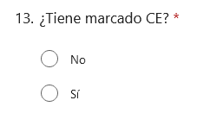  Fig. 4. Visual aspect for the question “Does it have CE certification?” in prototype 1 | 13. Does it have CE certification?  - No  - Yes
Prototype 2 | 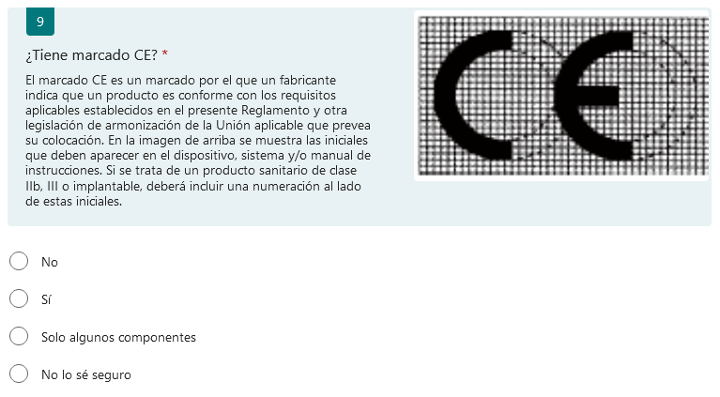  Fig. 5. Visual aspect for the question “Does it have CE certification?” in prototype 2 | 9. Does it have CE certification?  CE marking is the way in which a manufacturer indicates that a device conforms with the applicable requirements set out in Regulation 2017/746 on medical devices and other applicable Union harmonization legislation. In the picture above the two initials that must appear in the device, system and/or handbook are shown. If it is a medical device IIb, III or implantable type, it also must include some numbers next to the initials.  - No  - Yes  - Only some of the components  - I am not sure about this | The official description and picture of the CE certificate according to the European Regulation on Medical Devices [13] was added due to the difficulties in understanding the question which includes that term.  Questions and question number were highlighted using background green color to differentiate them from the answers.
Final version | 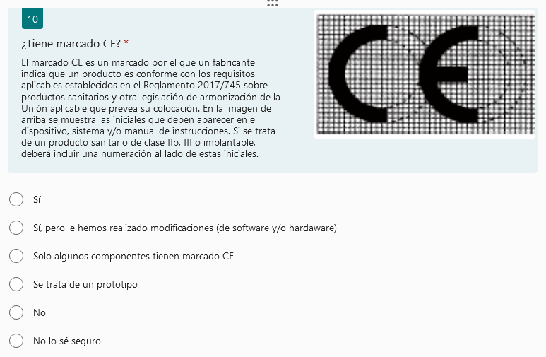  Fig. 6. Visual aspect for the question “Does it have CE certification?” in the final version. | 10. Does it have CE certification?  CE marking is the way in which a manufacturer indicates that a device conforms with the applicable requirements set out in Regulation 2017/745 on medical devices and other applicable Union harmonization legislation. In the picture above the two initials that must appear in the device, system and/or handbook are shown. If it is a medical device IIb, III or implantable type, it also must include some numbers next to the initials.  - Yes  - Yes, but some modifications were made (software and/or hardware)  - Only some of the components have CE certification  - It is a prototype  - No  - I am not sure about this | Answers were reorganized to be consistent throughout the questionnaire (“Yes” first, “No” below, and “I don’t know” last)  One participant proposed changing the question “Does it have CE certification?” with “Is the device or system a prototype?” but these two questions cannot be considered the same and so additional options were added within the answers for this question.
Answer referring that approval from an ethical committee is needed
Prototype 1 | 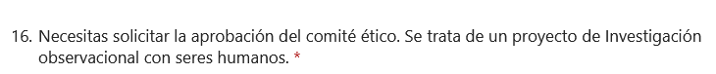  Fig. 7. Visual aspect for the answers in prototype 1. | 16. You need approval from an ethical committee. It is considered as and observational research project involving humans.
Prototype 2 | 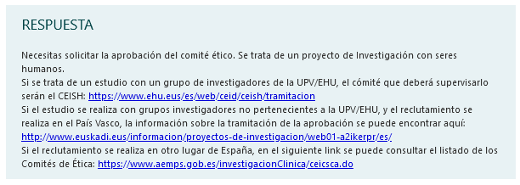  Fig. 8. Visual aspect for the answer in prototype 2. | ANSWER  You need the approval from an ethical committee. It is considered as a research project involving humans.  If it is research made together with researchers from the UPV/EHU, the committee that should supervise this research is the CEISH: https://www.ehu.eus/es/web/ceid/ceish/tramitacion  If the research is to be carried out by researchers that do not work at the UPV/EHU, and the recruitment is to be done in the Basque Country, the information about the approval can be found in the following link: http://www.euskadi.eus/informacion/proyectos-de-investigacion/web01-a2ikerpr/es/  If the recruitment is to be done in other place in Spain, in the following link the list of the different Ethical Committees can be found: https://www.aemps.gob.es/investigacionClinica/ceicsca.do | The information of each corresponding board (ethical committee and/or competent authority) was included in the final answer along with a link to their website, where the contact details and the necessary information for submitting the study can be found.  Answers were highlighted from the rest of the questionnaire content to differentiate them easily.
Final version | No changes | No changes | No changes
Question asking if participants will use a device or software
Prototype 1 | 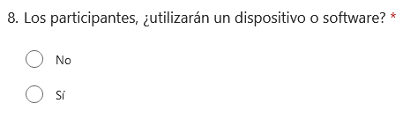  Fig. 9. Visual aspect for the question “Will the participants use a device or software?” in prototype 1. | 8. Will the participants use a device or software?  - No  - Yes
Prototype 2 | 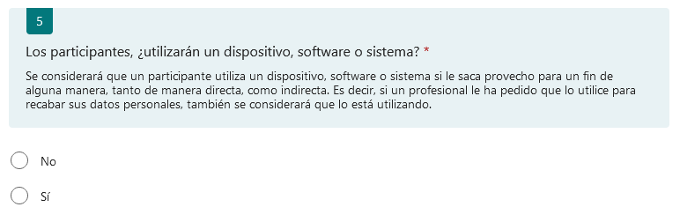  Fig. 10. Visual aspect for the question “Will the participants use a device, software or system?” in prototype 2. | 5. Will the participants use a device, software or system?  It is considered that a participant is using a device, software or system if she uses it to her advantage in any way, direct or indirectly. i.e. if a professional requested her to use it to collect any personal data, it will be also considered that it has been used.  - No  - Yes | The term “System” was also included in the question.  A description of device, software or system was included.
Final version | 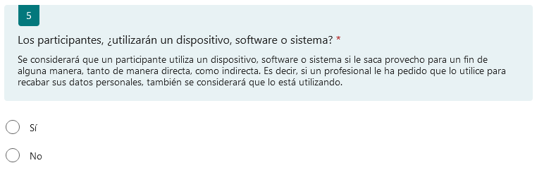  Fig. 11. Visual aspect for the question “Will the participants use a device, software or system?” in the final version. | 5. Will the participants use a device, software or system?  It is considered that a participant is using a device, software or system if she uses it to her advantage in any way, direct or indirectly. i.e. if a professional requested her to use it to collect any personal data, it will be also considered that it has been used.  - Yes  - No | Answers were reorganized to be consistent throughout the questionnaire.
New questions included
Final version | 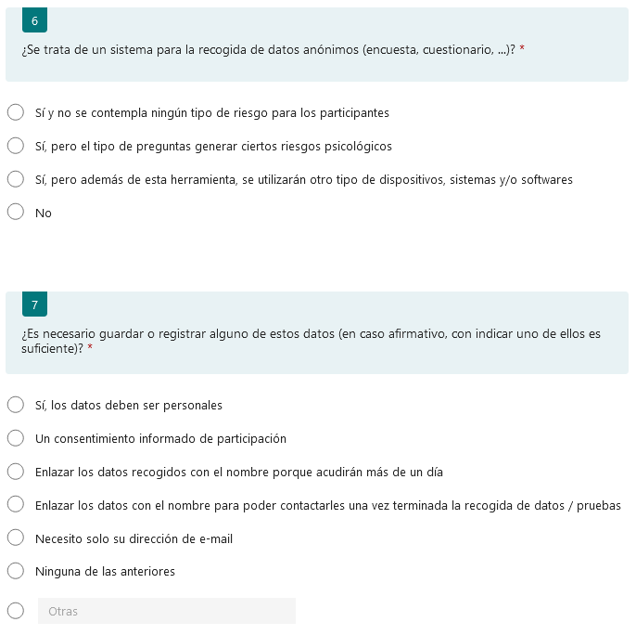  Fig. 12. Visual aspect for the questions “Is it a system for anonymous data collection (survey, questionnaire, …)?” and “Is it necessary to save or register any of the following data (if yes, only select one of them)?” included for the final version. | 6. Is it a system for anonymous data collection (survey, questionnaire, …)?  - Yes, and there is no foreseen risk for the participants.  - Yes, but the questions could cause some psychological risks  - Yes, but other type of devices, systems and/or software will be used.  - No  - 7. Is it necessary to save or register any of the following data (if yes, only select one of them)?  - Yes, the data must be personal  - An informed consent for the participation  - Link collected data with the name because they will participate more than once  - Link the data with the name to contact the participants after finishing the data collection / tests  - I only need their e-mail address  - None of the options above  - Other (need to be filled in) | New questions were included for the researchers who planned to include anonymous questionnaires for data collection. In this case, a researcher must evaluate if there is any risk for the participants (including psychological risks due to the nature of the questions), or if the participants target group is considered vulnerable. In the case that only anonymous questionnaires are used, with no evident risks, ethical committee approval is not mandatory, although it is recommended to ask the ethical committee for their support in case of doubt.

