SUPPLEMENTARY MATERIAL

Table of Contents

Supplementary Table 1. Total number of members, percentage of women members and percentage of women president according to Spanish medical societies, 2019-2021. 2
Supplementary Figure 1. Women Ratio in speakers invited in National Medical Congress according to Spanish medical societies, 2019-2021. 3
Supplementary Figure 2. Women Ratio in Members of the Scientific Committee in National Medical Congress according to Spanish medical societies, 2019-2021. 4
Supplementary Figure 4. Percentage of women on the board of directors by regions, academies of medicine 2021. 6
Supplementary Figure 5. Percentage of Technological development projects in health admitted, granted, and succeeded, along with the average funding per project according to sex, 2020. 7
Supplementary Figure 6. Percentage of AC International Joint Programming admitted, granted, and succeeded, along with the average funding per project according to sex, 2020. 8
Supplementary Figure 7. Percentage of Independent clinical research projects admitted, granted, and succeeded, along with the average funding per project according to sex, 2020. 9
Supplementary Figure 8. Percentage of Health research projects admitted, granted, and succeed, along with the average funding per project according to sex, 2020. 10
Supplementary Figure 9. Percentage of State Knowledge Generation Subprograms admitted, granted, and succeeded, along with the average funding per project according to sex, 2020. 11

Supplementary Table 1. Total number of members, percentage of women members and percentage of women president according to Spanish medical societies, 2019-2021.
Abbreviation | Medical Society | Total members | % Women members | % Women president
AEDV | Dermatology and venereology | 2844 | 43.5 | 0.0
AEBM - ML | Biopathology and laboratory | 1337 | 57.1 | 16.7
AEC | Surgery | 5408 | 42.3 | 0.0
AEP | Pediatrics | 11,924 | 65.9 | 83.3
AEU | Urology | 2654 | 0.0 | na
SEAIC | Allergology | 1595 | 64.1 | 0.0
SEAP-IAP | Anatomical pathology | 1844 | 68.2 | 0.0
SEDAR | Anesthesiology | 4122 | 54.4 | 0.0
SEACV | Vascular surgery | 930 | 39.4 | 0.0
SEQC-ML | Laboratory medicine | 2896 | 65.5 | 100.0
SEC | Cardiology | 4761 | 35.9 | 0.0
SECOMCyC | Oro-Maxillo-facial surgery | 906 | 31.6 | 0.0
SECOT | Orthopaedics and traumatology | 6736 | 25.9 | 0.0
SECPRE | Plastic, reconstructive and aesthetic surgery | 899 | 31.7 | 66.7
SECT | Thoracic surgery | 491 | 31.0 | 0.0
SEEN | Endocrinology | 1900 | na | 66.7
SEFC | Clinical Pharmacology | 348 | 54.3 | 100.0
SEGG | Geriatrics and gerontology | na | na | na
SEHH | Haematology and hemotherapy | 2807 | 65.5 | na
SEMFYC | Family and community medicine | 22,000 | 70.0 | 0.0
SEMICYUC | Intensive care | 2757 | na | 33.3
SEMI | Internal medicine | 7713 | 50.4 | 0.0
SEMNIM | Nuclear medicine | 827 | 57.6 | 33.3
SEMPSPH | Preventive medicine and public health | 367 | na | 0.0
SEMG | General and family medicine | 7403 | 48.8 | 0.0
SEN (Nefrología) | Nephrology | 2561 | 57.2 | 100.0
SEPAR | Pneumology | 4893 | 55.1 | 0.0
SEN (Neurología) | Neurology | 1500 | 53.3 | 0.0
SEO | Ophtalmology | 2739 | 43.5 | 0.0
SEOM | Medical oncology | 2957 | 59.9 | 33.3
SEOR | Radiation oncology | 1195 | 63.4 | na
SEORL-CCC | Otorhinolaryngology | 2921 | 39.8 | 0.0
SEPD | Gastroenterology | 2424 | 54.2 | 0.0
SEP | Psychiatry | 1357 | 48.4 | 0.0
SERAM | Radiology | 7335 | 50.6 | 33.3
SER | Rheumatology | 1976 | 55.7 | 0.0

Supplementary Figure 1. Women Ratio in speakers invited in National Medical Congress according to Spanish medical societies, 2019-2021.

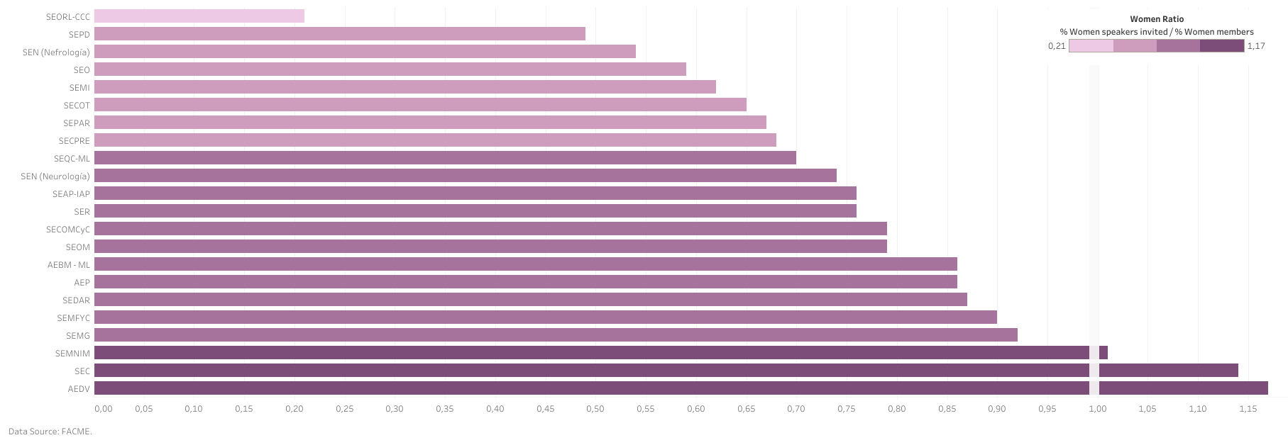

Supplementary Figure 2. Women Ratio in Members of the Scientific Committee in National Medical Congress according to Spanish medical societies, 2019-2021.

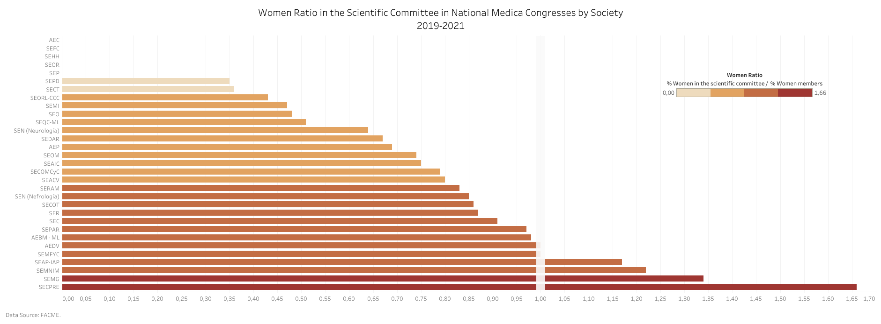

Supplementary Figure 3. Percentage of women on the board of directors by provinces, official colleges of physicians 2021.
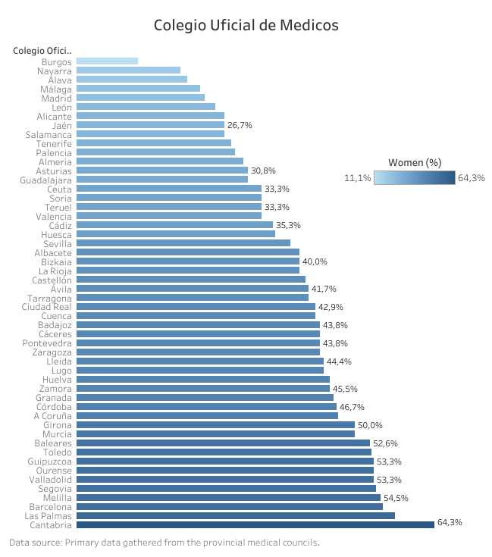

Supplementary Figure 4. Percentage of women on the board of directors by regions, academies of medicine 2021.

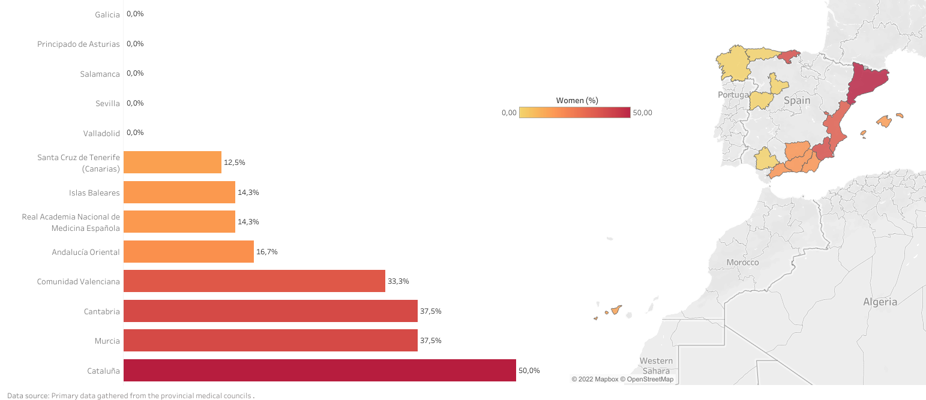

Supplementary Figure 5. Percentage of Technological development projects in health admitted, granted, and succeeded, along with the average funding per project according to sex, 2020.

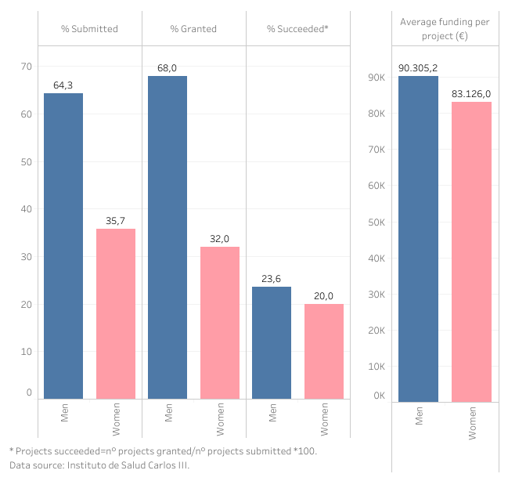

Supplementary Figure 6. Percentage of AC International Joint Programming admitted, granted, and succeeded, along with the average funding per project according to sex, 2020.

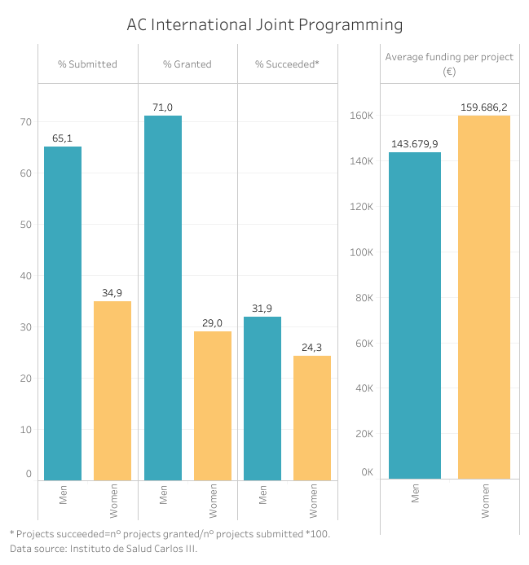

Supplementary Figure 7. Percentage of Independent clinical research projects admitted, granted, and succeeded, along with the average funding per project according to sex, 2020.

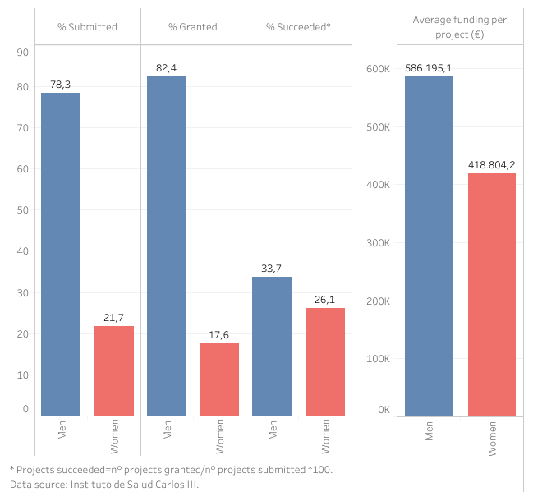

Supplementary Figure 8. Percentage of Health research projects admitted, granted, and succeed, along with the average funding per project according to sex, 2020.
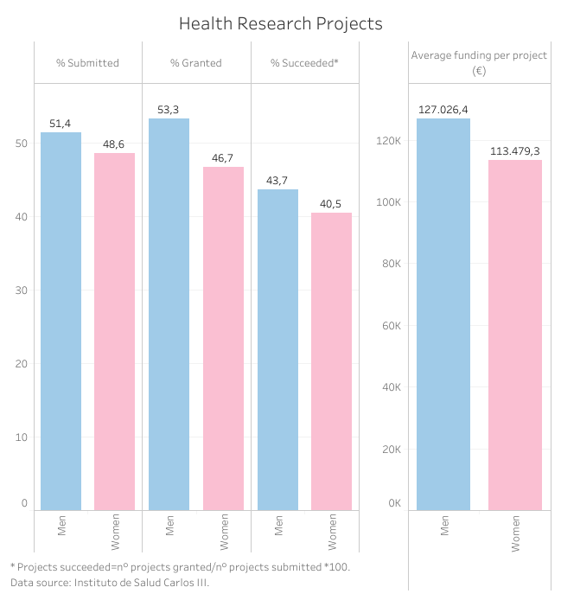

Supplementary Figure 9. Percentage of State Knowledge Generation Subprograms admitted, granted, and succeeded, along with the average funding per project according to sex, 2020.

