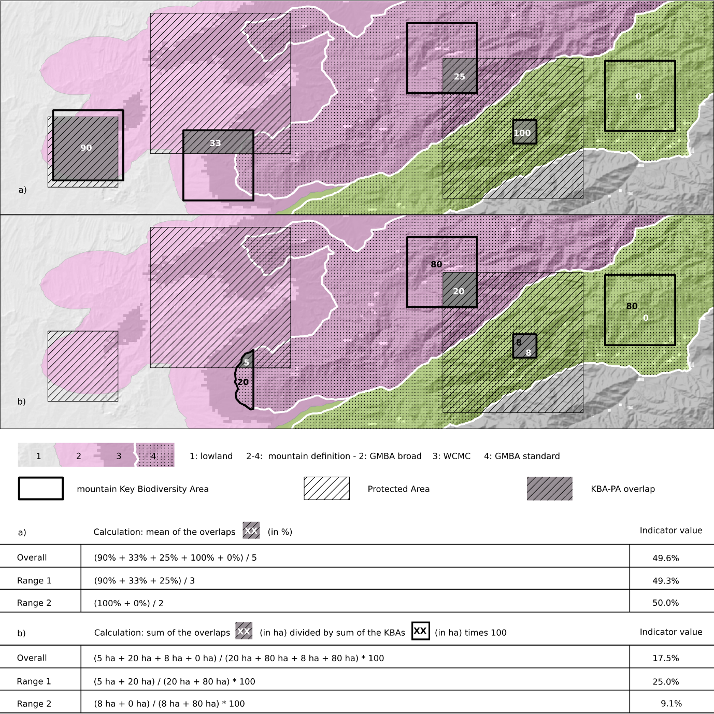
Fig. S2. Overlap between KBAs and PAs. a) site-based calculation; b) area-based calculation (See supplementary material for more information).

