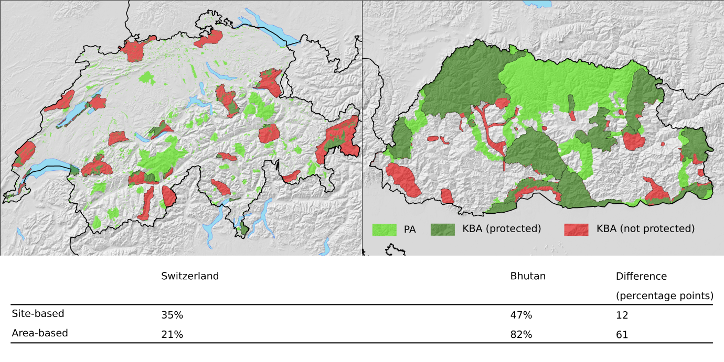
Fig. S3. Mountain biodiversity protection in Switzlerand (left) and Bhutan (right) and comparison between site-based and area-based national-level indicator estimates. Light green: PA not KBA; dark green: protected KBA; red: KBA not protected.

