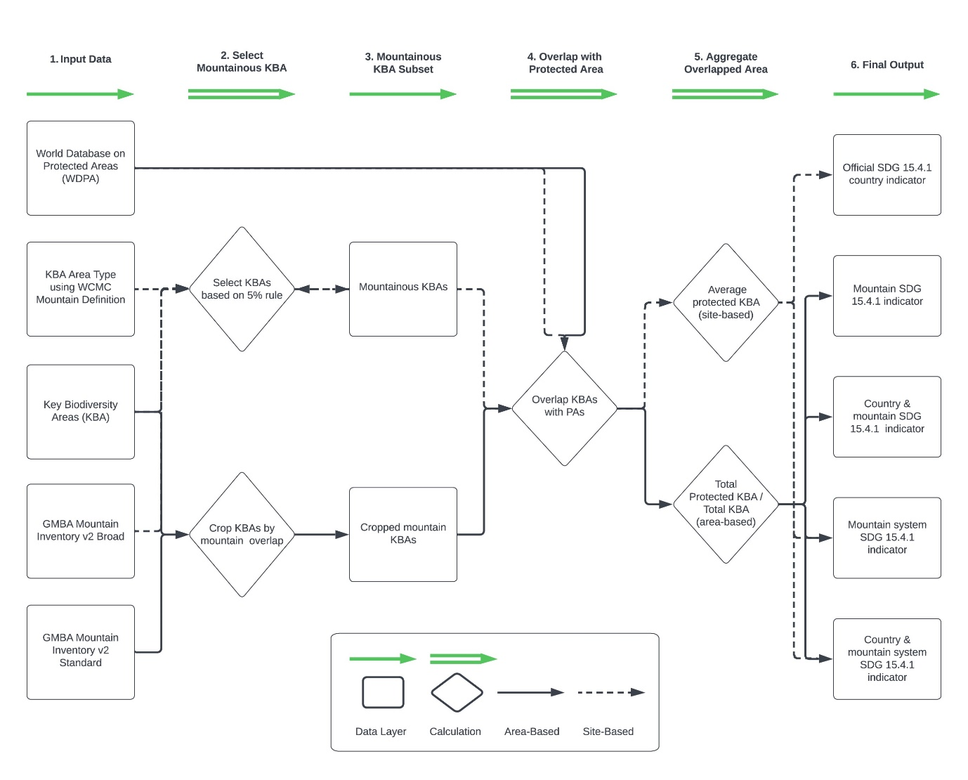
Fig. S1. Workflow for site- and area-based calculations. Data layers are squares or solid green lines. Pivotal calculation decisions are represented with diamonds or double green lines. Dotted black arrows are the site-based calculation method that closely resembles the Official SDG 15.4.1 indicator methodology. Solid arrows are area-based calculations.

