Mg modified nanobiochar from spent coffee grounds: Evaluation of the phosphate removal efficiency and its application as a phosphorous release fertilizer

Gemeda Begna Sisayª, Menbere Leul Mekonnen ^{a,b,*}
ª Industrial Chemistry Department, Addis Ababa Science, and Technology University,
P.O.Box 1647, Addis Ababa, Ethiopia
^{b} Nanotechnology Center of Excellence, Addis Ababa Science, and Technology University,
P.O.Box 1647, Addis Ababa, Ethiopia

* Corresponding author:–
Menbere Leul Mekonnen
Email: menbere.leul@aastu.edu.et

Table S1. Proximate analysis of spent coffee ground biochar as a function of temperature.
Temperature (ºC) | Yield (%) | Moisture content (%) | Ash content (%) | Volatile matter (%) | Fixed carbon (%) | pH
200 | 83.98±1.3 | 0.17±2.3 | 0.86±2.5 | 93.2±1.97 | 5.94 | 6.45±0.2
250 | 54.93±0.7 | 0.129±3.2 | 7.54±9.2 | 77±7.9 | 15.46 | 6.81±0.2
350 | 25.9±0.05 | 0.103±4.3 | 8.98±4.6 | 11.88±3.6 | 79.14 | 7.29±0.2

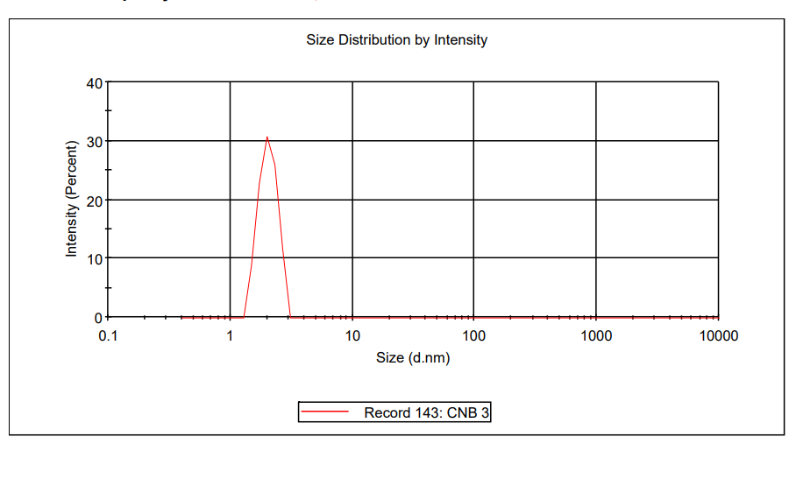
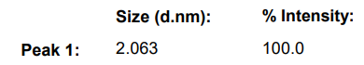

Figure S1 Dynamic light scattering result (insert shows peak size and intensity)

Table S1 Plant growth rate measured in terms shot height (result of pot test)

 | Height (cm) -garlic |  |  | Height (cm) - Bean
Days | PO₄³⁻ treated | control |  | PO₄³⁻ treated | control
5 | 19.6 | 6.7 |  | 18.3 | 16.13
8 | 20.5 | 11.2 |  | 20.3 | 17.4
11 | 23.3 | 21 |  | 24.7 | 23.1
14 | 29 | 26.2 |  | 26.5 | 25.7
17 | 29.5 | 26.8 |  | 27 | 26.3

