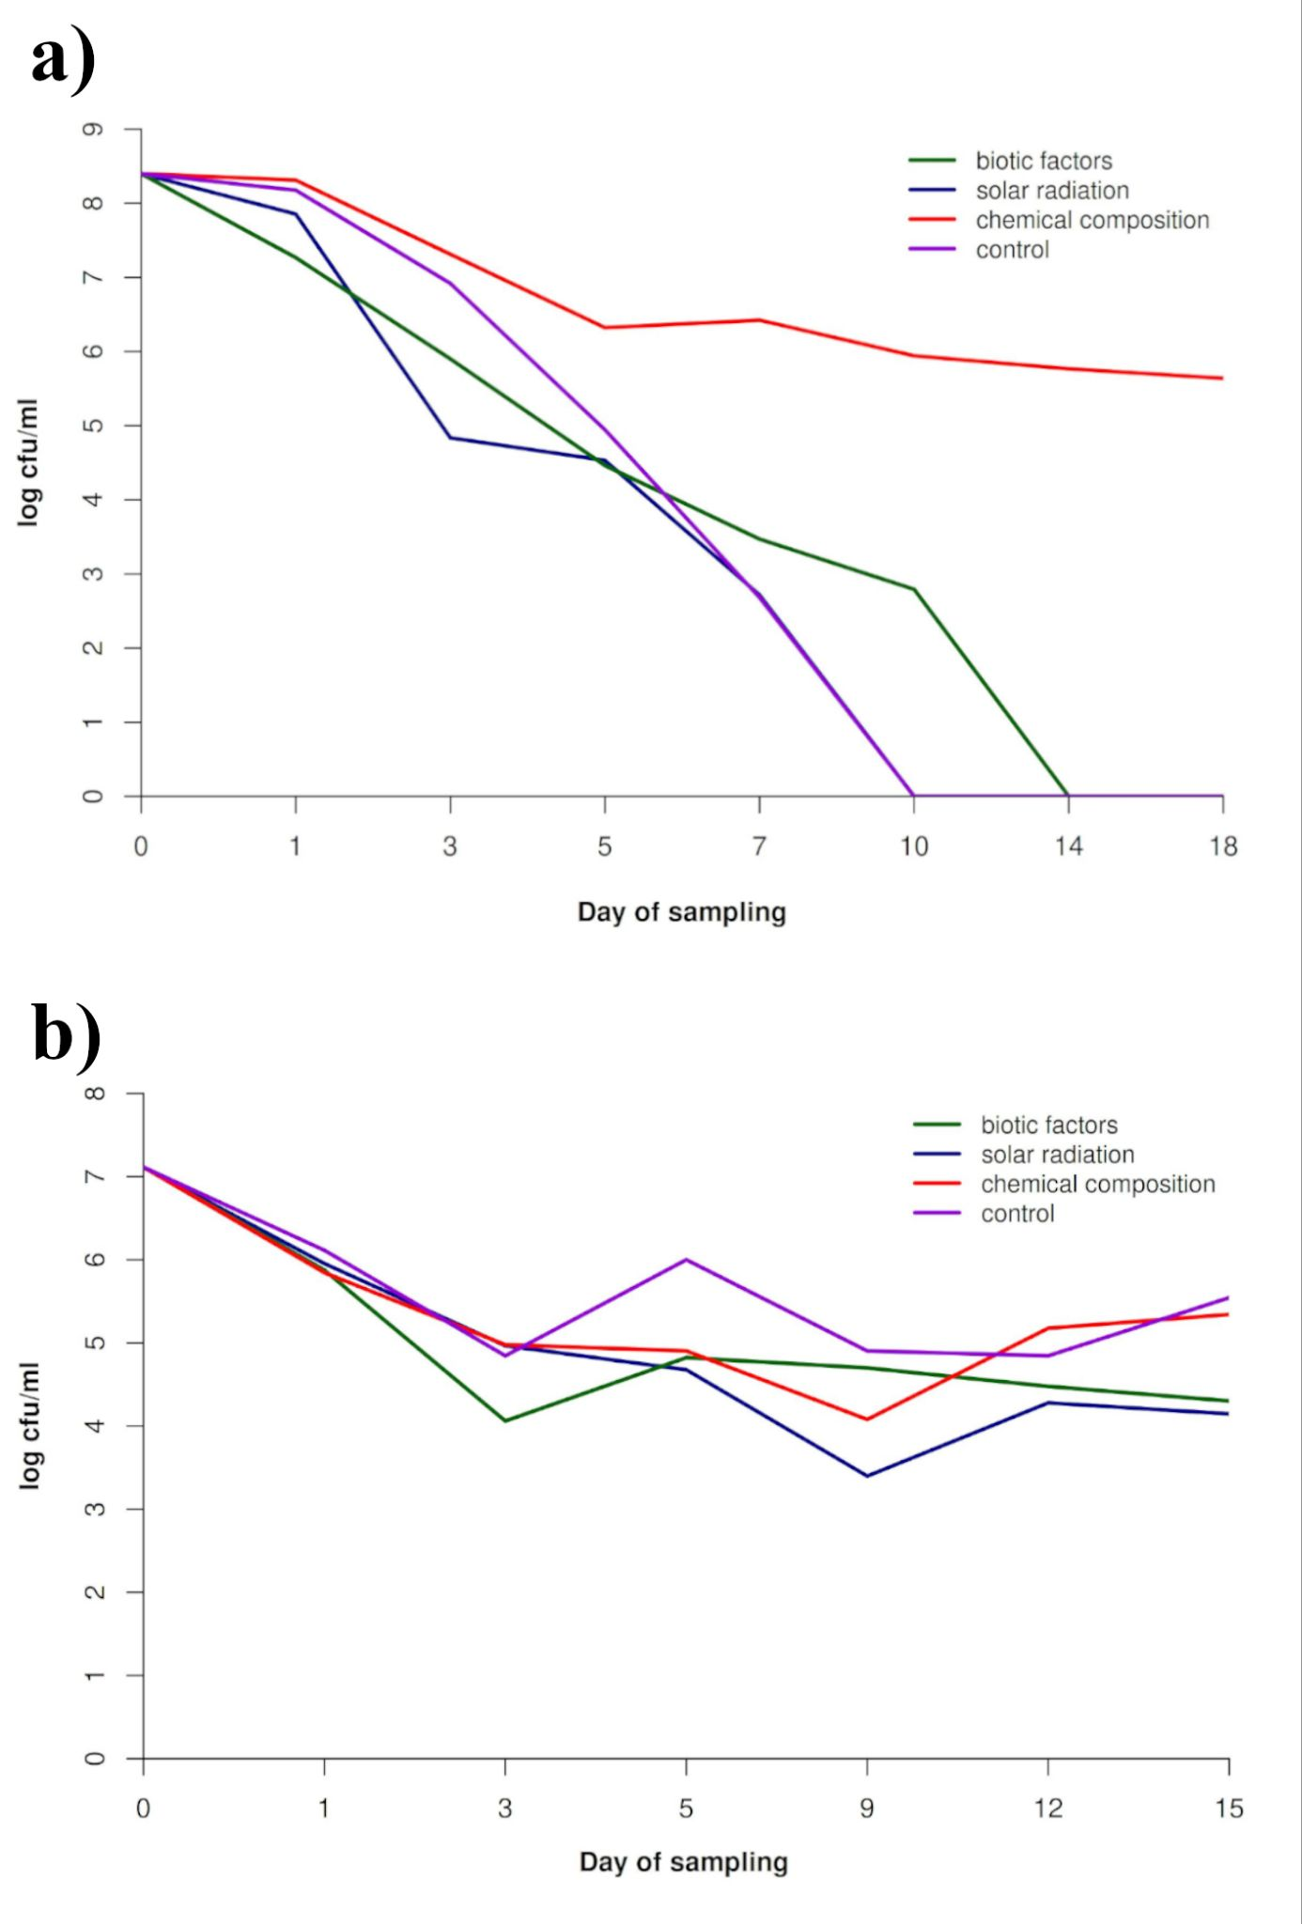
Fig. S1. Survival curve of E.coli during Arctic a) summer and b) winter as a function of the self-purifying factor of the Kongsfjorden water.

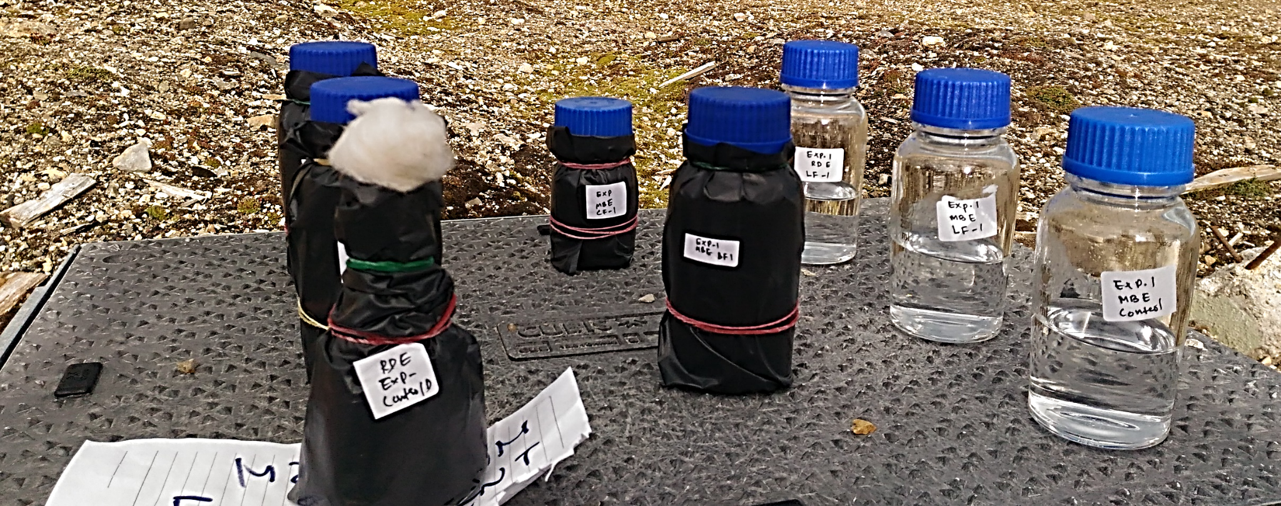
Fig. S2. Microcosm experiment setup in the Arctic during summer

