Supplementary materialS:
Table S1. Measures of biodiversity metrics considered in this study.
Diversity measure | Description | References
S | Species richness | Tilman et al. (1996)
H´ | Shannon’s evenness | Tilman et al. (1996)
Faith’s PD | Sum of all phylogenetic branch lengths connecting species | Faith (1992)
MPD | Mean pairwise distance: mean of all the distances connecting species in an assemblage | Webb et al. (2002)
MNTD | Mean nearest taxon distance: mean of the shortest distances connecting each species to any other species in an assemblage | Webb et al. (2002)
FRic | Functional richness: convex hull volume of the trait space | Cornwell, Schwilk & Ackerly, 2006;
FEve | Functional evenness: abundance-weighted pairwise functional distances | Villeger et al. (2008)
FDis | Functional dispersion: weighted distances from a weighted centroid in multitrait space | Villeger et al. (2008)
FDiv | Functional divergence: mean abundance-weighted deviance from an absolute abundance-weighted deviance | Villeger et al. (2008)
CWM_{H} | Community weighted mean of maximum plant height | Garnier et al. (2004)
CWM_{LC} | Community weighted mean of leaf carbon content | Garnier et al. (2004)
CWM_{LN} | Community weighted mean of leaf nitrogen content | Garnier et al. (2004)
CWM_{LP} | Community weighted mean of leaf phosphorus content | Garnier et al. (2004)

Table S2. Results of generalized linear model (GLM) for plant productivity as a function of several biodiversity metrics.
Model | k | LL | AIC_{c} | 𝚫AIC_{c} | wAIC_{c} | De
2700 m
~ CWM_{LN} | 3 | -90.259 | 188.019 | 0.000 | 0.262 | 26.3
~ CWM_{H} | 3 | -90.511 | 188.522 | 0.504 | 0.204 | 24.4
~ pH | 3 | -90.760 | 189.020 | 1.001 | 0.159 | 22.6
~ MPD | 3 | -91.522 | 190.543 | 2.525 | 0.074 | 16.5
~ 1 | 2 | -93.353 | 191.411 | 3.393 | 0.048 | 0.0
~ H´ | 3 | -92.320 | 192.140 | 4.121 | 0.033 | 9.7
~ N | 3 | -92.462 | 192.424 | 4.405 | 0.029 | 8.4
~ CWM_{LP} | 3 | -92.562 | 192.624 | 4.605 | 0.026 | 7.5
~ FRic | 3 | -92.577 | 192.654 | 4.635 | 0.026 | 7.4
~ C | 3 | -92.728 | 192.957 | 4.938 | 0.022 | 6.0
~ P | 3 | -92.755 | 193.010 | 4.991 | 0.022 | 5.7
~ S | 3 | -92.852 | 193.204 | 5.186 | 0.020 | 4.8
~ PD | 3 | -92.937 | 193.373 | 5.355 | 0.018 | 4.0
~ MNTD | 3 | -93.056 | 193.611 | 5.593 | 0.016 | 2.9
~ CWM_{LC} | 3 | -93.086 | 193.671 | 5.653 | 0.016 | 2.6
~ FDis | 3 | -93.235 | 193.969 | 5.951 | 0.013 | 1.2
~ FEve | 3 | -93.353 | 194.205 | 6.186 | 0.012 | 0.0
3200 m
~ MNTD | 3 | -92.721 | 192.943 | 0.000 | 0.237 | 20.6
~ MPD | 3 | -93.391 | 194.282 | 1.340 | 0.121 | 15.2
~ CWM_{H} | 3 | -93.616 | 194.732 | 1.789 | 0.097 | 13.3
~ 1 | 2 | -95.088 | 194.883 | 1.940 | 0.090 | 0.0
~ N | 3 | -93.716 | 194.933 | 1.990 | 0.088 | 12.5
~ CWM_{LC} | 3 | -94.260 | 196.020 | 3.078 | 0.051 | 7.7
~ FDis | 3 | -94.483 | 196.466 | 3.523 | 0.041 | 5.7
~ P | 3 | -94.588 | 196.675 | 3.733 | 0.037 | 4.7
~ CWM_{LN} | 3 | -94.625 | 196.750 | 3.808 | 0.035 | 4.4
~ pH | 3 | -94.779 | 197.058 | 4.115 | 0.030 | 3.0
~ FEve | 3 | -94.844 | 197.188 | 4.245 | 0.028 | 2.3
~ CWM_{LP} | 3 | -94.942 | 197.383 | 4.441 | 0.026 | 1.4
~ PD | 3 | -94.965 | 197.430 | 4.488 | 0.025 | 1.2
~ FRic | 3 | -94.989 | 197.478 | 4.536 | 0.025 | 1.0
~ S | 3 | -95.042 | 197.583 | 4.641 | 0.023 | 0.5
~ C | 3 | -95.068 | 197.636 | 4.694 | 0.023 | 0.2
~ H´ | 3 | -95.080 | 197.660 | 4.717 | 0.022 | 0.1
3400 m
~ CWM_{LC} | 3 | -82.073 | 171.646 | 0.000 | 0.330 | 30.3
~ H´ | 3 | -82.909 | 173.318 | 1.672 | 0.143 | 24.3
~ FDis | 3 | -83.087 | 173.675 | 2.029 | 0.120 | 22.9
~ CWM_{H} | 3 | -83.484 | 174.468 | 2.822 | 0.080 | 19.8
~ S | 3 | -83.804 | 175.108 | 3.461 | 0.058 | 17.3
~ MPD | 3 | -83.981 | 175.461 | 3.815 | 0.049 | 15.8
~ 1 | 2 | -85.732 | 176.169 | 4.523 | 0.034 | 0.0
~ C | 3 | -84.473 | 176.447 | 4.800 | 0.030 | 11.6
~ pH | 3 | -84.523 | 176.545 | 4.899 | 0.028 | 11.2
~ FRic | 3 | -84.652 | 176.805 | 5.158 | 0.025 | 10.1
~ PD | 3 | -84.909 | 177.319 | 5.672 | 0.019 | 7.8
~ P | 3 | -85.029 | 177.557 | 5.911 | 0.017 | 6.7
~ CWM_{LP} | 3 | -85.129 | 177.757 | 6.111 | 0.016 | 5.8
~ N | 3 | -85.161 | 177.822 | 6.176 | 0.015 | 5.5
~ CWM_{LN} | 3 | -85.168 | 177.837 | 6.191 | 0.015 | 5.4
~ MNTD | 3 | -85.382 | 178.265 | 6.618 | 0.012 | 3.4
~ FEve | 3 | -85.730 | 178.960 | 7.313 | 0.009 | 0.0
Notes: Biodiversity metrics include the number of species (S), Shannon’s evenness (H´), phylogenetic diversity (PD), mean pairwise distance (MPD), mean nearest taxon distance (MNTD), and various community-level means of single functional traits (CWM_{H}, maximum plant height; CWM_{LC}, leaf carbon content; CWM_{LN}, leaf nitrogen content; CWM_{LP}, leaf phosphorus content) or multivariate functional trait indices (FRic, functional richness; FEve, functional evenness, FDis; functional dispersion). Values represent the estimated number of model parameters (k), maximum log-likelihood (LL), Akaike’s information criterion corrected for small samples (AIC_{c}), change in AIC_{c} relative to the top-ranked model (𝚫AIC_{c}), AIC_{c} weight (wAIC_{c}, model probability), and the percentage of deviance explained (DE) as a measure of the model’s goodness-of-fit.
Fig. S1. Density distribution correlated to the soil pH at each meadow along with the elevational gradient.
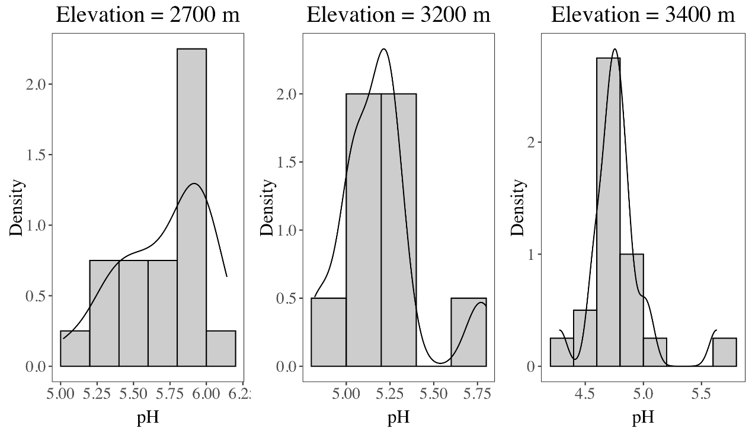

Fig. S2. Correlation matrix of several factors at local and regional ecological scales.
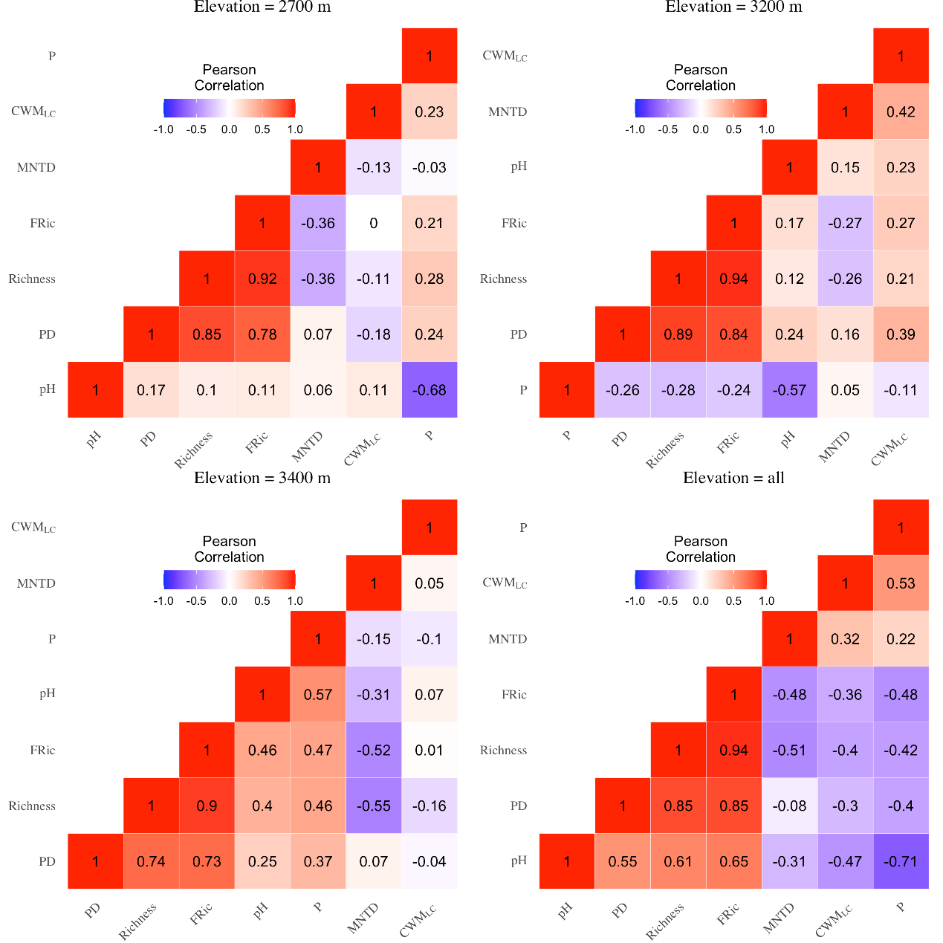
Notes: Factors included the number of species (richness), phylogenetic diversity (PD), mean nearest taxon distance (MNTD), community-level means of single functional traits (CWM_{LC}), multivariate functional diversity (FRic, functional richness), and soil chemical properties (pH, soil pH; P, total phosphorus concentration, mg/g). The values shown in the graph represent their correlation coefficients.
Raw data used for analysis.
comID | Biomass (g) | S | H´ | PD | MPD | MNTD | FRic | FEve | FDiv | FDis | RaoQ | CWM_{H} | CWM_{LC} | CWM_{LN} | CWM_{LP} | pH | P (mg/g) | N (mg/g) | C (mg/g) | Elevation (m)
1_1 | 92.538 | 18 | 1.86627614 | 6.88030163 | 1.5400274 | 0.40324807 | 14.0207247 | 0.38008114 | 0.56879983 | 1.38984158 | 2.35229398 | 0.01151665 | -0.2973717 | 0.27669893 | -0.3339546 | 5.42 | 0.0905 | 1.1745 | 13.64 | 2700
1_10 | 82.585 | 16 | 1.72979086 | 6.43649859 | 1.48102782 | 0.51985881 | 14.2235275 | 0.3364354 | 0.80003074 | 1.42828916 | 2.39659302 | 0.07959363 | -0.859331 | -0.3012934 | -0.3540777 | 5.58 | 0.052 | 0.8701 | 21.59 | 2700
1_11 | 62.775 | 20 | 2.0123026 | 6.72642389 | 1.45698123 | 0.36704474 | 15.2118738 | 0.33243448 | 0.94361373 | 1.85023952 | 3.67116627 | 0.47472873 | -0.4690493 | -0.4047326 | -0.4156496 | 5.62 | 0.0684 | 1.1716 | 14.35 | 2700
1_12 | 57.105 | 12 | 1.53961316 | 5.88752771 | 1.46697042 | 0.68433221 | 7.61012138 | 0.25590981 | 0.55905661 | 1.0018145 | 1.20085271 | 0.00501314 | -0.4897734 | -0.5266256 | -0.4713962 | 5.3 | 0.1037 | 1.7799 | 27.45 | 2700
1_13 | 149.532 | 21 | 2.15173151 | 7.74093504 | 1.51100245 | 0.46056018 | 17.7094306 | 0.42590106 | 0.85045351 | 1.37096421 | 2.2380368 | -0.5346342 | -0.3677458 | 0.75502662 | -0.1959727 | 6 | 0.0896 | 1.133 | 14.92 | 2700
1_14 | 128.046 | 21 | 2.29208208 | 8.32654833 | 1.53744427 | 0.52657072 | 16.1783508 | 0.41228849 | 0.85225587 | 1.88804323 | 3.84913853 | 0.17436865 | -0.4021161 | 0.19877975 | 0.06418897 | 5.72 | 0.1209 | 1.288 | 21.33 | 2700
1_15 | 134.017 | 22 | 1.93008315 | 7.72479953 | 1.49530187 | 0.43560394 | 19.5837182 | 0.42112552 | 0.8274482 | 1.40932869 | 2.31696951 | 0.46249751 | -0.3481786 | -0.337214 | -0.2895427 | 5.89 | 0.0974 | 0.904 | 11.24 | 2700
1_16 | 77.046 | 22 | 1.65142917 | 7.8216679 | 1.50187181 | 0.43645236 | 20.0370692 | 0.44969091 | 0.92898035 | 1.49703505 | 2.60261029 | 0.63033246 | -0.7075651 | -0.1560595 | -0.2814263 | 5.28 | 0.1124 | 1.8465 | 24.66 | 2700
1_17 | 47.17 | 20 | 2.19595211 | 7.26370981 | 1.41838697 | 0.48920401 | 15.4531736 | 0.39767358 | 0.88824455 | 1.68453144 | 3.16404855 | 0.3487384 | -0.2105677 | -0.4902759 | -0.431705 | 5.4 | 0.1836 | 0.9817 | 11.36 | 2700
1_18 | 104.4 | 19 | 1.61023158 | 7.64057137 | 1.54921116 | 0.48155684 | 20.7546105 | 0.54143465 | 0.66033585 | 1.32696032 | 2.39145634 | 0.08948878 | -0.3442845 | -0.3248428 | 0.08397877 | 5.94 | 0.06 | 1.1928 | 12.25 | 2700
1_19 | 67.001 | 27 | 2.43218917 | 9.37220375 | 1.49896394 | 0.44375327 | 26.5397273 | 0.54757842 | 0.87920642 | 1.99170485 | 4.15936464 | 0.54676868 | -0.1458156 | 0.37625816 | -0.3139418 | 5.9 | 0.0995 | 1.5922 | 19.72 | 2700
1_2 | 102.547 | 20 | 2.20083126 | 7.1670454 | 1.50866307 | 0.37199699 | 19.6261293 | 0.14653897 | 0.82567084 | 1.79941923 | 3.51720707 | 0.18160194 | -0.4239147 | 0.25228008 | -0.251453 | 5.48 | 0.0853 | 0.9518 | 19.87 | 2700
1_20 | 67.624 | 21 | 1.95217393 | 8.39527397 | 1.58028176 | 0.43485682 | 19.5083656 | 0.45864687 | 0.94548526 | 1.81253482 | 3.52910499 | 0.8232532 | -0.1936389 | -0.0205141 | -0.0614162 | 5.02 | 0.2158 | 1.5424 | 18.98 | 2700
1_3 | 95.584 | 13 | 1.26608279 | 5.84041994 | 1.53243384 | 0.52914937 | 11.1500675 | 0.38620857 | 0.9056559 | 1.46441874 | 2.35652006 | -0.3844394 | 0.45168765 | 0.38519096 | -0.578387 | 6.14 | 0.0498 | 0.6002 | 10.46 | 2700
1_4 | 78.611 | 22 | 1.97627051 | 9.22961297 | 1.5720695 | 0.56025442 | 18.6412072 | 0.38173448 | 0.85324351 | 1.5609721 | 2.6635055 | 0.88749864 | -0.6643298 | -0.5213872 | -0.4205885 | 6 | 0.0946 | 1.5078 | 24.77 | 2700
1_5 | 107.351 | 21 | 2.15977041 | 7.88007365 | 1.52606464 | 0.43769614 | 18.6816561 | 0.37354996 | 0.8644746 | 1.59895045 | 2.83201282 | -0.0750426 | -0.1769619 | -0.5025452 | -0.42493 | 5.93 | 0.0582 | 1.2265 | 14.74 | 2700
1_6 | 50.435 | 16 | 1.12489366 | 5.71047114 | 1.42792564 | 0.42910538 | 11.7651359 | 0.44222353 | 0.75234154 | 0.82656863 | 1.32593961 | 0.63215682 | -0.6975453 | -0.5993541 | -0.1032873 | 5.68 | 0.0652 | 1.2302 | 20.41 | 2700
1_7 | 87.03 | 16 | 1.41116009 | 6.29165442 | 1.5323665 | 0.3850409 | 10.8825324 | 0.59180705 | 0.87400968 | 1.20100795 | 2.02756894 | 0.84939458 | -0.4372231 | -0.4033284 | 0.09371377 | 5.93 | 0.0538 | 0.6877 | 7.79 | 2700
1_8 | 71.651 | 19 | 1.45272172 | 8.77353943 | 1.5778624 | 0.61341943 | 14.6829198 | 0.49318415 | 0.93352384 | 1.46648343 | 2.95045776 | 0.94072501 | -0.7823019 | -0.5974111 | -0.3432676 | 5.85 | 0.0486 | 0.8291 | 9.8 | 2700
1_9 | 92.545 | 22 | 2.05421841 | 8.6819021 | 1.58389103 | 0.48077965 | 19.2114261 | 0.43832804 | 0.90053737 | 1.57456891 | 2.99224047 | -0.2373271 | -1.0006623 | 0.13971843 | -0.1103326 | 5.99 | 0.0496 | 0.8375 | 11.43 | 2700
2_1 | 91.392 | 14 | 1.76222168 | 6.39418062 | 1.39851422 | 0.55493688 | 10.4450954 | 0.41206316 | 0.90137051 | 1.75149126 | 3.59007557 | 0.25391642 | 0.2859805 | -0.1491373 | -0.5025213 | 5.8 | 0.065 | 0.9395 | 9.83 | 3200
2_10 | 84.48 | 19 | 2.28242043 | 8.33246169 | 1.61823819 | 0.46804888 | 20.9222533 | 0.63281863 | 0.79365697 | 1.85030971 | 3.78066062 | 0.54083394 | 0.43133442 | -0.2005254 | -0.034548 | 5.74 | 0.1568 | 1.4907 | 19.57 | 3200
2_11 | 50.167 | 11 | 1.48065607 | 6.4940008 | 1.63645141 | 0.83424586 | 7.19837482 | 0.38847338 | 0.92071045 | 1.64210546 | 2.90854638 | 0.89369705 | 0.35085526 | -0.5794049 | -0.6032029 | 5.26 | 0.1613 | 0.467 | 20.43 | 3200
2_12 | 118.713 | 15 | 2.14775297 | 6.74567982 | 1.35461884 | 0.58192635 | 12.0134599 | 0.75072271 | 0.87132066 | 1.89563116 | 3.80082539 | 0.39440904 | -0.1079614 | -0.4881146 | -0.2707136 | 5.21 | 0.2279 | 0.8068 | 12.03 | 3200
2_13 | 47.254 | 14 | 1.81136278 | 6.73039379 | 1.50495885 | 0.61016725 | 9.62748101 | 0.57944089 | 0.92680103 | 2.00635979 | 4.25134298 | 1.27441113 | -0.0768637 | -0.6075506 | -0.5181353 | 5.26 | 0.1881 | 1.3438 | 14.16 | 3200
2_14 | 59.803 | 16 | 1.77464772 | 8.22771977 | 1.65414849 | 0.69384997 | 14.2721098 | 0.581175 | 0.95214047 | 1.90462278 | 4.060327 | 1.35861257 | 0.34255805 | -0.3215004 | -0.6259342 | 5.25 | 0.2359 | 0.3056 | 19.35 | 3200
2_15 | 30.654 | 13 | 1.82458368 | 6.5166268 | 1.56903035 | 0.72022801 | 6.57628757 | 0.51704267 | 0.93575776 | 1.86498858 | 3.65452875 | 0.47638585 | 0.45010274 | -0.6148137 | -0.5729801 | 5.11 | 0.2073 | 1.258 | 16.91 | 3200
2_16 | 39.555 | 14 | 1.73720008 | 7.33482728 | 1.6301307 | 0.69906345 | 11.678021 | 0.34161285 | 0.88592319 | 1.78395092 | 3.44820407 | 0.69388022 | 0.57985175 | -0.3941704 | -0.4508845 | 5.05 | 0.1526 | 1.188 | 16.06 | 3200
2_17 | 49.118 | 15 | 1.48302026 | 7.18141207 | 1.49468081 | 0.63641336 | 10.864806 | 0.37570639 | 0.95400195 | 2.09185727 | 4.67080033 | 1.86689099 | -0.6109015 | -0.6421523 | -0.3609176 | 5.15 | 0.2038 | 1.1703 | 15.12 | 3200
2_18 | 38.905 | 15 | 1.84304267 | 7.18407224 | 1.62023475 | 0.53016343 | 10.8357788 | 0.34912634 | 0.91215944 | 1.92057347 | 3.8415993 | 0.9145249 | 0.12617496 | -0.4668846 | -0.6561581 | 5.04 | 0.2206 | 0.0108 | 20.02 | 3200
2_19 | 66.075 | 18 | 2.31645167 | 8.01155936 | 1.49310766 | 0.53150762 | 16.6991149 | 0.45672844 | 0.85458445 | 1.9352466 | 4.05486213 | 0.78707096 | -0.2182144 | -0.3714863 | -0.4411119 | 5.03 | 0.1978 | 0.7979 | 8.57 | 3200
2_2 | 78.772 | 17 | 1.81149008 | 7.19832648 | 1.43403566 | 0.50399388 | 12.2915712 | 0.46214884 | 0.93287742 | 1.54073381 | 2.8606321 | 1.17759702 | -0.5891201 | -0.8425046 | -0.3409536 | 5.18 | 0.1372 | 1.031 | 11.35 | 3200
2_20 | 41.407 | 19 | 2.16571273 | 7.36507848 | 1.32061413 | 0.40767681 | 19.7600349 | 0.44363485 | 0.86541375 | 1.94430884 | 3.96754414 | 0.94793986 | -0.0487283 | -0.5731227 | -0.4489687 | 4.82 | 0.1901 | 0.8928 | 12.02 | 3200
2_3 | 70.783 | 15 | 1.90750505 | 6.99172467 | 1.48780221 | 0.49975415 | 9.49382816 | 0.56284238 | 0.93575131 | 1.65504848 | 3.47125442 | 0.73552683 | -0.253522 | -0.7939067 | -0.4861231 | 5.24 | 0.1304 | 0.7417 | 10.23 | 3200
2_4 | 156.506 | 16 | 1.55186897 | 7.1156706 | 1.50492165 | 0.48859648 | 13.9540461 | 0.49250239 | 0.94331362 | 1.61491664 | 2.84662369 | 0.67520567 | -0.2036791 | -0.9777075 | -0.5239682 | 5.21 | 0.0862 | 0.9068 | 10.2 | 3200
2_5 | 135.272 | 13 | 1.60333637 | 5.68377215 | 1.46187384 | 0.46091939 | 8.37619162 | 0.3579578 | 0.94075051 | 1.81664002 | 3.4955961 | 0.7146509 | -0.4537845 | -0.6692208 | -0.2475598 | 4.86 | 0.2465 | 2.4482 | 29.33 | 3200
2_6 | 68.798 | 17 | 1.36480081 | 7.75466433 | 1.56058601 | 0.56664968 | 14.6352414 | 0.57643036 | 0.89780428 | 1.2764584 | 2.24185137 | 1.01638249 | -1.013161 | -0.8420503 | -0.4588104 | 5.33 | 0.1308 | 0.4681 | 5.17 | 3200
2_7 | 76.371 | 15 | 2.16125521 | 7.03998546 | 1.46547224 | 0.53862974 | 14.4808808 | 0.31092449 | 0.87025726 | 1.88480307 | 3.84957268 | 0.91460013 | 0.10248192 | -0.4536265 | -0.4868065 | 5.24 | 0.1836 | 1.4944 | 19.98 | 3200
2_8 | 59.44 | 18 | 1.98177673 | 7.34238807 | 1.50291831 | 0.47462293 | 15.2585428 | 0.53806934 | 0.86226064 | 1.42971295 | 2.71479282 | 0.40972995 | 0.38065839 | -0.7898134 | -0.6275775 | 5.02 | 0.1574 | 0.5961 | 8.35 | 3200
2_9 | 63.181 | 6 | 1.10076038 | 3.18885307 | 1.50385321 | 0.42922005 | 0.30804895 | 0.7240506 | 0.87283209 | 1.82600769 | 3.80392524 | 1.17761078 | -0.9824206 | -0.5159345 | 1.18590083 | 5.02 | 0.238 | 0.9269 | 9.73 | 3200
3_1 | 71.11 | 22 | 2.37506496 | 7.53822949 | 1.39348317 | 0.38434863 | 15.8974759 | 0.50934151 | 0.77547182 | 1.70311328 | 3.23166506 | 0.22771266 | 0.18544458 | 0.50213035 | -0.4251998 | 4.78 | 0.3566 | 1.3605 | 15.71 | 3400
3_10 | 72.013 | 17 | 2.34176159 | 5.83865449 | 1.16613994 | 0.37498183 | 9.05960031 | 0.61474176 | 0.69351613 | 1.5426302 | 2.91125979 | 0.59028687 | 0.24834192 | 0.01353379 | -0.0953102 | 4.71 | 0.3258 | 1.2104 | 14.43 | 3400
3_11 | 32.207 | 13 | 2.04010559 | 5.82964762 | 1.42493644 | 0.46025761 | 7.56833667 | 0.28915166 | 0.84211343 | 1.79473569 | 3.53412089 | 0.29242486 | 0.4696865 | 0.29765068 | 0.13375053 | 4.58 | 0.2055 | 1.3611 | 24.67 | 3400
3_12 | 30.773 | 10 | 1.47783189 | 4.74775784 | 1.3417303 | 0.60426498 | 6.38042478 | 0.57079194 | 0.52967756 | 0.93239266 | 1.36718083 | -0.0742929 | 0.41309288 | -0.1259554 | -0.2117621 | 4.76 | 0.2865 | 1.2809 | 21.24 | 3400
3_13 | 70.343 | 14 | 1.52031204 | 7.22416694 | 1.58104409 | 0.70339937 | 8.36828055 | 0.61334253 | 0.84990313 | 1.67185393 | 3.09471892 | 1.43860294 | -0.1473821 | -0.9011713 | -0.5363499 | 4.77 | 0.277 | 1.2125 | 11.85 | 3400
3_14 | 57.976 | 10 | 1.4453238 | 4.61011449 | 1.44482692 | 0.53926872 | 6.0368546 | 0.34418083 | 0.94046073 | 1.63736131 | 2.83274117 | 0.98334864 | 0.7423896 | -0.0095107 | -0.1761223 | 4.86 | 0.2289 | 1.0953 | 12.69 | 3400
3_15 | 54.058 | 9 | 1.48249709 | 4.66133489 | 1.54685735 | 0.65028339 | 1.75885427 | 0.26620116 | 0.77274246 | 1.47740655 | 2.35138772 | 0.5501306 | 0.30712712 | -0.6161419 | -0.3533788 | 4.56 | 0.2175 | 2.438 | 30.32 | 3400
3_16 | 25.939 | 10 | 1.36634042 | 5.84048949 | 1.63688588 | 0.78810326 | 3.24374811 | 0.62777063 | 0.90301345 | 1.42969245 | 2.53346491 | -0.3169822 | 0.93935602 | -0.3577791 | -0.2958116 | 4.69 | 0.319 | 1.2356 | 15.14 | 3400
3_17 | 40.752 | 10 | 1.56222149 | 5.6053229 | 1.56216968 | 0.68692325 | 4.45932272 | 0.4252007 | 0.81583823 | 1.29838315 | 2.45173262 | 0.06168442 | 0.71900212 | -0.5036703 | -0.1476124 | 4.28 | 0.1289 | 1.2594 | 13.61 | 3400
3_18 | 46.669 | 11 | 1.15098994 | 4.77758734 | 1.46818672 | 0.51469899 | 2.64452448 | 0.51890115 | 0.96915819 | 1.47907994 | 2.52644023 | 0.94475721 | 0.07971326 | -1.0638281 | -0.6895152 | 4.73 | 0.1889 | 1.3981 | 18.15 | 3400
3_19 | 48.404 | 11 | 1.46716482 | 4.28155722 | 1.37543754 | 0.43279351 | 5.79469745 | 0.32865768 | 0.7977581 | 1.39695628 | 2.22934806 | 0.40799861 | 0.45352893 | -0.6996587 | -0.3745469 | 4.7 | 0.3582 | 1.3773 | 17.55 | 3400
3_2 | 38.348 | 11 | 1.60776797 | 6.49938614 | 1.64448285 | 0.83248891 | 5.42322833 | 0.31169326 | 0.77427972 | 1.13108505 | 1.63111277 | 0.44959352 | 0.27981889 | -0.8430333 | -0.5247015 | 4.67 | 0.3145 | 1.3812 | 16.07 | 3400
3_20 | 51.465 | 13 | 1.8527399 | 5.91594763 | 1.53864435 | 0.55063195 | 5.578335 | 0.53085572 | 0.87083274 | 1.38776469 | 2.4204505 | 0.55222621 | 0.71832173 | -0.5266311 | -0.4618756 | 4.86 | 0.2415 | 0.727 | 8 | 3400
3_3 | 42.763 | 12 | 2.08276652 | 5.75833119 | 1.53259648 | 0.54256375 | 7.27323918 | 0.5924869 | 0.76806276 | 1.64744999 | 3.08736535 | 0.1662444 | 0.39969868 | 0.19963915 | -0.2761792 | 4.99 | 0.4271 | 1.0955 | 8.1 | 3400
3_4 | 73.905 | 12 | 2.03479733 | 5.73846909 | 1.25118452 | 0.76952045 | 2.26746066 | 0.351338 | 0.85755457 | 1.76525024 | 3.47206464 | 0.35016873 | 0.01985783 | -0.2772867 | 0.17346556 | 4.85 | 0.3636 | 1.3212 | 15.8 | 3400
3_5 | 64.344 | 11 | 1.56776483 | 4.23505945 | 1.26180506 | 0.44109496 | 3.27938055 | 0.47677626 | 0.64514221 | 1.16405604 | 1.78945428 | 0.35153795 | -0.3234081 | -0.6688639 | -0.3363192 | 4.61 | 0.2605 | 0.9881 | 10.56 | 3400
3_6 | 102.302 | 13 | 2.17381589 | 6.67615309 | 1.48792813 | 0.66123796 | 9.64841275 | 0.49541706 | 0.83102274 | 1.7646575 | 3.27976311 | 0.54038345 | 0.04029174 | 0.36629199 | 0.28728807 | 4.8 | 0.314 | 2.4123 | 12.13 | 3400
3_7 | 54.994 | 17 | 2.30162286 | 6.52853718 | 1.27162115 | 0.53966801 | 12.6908348 | 0.6004141 | 0.75730769 | 1.70195208 | 3.22587083 | 0.14493353 | 0.22468853 | -0.0273204 | 0.0226371 | 4.78 | 0.3182 | 0.9818 | 10.46 | 3400
3_8 | 76.745 | 16 | 2.3385433 | 5.98496713 | 1.24456069 | 0.4185133 | 11.5917294 | 0.29469849 | 0.80527312 | 1.49701553 | 2.50086365 | 0.32826445 | 0.48248533 | -0.1069669 | -0.4680717 | 5.63 | 0.3462 | 0.8287 | 9.34 | 3400
3_9 | 50.927 | 18 | 2.07876109 | 7.52702705 | 1.46262465 | 0.43316892 | 15.6481989 | 0.50475057 | 0.86326745 | 1.65542935 | 3.14429424 | 0.41711736 | 0.60112233 | 0.32583762 | -0.2210624 | 5.05 | 0.3739 | 1.2162 | 14.76 | 3400
Notes: detailed information for each variable see Table S1.

