ONLINE SUPPLEMENTARY MATERIAL

Appendix Number | Appendix Purpose
Appendix 1 | Variables description and summary statistics
Appendix 2 | List of noise monitoring stations across cities
Appendix 3 | Distribution of academic performance of Class 12 boys and girls
Appendix 4 | Distribution of median noise levels by quarter
Appendix 5 | Distribution of noisy days by quarter
Appendix 6 | Distribution of median noise levels by month
Appendix 7 | Distribution of noisy days by month
Appendix 8 | Distribution of change in enrollment in Class 12 and in school
Appendix 9 | Relationship between noise and change in enrollment at class or school level (falsification test)
Appendix 10 | Relationship between noise (away from examination days) and academic performance of Class 12 boys and girls
Appendix 11 | Relationship between noise and academic performance of Class 11, Class 10, and Class 9 boys and girls
Appendix 12 | Relationship between noise and academic performance in higher (relative to lower) economic growth locations

Appendix 1 | Variables description and summary statistics. This table describes all key variables used in the analyses. The unit of analysis is school-year.
Variable | Description | Mean | Standard Deviation
Boys Class 12 Fail % | Percentage of boys who fail the Class 12 exam in a school (s) in the year (t) | 0.82 | 4.60
Girls Class 12 Fail % | Percentage of girls who fail the Class 12 exam in a school (s) in the year (t) | 0.47 | 4.17
Change in Enrollment Class 12 | Change in the number of students in Class 12 of a school (s) in year (t) relative to the previous year (t-1) | -4.5 | 80.3
Change in Enrollment School | Change in the total number of students of a school (s) in year (t) relative to the previous year (t-1) | -25.9 | 291.5
Noisy Days % (Jan-Mar Quarter in Calendar Year t) | Percentage of days with high noise (i.e., above 55 dB) in January-March quarter of calendar year (t) as measured by the nearest noise monitoring station of a school (s) | 86.8 | 29.7
Noisy Days % (Oct-Dec Quarter in Calendar Year t-1) | Percentage of days with high noise (i.e., above 55 dB) in October-December quarter of calendar year (t-1) as measured by the nearest noise monitoring station of a school (s) | 85.7 | 29.9
Noisy Days % (Jul-Sep Quarter in Calendar Year t-1) | Percentage of days with high noise (i.e., above 55 dB) in July-September quarter of calendar year (t-1) as measured by the nearest noise monitoring station of a school (s) | 86.9 | 28.1
Noisy Days % (Apr-Jun Quarter in Calendar Year t-1) | Percentage of days with high noise (i.e., above 55 dB) in April-June quarter of calendar year (t-1) as measured by the nearest noise monitoring station of a school (s) | 86.9 | 28.4
Class Size | Number of students in the respective class 12 of school (s) in the year (t) | 160.7 | 208.1
School Size | Total number of students in the school (s) in the year (t) | 1,277.7 | 962.2
School | Categorical variable referring to each school (s) | - | -
Year | Categorical variable referring to each year (t) | - | -
Noisy Days % (Mar in Calendar Year t) | Percentage of days with high noise (i.e., above 55 dB) in March month of calendar year (t) as measured by the nearest noise monitoring station of a school (s) | 88.0 | 28.5
Noisy Days % (Feb in Calendar Year t) | Percentage of days with high noise (i.e., above 55 dB) in February month of calendar year (t) as measured by the nearest noise monitoring station of a school (s) | 87.5 | 29.5
Noisy Days % (Jan in Calendar Year t) | Percentage of days with high noise (i.e., above 55 dB) in January month of calendar year (t) as measured by the nearest noise monitoring station of a school (s) | 85.2 | 32.5
Noisy Days % (Dec in Calendar Year t-1) | Percentage of days with high noise (i.e., above 55 dB) in December month of calendar year (t-1) as measured by the nearest noise monitoring station of a school (s) | 86.0 | 31.3
Noisy Days % (Nov in Calendar Year t-1) | Percentage of days with high noise (i.e., above 55 dB) in November month of calendar year (t-1) as measured by the nearest noise monitoring station of a school (s) | 87.5 | 28.9
Noisy Days % (Oct in Calendar Year t-1) | Percentage of days with high noise (i.e., above 55 dB) in October month of calendar year (t-1) as measured by the nearest noise monitoring station of a school (s) | 83.9 | 30.9
Noisy Days % (Sep in Calendar Year t-1) | Percentage of days with high noise (i.e., above 55 dB) in September month of calendar year (t-1) as measured by the nearest noise monitoring station of a school (s) | 86.2 | 29.0
Noisy Days % (Aug in Calendar Year t-1) | Percentage of days with high noise (i.e., above 55 dB) in August month of calendar year (t-1) as measured by the nearest noise monitoring station of a school (s) | 86.6 | 29.6
Noisy Days % (Jul in Calendar Year t-1) | Percentage of days with high noise (i.e., above 55 dB) in July month of calendar year (t-1) as measured by the nearest noise monitoring station of a school (s) | 87.5 | 28.5
Noisy Days % (Jun in Calendar Year t-1) | Percentage of days with high noise (i.e., above 55 dB) in June month of calendar year (t-1) as measured by the nearest noise monitoring station of a school (s) | 86.9 | 29.1
Noisy Days % (May in Calendar Year t-1) | Percentage of days with high noise (i.e., above 55 dB) in May month of calendar year (t-1) as measured by the nearest noise monitoring station of a school (s) | 86.9 | 29.7
Noisy Days % (Apr in Calendar Year t-1) | Percentage of days with high noise (i.e., above 55 dB) in April month of calendar year (t-1) as measured by the nearest noise monitoring station of a school (s) | 87.2 | 29.6
Boys Class 11 Fail % | Percentage of boys who fail the Class 11 exam in a school (s) in the year (t) | 9.99 | 13.6
Girls Class 11 Fail % | Percentage of girls who fail the Class 11 exam in a school (s) in the year (t) | 8.00 | 11.8
Boys Class 10 Fail % | Percentage of boys who fail the Class 10 exam in a school (s) in the year (t) | 5.46 | 16.8
Girls Class 10 Fail % | Percentage of girls who fail the Class 10 exam in a school (s) in the year (t) | 5.86 | 18.5
Boys Class 9 Fail % | Percentage of boys who fail the Class 9 exam in a school (s) in the year (t) | 10.25 | 16.2
Girls Class 9 Fail % | Percentage of girls who fail the Class 9 exam in a school (s) in the year (t) | 8.62 | 15.1

Appendix 2 | List of noise monitoring stations across cities. This table lists the noise monitoring stations in our sample.
Bengaluru | Chennai | Delhi | Hyderabad | Lucknow | Mumbai
BTM | ANNA_NAGAR | ANAND_VIHAR | ABIDS | ALIGANJ | ACWORTH_HOSPITAL
MART | EYEH | CIVIL_LINES | JEEDIMETLA | CCS_AIRPORT | AMBASSADOR_HOTEL
NIMHANS | GNDY | CPCB | JUBLEE_HILLS | CHINHAT | BANDRA
NISA | PALLIKARANAI | DCE | PUNJAGUTTA | GOMTI_NAGAR | BISLERI_ANDHER
PARI | PRMB | DILSHAD_GARDEN | ZOO | HAZRAT_GUNJ | LT_POWAI
PNYA | SOWCARPET | ITO |  | INDIRA_NAGAR | MM_KANDIVALI
RVCE | TNGR | MANDIR_MARG |  | ITOLLEGE | PEPSICOHEMBUR
TERI_DOLMUR | TRLN | NSIT |  | PGI | TMCO
WHITE_FIELD | VELACHERRY | PUNJABI_BAGH |  | TALKATORA
YASHWANTHPUR | WASHERMANPET | RK_PURAM |  | VIBHUTI_KHAND

Appendix 3 | Distribution of academic performance of Class 12 boys and girls. Appendix 3a and 3b show the kernel density estimates of academic performance of Class 12 boys and girls respectively.
b
a
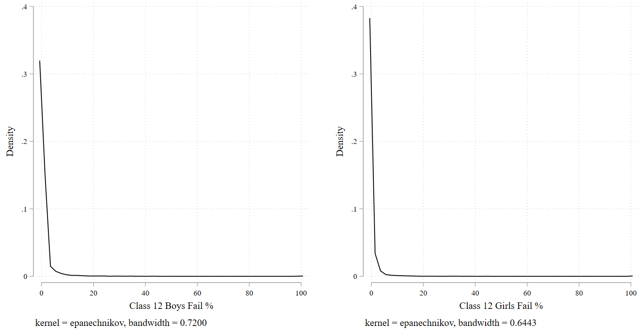

Appendix 4 | Distribution of median noise levels by quarter. Appendix 4a-4d show the kernel density estimates of median noise levels in dB in each of the four quarters.
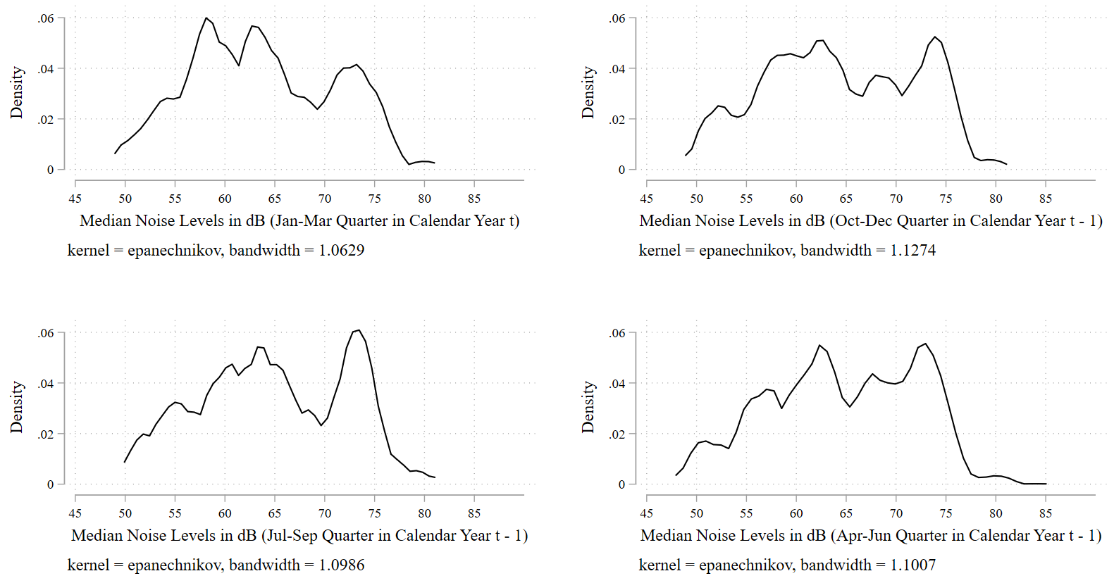
a
c
d
b

Appendix 5 | Distribution of noisy days by quarter. Appendix 5a-5d show the kernel density estimates of noisy days % in each of the four quarters.
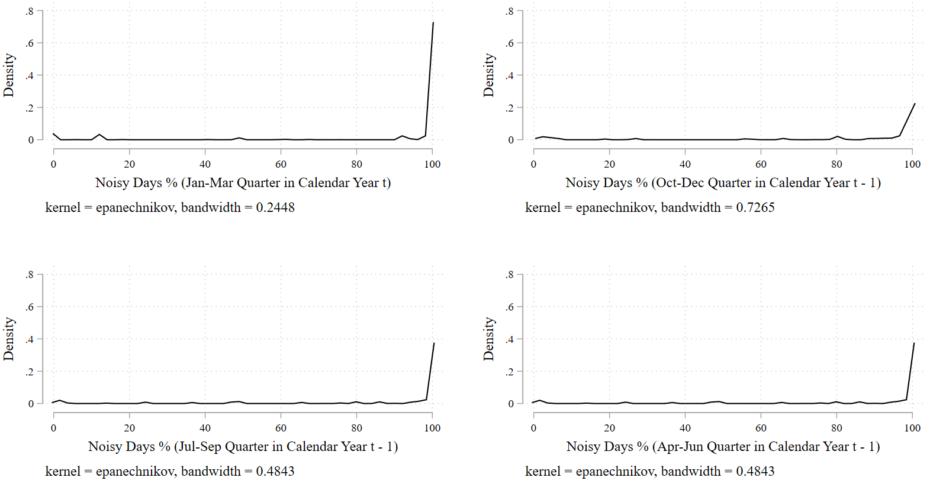
a
c
d
b

Appendix 6 | Distribution of median noise levels by month. Appendix 6a-6l show the kernel density estimates of median noisy levels in dB in each of the 12 months.
c
b
a
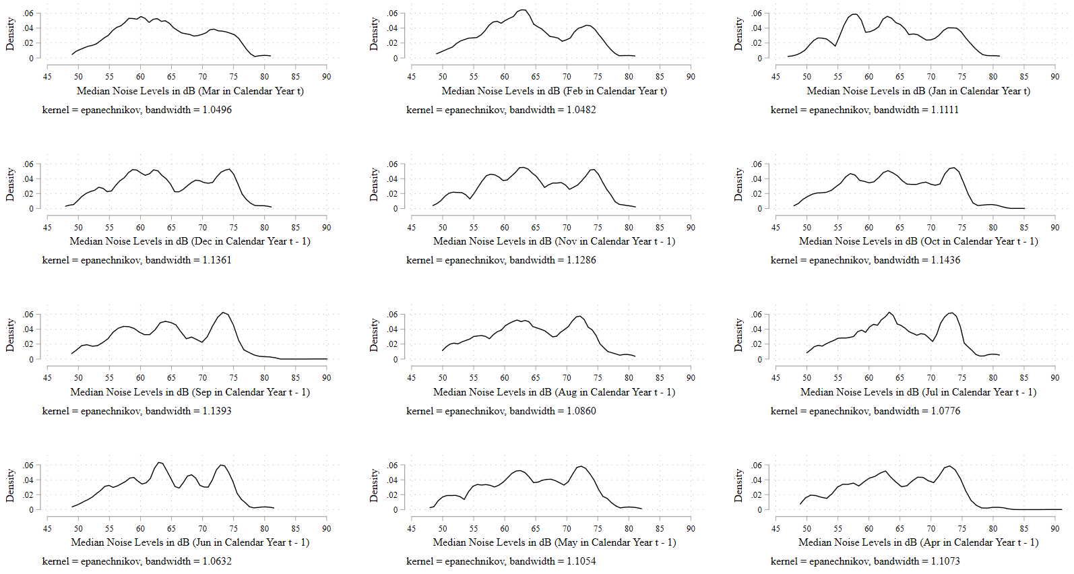
l
i
f
k
h
e
j
g
d

Appendix 7 | Distribution of noisy days by month. Appendix 7a-7l show the kernel density estimates of noisy days % in each of the 12 months.
c
b
a
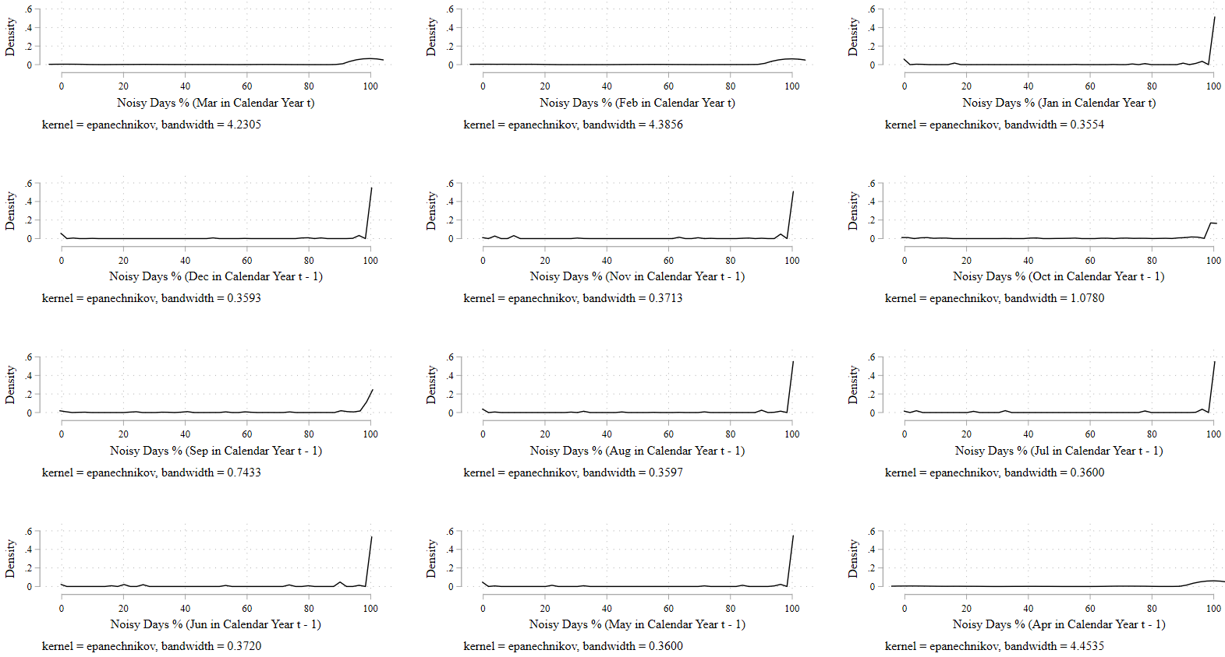
l
i
f
k
h
e
j
g
d

Appendix 8 | Distribution of change in enrollment in Class 12 and in school. Appendix 8a and 8b show the kernel density estimates of the change in enrollment in Class 12 and in school respectively.
b
a
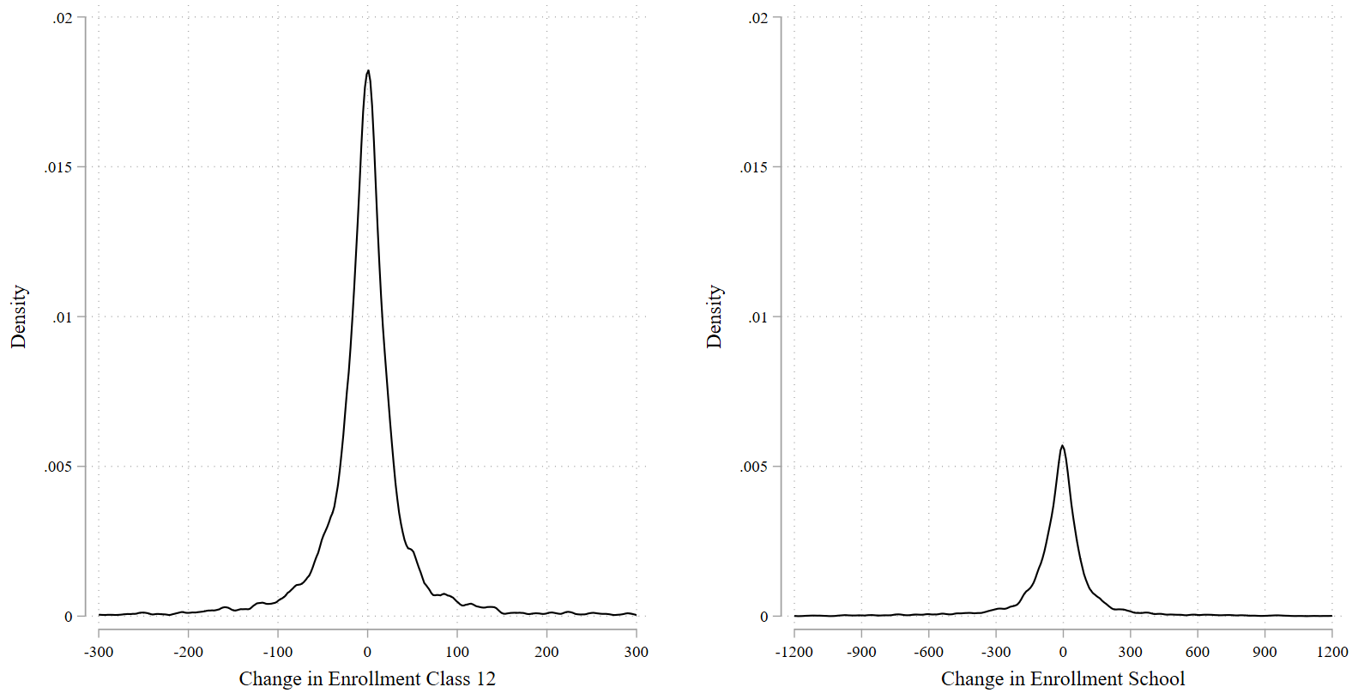

Appendix 9 | Relationship between noise and change in enrollment at class and school level (falsification test). The unit of analysis is school-year. Standard errors are clustered at the school level; exact p-values are reported in brackets.
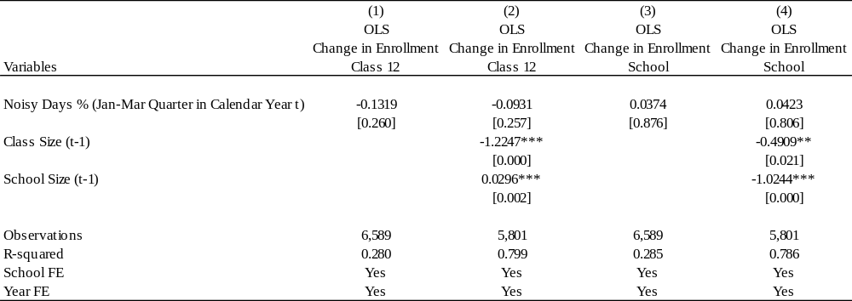

Appendix 10 | Relationship between noise (away from examination days) and academic performance of Class 12 boys and girls. The unit of analysis is school-year. Standard errors are clustered at the school level; exact p-values are reported in brackets.
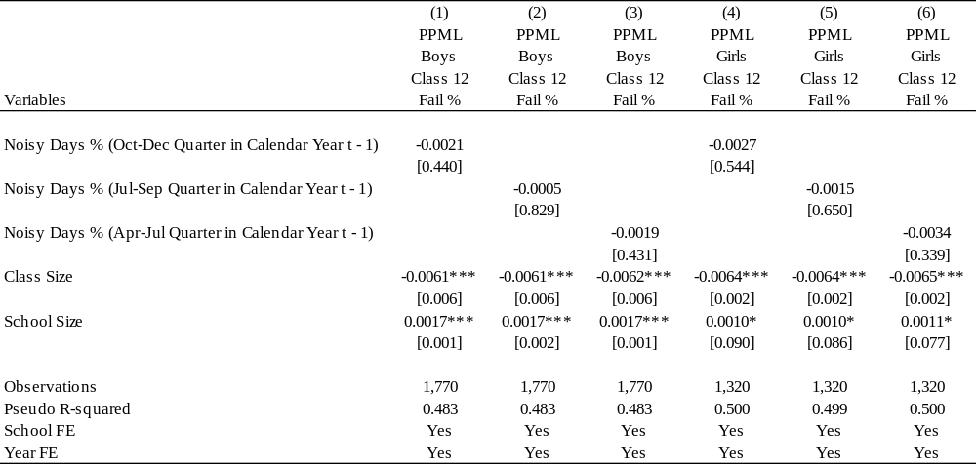

Appendix 11 | Relationship between noise and academic performance of Class 11, Class 10, and Class 9 boys and girls. The unit of analysis is school-year. Standard errors are clustered at the school level; exact p-values are reported in brackets.
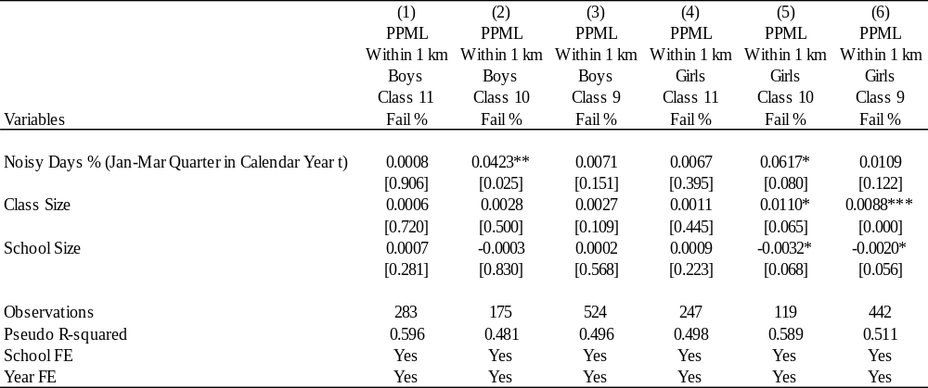

Appendix 12 | Relationship between noise and academic performance in higher (relative to lower) economic growth locations. The unit of analysis is school-year. Standard errors are clustered at the school level; exact p-values are reported in brackets. FE stands for fixed effects. The coefficient estimate of “Higher Economic Growth” is not estimated separately because school-fixed effects are already included in the regression analyses. The sample includes all schools located within 5 km of the nearest noise monitoring stations.
