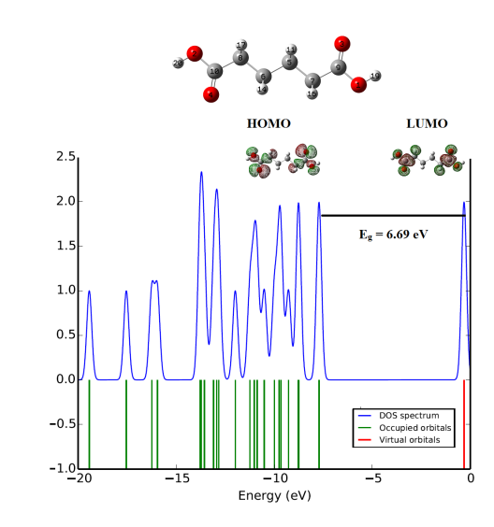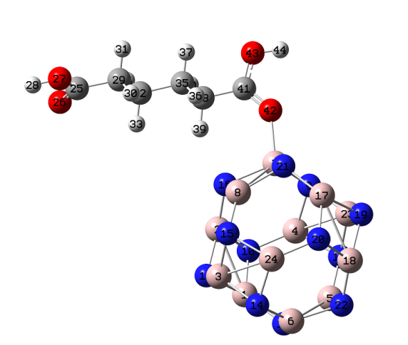
- Interaction of adipic acid with fullerene like metal nanocages
- Enhancement of spectral properties
- Changes in charge transfer values in nanocage-drug system
- Docking studies identifies the drug delivery property

