Adsorption of Adipic acid in Al/B-N/P nanocages: DFT investigations

Jamelah S.Al-Otaibiª, Y.Sheena Mary^{b*}, Y.Shyma Mary^{b}, Goncagül Serdaroglu^{c}

ª Department of Chemistry, College of Science, Princess Nourah bint Abdulrahman University, Saudi Arabia
^{b} Researcher, Thushara, Neethinagar-64, Kollam, Kerala, India
^{c}Sivas Cumhuriyet University, Faculty of Education, Math. and Sci. Edu., 58140 Sivas/ TURKEY

*author for correspondence: email: marysheena2018@rediffmail.com

Fig.S1 HOMO-LUMO distributions along with DOSs for (a) AlN (b) AlN-ADPA
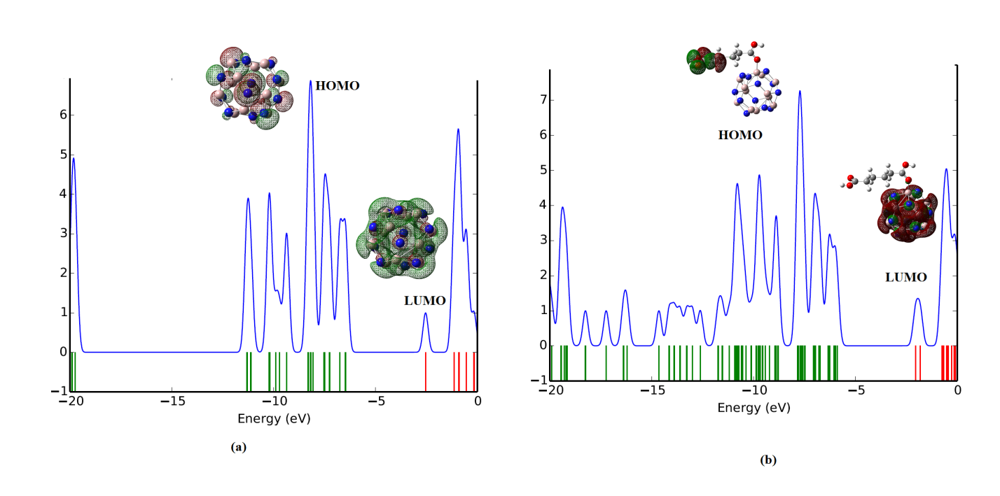

Fig.S2 HOMO-LUMO distributions along with DOSs for (a) AlP (b) AlP-ADPA
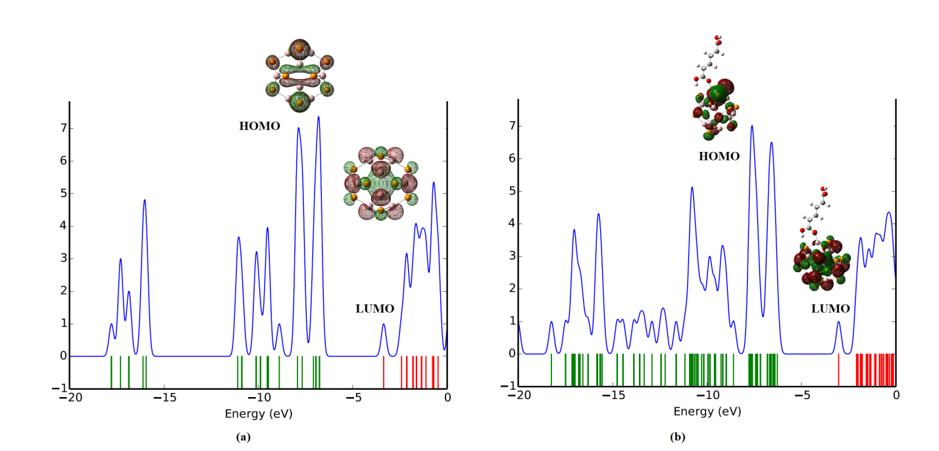
Fig.S3 HOMO-LUMO distributions along with DOSs for (a) BN (b) BN-ADPA
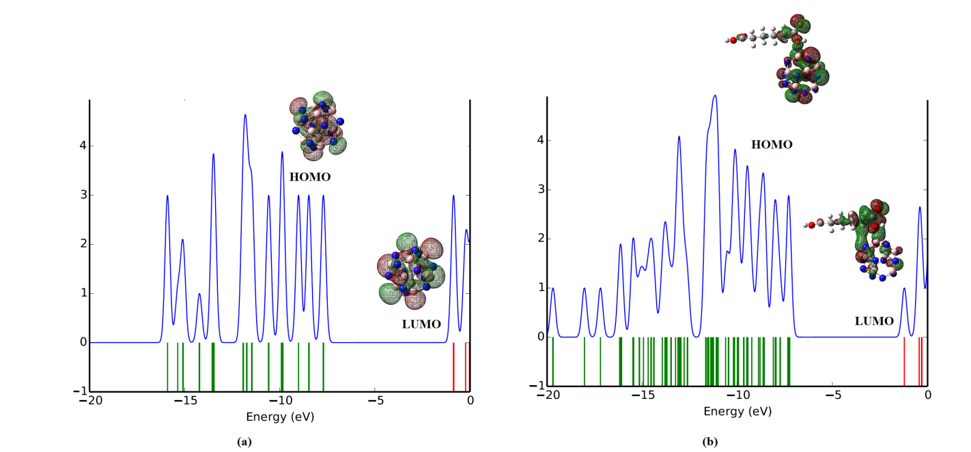

Fig.S4 HOMO-LUMO distributions along with DOSs for (a) BP (b) BP-ADPA
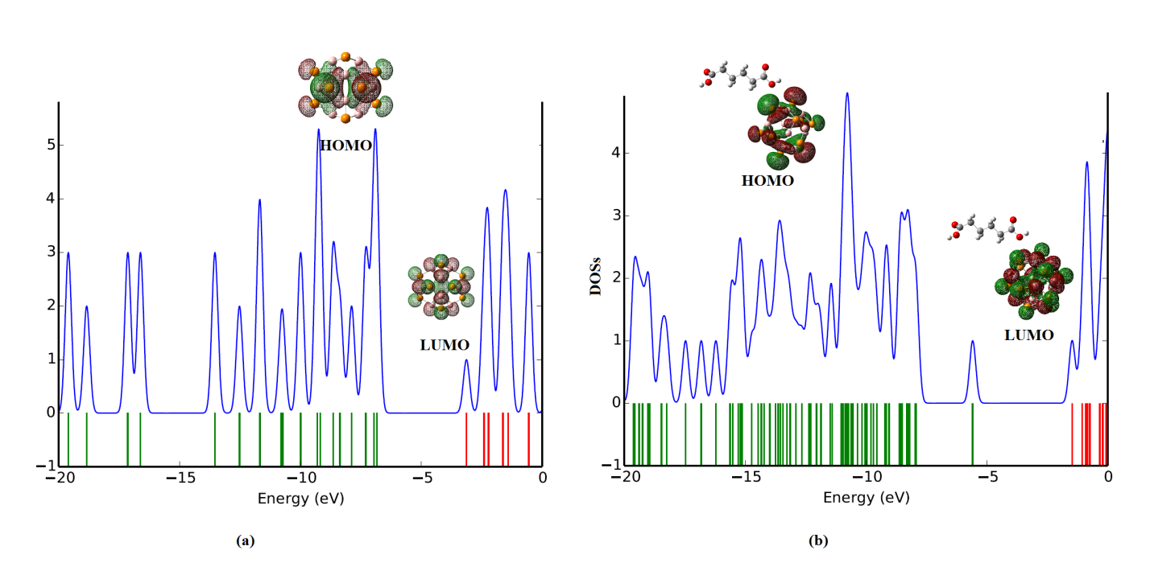

Fig.S5.1 UV plot of ADPA
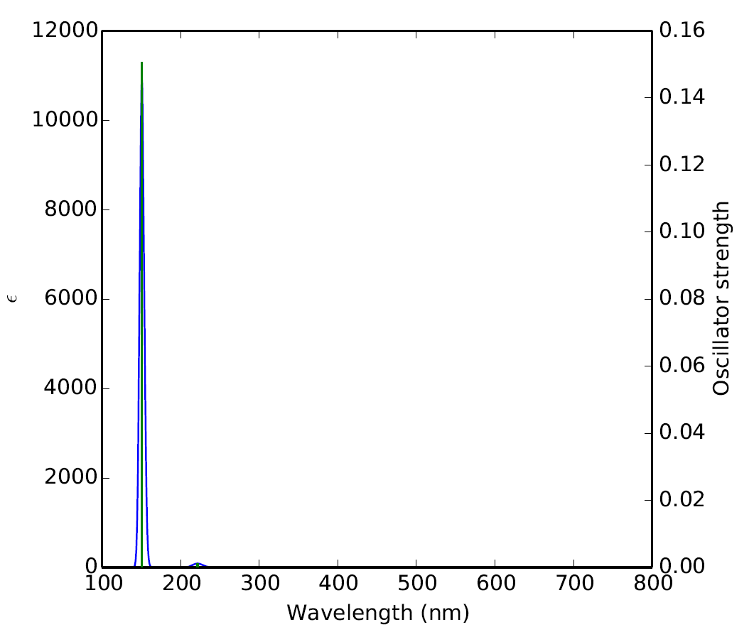

Fig.S5.2 UV plot of AlN-ADPA
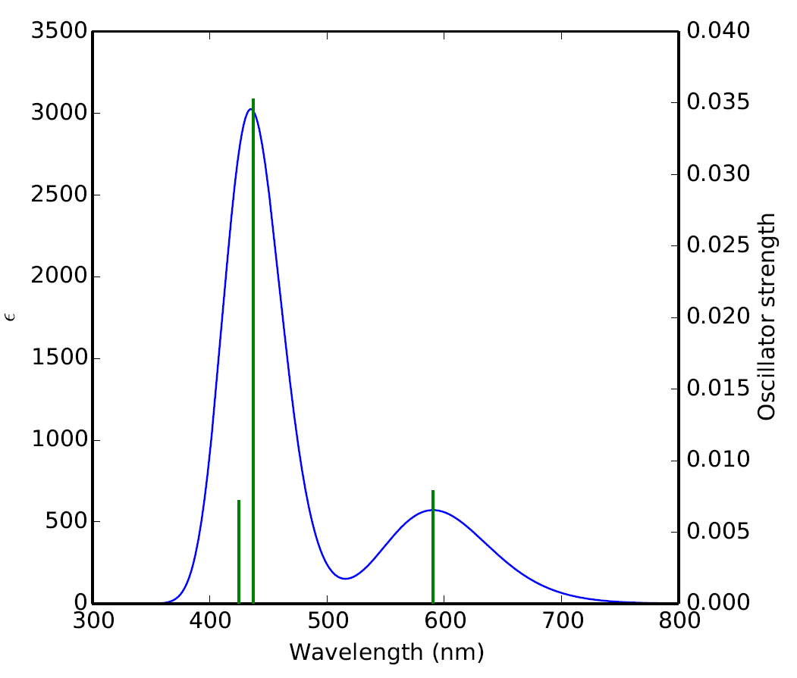

Fig.S5.3 UV plot of AlP-ADPA
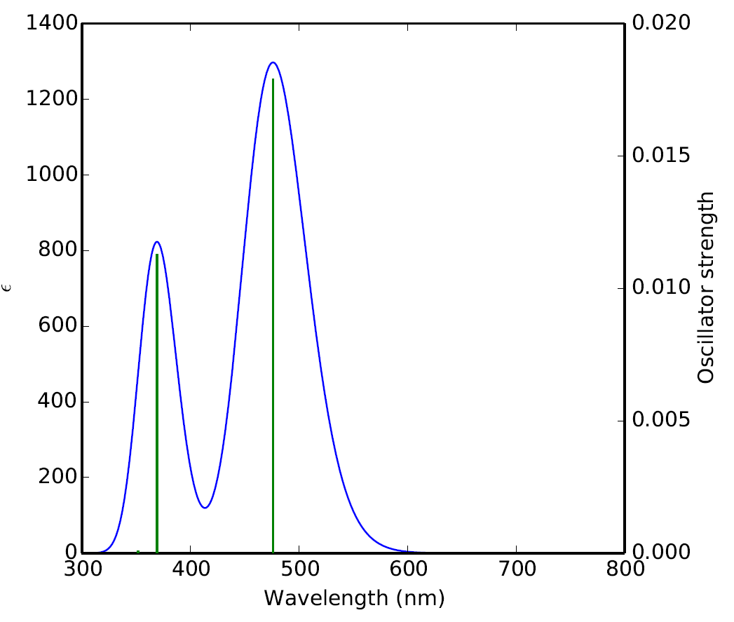

Fig.S5.4 UV plot of BN-ADPA
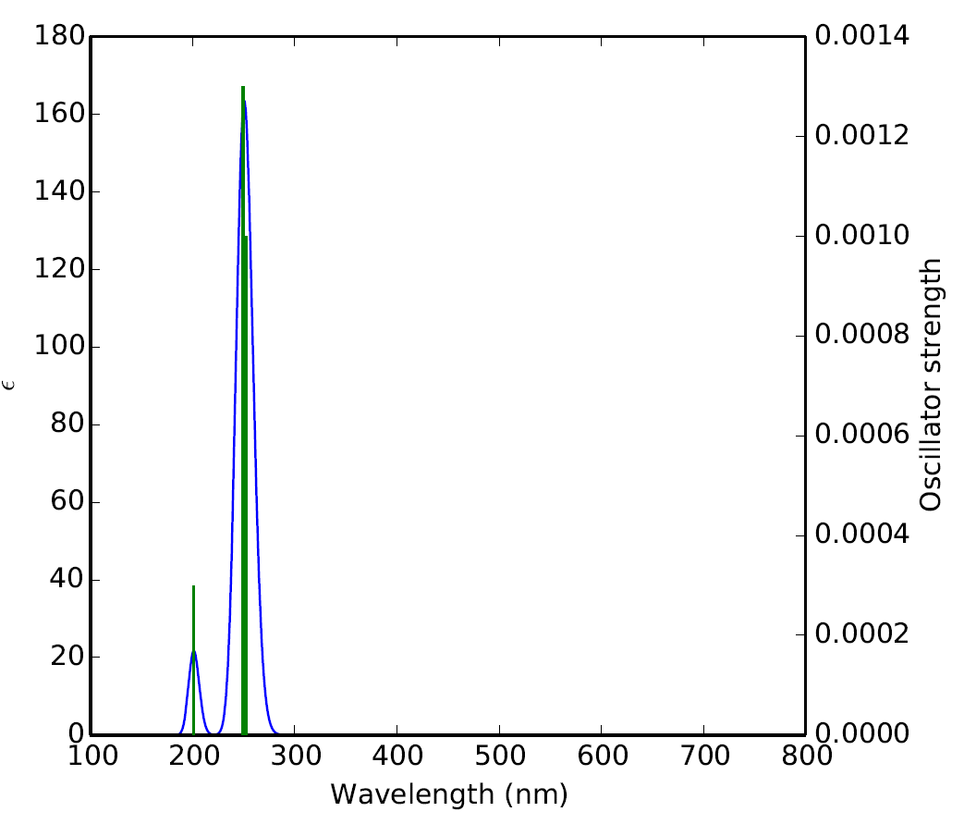

Fig.S5.5 UV plot of BP-ADPA
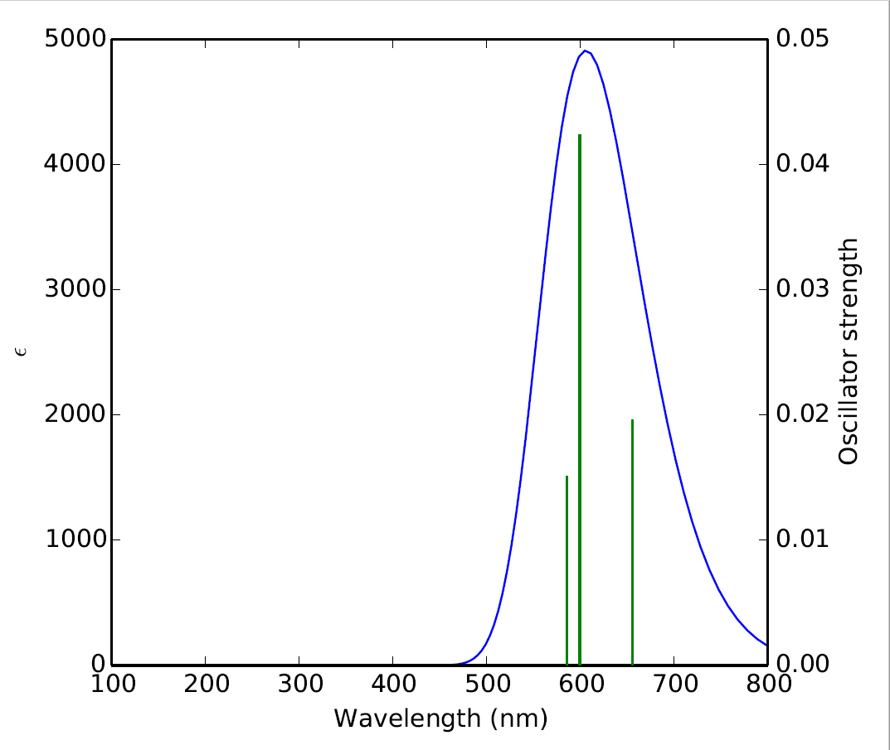

Fig.S6.1 Raman spectrum of ADPA
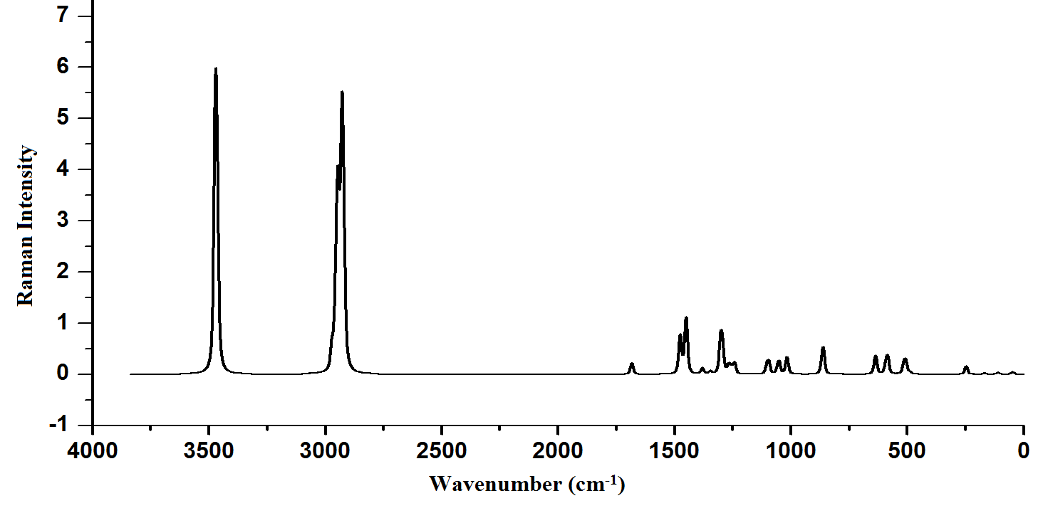

Fig.S6.2 Raman spectrum of AlN-ADPA
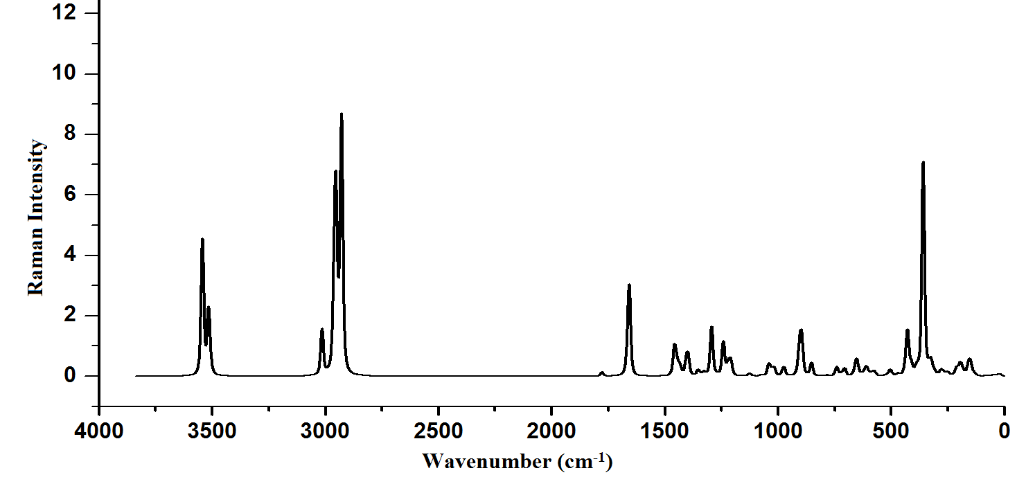

Fig.S6.3 Raman spectrum of AlP-ADPA
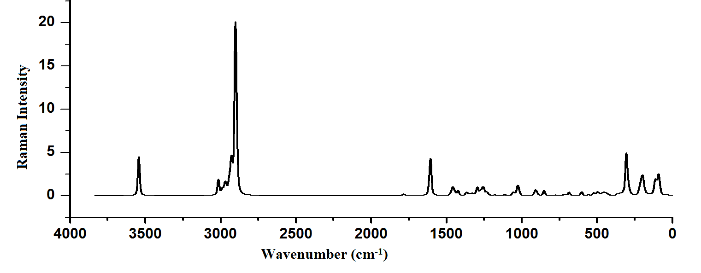

Fig.S6.4 Raman spectrum of BN-ADPA
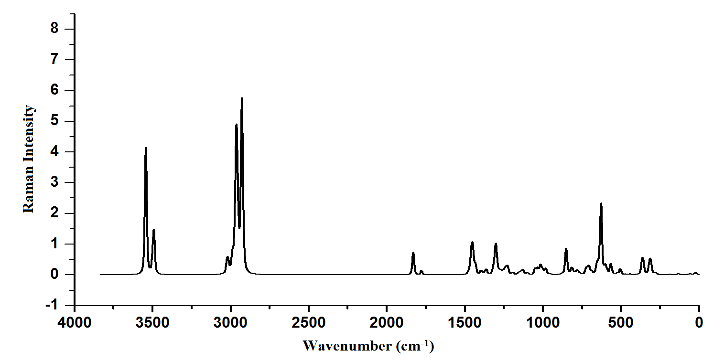

Fig.S6.5 Raman spectrum of BP-ADPA
