Table 3. Pd(0)@MnO₂-CF catalyzed oxidation of alcohols^{a,b}
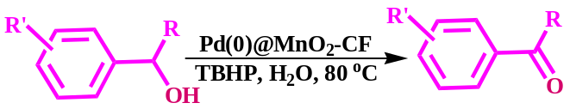
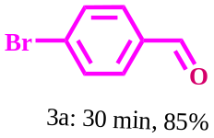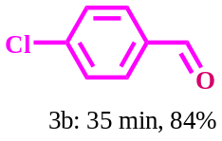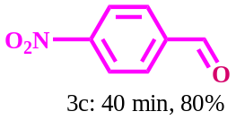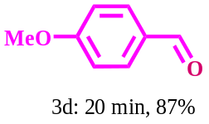
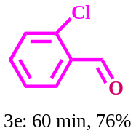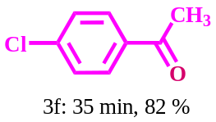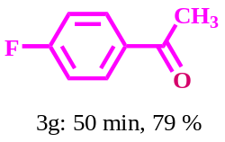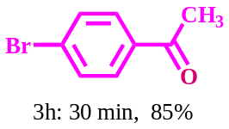
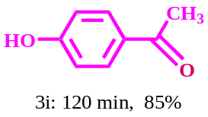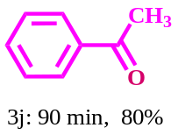
ªReaction conditions: alcohol (1 mmol), TBHP (0.5 mmol), Pd(0)@MnO₂-CF (1cm×1 cm) in water (10 mL) at 80 °C.
^{b}Column chromatography yield.

Table 4. Pd(0)@MnO₂-CF catalyzed oxidative deprotection of oximes^{a,b}
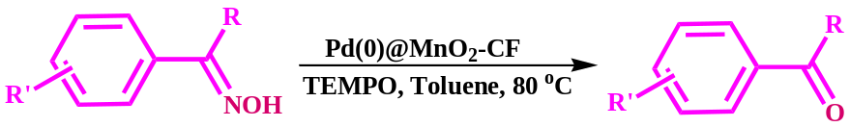
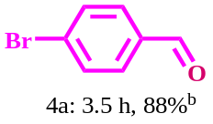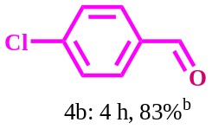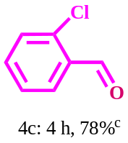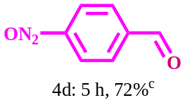
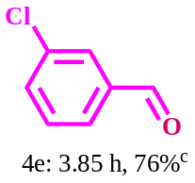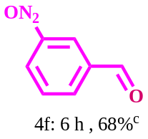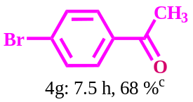
ªReaction conditions: oxime (1 mmol, 0.2 g), TEMPO (0.25 mmol, 0.078 g), Pd(0)@MnO₂-CF (1×1 cm) in toluene (10 mL) at 80 °C.
^{b}Isolated yield.
^{c}Column chromatography yield.

