Supporting Information
Manganese dioxide coated cotton fabric decorated with palladium nanoparticles for oxidation of alcohols, oxidative deprotection of oximes and degradation of methyl orange
Surbhi Sharma, Vrinda Sharma, Anu Choudhary, Sukanya Sharma and Satya Paul*
Department of Chemistry, University of Jammu, Jammu 180006, India. Fax: +91-191-2431365; Tel: +91-191-2453969; Email: satyapaul@jammuuniversity.ac.in.
 | List of Contents | Page no.
S1. | Materials | 2
S2. | Spectral details of the compounds listed in Table 3 and Table 4 | 2-5
S3. | ¹H NMR and ¹³C NMR spectra of compounds listed in Table 3  and Table 4 | 5-17

.

S1. Materials
All the chemicals used were purchased from Aldrich Chemical Company. Cotton fabric was obtained from a textile industry of Jammu, India. The FTIR of the catalyst was recorded on the Fourier transform infrared spectrophotometer (Agilent Technologies, L1600312 spectrum TWOLITA/ZnSe). Thermogravimetric analysis (TGA) was recorded on a PerkinElmer, Diamond TG/differential thermal analysis (DTA) with a heating rate of 10 °C min. X-ray diffraction (XRD) was recorded on a Bruker AXSD8 ADVANCE X-ray diffractometer in the 2θ range of 10-80° using Cu Kα radiations. Scanning electron microscope, MODEL: SU8010 SERIES, Hitachi, was used to record SEM, EDX as well as elemental mapping. To determine the amount of metal loading, inductively coupled plasma atomic emission spectroscopy (ICP-AES) analysis was performed using an ARCOS, Simultaneous ICP spectrometer. XPS spectra of the catalysts were recorded on a Kratos ESCA model AXIS 165 (resolution). ¹ H NMR (400 MHz) and ¹³C NMR (100 MHz) spectra of the samples were recorded in CDCl₃ on a Bruker AVANCE III spectrometer using TMS as an internal standard.
S2. Spectral details of the compounds listed in Table 3 and Table 4

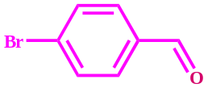
4-Bromobenzaldehyde (3a, 4a)
¹H NMR (400 MHz, CDCl₃): δ 9.98 (s, 1H, CHO), 7.76 (d, J = 8.4 Hz, 2H, Ar-H), 7.69 (d, J = 8.4 Hz, 2H, Ar-H); ¹³C NMR (100 MHz, CDCl₃): δ 191.45, 135.05, 132.44, 130.99, 129.79.
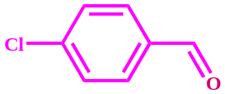
4-Chlorobenzaldehyde (3b, 4b)
¹H NMR (400 MHz, CDCl₃): δ 10.00 (s, 1H, CHO), 7.84 (d, J = 8.3 Hz, 2H, Ar-H), 7.53 (d, J = 8.2 Hz, 2H, Ar-H); ¹³C NMR (100 MHz, CDCl₃): δ 191.06, 140.97, 134.70, 130.93, 129.47.
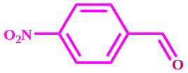
4-Nitrobenzaldehyde (3c, 4d)
¹H NMR (400 MHz, CDCl₃): δ 10.19 (s, 1H, CHO), 8.42 (d, J = 8.5 Hz, 2H, Ar-H), 8.11 (d, J = 8.5 Hz, 2H, Ar-H); ¹³C NMR (100 MHz, CDCl₃) : δ 190.63, 151.87, 140.16, 130.63, 124.55.
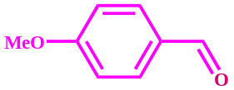
4-Methoxybenzaldehyde (3d)
¹H NMR (400 MHz, CDCl₃): δ 9.66 (s, 1H, CHO), 7.59 (d, J = 4.4 Hz, 2H, Ar-H), 6.76 (d, J = 7.7 Hz, 2H, Ar-H ), 3.64 (s, 3H, OCH₃); ¹³C NMR (100 MHz, CDCl₃): δ 190.65, 164.43, 131.75, 129.95, 114.14, 55.30.
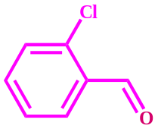
2-Chlorobenzaldehyde (3e, 4c)
¹H NMR (400 MHz, CDCl₃): δ 10.34 (s, 1H, CHO), 7.79 (d, J = 7.6 Hz, 1H, Ar-H), 7.44-7.27 (m, 3H, Ar-H); ¹³C NMR (100 MHz, CDCl₃): δ 189.69, 137.78, 135.15, 132.28, 130.53, 129.26, 127.25.
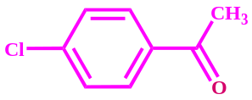
4-Chloroacetophenone (3f)
¹H NMR (400 MHz, CDCl₃) δ 7.90 (d, J = 8.6 Hz, 2H, Ar-H), 7.44 (d, J = 8.6 Hz, 2H, Ar-H), 2.59 (s, 3H, COCH₃); ¹³C NMR (100 MHz, CDCl₃) δ 196.78, 139.64, 135.57, 129.73, 128.88, 26.57.
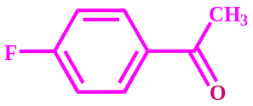
4-Fluoroacetophenone (3g)
¹H NMR (400 MHz, CDCl₃): δ 7.71 – 7.68 (m, 2H, Ar-H), 6.85 – 6.81 (m, 2H, Ar-H), 2.29 (s, 3H, COCH₃); ¹³C NMR (100 MHz, CDCl₃): δ 195.80, 165.38 (d, J = 253.9 Hz), 133.35 (d, J = 3.0 Hz), 130.68 (d, J = 9.3 Hz), 115.23 (d, J = 21.9 Hz), 26.32.
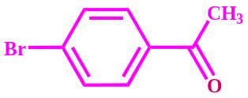
4-Bromoacetophenone (3h, 4g)
¹H NMR (400 MHz, CDCl₃): δ 7.84 (d, J = 8.3 Hz, 2H, Ar-H), 7.63 (d, J = 8.5 Hz, 2H, Ar-H 3H, Ar-H), 2.61(s, 3H, COCH₃); ¹³C NMR (100 MHz, CDCl₃): δ 197.08, 135.73, 131.75, 129.87, 128.48, 26.46.
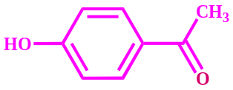
4-Hydroxyacetophenone (3i)
¹H NMR (400 MHz, CDCl₃): δ 7.93 (d, J = 8.6 Hz, 2H, Ar-H), 7.49 (bs, OH), 6.95 (d, J = 8.6 Hz, 2H, Ar-H), 2.60 (s, 3H, COCH₃); ¹³C NMR (100 MHz, CDCl₃): δ 198.46, 161.33, 131.26, 130.23, 115.51, 26.60.
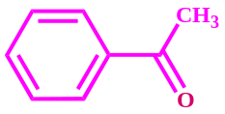
Acetophenone (3j)
¹H NMR (400 MHz, CDCl₃): δ 7.98 (d, J = 8.0 Hz, 2H, Ar-H ), 7.58 (t, J = 7.3 Hz, 1H, Ar-H), 7.48 (t, J = 7.1 Hz, 2H, Ar-H), 2.62 (s, 3H, COCH₃); ¹³C NMR (100 MHz, CDCl₃): δ 198.44, 137.11, 133.14, 128.59, 128.32, 26.64.
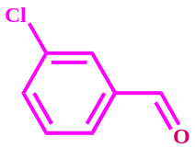
3-Chlorobenzaldehyde (4e)
¹H NMR (400 MHz, CDCl₃): ¹H NMR (400 MHz, CDCl₃) δ 9.94 (s, 1H, CHO), 7.77 (s, 1H, Ar-H), 7.71 (d, J = 7.5 Hz, 1H, Ar-H), 7.53 (d, J = 8.0 Hz, 1H, Ar-H), 7.42 (t, J = 7.8 Hz, 1H, Ar-H); ¹³C NMR (100 MHz, CDCl₃): δ 190.01, 137.96, 135.33, 134.30, 130.36, 129.12, 127.98.
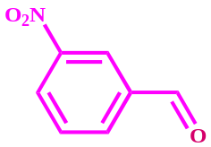
3-Nitrobenzaldehyde (4f)
¹H NMR (400 MHz, CDCl₃): δ 10.15 (s, 1H, CHO), 8.75 (s, 1H, Ar-H), 8.52 (d, J = 8.3 Hz, 1H, Ar-H ), 8.26 (d, J = 8.4 Hz, 1H, Ar-H), 7.80 (t, J = 7.2 Hz, 1H, Ar-H); ¹³C NMR (100 MHz, CDCl₃): δ 189.63, 148.67, 137.30, 134.42, 130.35, 128.49, 124.34.

S3. ¹H NMR and ¹³C NMR spectra of compounds listed in Table 3 and Table 4

