Table 1. Basic patients’ characteristics
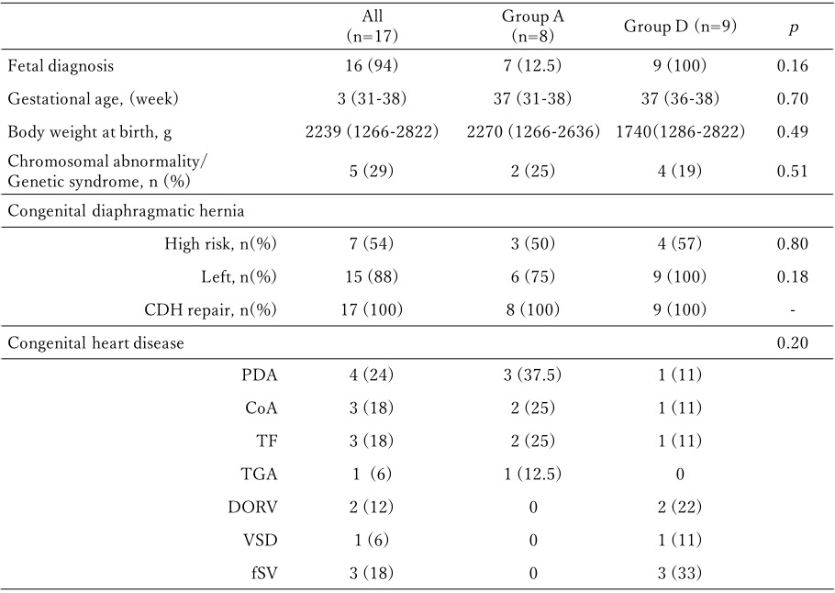
CDH, congenital heart disease; PDA, patent ductus arteriosus; CoA, coactation of aorta; TF, tetralogy of Fallot; TGA, transposition of the great arteries; DORV, double outlet right ventricle; VSD, ventricular septal defect; fSV, functional single ventricle. Group A, alive patients; Group D, dead patients

