Table 3. Details of patients with two ventricles
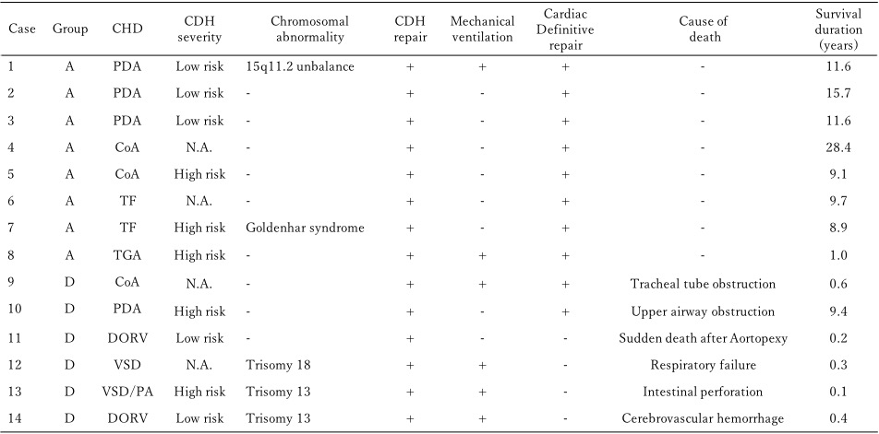
Group A, alive patients; Group D, dead patients.
PDA, patent ductus arteriosus; CoA, coactation of aorta; TF, tetralogy of Faloot; TGA, transposition of great arteries; DORV, double outlet right ventricle; VSD, ventricular septal defect; PA, pulmonary atresia; N.A., not available

