APPENDIX
Is Swift’s formula for strike the least squares solution?
The suspicion that Swift’s formula couldn’t be a least square solution for strike came when using it as a stepping stone to obtain a similar formula for the phase tensor. The formula is given as

$$tan4θ=\frac{2Real\left[\left(Z_{yy}-Z_{xx}\right)(Z_{xy}^{*}+Z_{yx}^{*}\right]}{{\left|Z_{xy}+Z_{yx}\right|}^{2}-{\left|Z_{yy}-Z_{xx}\right|}^{2}} . (A1)$$

The asterisk stands for the conjugate of a complex number. It is stated in articles and textbooks that this follows from minimizing ${\left|Z_{xx}^{'}\right|}^{2}+{\left|Z_{yy}^{'}\right|}^{2}$ or maximizing${\left|Z_{xy}^{'}\right|}^{2}+{\left|Z_{yx}^{'}\right|}^{2}$ in equation 9 (e.g. Vozoff, 1972; Gamble et al., 1979; Clarke et al., 1983; Simpson and Bahr, 2005; Chave and Jones, 2012). The most cited reference for the origin of the formula is Swift’s doctoral thesis. However, although he describes the above procedure the formula is nowhere in his thesis. The first explicit form is in Sims and Bostick (1969), who consider a special combination of the tensor elements and show that the quantity describes an ellipse when rotated. Then they find the angle of the major axis of the ellipse by solving a classical problem of maxima and minima. Thus what they found is an exact, analytical solution. They mention that their result can also be obtained using Swift’s least squares approach. This is true, equation A1 is indeed one of four possible solutions of a fourth degree equation for $tanθ$that results from the least squares approach.
Let’s go back to the analogy of the impedance and phase tensors. For the phase tensor we would require to minimize${\left|Φ_{12}^{'}\right|}^{2}+{\left|Φ_{21}^{'}\right|}^{2}$ in equation 14. We then need the derivative with respect to $θ$and then setting it to zero. However, this is not necessary. The derivative of ${\left|Z_{xy}^{'}\right|}^{2}+{\left|Z_{yx}^{'}\right|}^{2}$ is the same as the derivative of${\left|Φ_{12}^{'}\right|}^{2}+{\left|Φ_{21}^{'}\right|}^{2}$, except that the elements of the phase tensor are real. The ambiguity of whether this leads to a maximum or a minimum can be checked a posteriori. Now substitute the corresponding elements of the phase tensor in equation A1 as${ Z}_{xx}↔Φ_{11}, Z_{xy}↔Φ_{12}, Z_{yx}↔Φ_{21}, Z_{yy}↔Φ_{22}$ . The results is

$$tan4θ=\frac{2\left[\left(Φ_{22}-Φ_{11}\right)(Φ_{12}+Φ_{21}\right]}{{(Φ_{12}+Φ_{21})}^{2}-{{(Φ}_{22}-Φ_{11})}^{2}} . (A2)$$

Presumably this would be the least squares solution for the strike in terms of the elements of the phase tensor. However, there is nothing new about this formula. Consider the equivalent form

$$tan4θ=\frac{2\frac{Φ_{12}+Φ_{21}}{Φ_{22}-Φ_{11}}}{\frac{{(Φ_{12}+Φ_{21})}^{2}}{{(Φ_{22}-Φ_{11})}^{2}}-1} . (A3)$$

Or in more familiar terms

$$tan4θ=\frac{2\frac{Φ_{12}+Φ_{21}}{Φ_{11}-Φ_{22}}}{1-\frac{{(Φ_{12}+Φ_{21})}^{2}}{{(Φ_{11}-Φ_{22})}^{2}}} . (A4)$$

It can be recognized that the ratios in the numerator and the denominator are, according to equation 7,$tan2α$ and $\tan^{2}2α$, respectively. The result is the familiar trigonometric identity for the double angle

$$tan4θ=\frac{2tan2α}{1-\tan^{2}2α} . (A5)$$

This means that adapting equation A1 to the phase tensor doesn’t add to the original estimation of$tan2α$. It simply replaces the estimation of 2$θ$ by that of 4$θ$. It may still be argued that this is precisely the type of transformation that makes equation A5 into a least squares solution. Just to be on the safe side we applied both criteria to the noisy and distorted data shown in Figure A1.

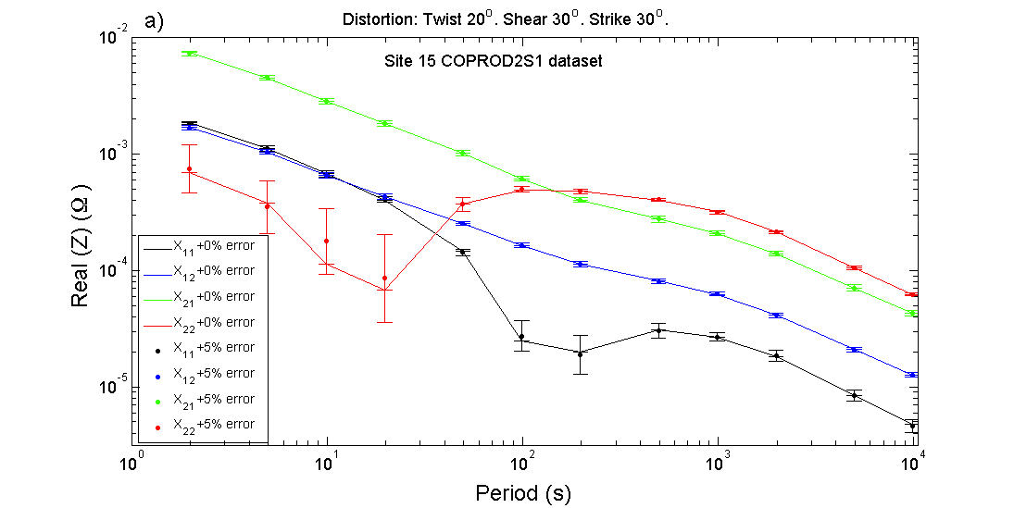
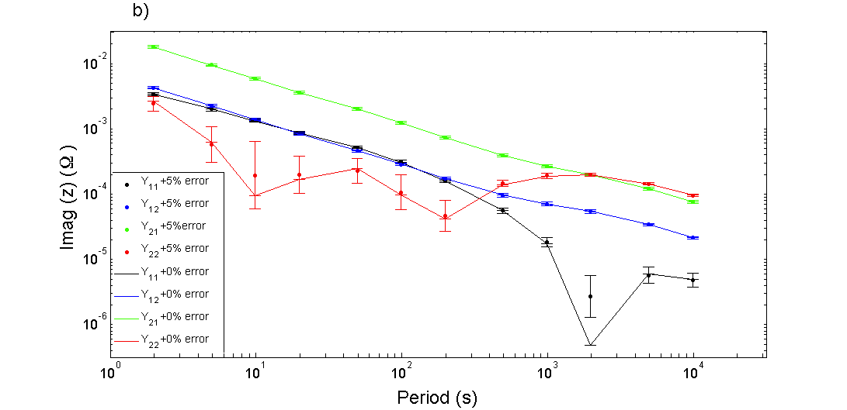
Figure A1. a) The elements of the real part of the distorted impedance tensor for site # 15 of the COPROD2S1 dataset. b) The corresponding elements of the imaginary part of the impedance tensor. The error was computed as 5% of the off-diagonal distorted elements. The continuous lines represent the error-free values.

The comparison of the estimations using equation A5 and the numerical least squares approach is shown in Figure A2. It can be observed that the numerical solution outperforms equation A5 for most periods. One last thing must be said about equation A5. We can tell a posteriori that it would correspond to the minimum because it provides the same solution as equation 7. On the other hand, the maximum should correspond to the negative of the same angle. This is because we purposely chose the positive sign in the denominator of the numerator when going from equation A2 to A3. Notice that the squared difference may take one sign or the other.
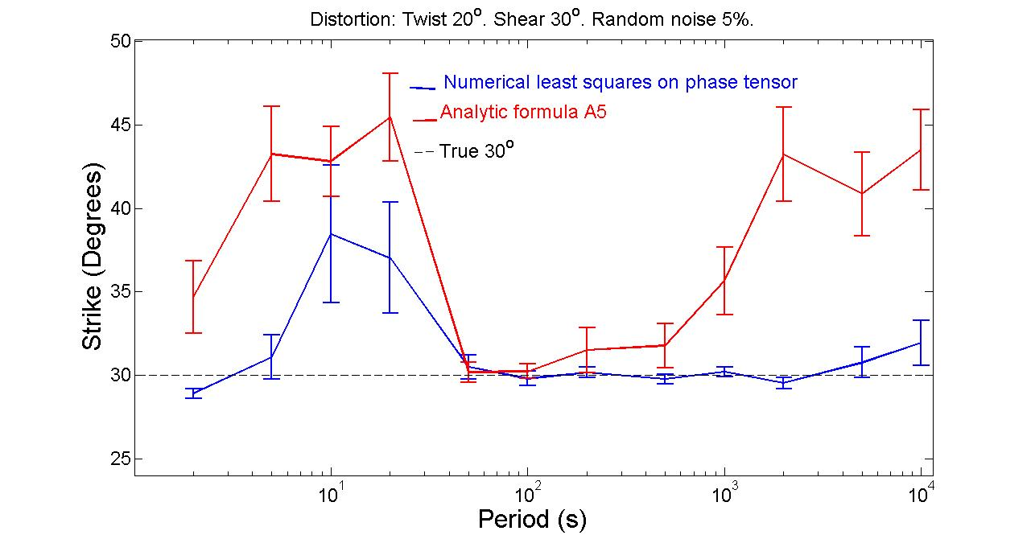
Figure A2. Comparison of the estimators of formula A5 and those of the numerical least squares applied to the phase tensor elements. The red curve corresponds to the analytic formula, the blue curve to the numerical least squares approach and the black dashed line to the true strike.

As commented in the main text, there is nothing wrong with equation A1, except that it is not the claimed least squares solution to strike. Figure A3 illustrates how the numerical approach of least squares outperforms the estimates using equation A1. The results are very similar when the synthetic data is contaminated with small random errors but the differences are significant when the errors increase.
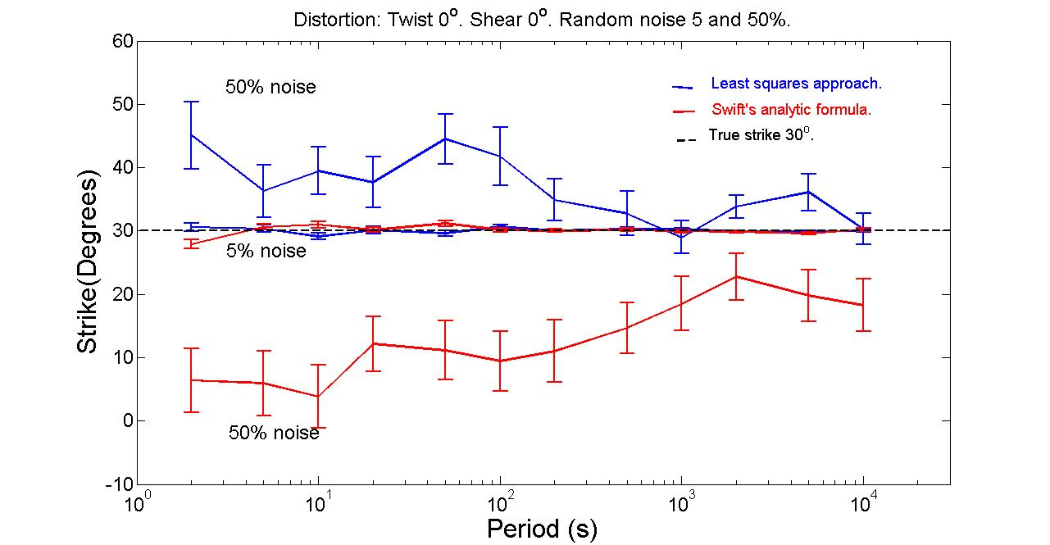
Figure A3. Comparison of the numerical least squares approach using windows of one period with Swift’s analytic formula. The red curves correspond to Swift’s analytic formula, the blue curves to the numerical least squares approach and the black dashed line to the true strike. Notice that for a 5% noise the blue curveis only slightly more accurate than the red one. However, for 50% noise the differences amplify leaving the least squares approach the better estimator.

