APPENDIX

Is Swift’s formula for strike the least squares solution?

The suspicion that Swift’s formula couldn’t be a least square solution for strike came when using it as a stepping stone to obtain a similar formula for the phase tensor. The formula is given as

𝑡𝑎𝑛4𝜃 =
2𝑅𝑒𝑎𝑙 𝑍!! − 𝑍!! (𝑍∗ + 𝑍∗
!" !"
!!

𝑍!"

+ 𝑍!"

! − 𝑍

− 𝑍!!
!
. (𝐴1)

The asterisk stands for the conjugate of a complex number. It is stated in articles

and textbooks that this follows from minimizing 𝑍′ ! + 𝑍′ ! or
!! !!

maximizing 𝑍′ ! + 𝑍′ ! in equation 9 (e.g. Vozoff, 1972; Gamble et al., 1979;
!" !"

Clarke et al., 1983; Simpson and Bahr, 2005; Chave and Jones, 2012). The most cited reference for the origin of the formula is Swift’s doctoral thesis. However, although he describes the above procedure the formula is nowhere in his thesis. The first explicit form is in Sims and Bostick (1969), who consider a special

combination of the tensor elements and show that the quantity describes an ellipse when rotated. Then they find the angle of the major axis of the ellipse by solving a classical problem of maxima and minima. Thus what they found is an exact, analytical solution. Here is where the confusion appears: they mention that their result could also be obtained using Swift’s least squares approach. The good news is that the least squares solution is still to be found. Our attempts lead to an untreatable fourth degree equation for 𝑡𝑎𝑛𝜃.
Let’s go back to the analogy of the impedance and phase tensors. For the

phase tensor we would require to minimize Φ! ! + Φ! ! in equation 14. We then
!" !"

need the derivative with respect to 𝜃and then setting it to zero. However, this is not

necessary. The derivative of 𝑍′ ! + 𝑍′ ! is the same as the derivative
!" !"

! ! !
Φ
Φ
of
+
!" !"
!, except that the elements of the phase tensor are real. The

ambiguity of whether this leads to a maximum or a minimum can be checked a posteriori. Now substitute the corresponding elements of the phase tensor in equation A1 as 𝑍!! ↔ Φ!!, 𝑍!" ↔ Φ!", 𝑍!" ↔ Φ!", 𝑍!! ↔ Φ!! . The results is

𝑡𝑎𝑛4𝜃 =

2
Φ!! − Φ!! (Φ!" + Φ!"
(Φ!" + Φ!")! − (Φ!! − Φ!!)!
. (𝐴2)

Presumably this would be the least squares solution for the strike in terms of the elements of the phase tensor. However, there is nothing new about this formula. Consider the equivalent form

2 !!"!!!"
𝑡𝑎𝑛4𝜃 = !!!!!!!
(!!"!!!")! − 1
(!!!!!!!)!

. (𝐴3)

Or in more familiar terms

2 !!"!!!"
𝑡𝑎𝑛4𝜃 = !!!!!!!
1 − (!!"!!!")!
(!!!!!!!)!

. (𝐴4)

It can be recognized that the ratios in the numerator and the denominator are, according to equation 7,𝑡𝑎𝑛2𝛼 and 𝑡𝑎𝑛!2𝛼, respectively. The result is the familiar trigonometric identity for the double angle

𝑡𝑎𝑛4𝜃 = 2𝑡𝑎𝑛2𝛼
1 − 𝑡𝑎𝑛!2𝛼

. (𝐴5)

This means that adapting equation A1 to the phase tensor doesn’t add to the original estimation of 𝑡𝑎𝑛2𝛼. It simply replaces the estimation of 2𝜃 by that of 4𝜃. It may still be argued that this is precisely the type of transformation that makes equation A5 into a least squares solution. Just to be on the safe side we prepared Figure A1that compares the estimations using equation A5 and the numerical least squares approach. It can be observed that the numerical solution outperforms equation A5. One last thing must be said about equation A5. We can tell a posteriori that it would correspond to the minimum because it provides the same solution as equation 7. On the other hand, the maximum should correspond to the

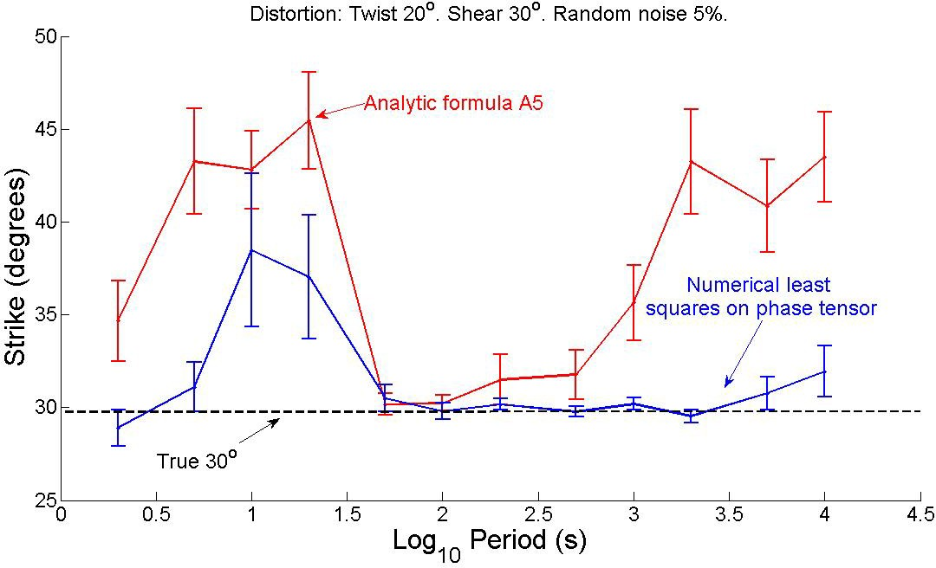
negative of the same angle. This is because we purposely chose the positive sign in the denominator of the numerator when going from equation A2 to A3. Notice that the squared difference may take one sign or the other.

Figure A1. Comparison of the estimators of formula A5 and those of the numerical least squares applied to the phase tensor elements.

As commented in the main text, there is nothing wrong with equation A1, except that it is not the claimed least squares solution to strike. Figure A2 illustrates how the numerical approach of least squares outperforms the estimates using equation A1. The results are very similar when the synthetic data is contaminated with small random errors but the differences are significant when the errors increase.

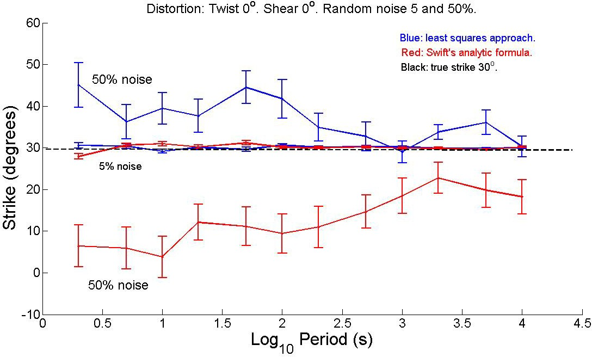

Figure A2. Comparison of the numerical least squares approach using windows of one period with Swift’s analytic formula. Notice that for a 5% noise the blue curve is only slightly more accurate than the red one. However, for 50% noise the differences amplify leaving the least squares approach the better estimator.

