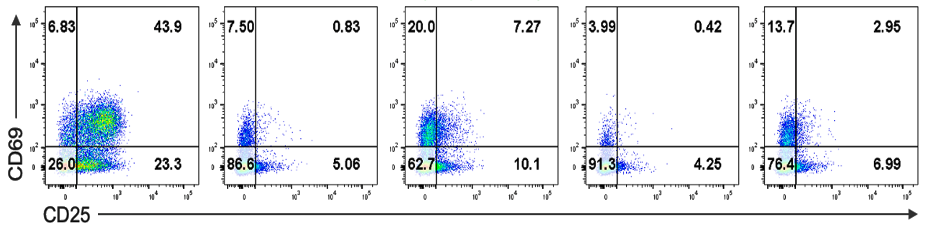
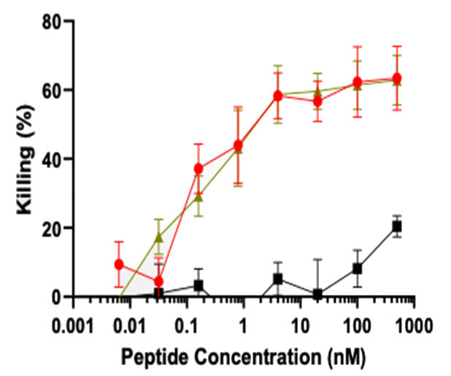

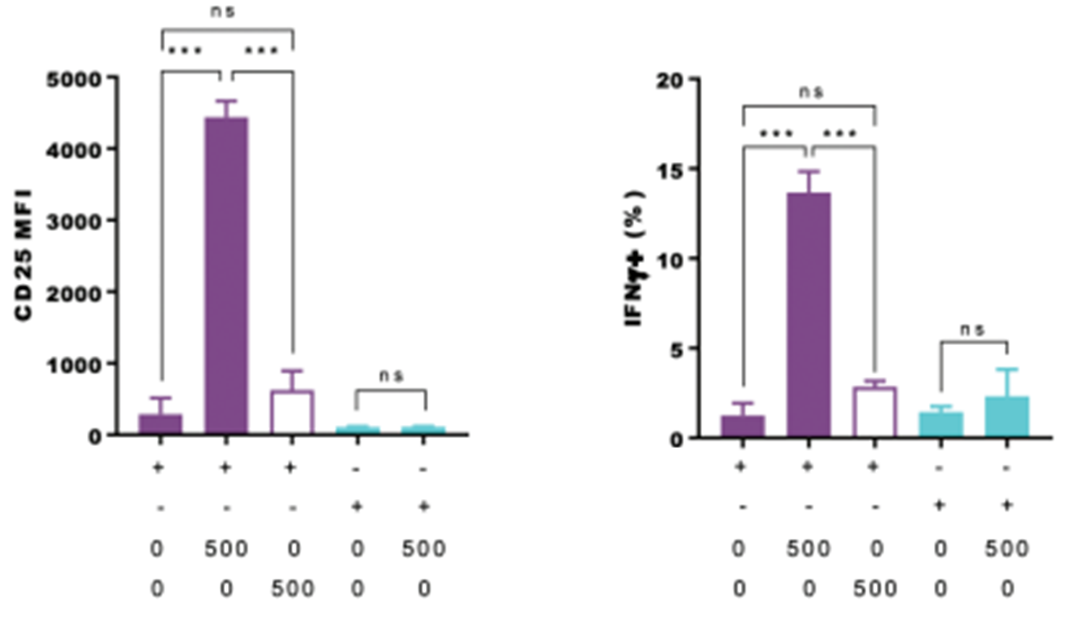
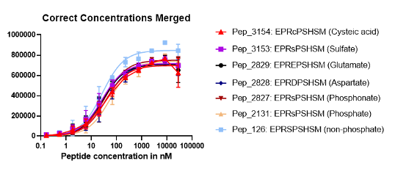
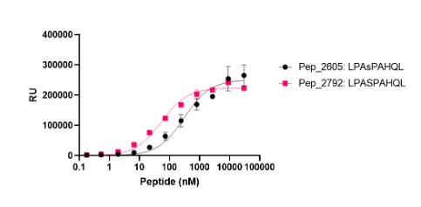
EPRSPSHSM
EPR(pS)PSHSM
EPR(E7P)PSHSM
EPREPSHSM
EPRDPSHSM
EPR(pS)PSHSM
EPRSPSHSM
LPA(pS)PAHQL
***
HLA-B*0702
HLA-A*0201
pMLL₇₄₇₋₇₅₅
pMLL₇₄₇₋₇₅₅
HLA-B*0702
HLA-A*0201
pMLL₇₄₇₋₇₅₅
pMLL₇₄₇₋₇₅₅
TCR27

No TCR
A.
D.
E.
T cell activation, each peptide concentration 1 μM
LPA(pS)PAHQL
LPASPAHQL
EPRCPSHSM
EPR(OSE)PSHSM
EPREPSHSM
EPRDPSHSM
EPR(E7P)PSHSM
EPR(pS)PSHSM
EPRSPSHSM
B.
C.
Testing HLA specificity

Figure S1. The key role of phosphoserine P₄ in TCR27-dependent T cell activation.
A. The activated T cells were gated by the activation markers (CD25 and CD69) using flow cytometry.
The T2 cells expressing HLA-B*0702 were pulsed with various concentrations of pMLL₇₄₇₋₇₅₅ peptide or each of its analogues the AA sequences of which varied at P₄. After treatment the T2 cells were co-cultured with TCR27-transduced T cells or with control non-transduced T cells.
B. Binding plots between HLA-B*0702 and pMLL₇₄₇₋₇₅₅ or its mutants with substituted residue P₄. Alpha assay.
C. Binding plots between HLA-B*0702, pDOT1L₉₉₈₋₁₀₀₆ and DOT1L₉₉₈₋₁₀₀₆ peptides, respectively. Alpha assay.
D. Concentration-dependent and peptide-specific T cell cytotoxicity was determined as described in Methods.
E. HLA-peptide matching. The T2 cells expressing either HLA-B*0702 or HLA-A*0201 were pulsed with 0.5 μM of each pMLL₇₄₇₋₇₅₅ or MLL₇₄₇₋₇₅₅ peptide, respectively. Pulsed T2 cells were co-cultured with TCR27-transduced or control (untreated) T cells. The activation markers (CD25 and IFN_{γ}) were detected by flow cytometry.

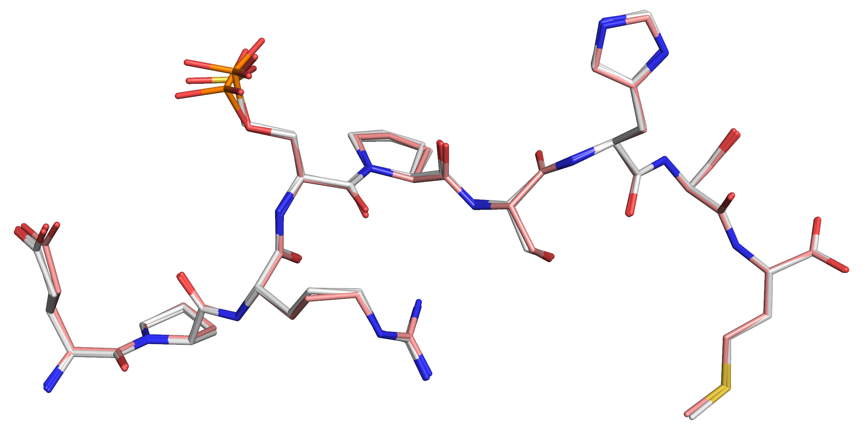
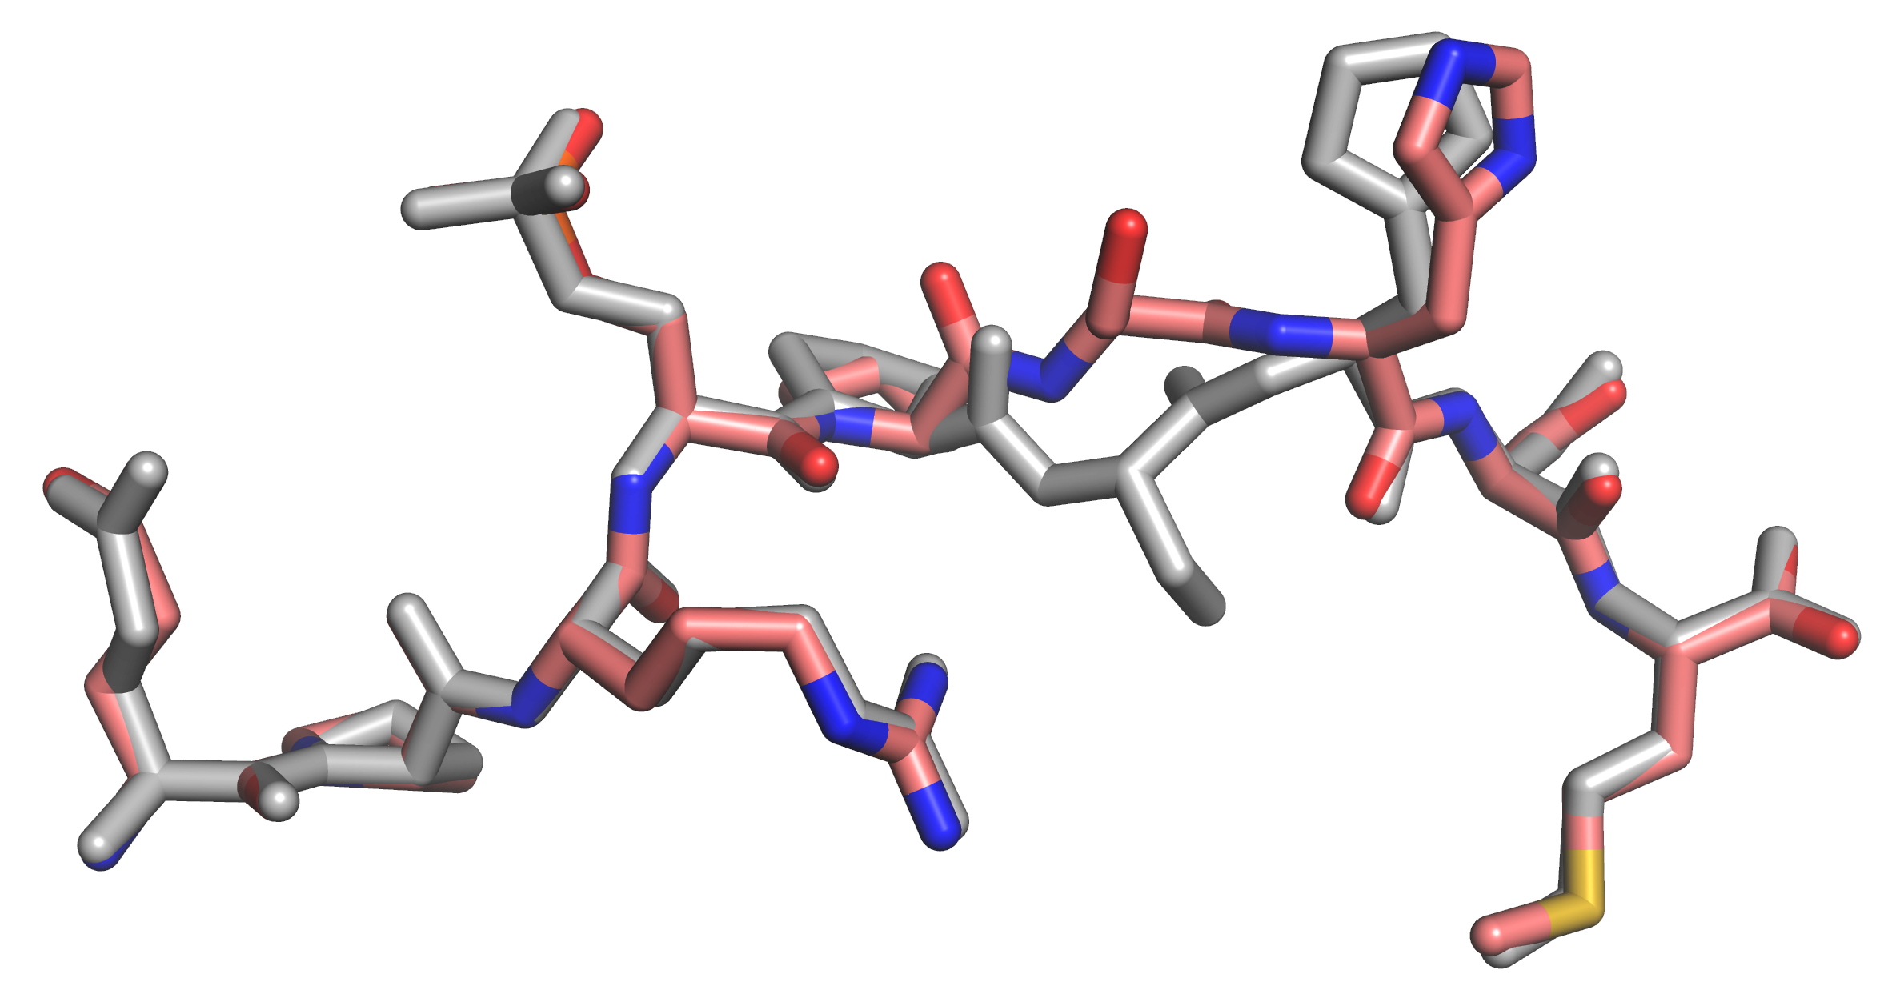
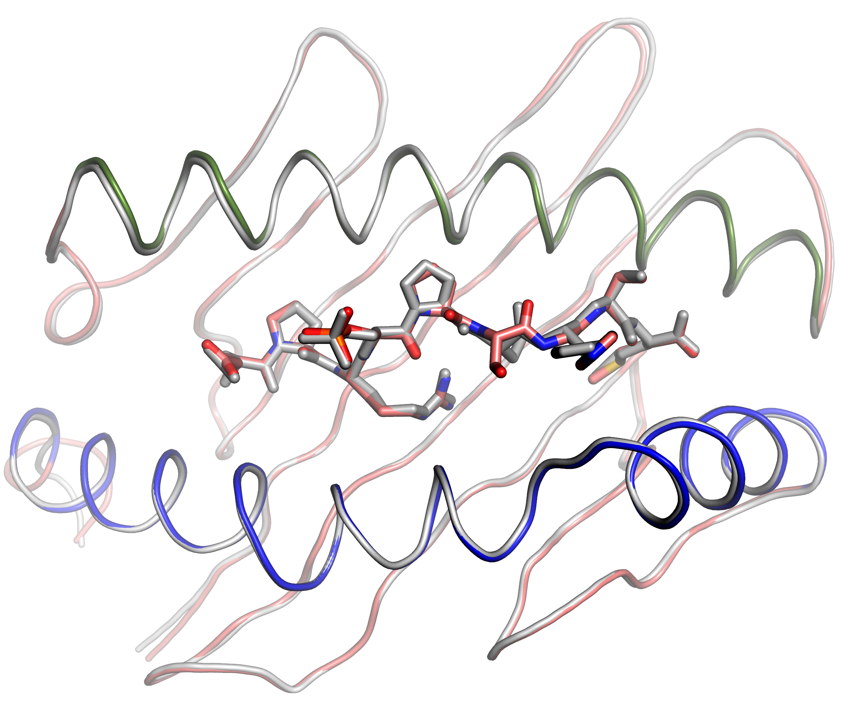
Figure S2. RMSD plots indicate differences and similarities between the peptide-binding HLA-B*0702 domains (AA residues 1-180, Cα atoms only) in the different pMHC structures. All the structures were aligned using the atomic coordinates of the α₁ helices (AA residues 57-85, Cα carbons only). The horizontal dotted line in each figure indicates a core average RMSD value. The loops were arbitrary assigned. Peptides are shown as stick models. The helical regions are indicated.
α₁
pMLL₇₄₇₋₇₅₅ vs MLL₇₄₇₋₇₅₅
pMLL₇₄₇₋₇₅₅ vs OSE-MLL₇₄₇₋₇₅₅
pMLL₇₄₇₋₇₅₅ vs E7P-MLL₇₄₇₋₇₅₅
α₂
E7P
OSE
pS
E1
P2
R3
P5
S6
H7
S8
M9
Loop D
Loop E
Core RMSD, Å
B.
Loop A
Loop B
Loop C
Loop D
α₁
α₂
Loop E
Loop E
Loop D
Loop A
Loop B
E1
P2
R3
SEP4
P5
S6
H7
S8
M9
α₁
α₂
pMLL₇₄₇₋₇₅₅ #1 vs pMLL₇₄₇₋₇₅₅ #2
A.
A. The RMSD plot between the two non-isomorphous pMLL₇₄₇₋₇₅₅/HLA-B*0702 structures demonstrated differences, mainly around protein loops. Inserts - the superimposed peptides, the structure #1 is colored in gray. Cartoon representation shows an overall domain view including bound peptide.
B. The RMSD plots between the HLA-B*0702 structure in complex with pMLL₇₄₇₋₇₅₅ versus MLL₇₄₇₋₇₅₅, E7P-MLL₇₄₇₋₇₅₅, or OSE-MLL₇₄₇₋₇₅₅ peptides, respectively. The average core RMSD between these structures was 0.1 Å. Note that the largest variations were observed between the residues in loops D and E, respectively. Insert - superimposed peptides as stick models.

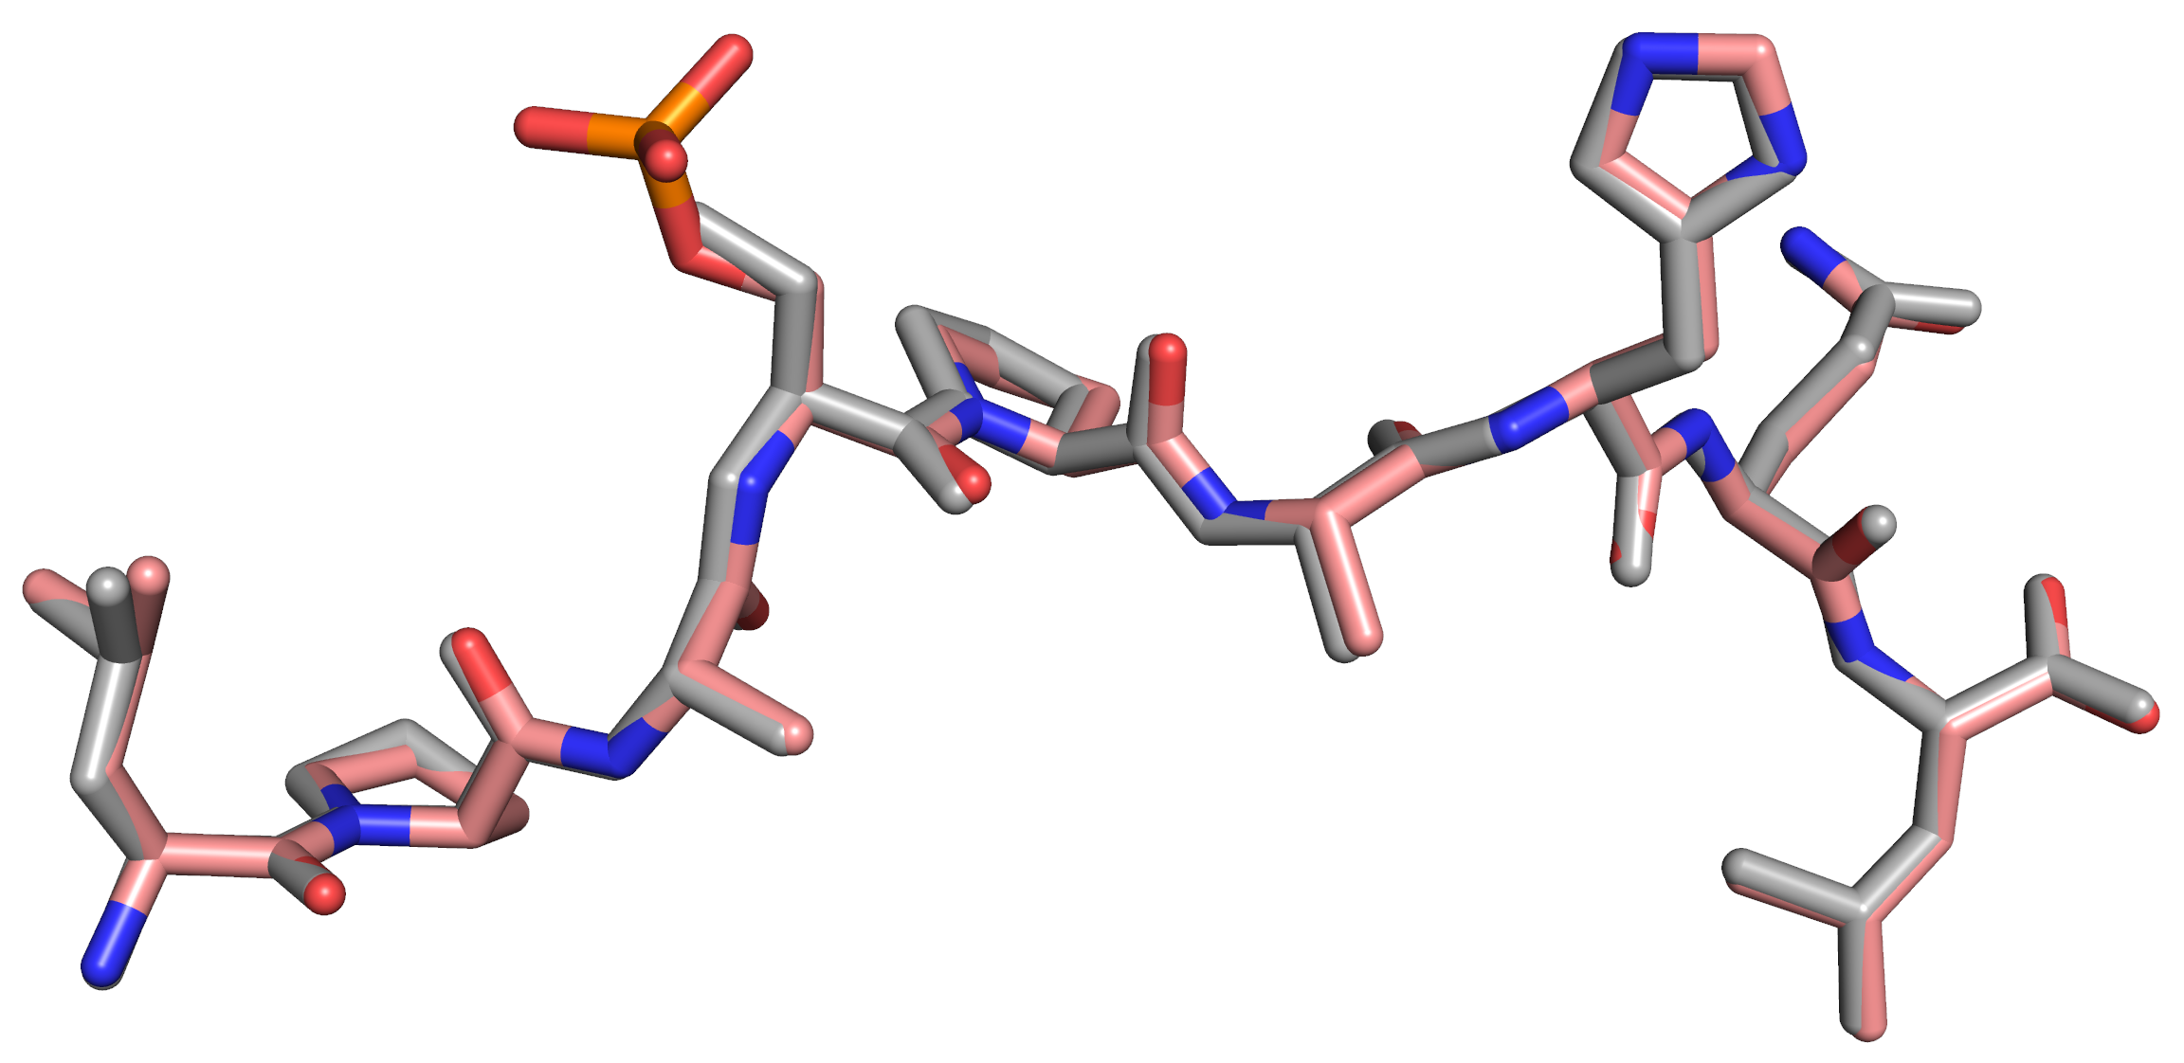
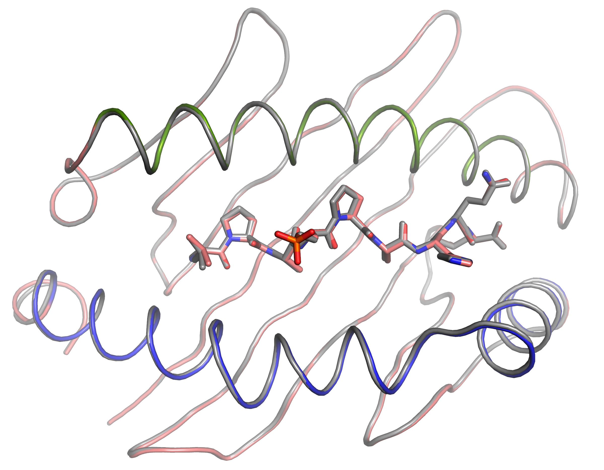
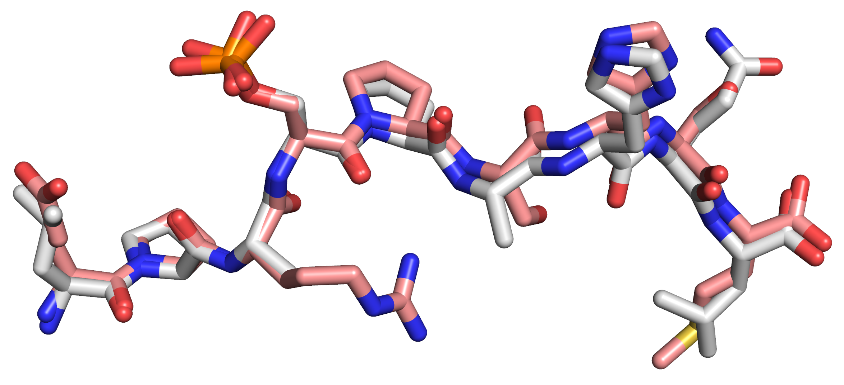
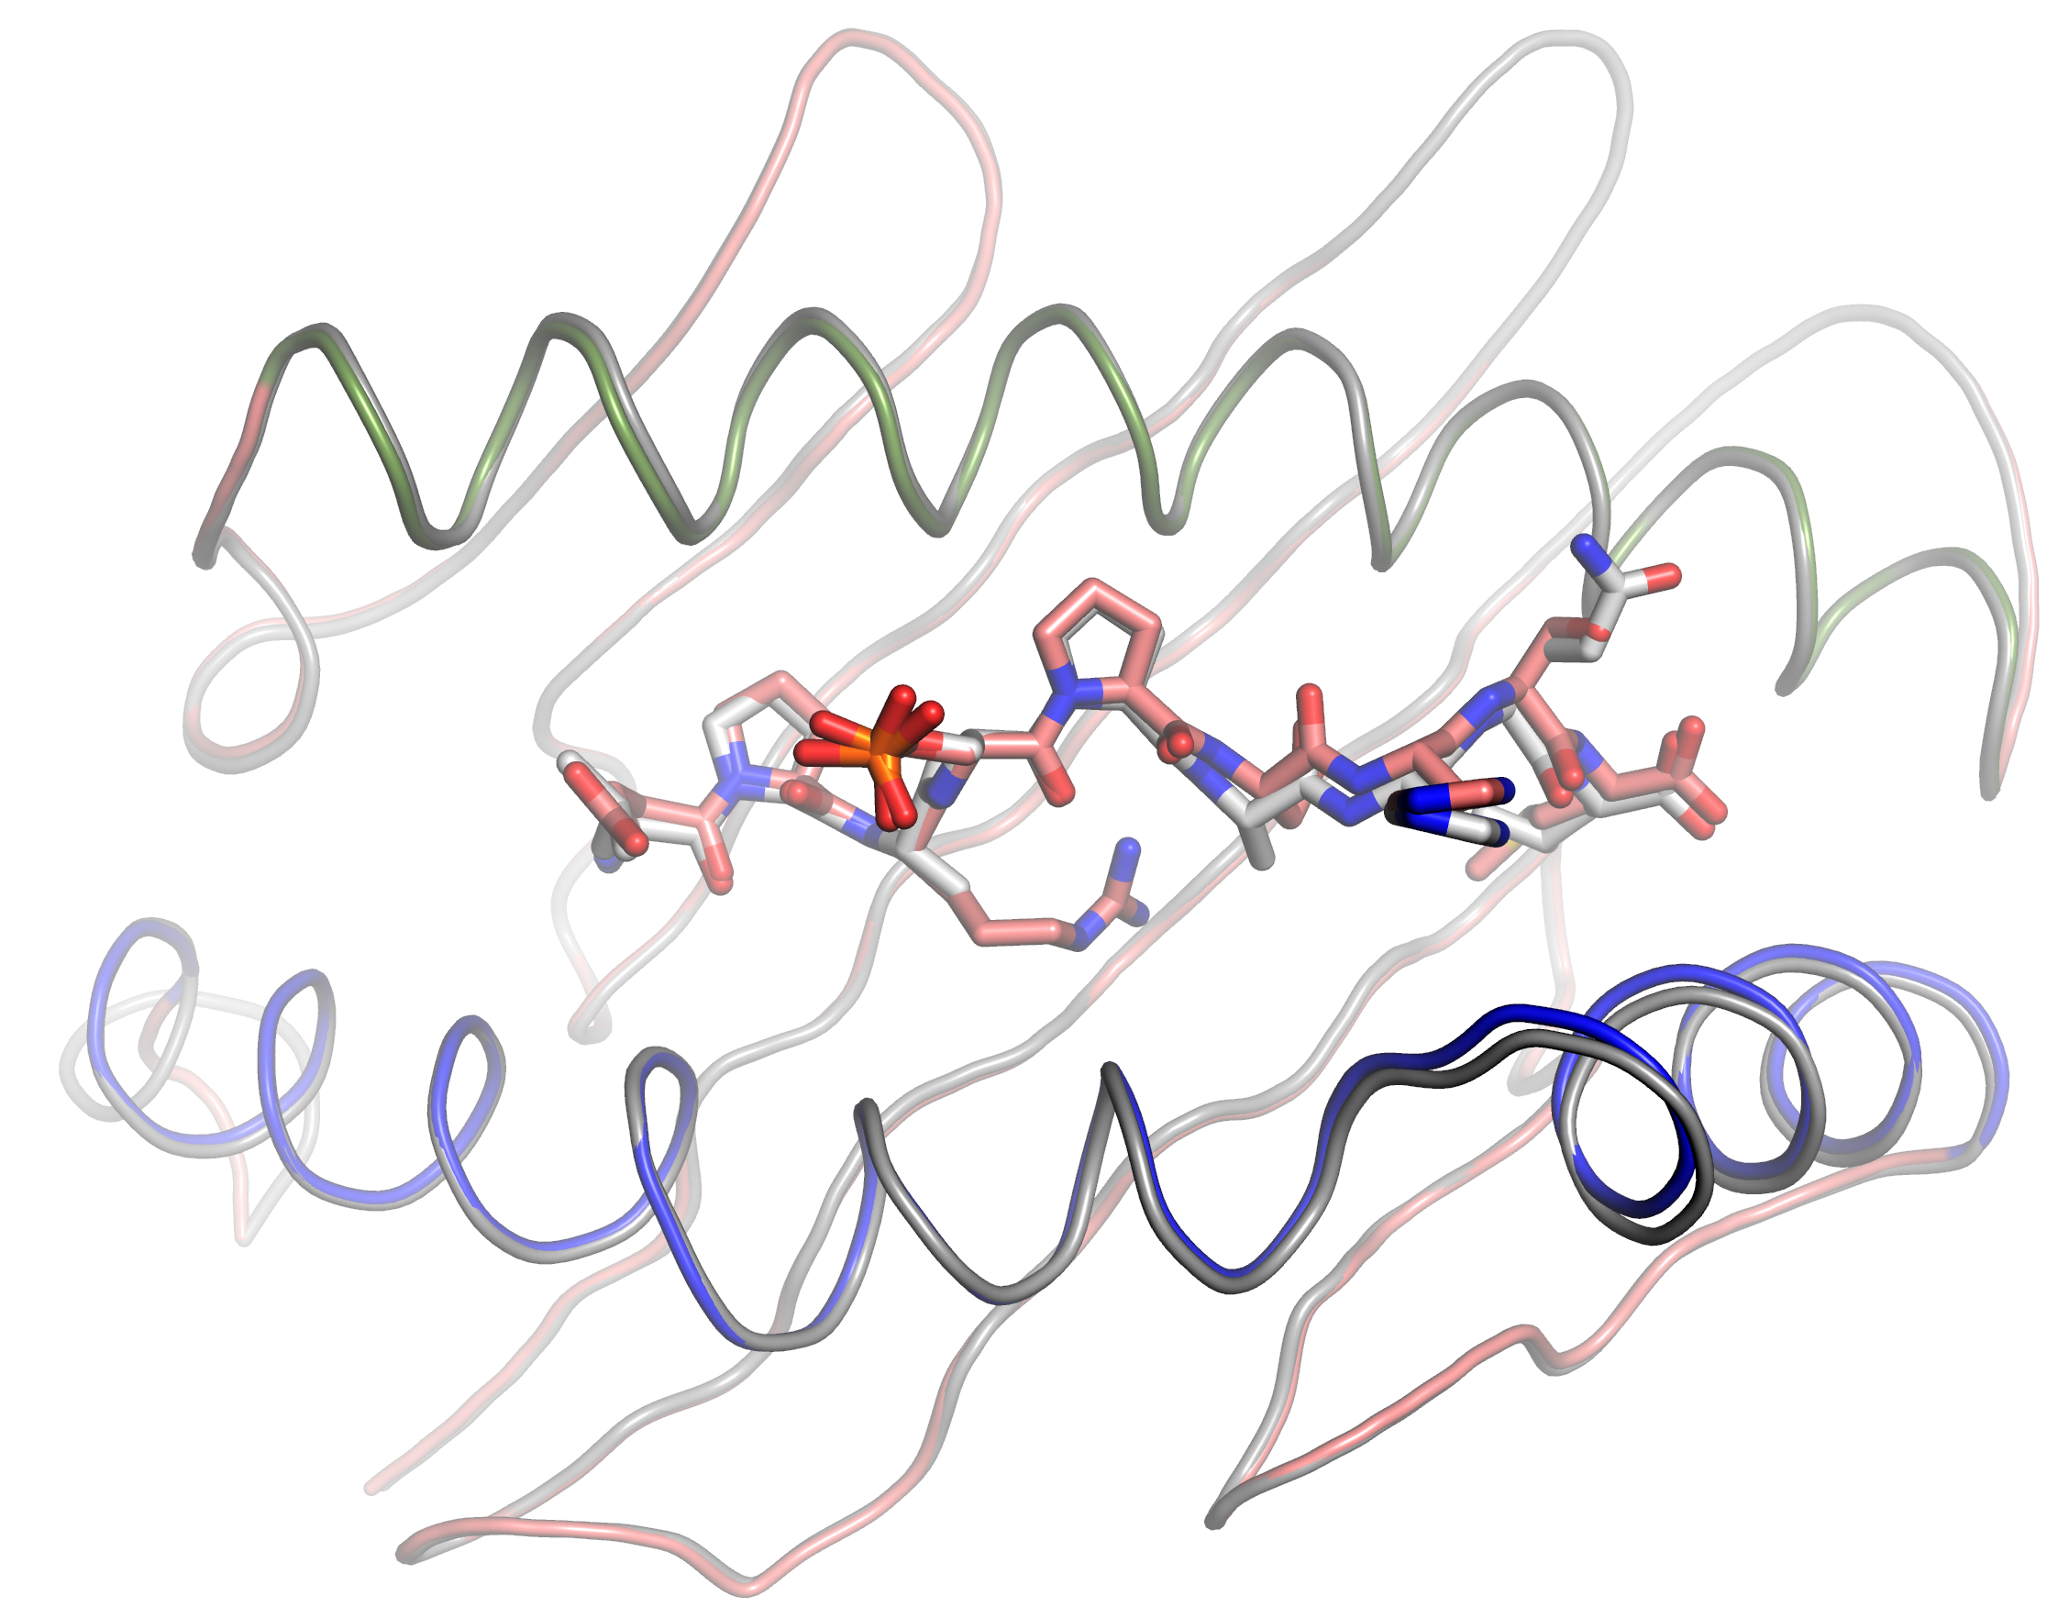
Loop A
Loop B
Loop C
Loop D
α₁
α₁
α₂
α₂
Loop E
L1
P2
A3
pS4
P5
A6
H7
Q8
L9
S4
Loop D
pDOT1L₉₉₈₋₁₀₀₆ vs DOT1L₉₉₈₋₁₀₀₆
Core RMSD, Å
Loop A
Loop B
Loop C
Loop D
α₁
α₂
Loop E
Loop E
Loop D
Loop A
Loop B
E1
P2
R3
pS4
P5
S6
H7
M9
A6
A3
L9
Q8
S8
α₁
α₂
Loop C
pMLL₇₄₇₋₇₅₅ vs pDOT1L₉₉₈₋₁₀₀₆
pMLL₇₄₇₋₇₅₅ vs DOT1L₉₉₈₋₁₀₀₆
A.
B.
Core RMSD, Å
Figure S3. RMSD plots. Designations are the same as in Fig.S2.
A. The RMSD plot between the HLA-B*0702 structures in complex with pDOT1L₉₉₈₋₁₀₀₆ or DOT1L₉₉₈₋₁₀₀₆ peptides, respectively. Inserts - Domain superimposition is shown as cartoon, and the peptides are presented as sticks.
B. The RMSD plots between all the HLA-B*0702 isomorphous structures in complex with pMLL₇₄₇₋₇₅₅, DOT1L₉₉₈₋₁₀₀₆, or DOT1L₉₉₈₋₁₀₀₆ peptides, respectively. Inserts - The cartoon view of superimposed pMHC structures, with pMLL₇₄₇₋₇₅₅ or pDOT1L₉₉₈₋₁₀₀₆ peptide, respectively. Note a difference in relative positions of the α₂ helices.

Figure S4. Glycerol affects peptide conformation in the crystal structure of the pMHC. The peptide residues are shown as sticks, the 2FoFc electron density maps (σ>1.0, cutoff radius = 1.5 Å) are drawn as mesh around designated atoms only. The hydrogen bonds are shown as grey dotted lines, all other distances are depicted as yellow dashes. Waters are presented as non-bonded spheres.
A. The HLA-B*0702 structure in complex with MLL₇₄₇₋₇₅₅ peptide and bound glycerol, carbons of which are yellow.
B. The HLA-B*0702 structure in complex with MLL₇₄₇₋₇₅₅ peptide without glycerol but with bound water.
C. The HLA-B*0702 structure in complex with pMLL₇₄₇₋₇₅₅ peptide and bound glycerol, its carbons are gray.
D. Superimposition of the HLA-B*0702 structures in complex with pMLL₇₄₇₋₇₅₅ or MLL₇₄₇₋₇₅₅ peptides and with bound glycerol shows high similarity between the conformations of the two peptides.

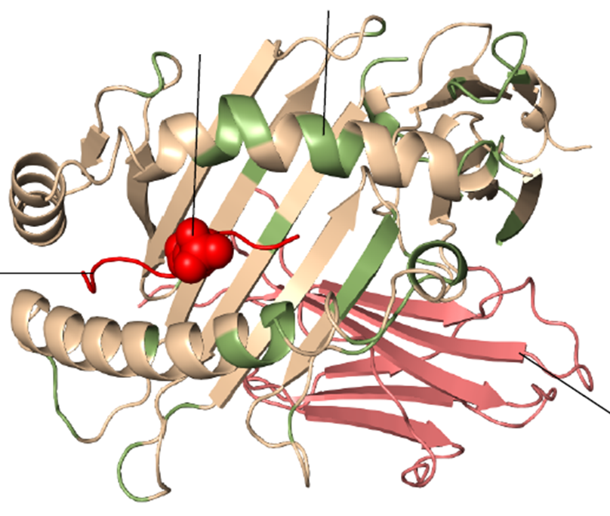
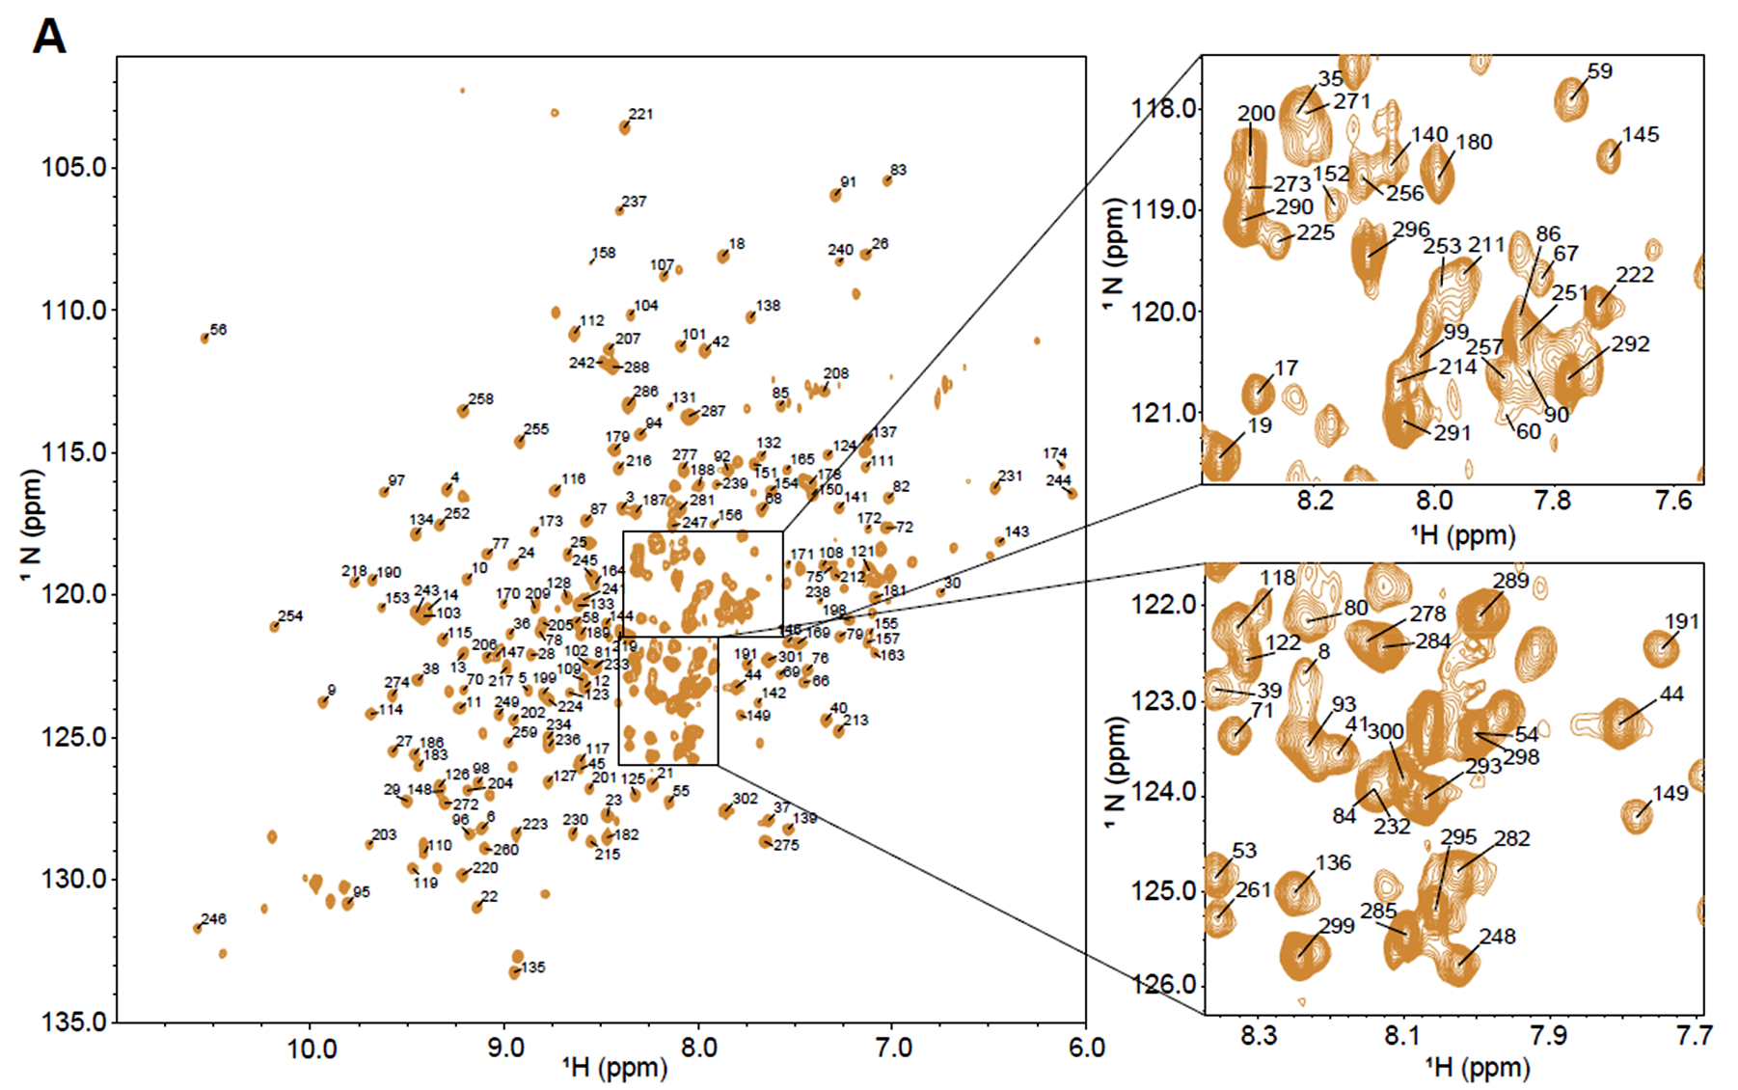
β2M
Unassigned regions
pSer-P4
Peptide
C-terminus
B.
A.
NMR assignment of
HLA-B*0702 residues
Figure S5. NMR assignments of amino acid residues in HLA-B*0702 complexed with pMLL₇₄₇₋₇₅₅.
A. ¹⁵N-TROSY spectra of pMLL₇₄₇₋₇₅₅/HLA-B*0702 with assignments depicted on the spectrum with residue numbers. Boxes – zoomed-in-view of the central crowded regions of the ¹⁵N-TROSY spectra of the pMLL₇₄₇₋₇₅₅/HLA-B*0702 complex with assignments depicted.
B. Cartoon representation of the pMLL₇₄₇₋₇₅₅/HLA-B*0702 crystal structure with NMR-assigned regions indicated in cream color. The peptide red-colored with pSer-P₄ represented as spheres. Human β2M is colored in pink. The unassigned regions are colored in green. A total of 86% of all assignable (excluding proline residues) backbone N and HN HLA-B*0702 atoms were assigned and 84% of all the residues of the alpha helical regions that surround the bound peptide were assigned.

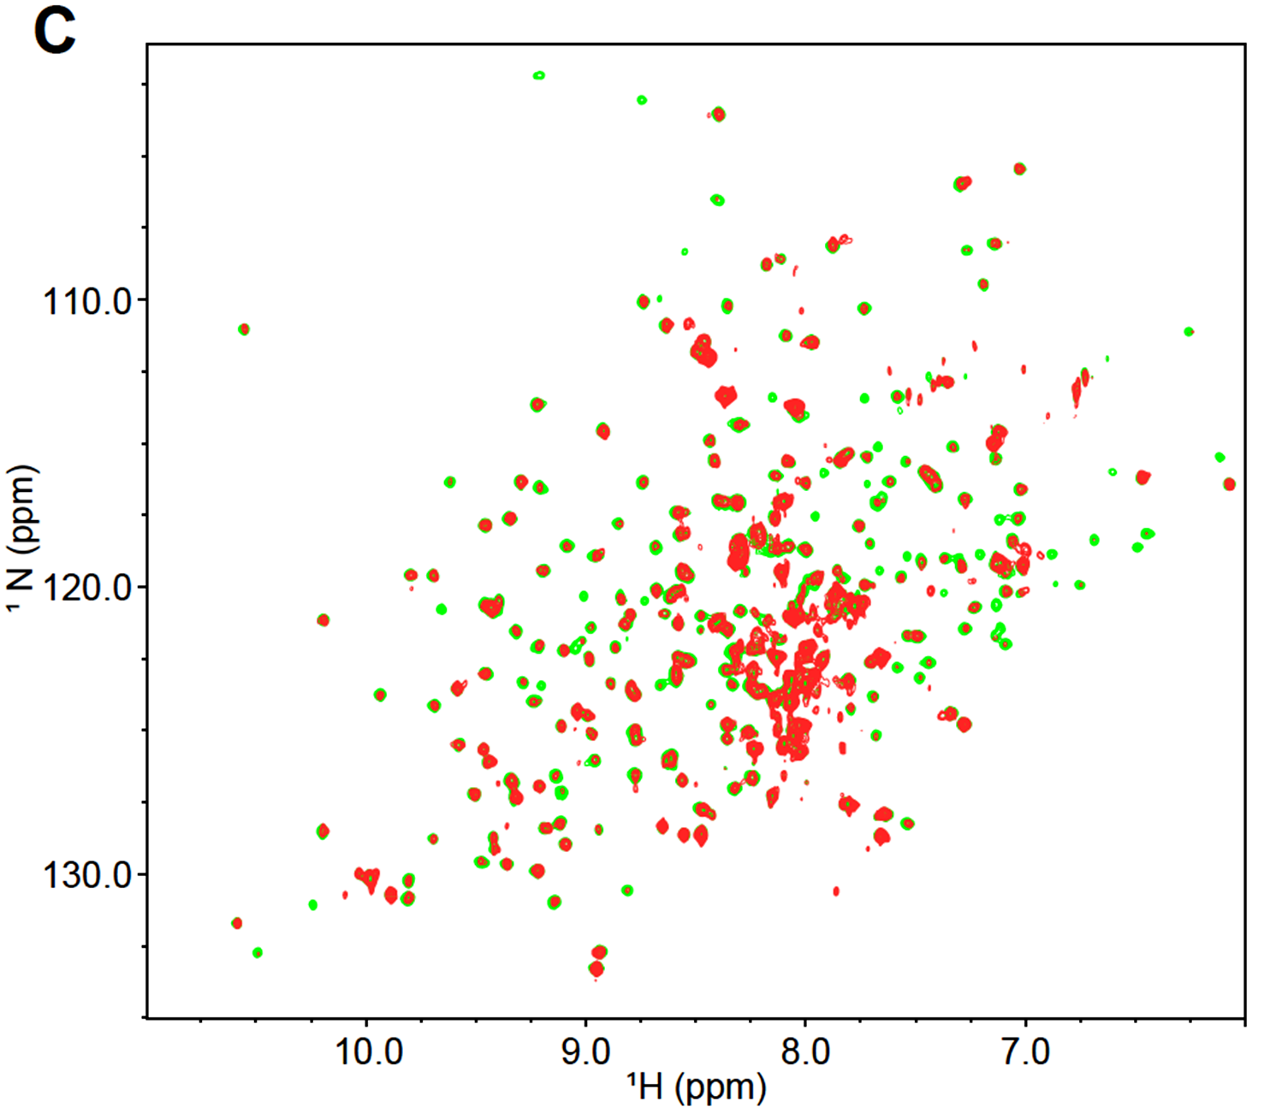
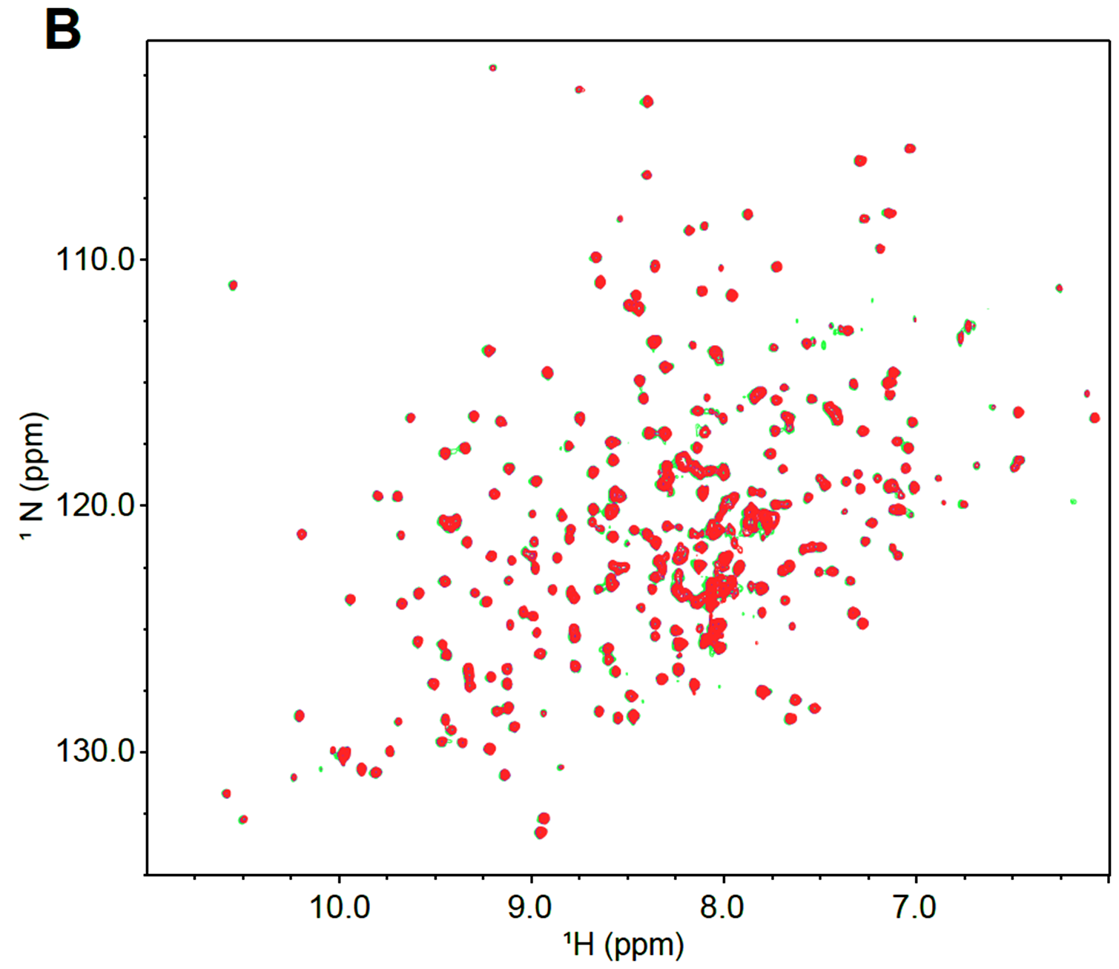
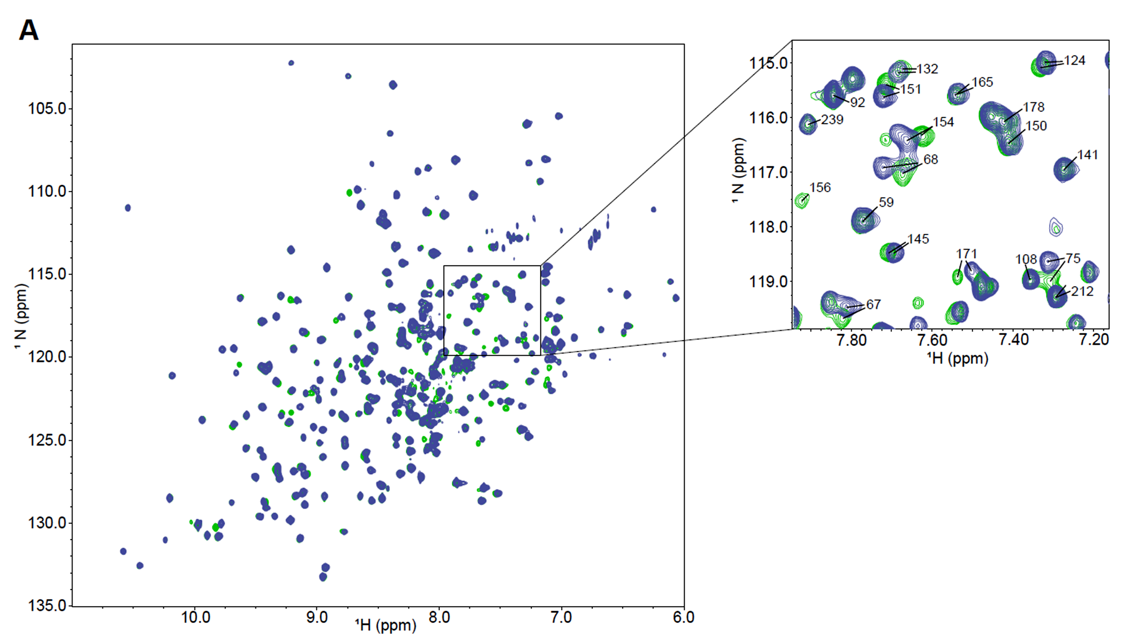
A.
B.
C.
TCR27 + HLA-B*0702/MLL₇₄₇₋₇₅₅
TCR27 + HLA-B*0702/pMLL₇₄₇₋₇₅₅
TCR27 + HLA-B*0702/pMLL₇₄₇₋₇₅₅

Figure S6. NMR spectra of pMLL₇₄₇₋₇₅₅/HLA-B*0702 vs MLL₇₄₇₋₇₅₅/HLA-B*0702 and pMLL₇₄₇₋₇₅₅/HLA-B*0702 in complex with TCR27 demonstrate that the TCR-pMHC binding is dependent on phosphoserine P₄
A. Overlay of the ¹⁵N-TROSY spectra for pMLL₇₄₇₋₇₅₅/HLA-B*0702 (green) and MLL₇₄₇₋₇₅₅ /HLA-B*0702 (blue) complexes. Box – zoomed-in-view of the overlay highlighting chemical shift perturbations of the individual residues located at or close to the peptide-HLA interface.
B. Overlay of the ¹⁵N-TROSY spectra for MLL₇₄₇₋₇₅₅/HLA-B*0702 (green) and for TCR27: MLL₇₄₇₋₇₅₅/HLA-B*0702 mixture (1:1 molar ratio, red). No significant differences were observed.
C. Overlay of the ¹⁵N-TROSY spectra for pMLL₇₄₇₋₇₅₅/HLA-B*0702 (green) and for TCR27: pMLL₇₄₇₋₇₅₅/HLA-B*0702 mixture (1:1 molar ratio, red). Significant drops in peak intensities indicate protein complexation.

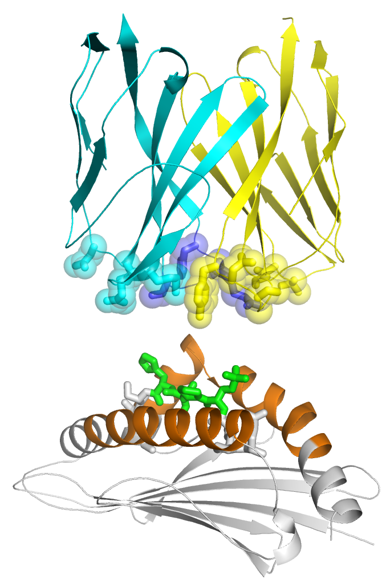
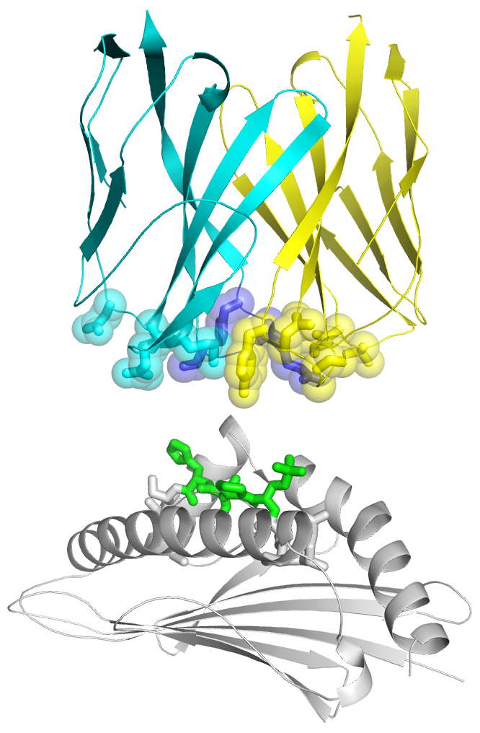
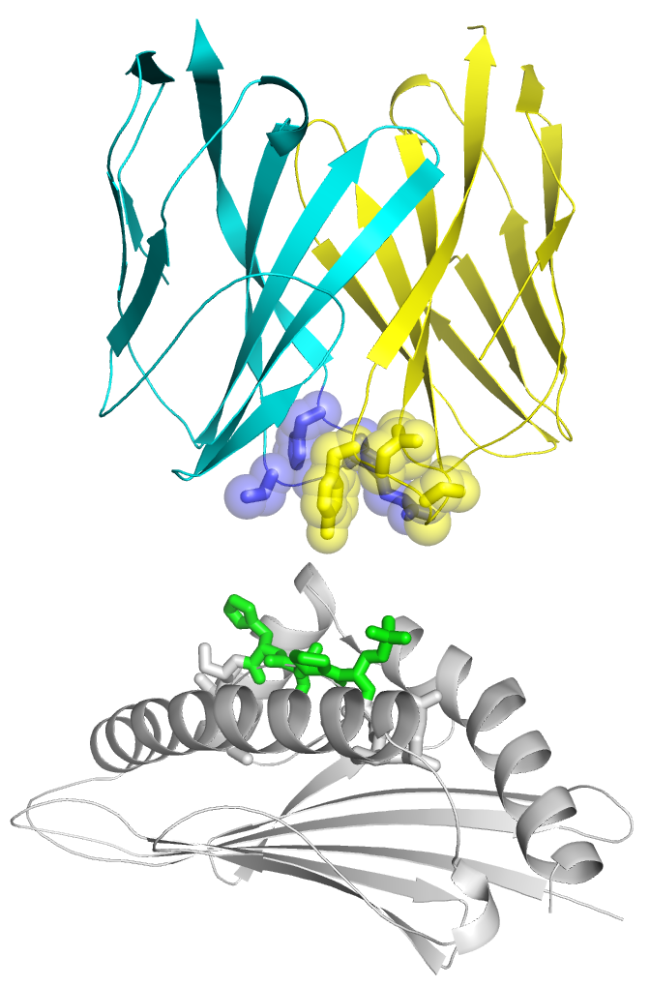
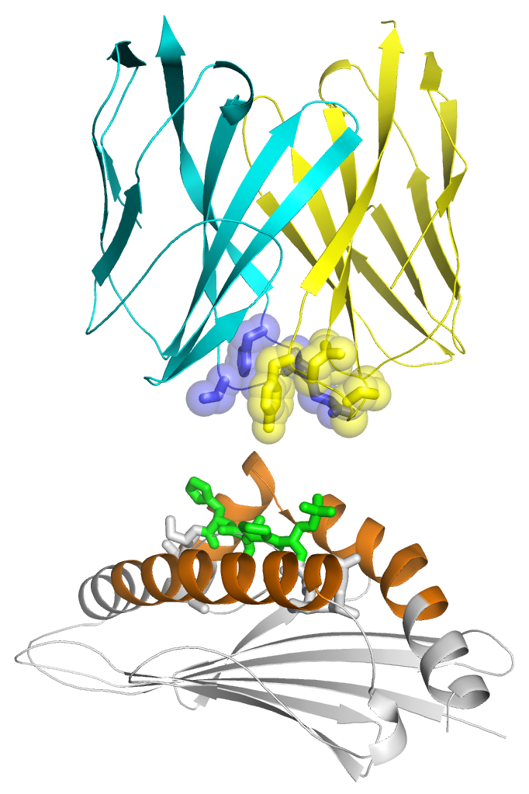
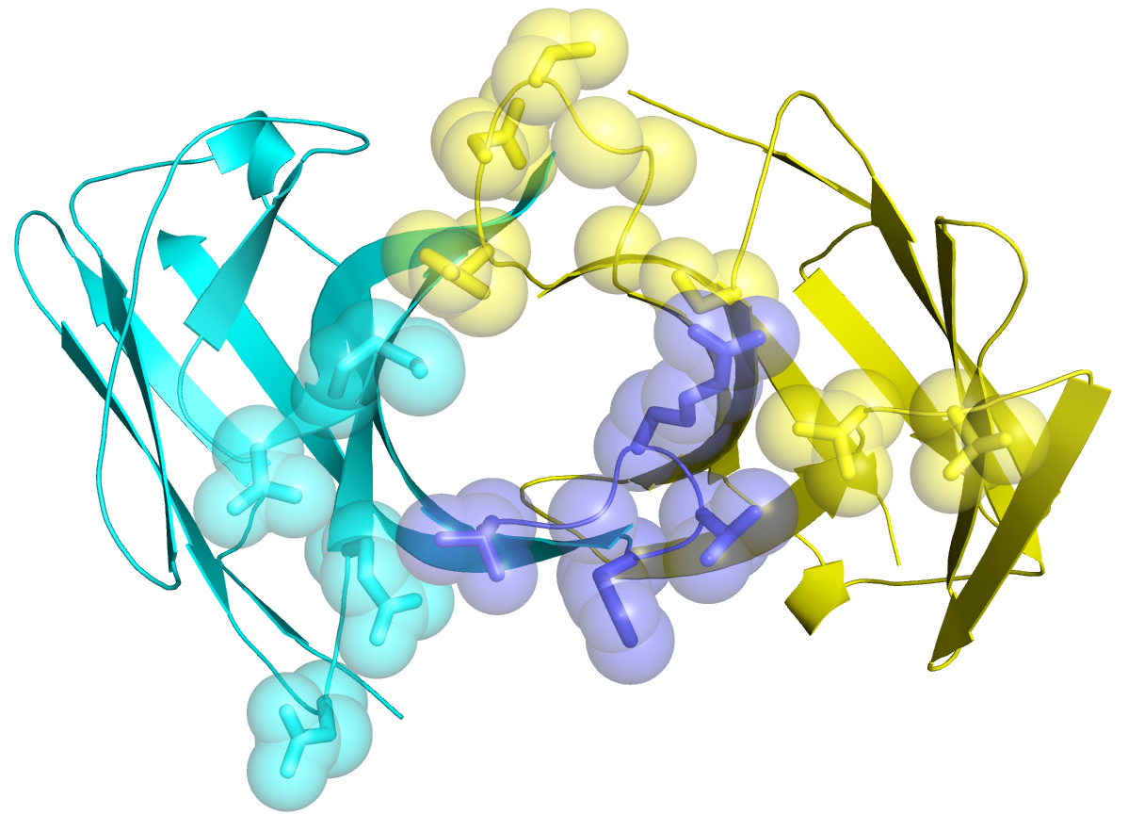
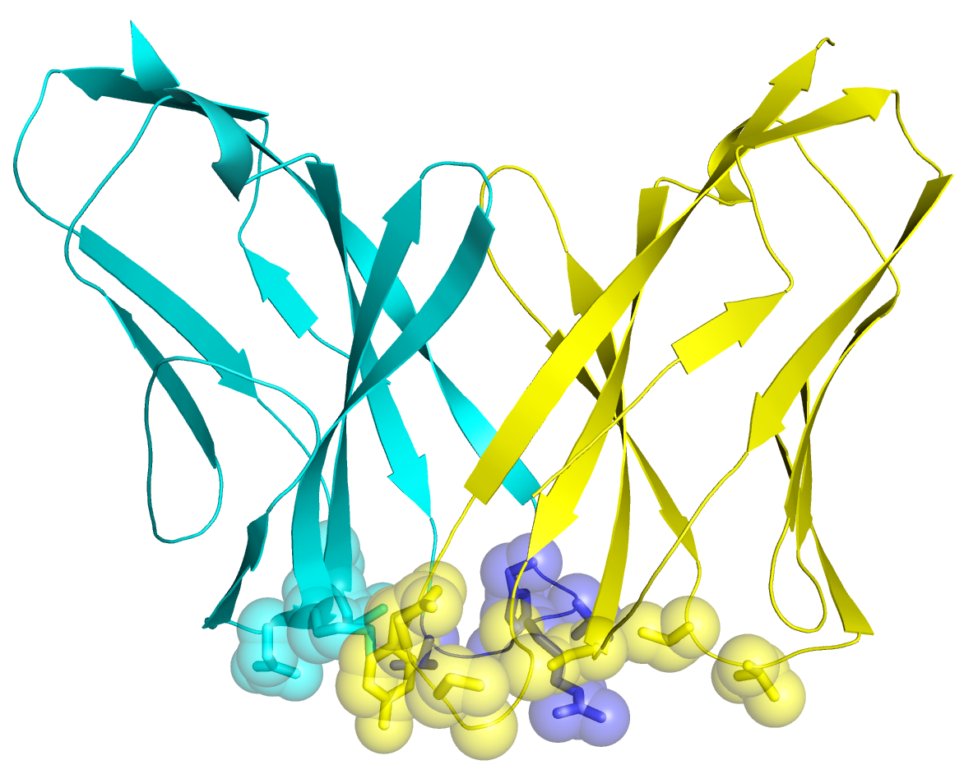
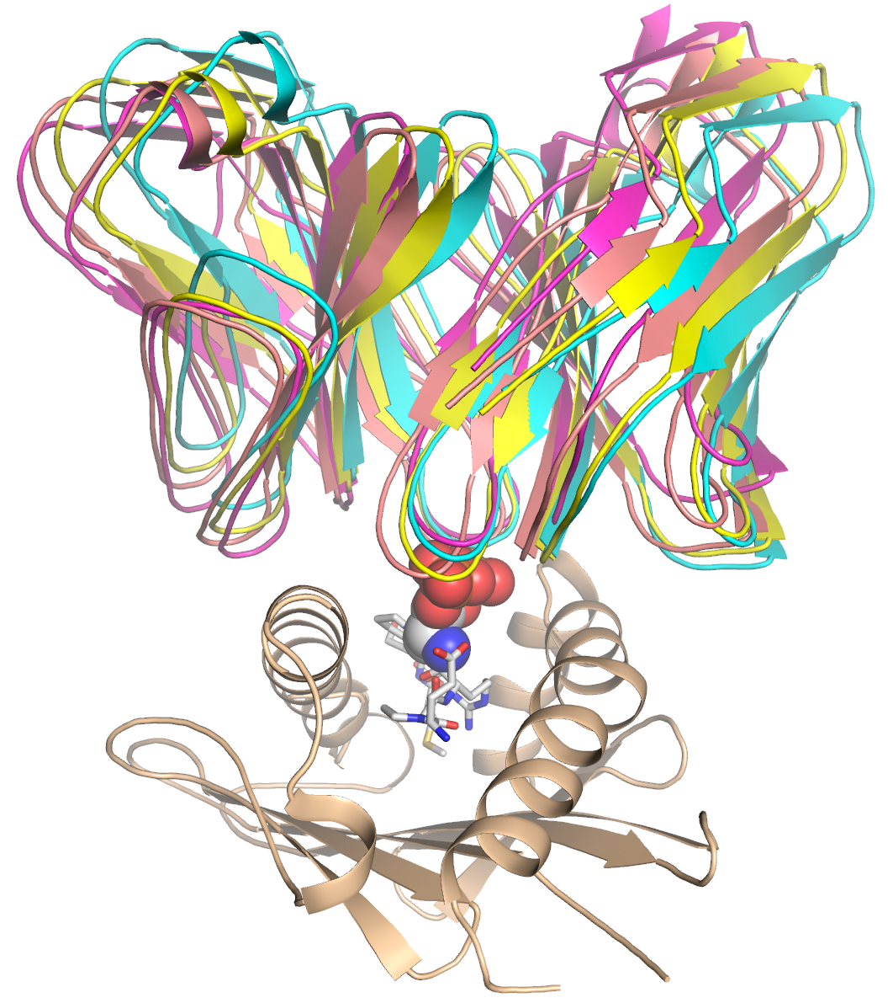
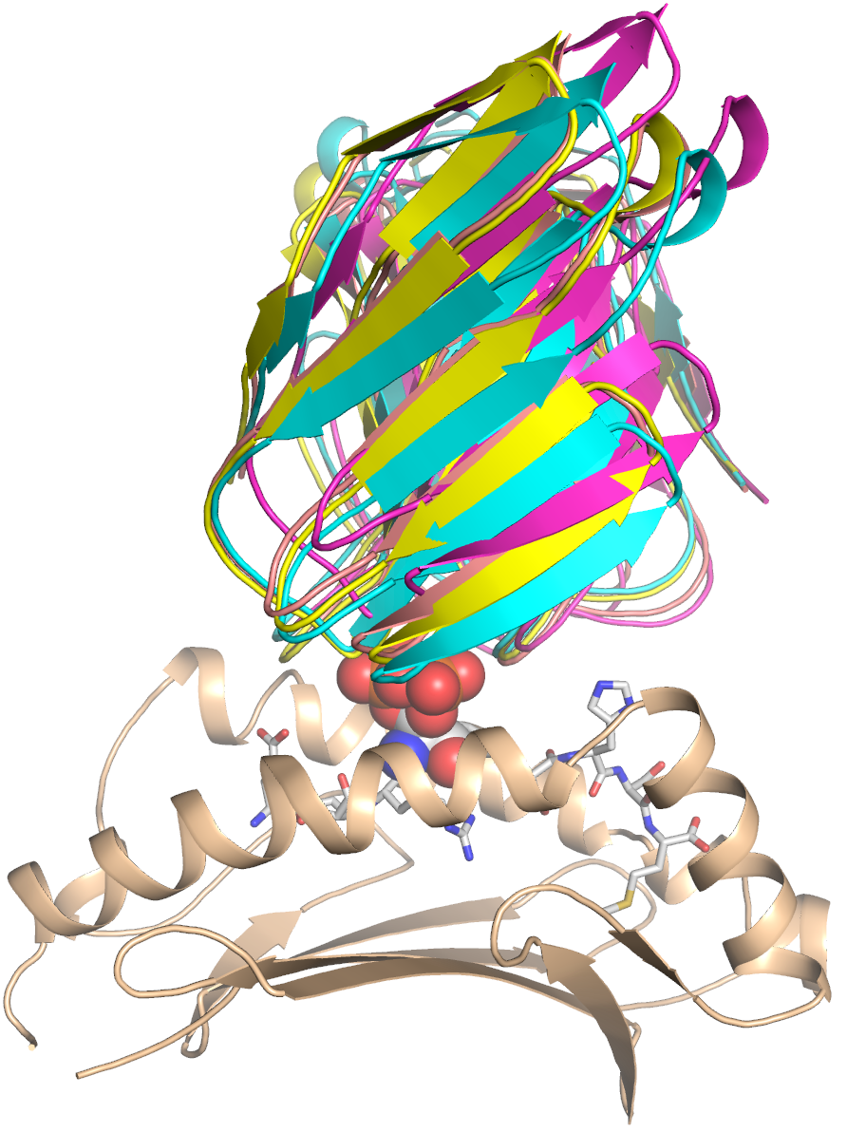
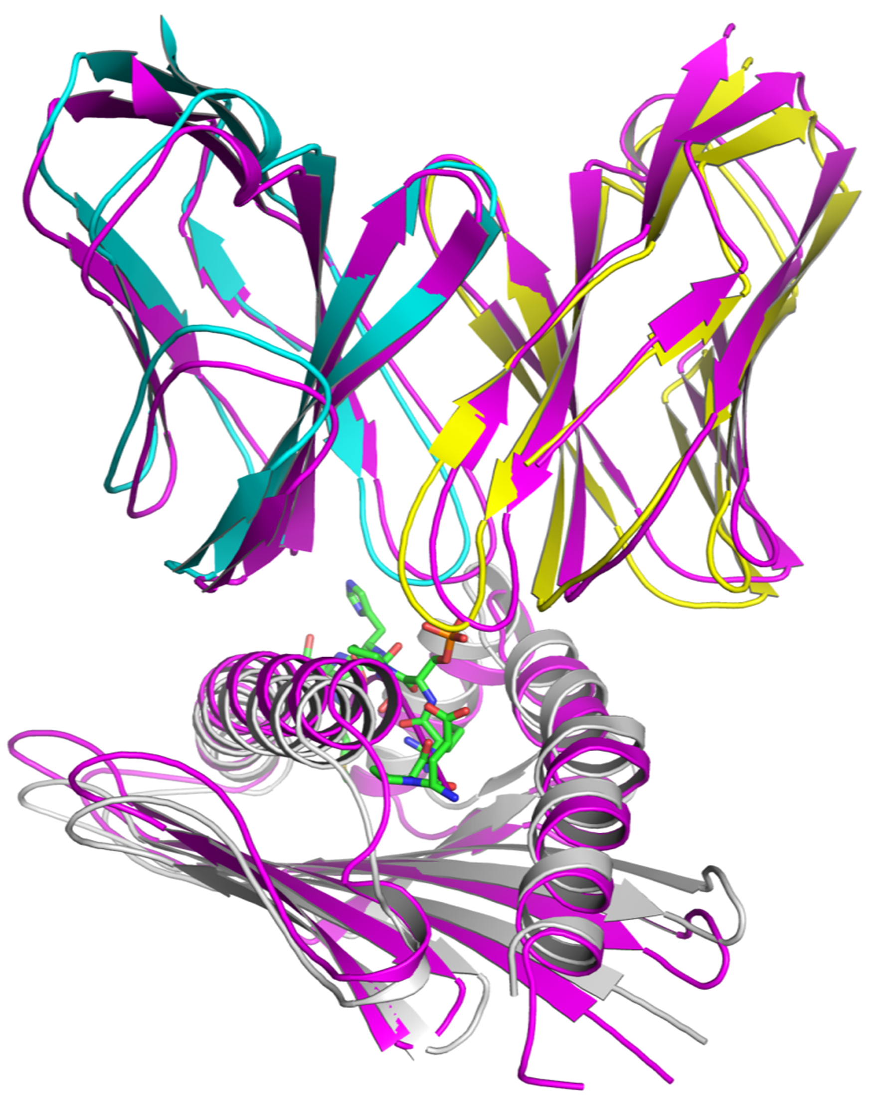
#1
#2
#3
#4
Vα
Vα
Vα
Vα
Vα
Vα
90°
H98β
R96β
T94β
V97β
S95α
Y97α
N96α
S29α
T50α
M48α
N49α
E26α
N28α
V49α
CDR3α
G93α
CDR3β
CDR2α
CDR1β
CDR3β
Vβ
Vβ
Vβ
Vβ
Vβ
Vβ
α₁
α₁
α₁
α₁
α₂
α₂
α₂
α₂
CDR3α
Docking scenarios
CDR3α
α₁
α₂
α₁
α₂
pSer-P4
Vα
Vα
Vβ
90°
α₂
α₁
Vα
Vβ
CDR2β
CDR1α
CDR2α
CDR2β
A.
B.
C.
D.
pMLL₇₄₇₋₇₅₅ vs pDOT1L₉₉₈₋₁₀₀₆
The highest scoring models
from all 4 docking scenarios
TCR
HLA-B*0702
TCR
TCR
TCR
CDR loops
Figure S7. Haddock docking strategy and the TCR-pMHC docking results. The TCR-pMHC truncated model (cartoon representation) included the variable region of TCR27, the peptide binding domain of HLA-B*0702 (AA residues 1-180) and peptide (stick model) only.
A. Residue selection in the different docking scenarios. The selected regions in HLA are colored, not selected are gray. The residues selected in TCR are shown as sticks and semi-transparent spheres.
B. Residue selection is shown in the TCR_1 structure (two orientations are related by about 90° rotation). The residues selected for docking and located on the CDR loops are shown as sticks and spheres.
C. Superposition of the top solutions from docking scenarios ##1-4 (with pMLL₇₄₇₋₇₅₅ peptide). The coordinates of pMHC atoms were aligned to demonstrate a relative position of TCR27 with respect to pMHC in the ternary complex. The maximum RMSD value between these models was 3.1Å and a minimum value was 0.9Å.
D. Comparison between the TCR-pMHC models with pMLL₇₄₇₋₇₅₅ or pDOT1L₉₉₈₋₁₀₀₆ epitopes, respectively.
Alignment between the top solutions from scenarios #4 was performed as in (B), the RMSD value between all the aligned atoms was 1.9Å.
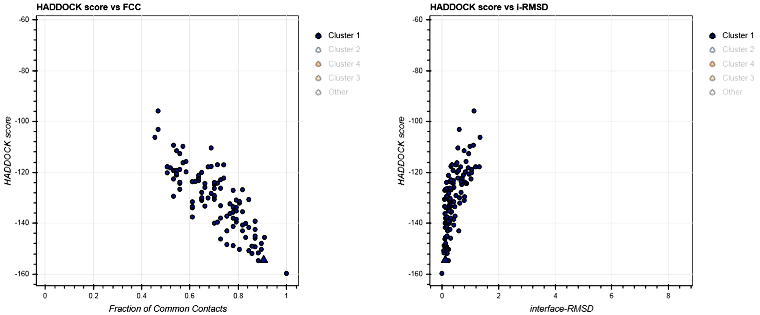
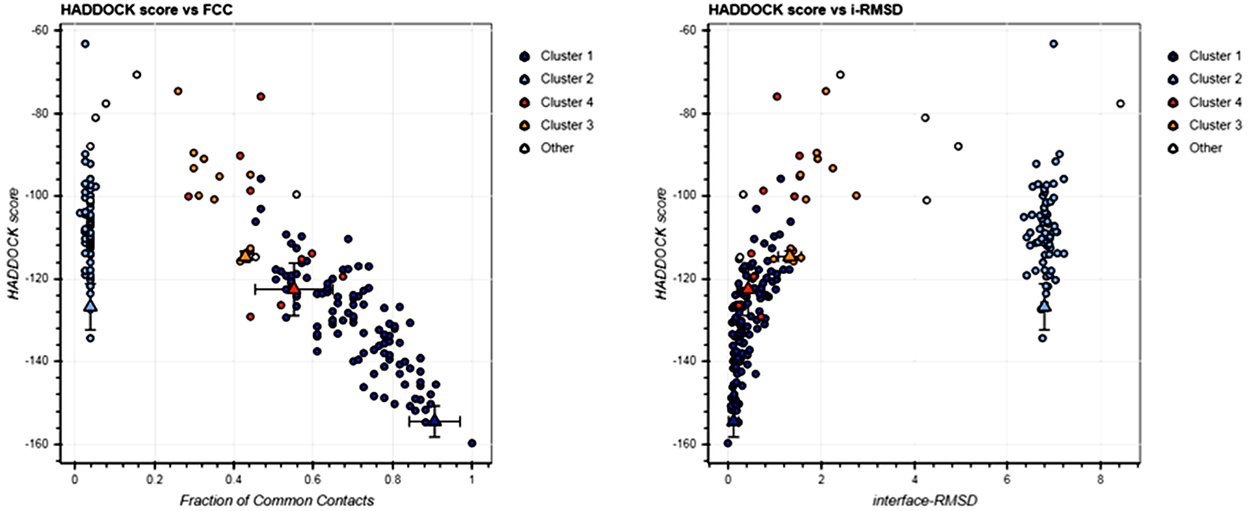
Docking statistics from the Haddock scenario #4
Fraction of Common Contacts
Interface Root-Mean-Square Deviation
Interface Root-Mean-Square Deviation
Fraction of Common Contacts
Outputs from Haddock scenario #4
Cluster 1
Cluster 1
All clusters
All clusters
A.
B.
Property | Cluster 1 | Cluster 2
HADDOCK score | -143.8 +/- 2.3 | -105.7 +/- 4.3
Cluster size | 154 | 15
RMSD from the overall lowest-energy structure | 0.6 +/- 0.4 | 17.1 +/- 0.4
Van der Waals energy | -58.8 +/- 4.1 | -52.7 +/- 7.0
Electrostatic energy | -407.4 +/- 10.1 | -259.4 +/- 26.8
Desolvation energy | -4.7 +/- 1.5 | -5.4 +/- 1.6
Restraints violation energy | 11.6 +/- 3.2 | 42.9 +/- 22.3
Buried Surface Area | 1868.0 +/- 66.0 | 1776.2 +/- 28.9
Z-Score | -1.4 | 0.6

Figure S8. An example of Haddock output files.
E. Haddock output from docking scenario #4 (with pMLL₇₄₇₋₇₅₅). Comparison between the top 4 clusters is presented in top figure, and the data from cluster 1 – in the bottom figure.
F. The output data from Haddock run, scenario #4. Comparison between the top clusters 1 and 2.
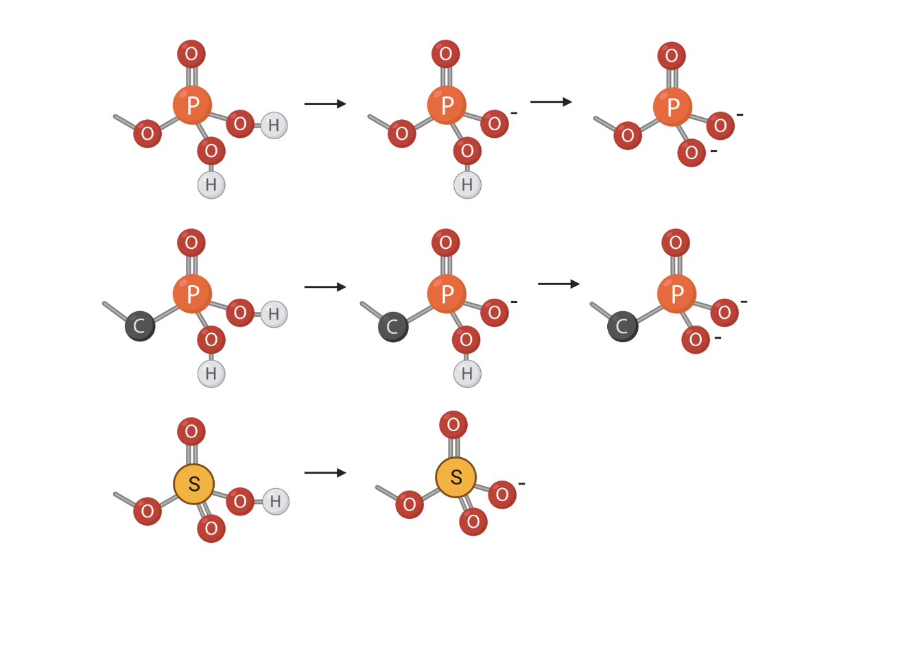
1.61 Å
1.50 Å
1.80 Å
1.60 Å
1.45 Å
pK_{a}=1.54
pK_{a}=6.31
pK_{a}=2.39
pK_{a}=7.39
pK_{a}=-3.4
1.52 Å
112°
119°
117°

Figure S9. The electronic structures, charge and pK_{a} values for alkyl-derivatives of phosphate, phosphonate and sulfate, respectively.

