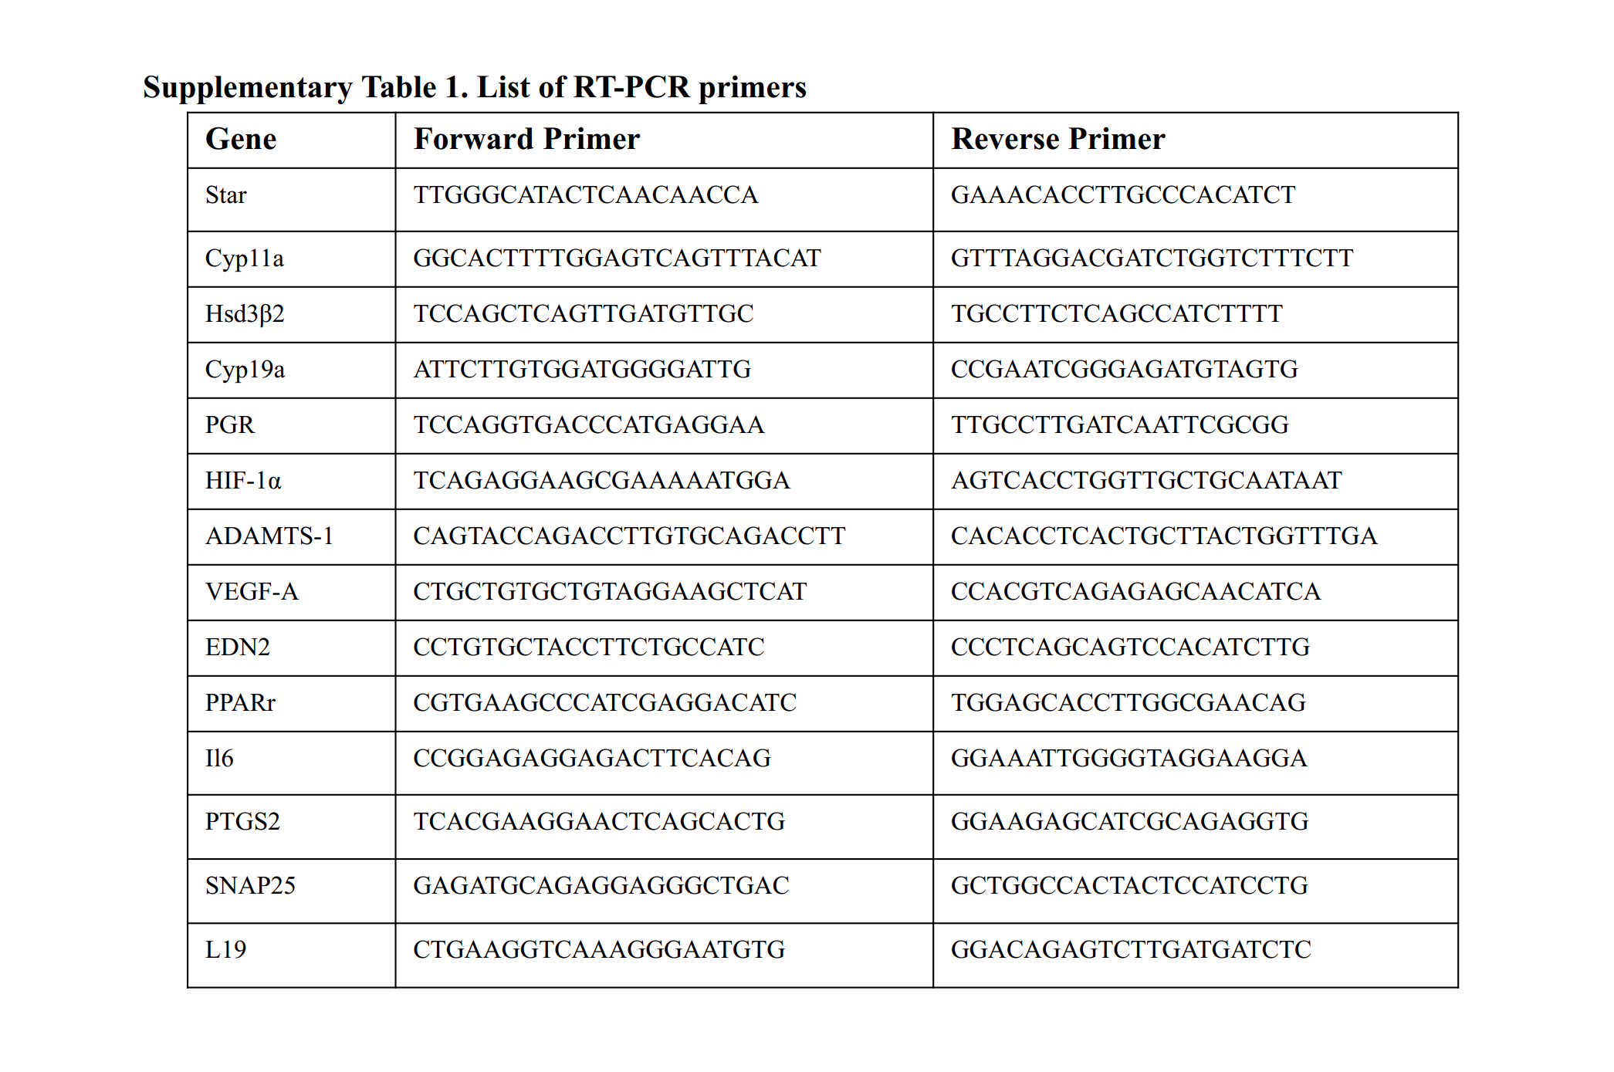
Supplementary Table 1. List of RT-PCR primers. The relevant primer sequences for Real-Time PCR

