Supplementary material
TFPS1, TFPS2, TFPS3 and TFPS4 were hydrolyzed to monosaccharides by trifluoroacetic acid and NaOH, and then their monosaccharide composition could be known by HPLC analysis [1]. The monosaccharide compositions of the four purified polysaccharide fractions are illustrated in Fig. S3. There were 12 peaks in the HPLC profiles of the mixed solutions of various standard monosaccharides. The peaks 1-12 represent mannose, ribose, rhamnose, glucuronide, galacturonide, N-acetyl-aminoglucose, glucose, N-acetyl-aminogalactose, galactose, xylose, arabinose and fucose, respectively. It can be observed from the Fig.S3 that glucose was the main monosaccharide of TFPS1 and TFPS2. Both TFPS1 and TFPS2 were made up of mannose, ribose, glucuronic acid, galacturonic acid, glucose, galactose, xylose, arabinose and fucose. Moreover, mannose was the major monosaccharide of TFPS3 and TFPS4. Both TFPS3 and TFPS4 were composed of mannose, ribose, rhamnose, glucuronic acid, galacturonic acid, glucose, galactose, xylose, arabinose, and fucose. The monosaccharide composition of the four purified polysaccharides was slightly different.

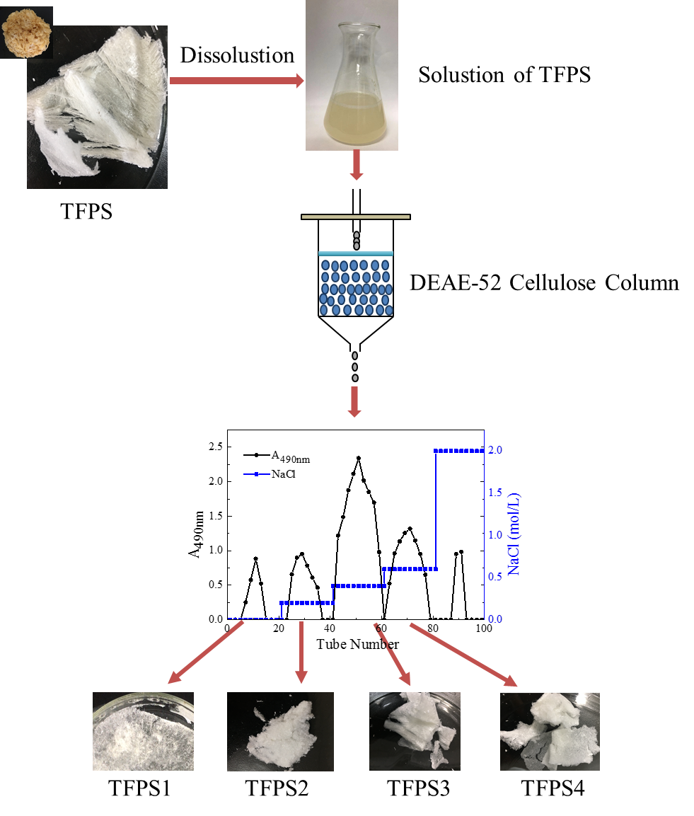
Fig. S1 Preparation of TFPS1, TFPS2, TFPS3 and TFPS4 using DEAE-52 cellulose column

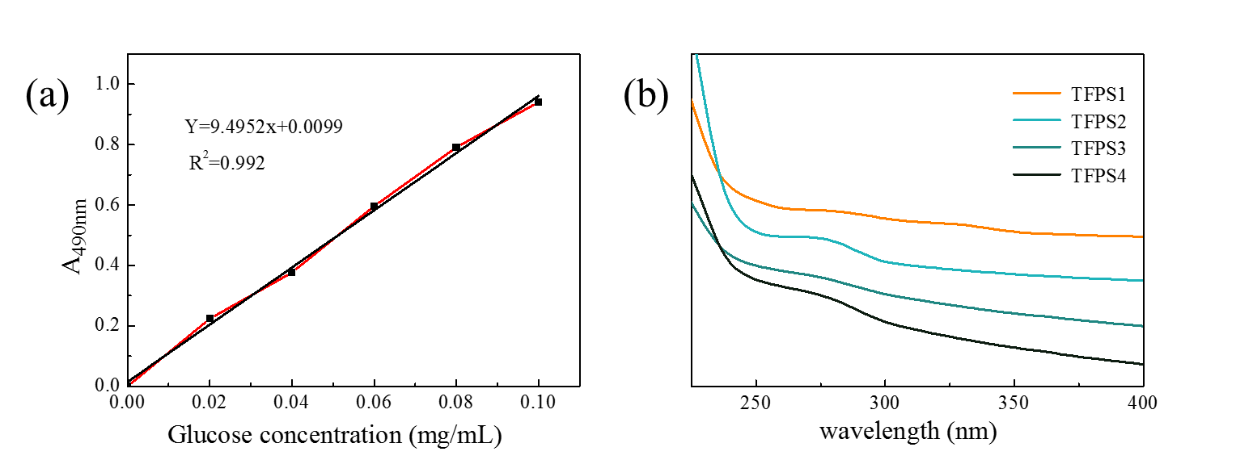
Fig. S2 (a) Glucose standard curve, (b) UV-Vis Spectra of TFPS1, TFPS2, TFPS3 and TFPS4

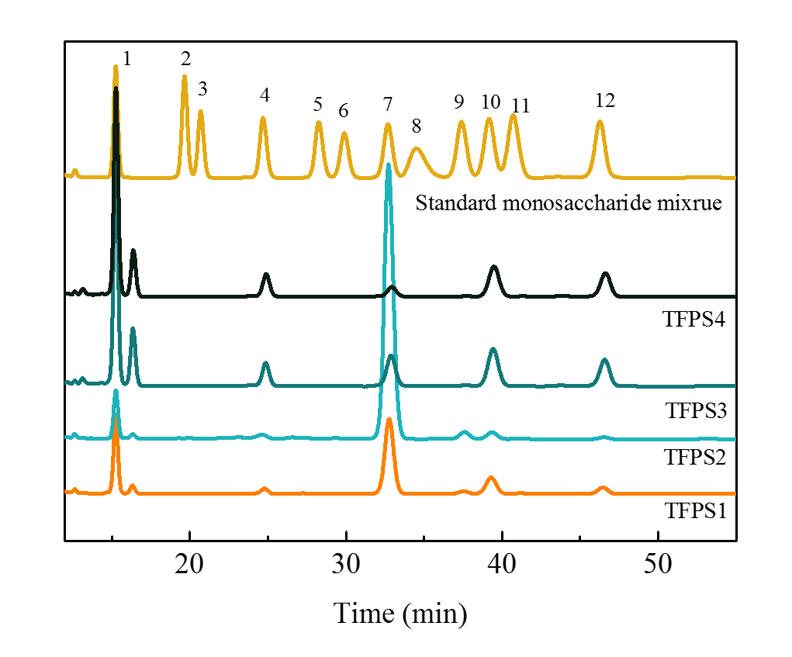
Fig. S3 Monosaccharide composition of TFPS1, TFPS2, TFPS3 and TFPS4.

References
[1] H.J. Yuan, L. Dong, Z.Y. Zhang, Y. He, X. Ma, Production, structure, and bioactivity of polysaccharide isolated from tremella fuciformis, Food Science and Human Wellness 11 (4) (2022) 1010-1017. https://doi.org/10.1016/j.fshw.2022.03.030.

