Electronic structural and lattice thermodynamic properties of MAlO₂ and M₅AlO₄ (M=Li, Na, K) sorbents for CO₂ capture applications

Yuhua Duan
National Energy Technology Laboratory, United States Department of Energy, Pittsburgh, Pennsylvania 15236, United States

Supplementary Information

Fig. S1 The phase diagram of Li₂O-Al₂O₃
Fig. S2 The calculated band structures and density of states (TDOS, PDOS) for α-LiAlO₂.
Fig. S3 The calculated band structures and density of states (TDOS, PDOS) for β-Li₅AlO₄.
Fig. S4 The calculated band structures and density of states (TDOS, PDOS) for α-NaAlO₂.
Fig. S5 The calculated band structures and density of states (TDOS, PDOS) for Na₅AlO₄.
Fig. S6 The calculated band structures and density of states (TDOS, PDOS) for ht-KAlO_{2.}
Fig. S7 The calculated band structures and density of states (TDOS, PDOS) for K₅AlO_{4.}
Fig. S8 The lattice phonon dispersions. (a) α-NaAlO₂, (b) Na₅AlO₄, (c) lt-KAlO₂, (d) K₅AlO₄.
Fig. S9 The phonon density of states of MAlO₂ and M₅AlO₄ (M=Na, K).
Fig. S10 The calculated van’t Hoff plot of CO₂ pressures versus inverse temperatures (1/T) for MAlO₂ and M₅AlO₄ (M=Li, Na, K) capturing CO₂.
References

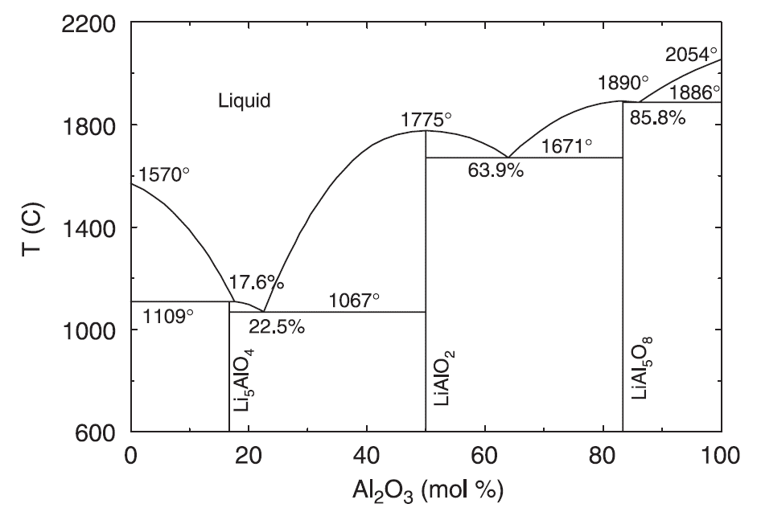
Fig. S1 The phase diagram of Li₂O-Al₂O₃ based on Kulkarni and Besmann’s optimization.¹ The high-Li content Li₅AlO₄ could be stable up to 1067 °C as solid phase.

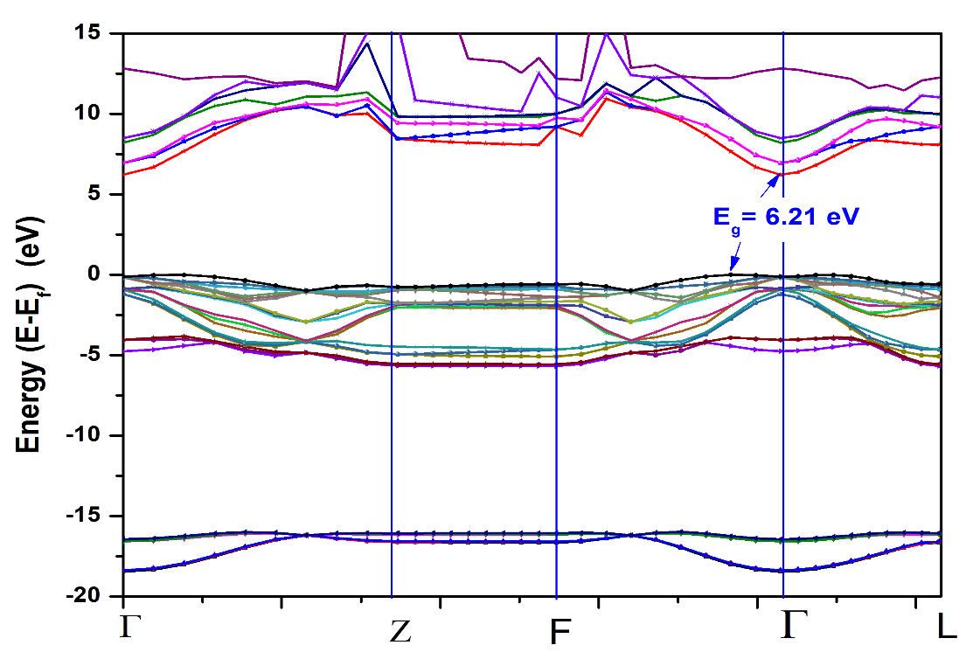
(a)
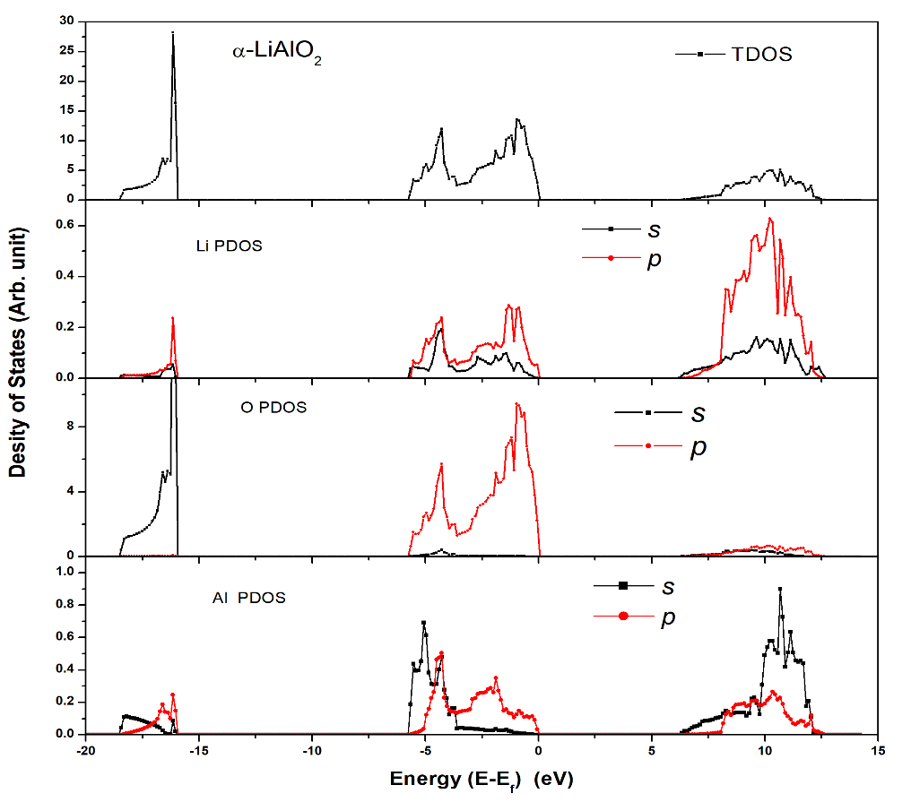
(b)
Fig.S2 The Band structure (a) and Density of States (b) of α-LiAlO₂.

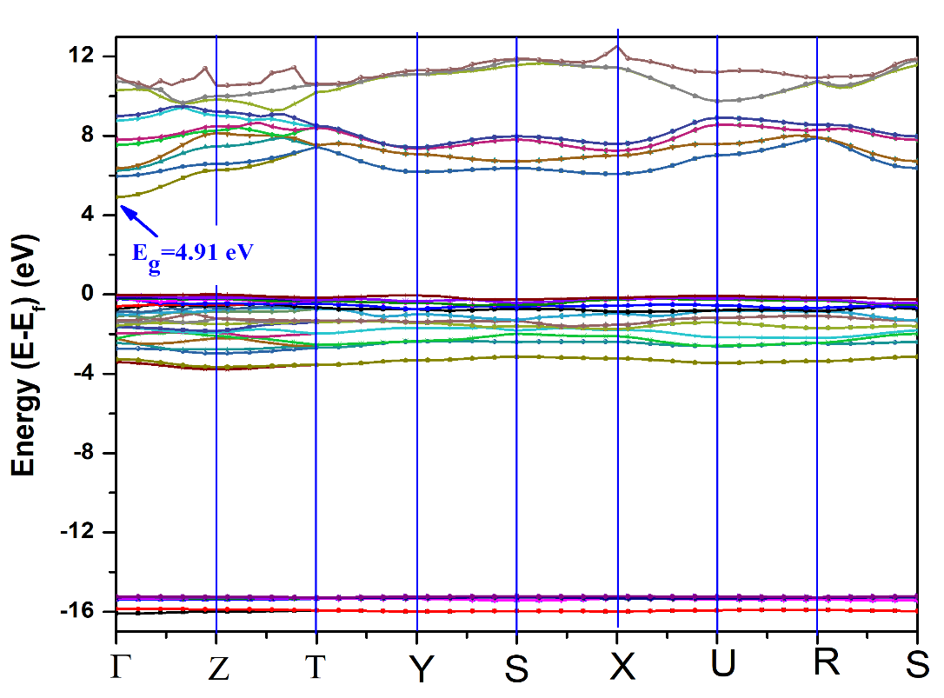
(a)
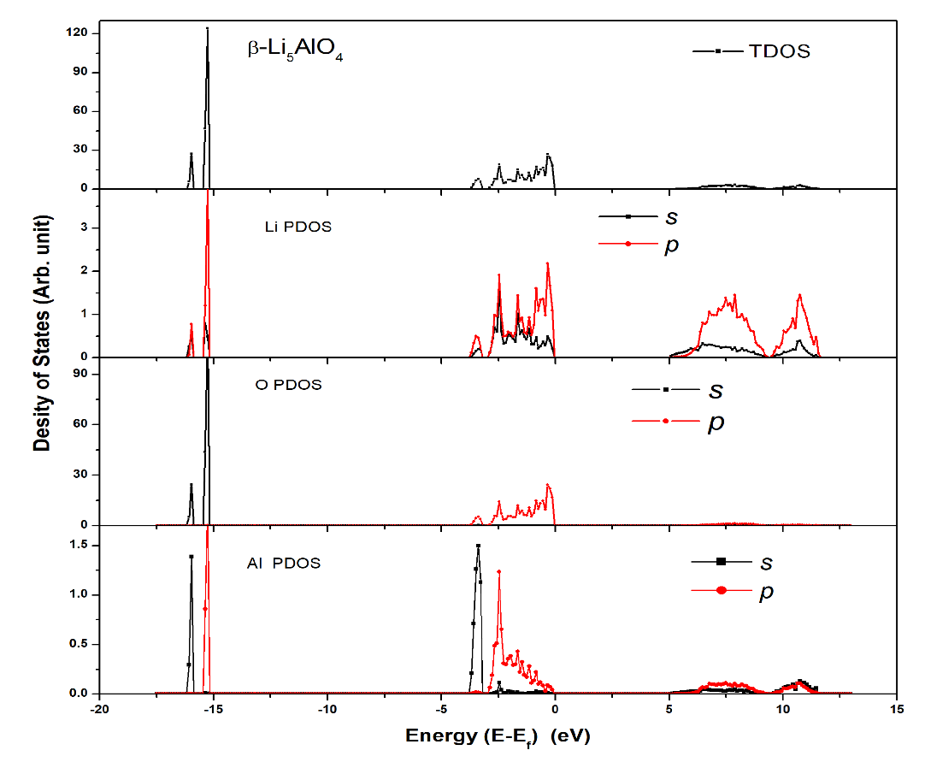
(b)
Fig.S3 The Band structure (a) and Density of States (b) of β-Li₅AlO₄.

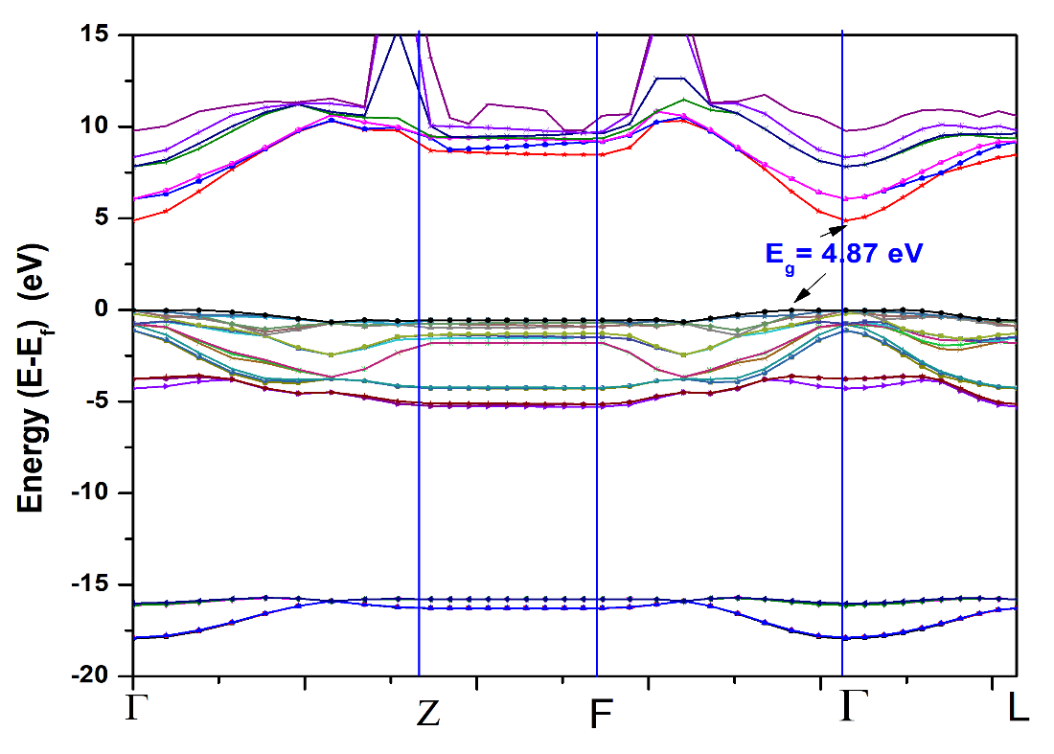
(a)
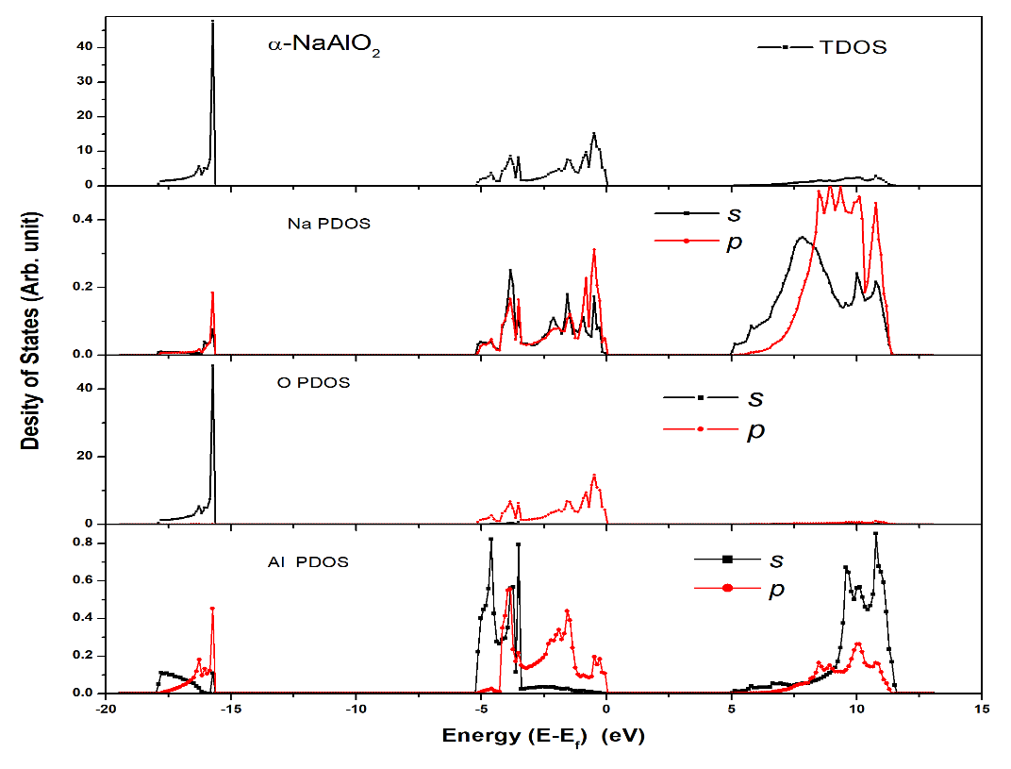
(b)
Fig.S4 The Band structure (a) and Density of States (b) of α-NaAlO₂.

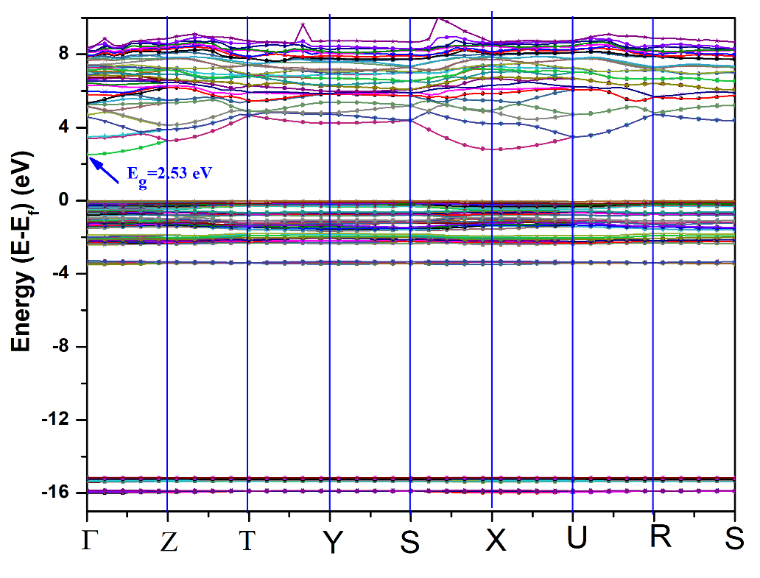
(a)
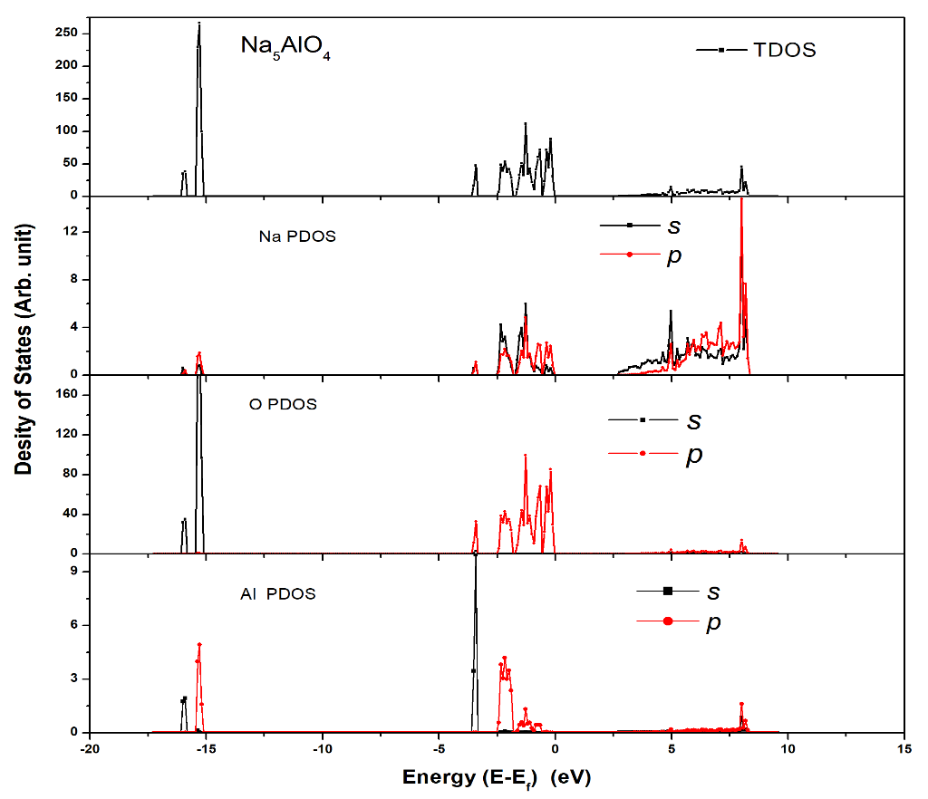
(b)
Fig.S5 The Band structure (a) and Density of States (b) of Na₅AlO₄.

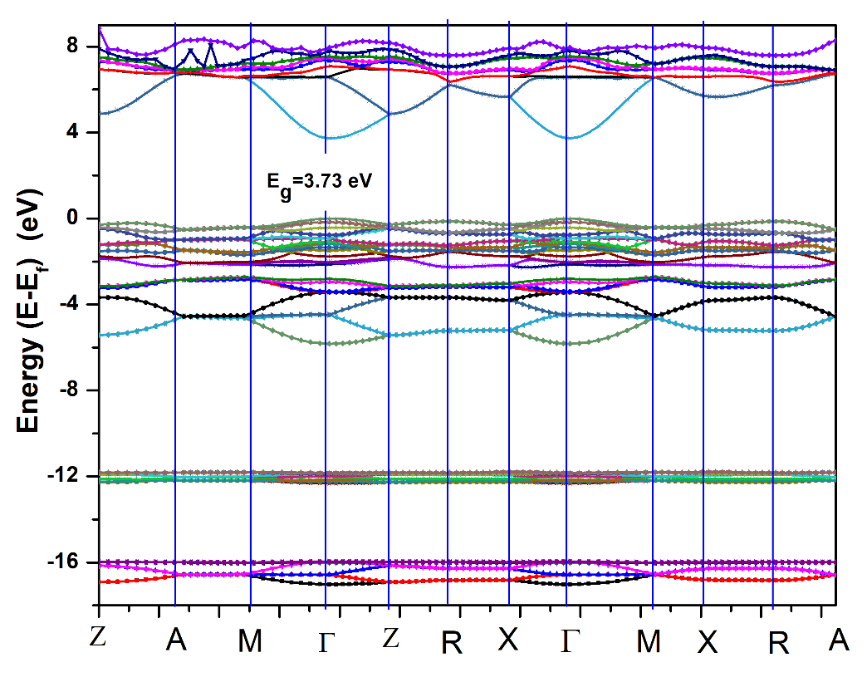
(a)
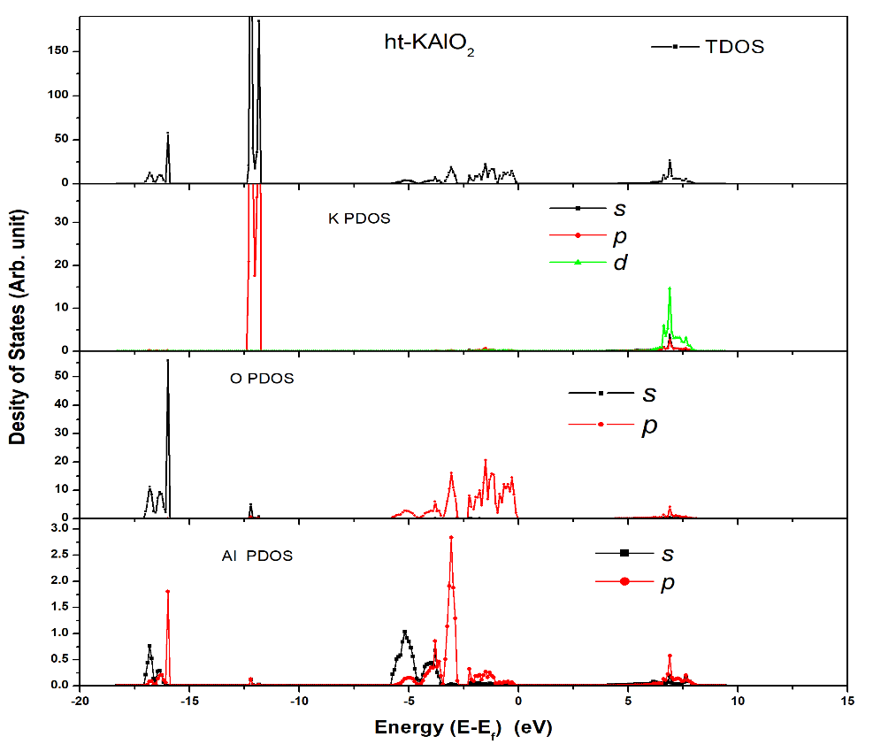
(b)
Fig.S6 The Band structure (a) and Density of States (b) of ht-KAlO₂.

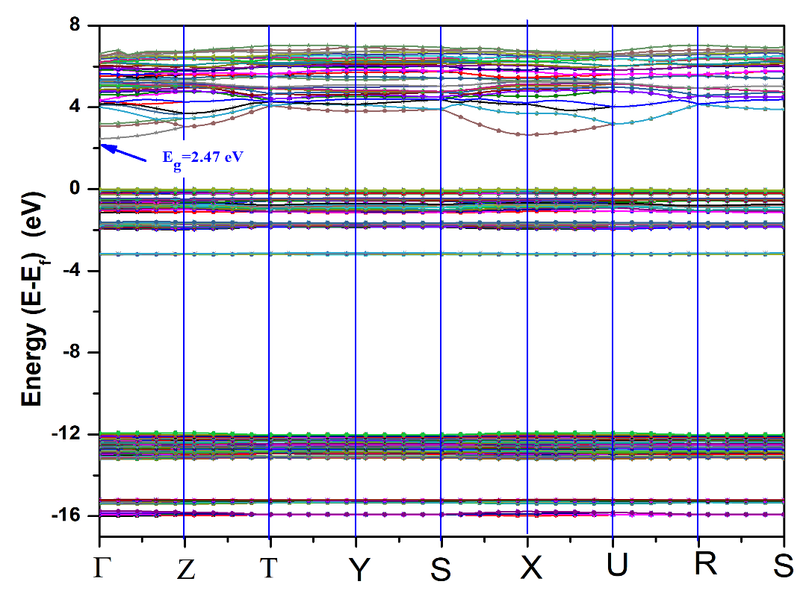
(a)
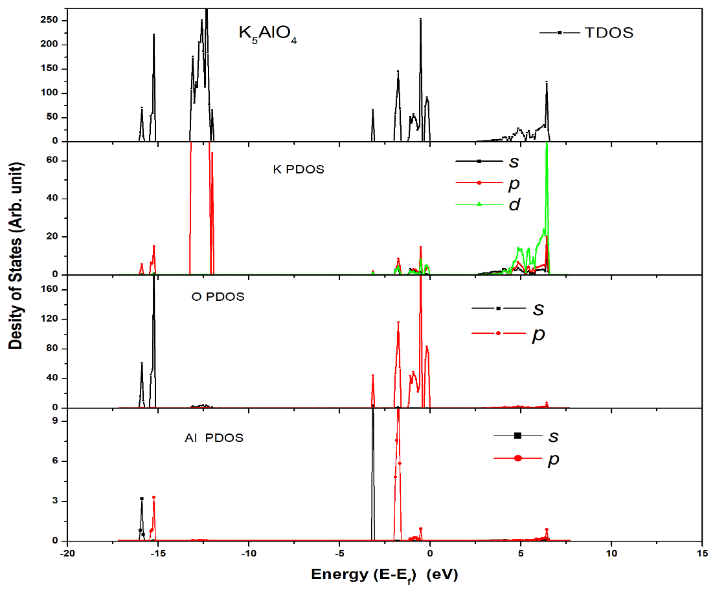
(b)
Fig.S7 The Band structure (a) and Density of States (b) of K₅AlO₄.

- α-NaAlO₂ | - Na₅AlO₄
- ht-KAlO₂ | - K₅AlO₄
Fig.S8. The lattice phonon dispersions. (a) α-NaAlO₂, (b) Na₅AlO₄, (c) lt-KAlO₂, (d) K₅AlO₄.

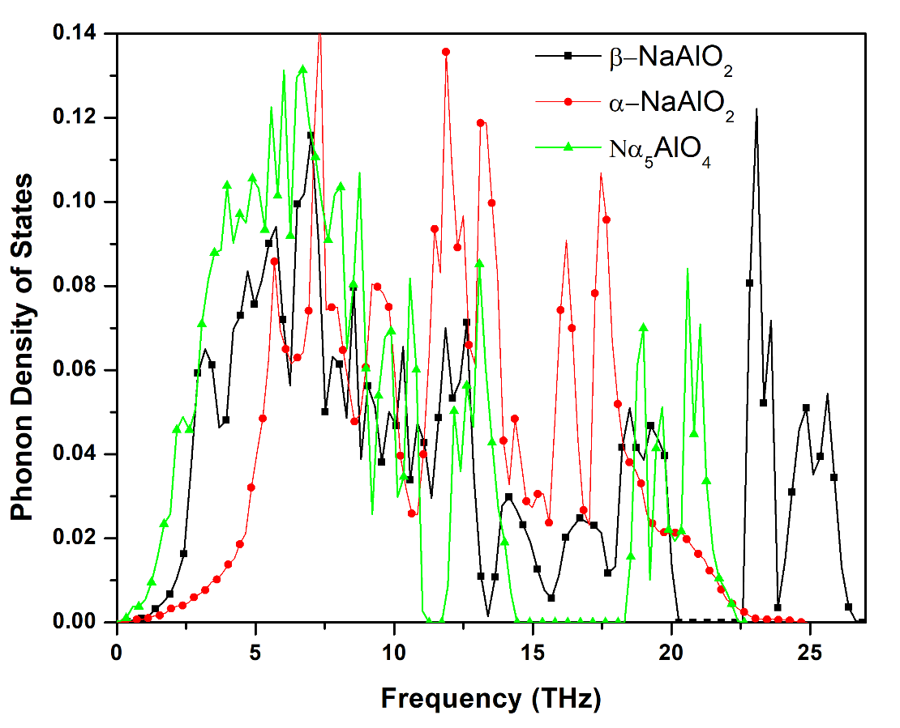

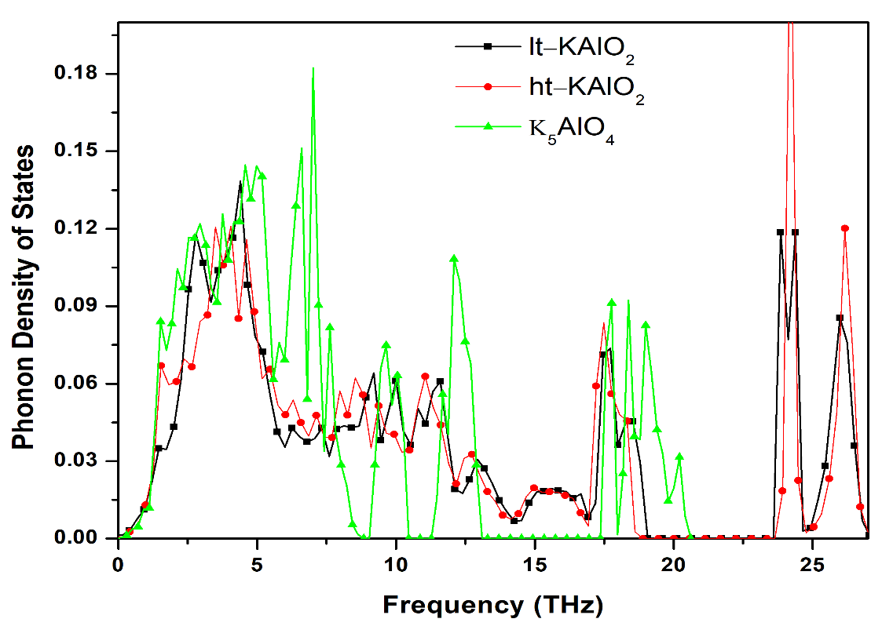
(b)
Fig.S9. The phonon density of states of MAlO₂ and M₅AlO₄ (M=Na, K).
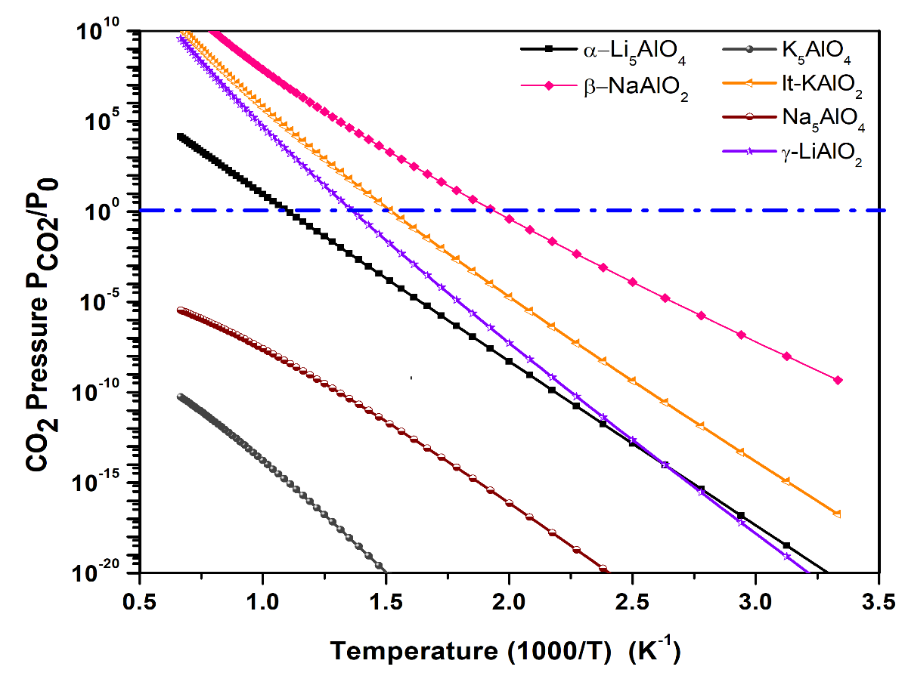
Fig. S10 The calculated van’t Hoff plot of CO₂ pressures versus temperatures for MAlO₂ and M₅AlO₄ (M=Li, Na, K) capturing CO₂. Y-axis plotted in logarithm scale. Only the ΔG=0 curve is shown explicitly. For each reaction, above its ΔG=0 curve, their ΔG<0, which means the solids absorb CO₂ and the reaction goes forward, whereas below the ΔG=0 curve, their ΔG>0, which means the CO₂ start to release and the reaction goes backward to regenerate the sorbents. The α-phase of Li₅AlO₄ and γ-phase of LiAlO₂ were taken from previous study.^{2,3}

References:

1 Kulkarni, N. S., Besmann, T. M. & Spear, K. E. Thermodynamic Optimization of Lithia-Alumina. Journal of the American Ceramic Society 91, 4074-4083, doi:10.1111/j.1551-2916.2008.02753.x (2008).
2 Duan, Y. Theoretical investigations of the CO₂ capture properties of r-LiAlO₂ and a-Li₅AlO₄. Micro and Nanosystems 13, 32-41, doi: 10.2174/1876402911666190913184300 (2021).
3 Duan, Y., Sorescu, D. C., Jiang, W. L. & Senor, D. J. Theoretical study of the electronic, thermodynamic, and thermo-conductive properties of gamma-LiAlO₂ with Li-6 isotope substitutions for tritium production. Journal of Nuclear Materials 530, 152963, doi:10.1016/j.jnucmat.2019.151963 (2020).

Author to whom correspondence should be addressed. Tel. 412-386-5771, Fax 412-386-5990, E-mail: yuhua.duan@netl.doe.gov

