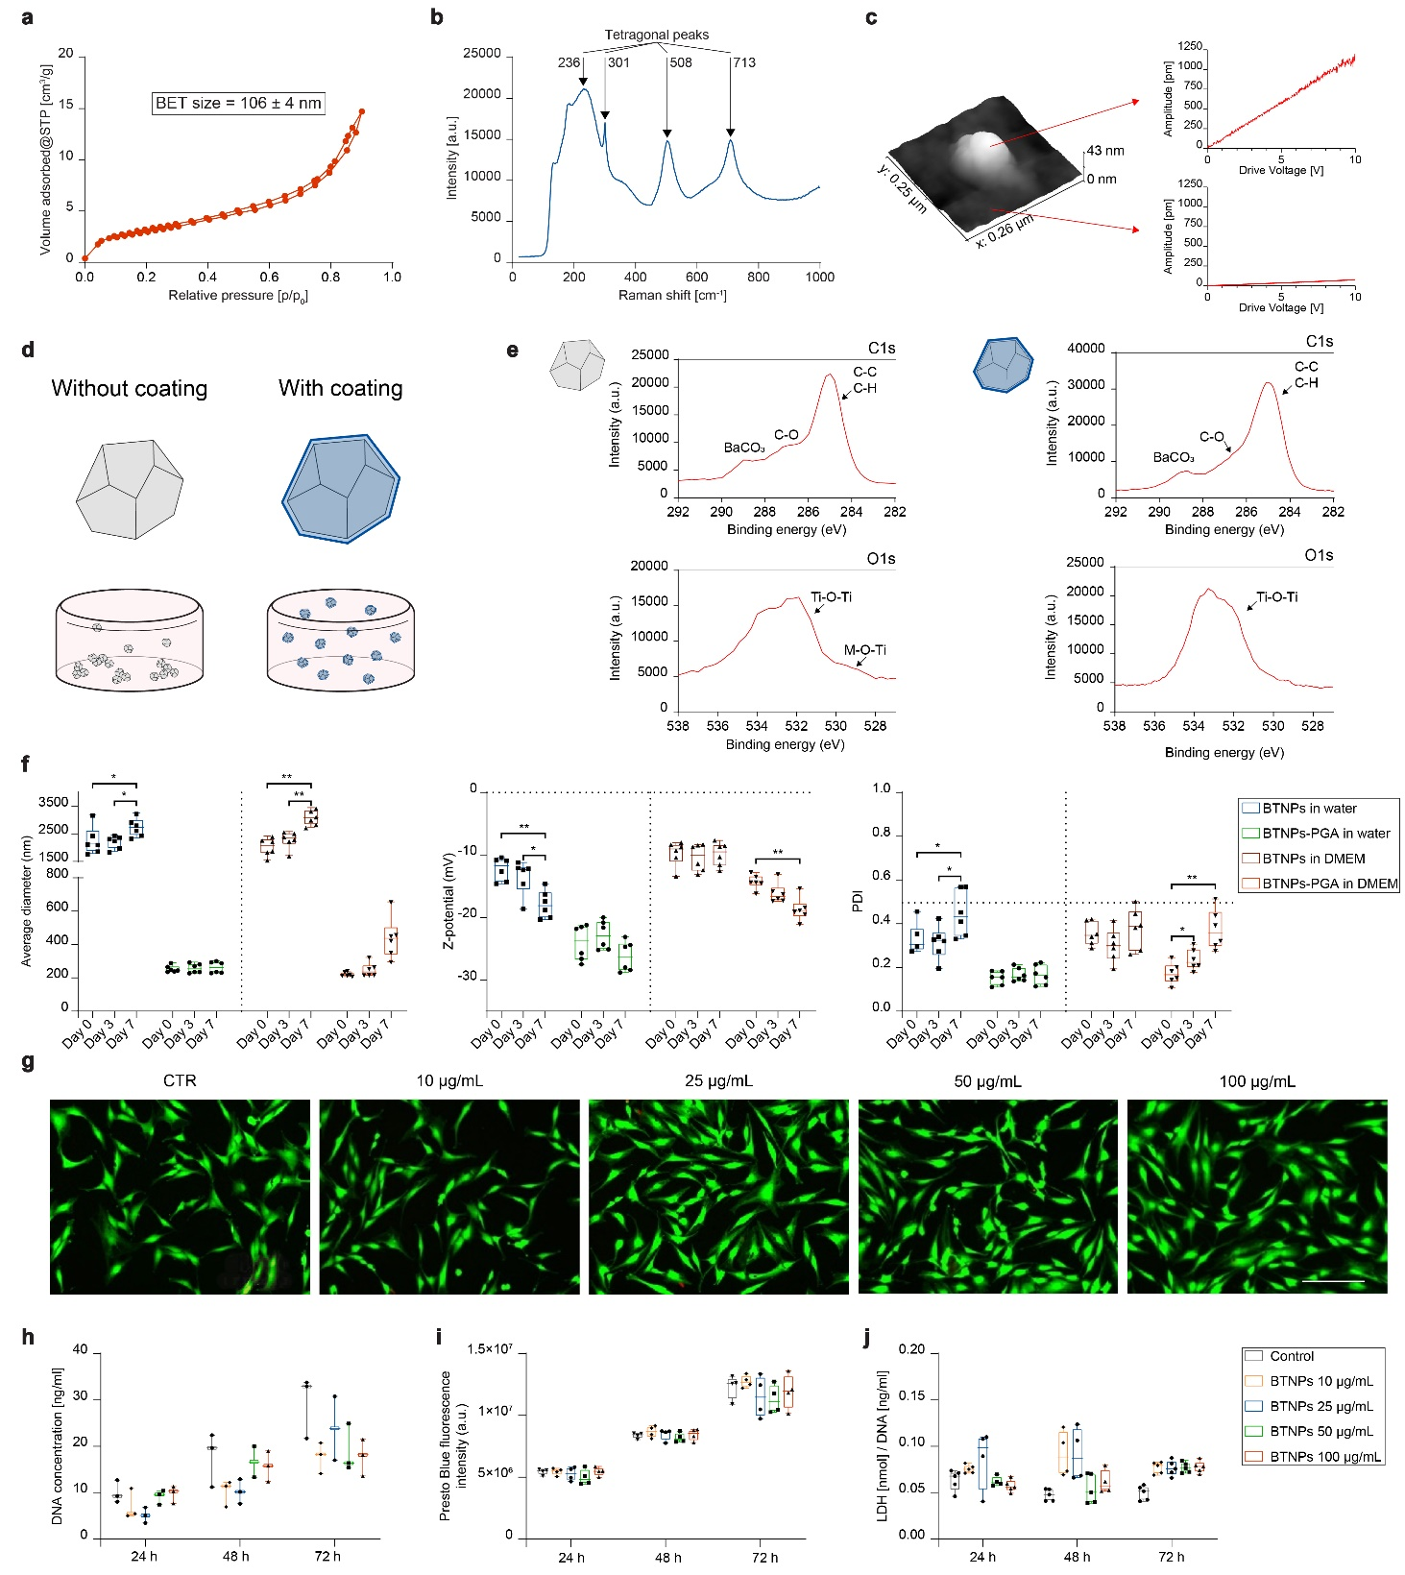
Extended Data Fig. 1. BTNP characterization and cytocompatibility. a, BET analysis: the resultant BET specific surface area was 9.4 ± 0.4 m²/g, corresponding to a BET size of 106 ± 4 nm. b, Raman spectrum: spectra lines at 239, 300, 506 and 707 cm⁻¹ indicate a local tetragonal distortion. c, PFM analysis: 3D map of a particle and amplitude signal of the displacement vs. the drive voltage on the PFM tip, for both nanoparticle and background. d, Graphical representation of an uncoated (left) and PGA-coated (right) BTNP, and depiction of their behavior within an aqueous solution (e.g., the hydrogel before crosslinking). e, XPS analysis for the uncoated (left) and coated (right) BTNPs, showing the different functional groups in the 1s orbital of C and O signals. f, DLS characterization of BTNPs in terms of average diameter, zeta potential and polydispersity index (PDI) at different time-points (0, 3 and 7 days). The analysis was performed in deionized water and DMEM. g, Live/Dead fluorescence images of human chondrocytes after 24 h of incubation with different concentrations of PGA-coated BTNPs. Live cells are shown in green, dead/necrotic cells are shown in red. Scale bar = 75 μm. h, Quantification of DNA. i, Fluorescence signal, proportional to the metabolic activity of human chondrocytes at different time points (24, 48 and 72 h), incubated with different concentrations of coated BTNPs. j, LDH release normalized to DNA content. Results in h,i,j, refer to human chondrocytes at different time-points (24, 48 and 72 h) incubated with different concentrations of coated BTNPs. In f, h, i and j, data are represented as box plots with median, minimum and maximum. *p<0.05, **p<0.01.
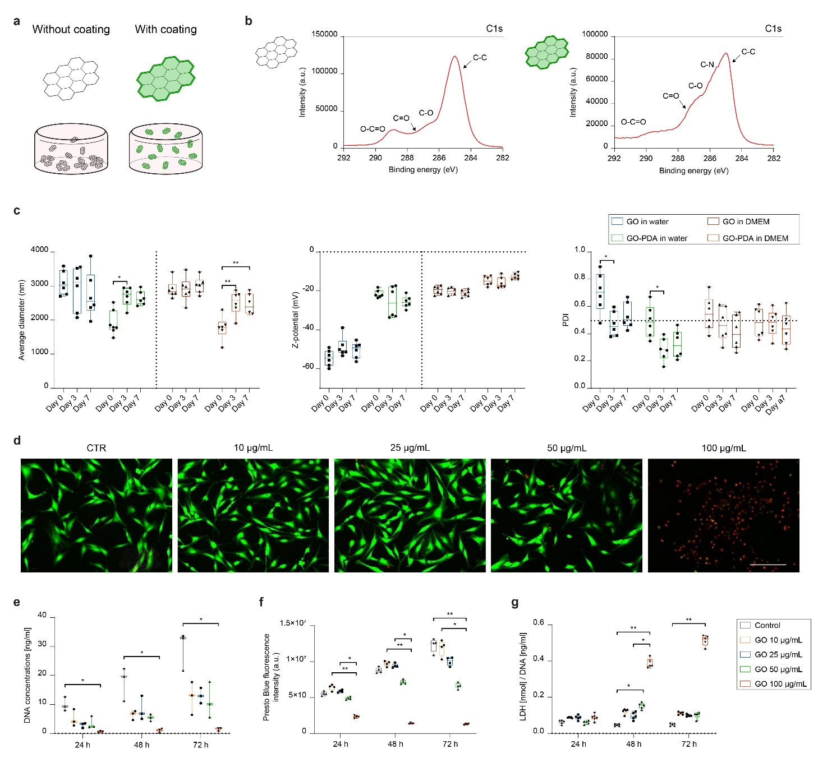
Extended Data Fig. 2. GO nanoflakes characterization and cytocompatibility. a, Graphical representation of an uncoated (left) and PDA-coated (right) GO nanoflakes, and depiction of their behavior within an aqueous solution (e.g., the hydrogel before crosslinking). b. XPS analysis for the uncoated (left) and coated (right) GO nanoflakes, showing the different functional groups in the C1s signals. c, DLS characterization of GO nanoflakes in terms of average diameter, zeta potential and polydispersity index (PDI) at different time-points (0, 3 and 7 days). The analysis was performed in deionized water and DMEM. d, Live/Dead fluorescence images of human chondrocytes after 24 h of incubation with different concentrations of PDA-coated GO nanoflakes. Live cells are shown in green, dead/necrotic cells are shown in red. Scale bar = 75 μm. e, Quantification of DNA. f, Fluorescence signal, proportional to cell metabolic activity. g, LDH release normalized to DNA content. Results in e,f,g, refer to human chondrocytes at different time points (24, 48 and 72 h) incubated with different concentrations of coated GO nanoflakes. In c,e,f,g, data are represented with box plots with median, minimum and maximum. *p<0.05, **p<0.01.

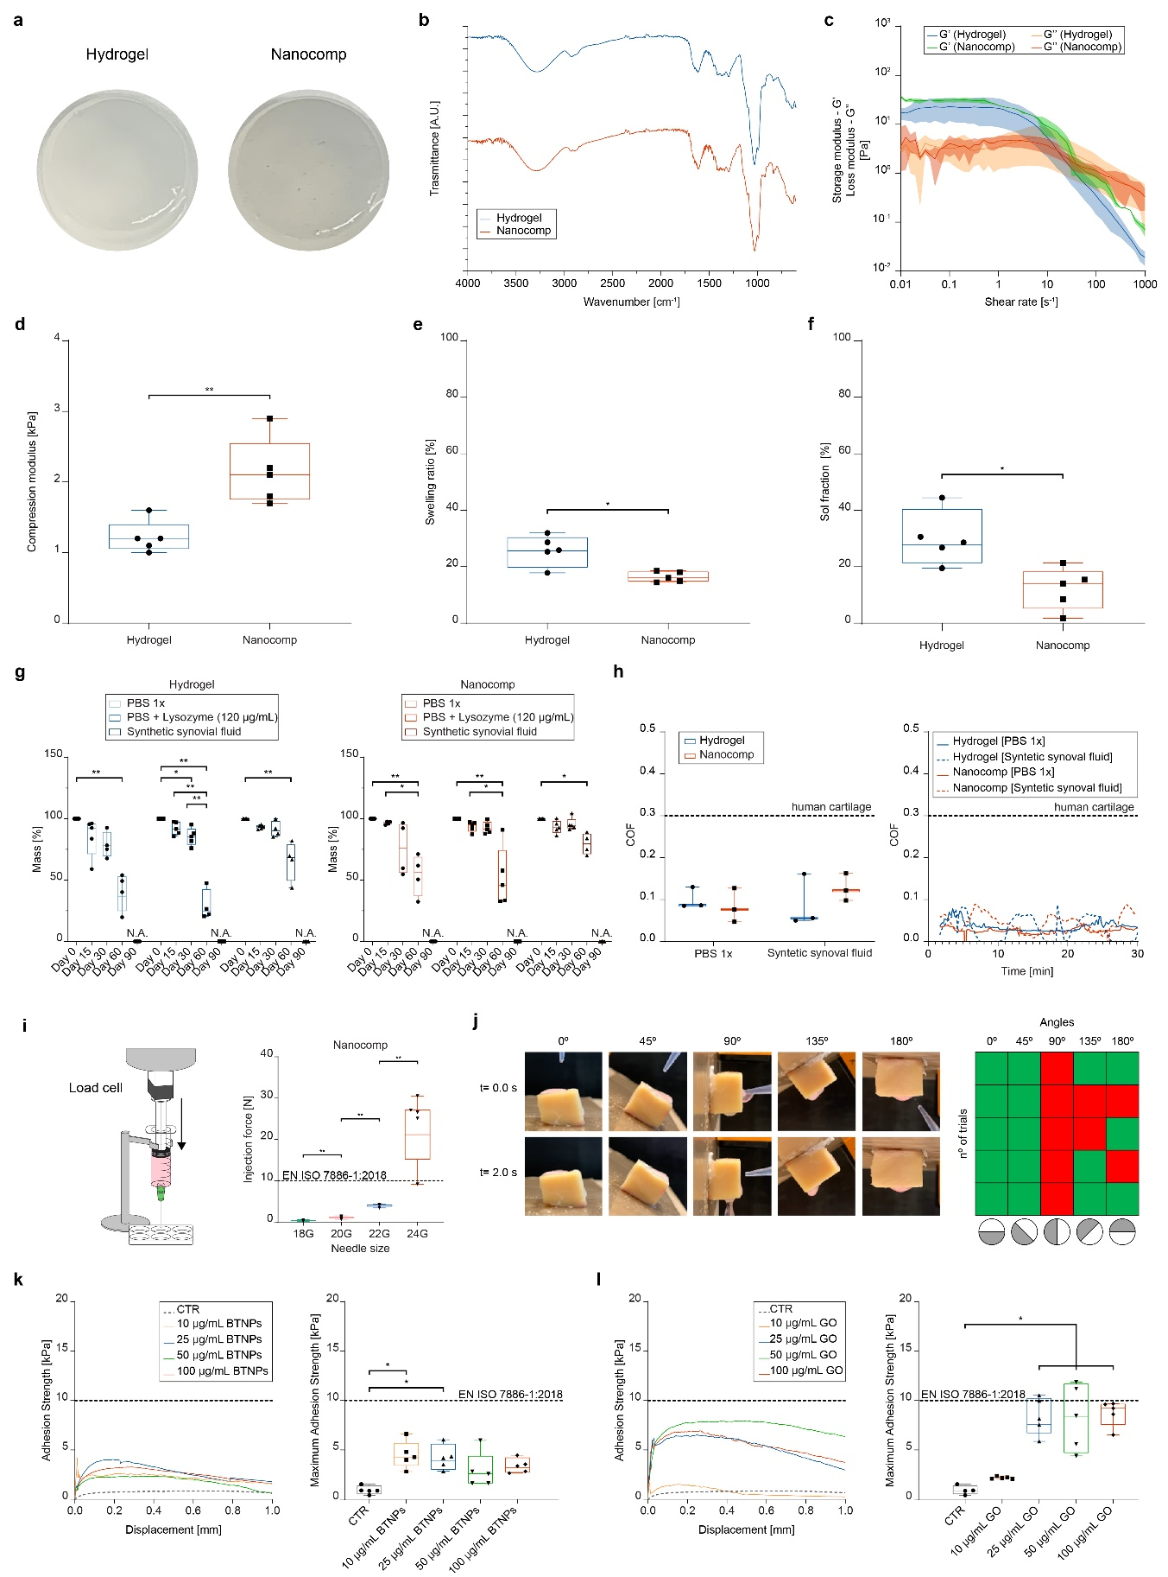
Extended Data Fig. 3. Characterization of the nanocomposite hydrogel. a, Photos (top view) of the non-doped hydrogel (Hydrogel) and the nanocomposite hydrogel doped with GO nanoflakes and BTNPs (Nanocomp). b, FT-IR spectra. c, Rheometric properties (storage modulus G’ and loss modulus G’’). d, Compression modulus. e, Swelling ratio. f, Sol fraction. g, Mass loss over time, accounting for material degradation in different media. Data at day 90 are not shown because all samples were entirely dissolved at this time-point (N.A.). h, Coefficient of friction (COF) measured at the transition region between the static and kinematic regimes, and analysis of the hydrogel wear (variation of the COF over time) upon the application of a constant normal force (0.1 N) and at a constant rotational speed (0.05 mm⁻¹) for 30 min. i, Graphical representation (left) of the set-up used to assess the Nanocomp injection force and graph with the experimental results obtained (right). j, Analysis of the Nanocomp sliding behavior: the Nanocomp solution was applied with a pipette onto a bovine cartilage tissue sample approaching it at different angles (top images). Another image was acquired 2 s after material deposition, to verify material stability (bottom images). On the right, a heat map is shown, representing the number of trials (rows) and the different angles (columns): green means successful (the material drop remained on site); red means unsuccessful (the material drop flew away from the cartilage). k, (left) Representative adhesion strength vs displacement curves for the hydrogel embedding different concentrations of BTNPs and non-doped control (CTR); (right) maximum adhesion strength values derived from the curves. l, (left) Representative adhesion strength vs displacement curves for the hydrogel embedding different concentrations of GO nanoflakes and non-doped control (CTR); (right) maximum adhesion strength values derived from the curves. In d, e, f, g, h, i, k and l, data are represented as box plots with median, minimum and maximum. *p<0.05, **p<0.01.

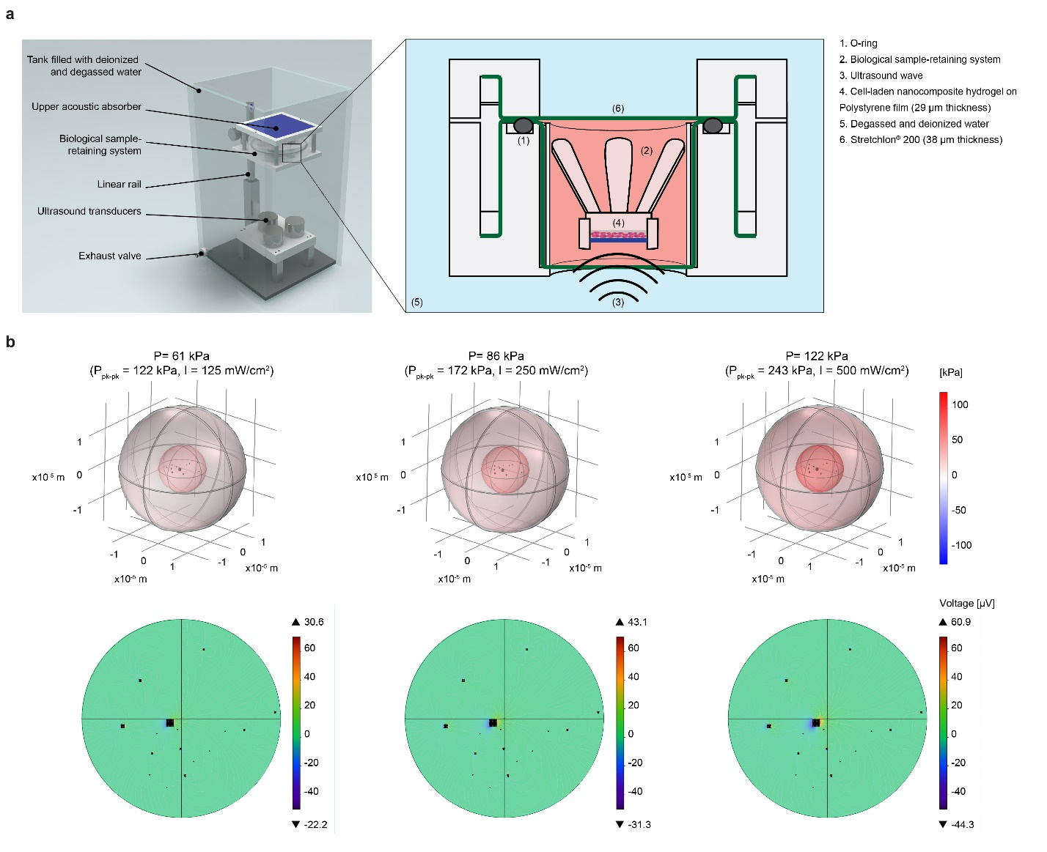
Extended Data Fig. 4. Set-up for in vitro controlled stimulation of the nanocomposite hydrogel and estimation of the voltage generated within the cell. a, Depiction of the controlled US set-up used for the dose-controlled in vitro stimulation of the nanocomposite hydrogel; the right image shows a zoom of the holder where the sample is located during in vitro US exposure. Thanks to its architecture, the holder guarantees both transparency to the US dose (avoiding undesired attenuation and reflections) and sealing ability, thus sterility of the sample. b, Pressure distribution (top) and electric potential visualization in a representative 2D plane within the cell (bottom) at different US doses.
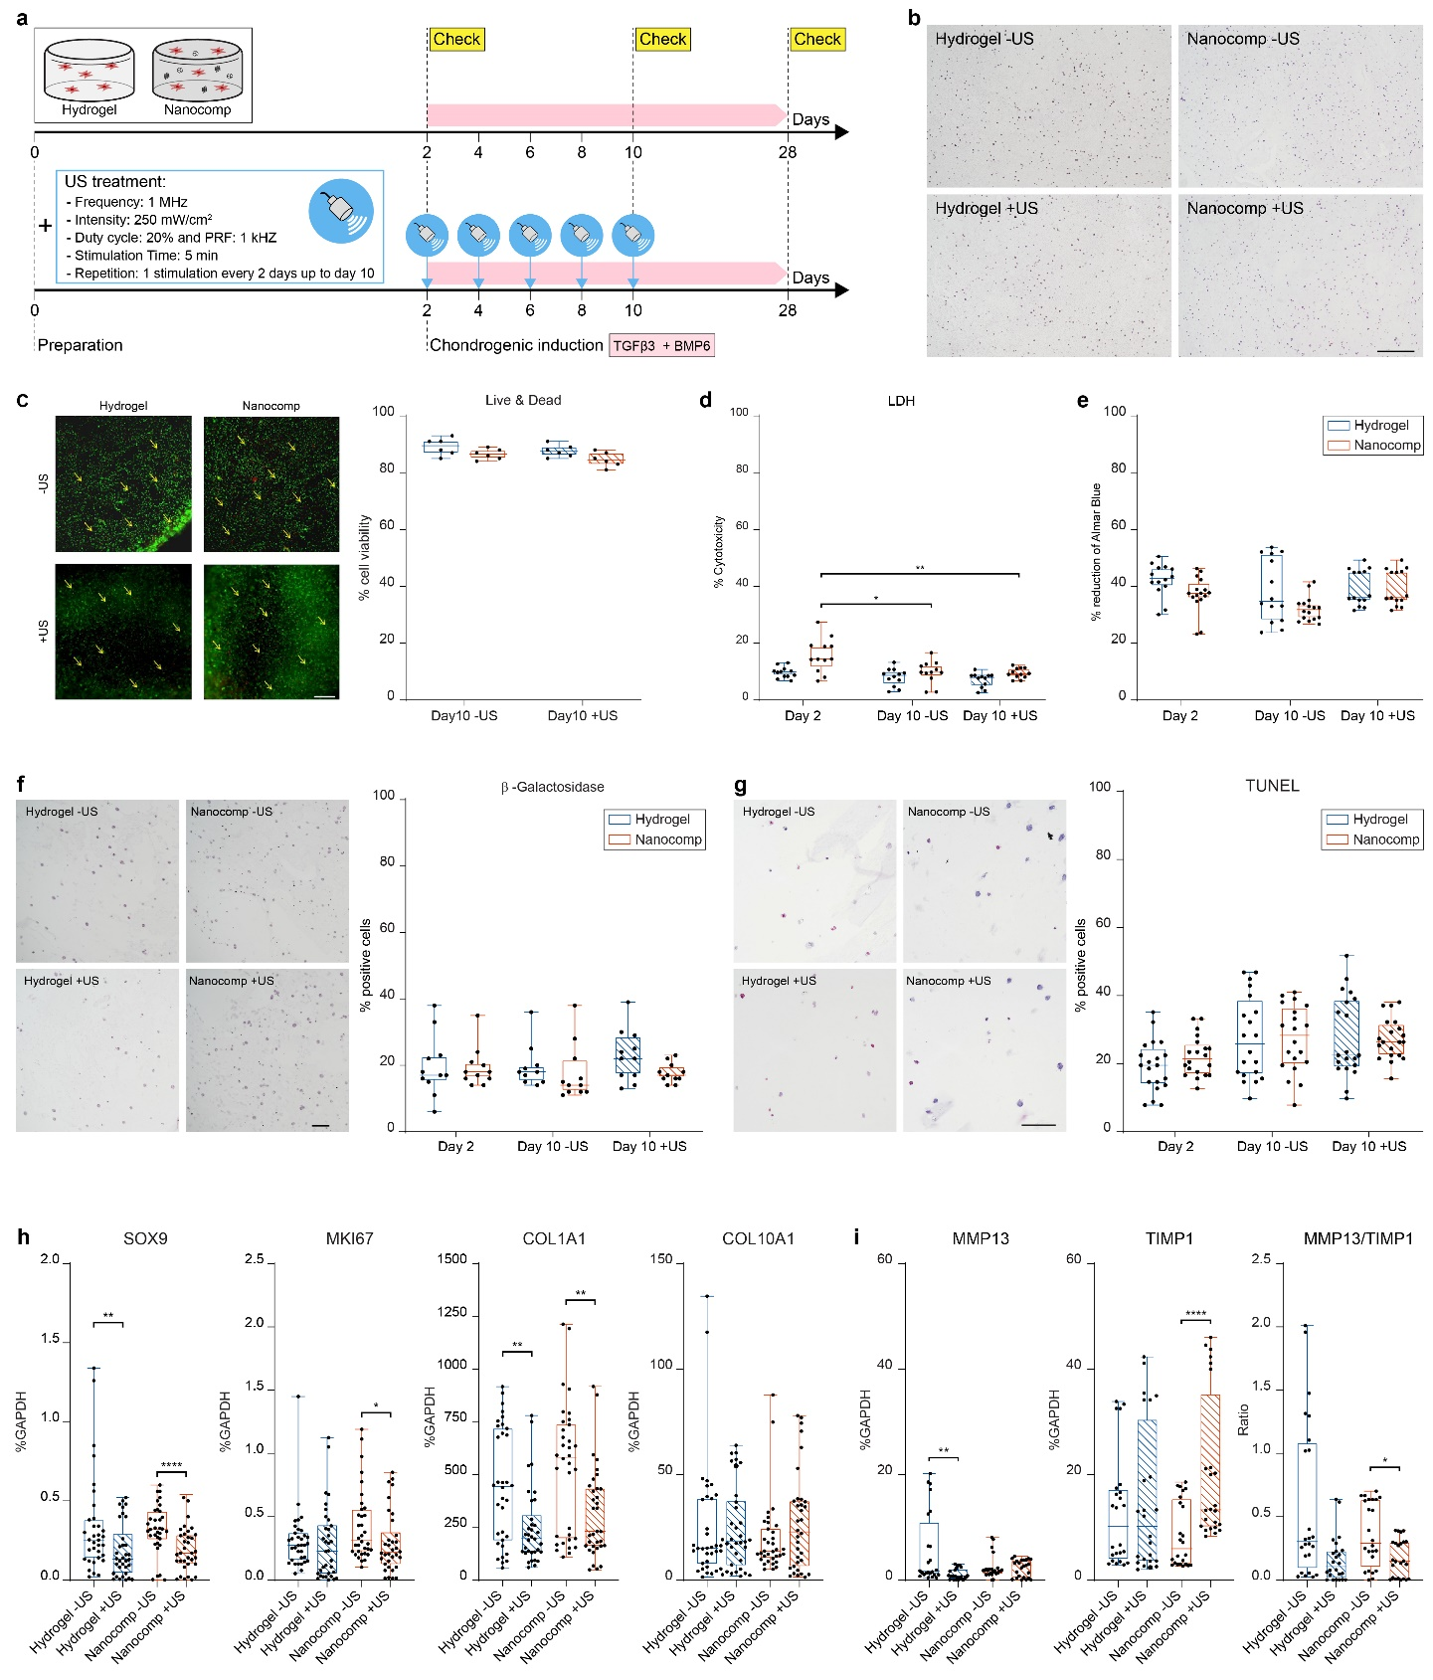
Extended Data Fig. 5. Viability and chondrogenic commitment of ASCs embedded in the hydrogels with or without US. a, Scheme of the experiment. b, Histological analysis on day 10 to assess ASC distribution. Scale bar = 500 µm. c, Live/Dead images on day 10. Viable cells are shown in green; dead cells are shown in red (highlighted by yellow arrows). Scale bar =500µm. The graphs shows the quantification of viable ASCs. d, LDH release from ASCs on day 10. Data are expressed as a percentage of cytotoxicity. e, Results of the Alamar Blue assay, on day 10. Data are expressed as percentage of reduction of Alamar Blue, f, β-galactosidase immunostaining images (left) on day 10 to identify senescent cells. Scale bar = 100 µm. Quantification of the percentage of positive cells (right). g, Results of the Tunel assay to identify apoptotic cells (left) on day 10. Scale bar = 100 µm. Quantification of the percentage of positive cells (right). h, Expression of SOX9, MKI67, COL1A1 and COL10A1 genes on day 10 in Hydrogel and Nanocomp, – and + US. i, Expression of MMP13, TIMP1 and MMP13/TIMP1 genes on day 10 in hydrogel and nanocomp, – and +US. In h,i, data are expressed as a percentage of the GAPDH housekeeping gene. In all graphs, data are represented with box plots showing the median, minimum, and maximum values. *p<0.05, **p<0.01, ***p<0.001.

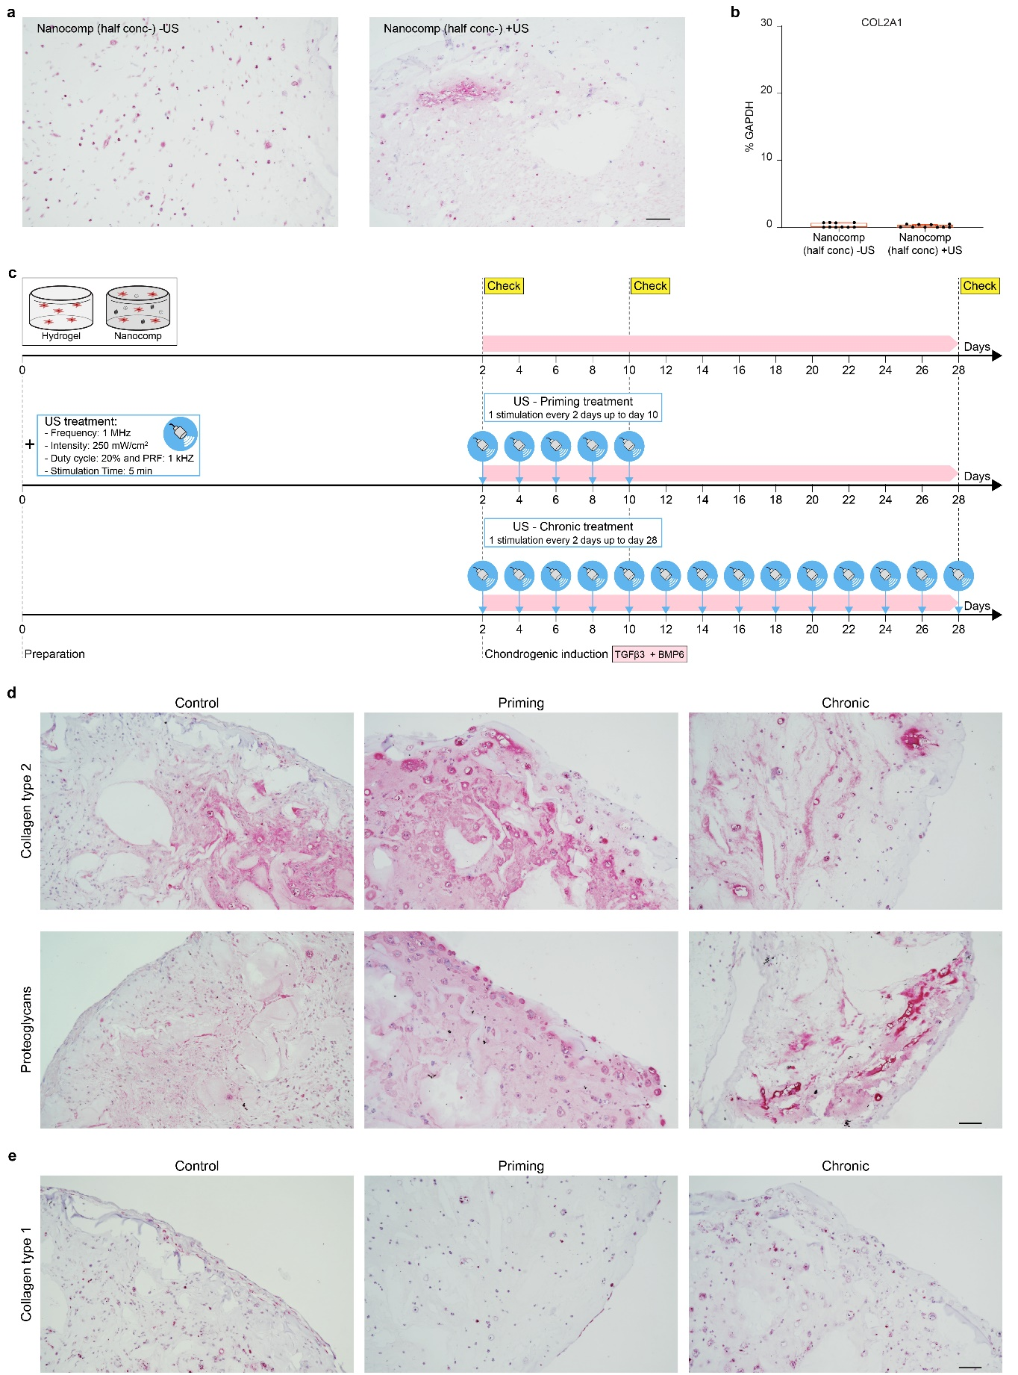
Extended Data Fig. 6. Effect of nanomaterial concentration and number of US applications on ACS chondrogenic commitment. a, Collagen type 2 immunostaining on day 10 in Nanocomp embedding half nanomaterial concentration. Scale bar = 100 µm. b, Expression of COL2A1 on day 10. Data are expressed as a percentage of the GAPDH housekeeping gene. c, Scheme of the experiment for evaluating ASC chondrogenic differentiation. Priming = US applied once every 2 days, for 10 days. Chronic = US applied once every 2 days, for 28 days. d, Collagen type 2 and proteoglycans immunostaining on day 28. Scale bar = 100 µm. e, Collagen type 1 immunostaining on day 28. Scale bar = 100 µm. Data were represented with box plots showing the median, minimum, and maximum values.

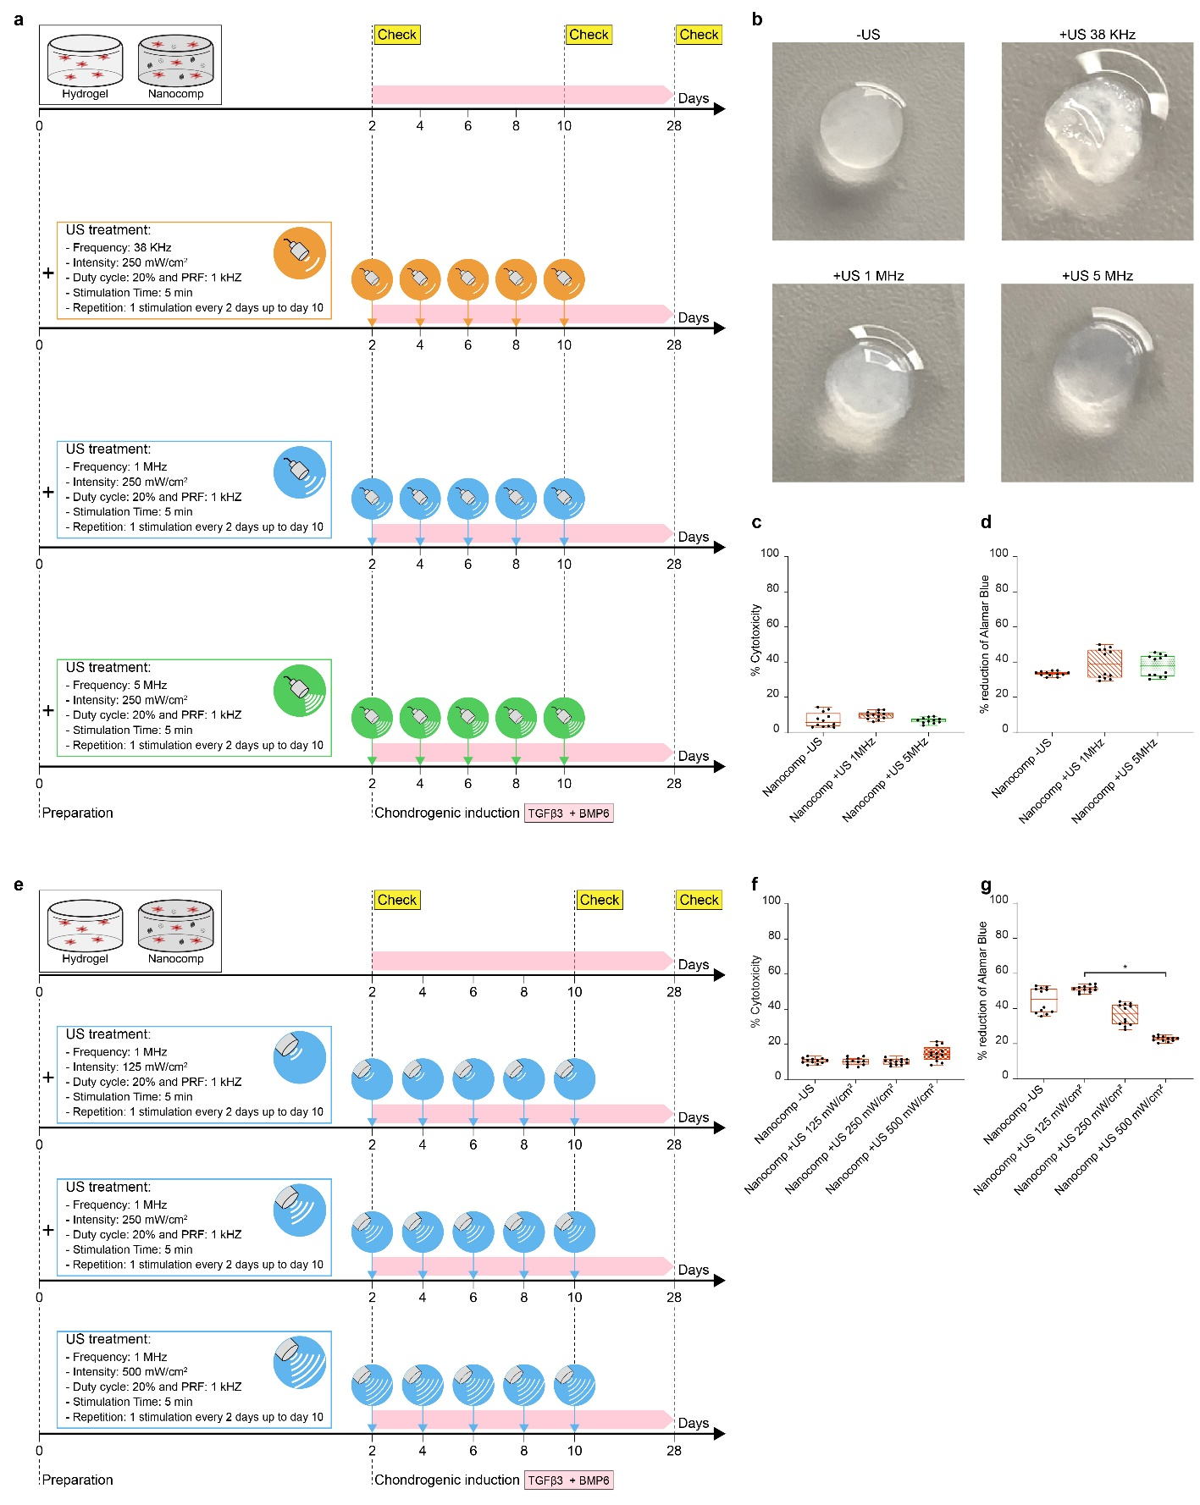
Extended Data Fig. 7. Effect of different US frequencies and intensities on ASC chondrogenic commitment. a, Scheme of the experiment for evaluating ASC chondrogenic differentiation by exposing the nanocomposite hydrogel to different US frequencies (38 kHz, 1 MHz and 5 MHz). b, Representative photos of Nanocomp – US and + US (38 kHz, 1 MHz, 5 MHz) on day 10, after receiving 5 US stimulations, c, LDH release from ASCs embedded in Nanocomp – and + US (1 MHz, 5 MHz) on day 10. Data are expressed as a percentage of cytotoxicity. d, Results of Alamar Blue assay, to evaluate the metabolic activity of ASCs. Data are expressed as percentage of reduction of Alamar Blue, e, Scheme of the experiment for evaluating ASC chondrogenic differentiation by exposing the nanocomposite hydrogel to different US intensities (125, 250 and 500 mW/cm²). f, LDH release from ASCs embedded in Nanocomp – and + US (125, 250, 500 mW/cm²) on day 10. Data are expressed as a percentage of cytotoxicity. g, Results of Alamar Blue assay, to evaluate the metabolic activity of ASCs on day 10. In all graphs, data are represented with box plots showing the median, minimum, and maximum values. * p<0.05.

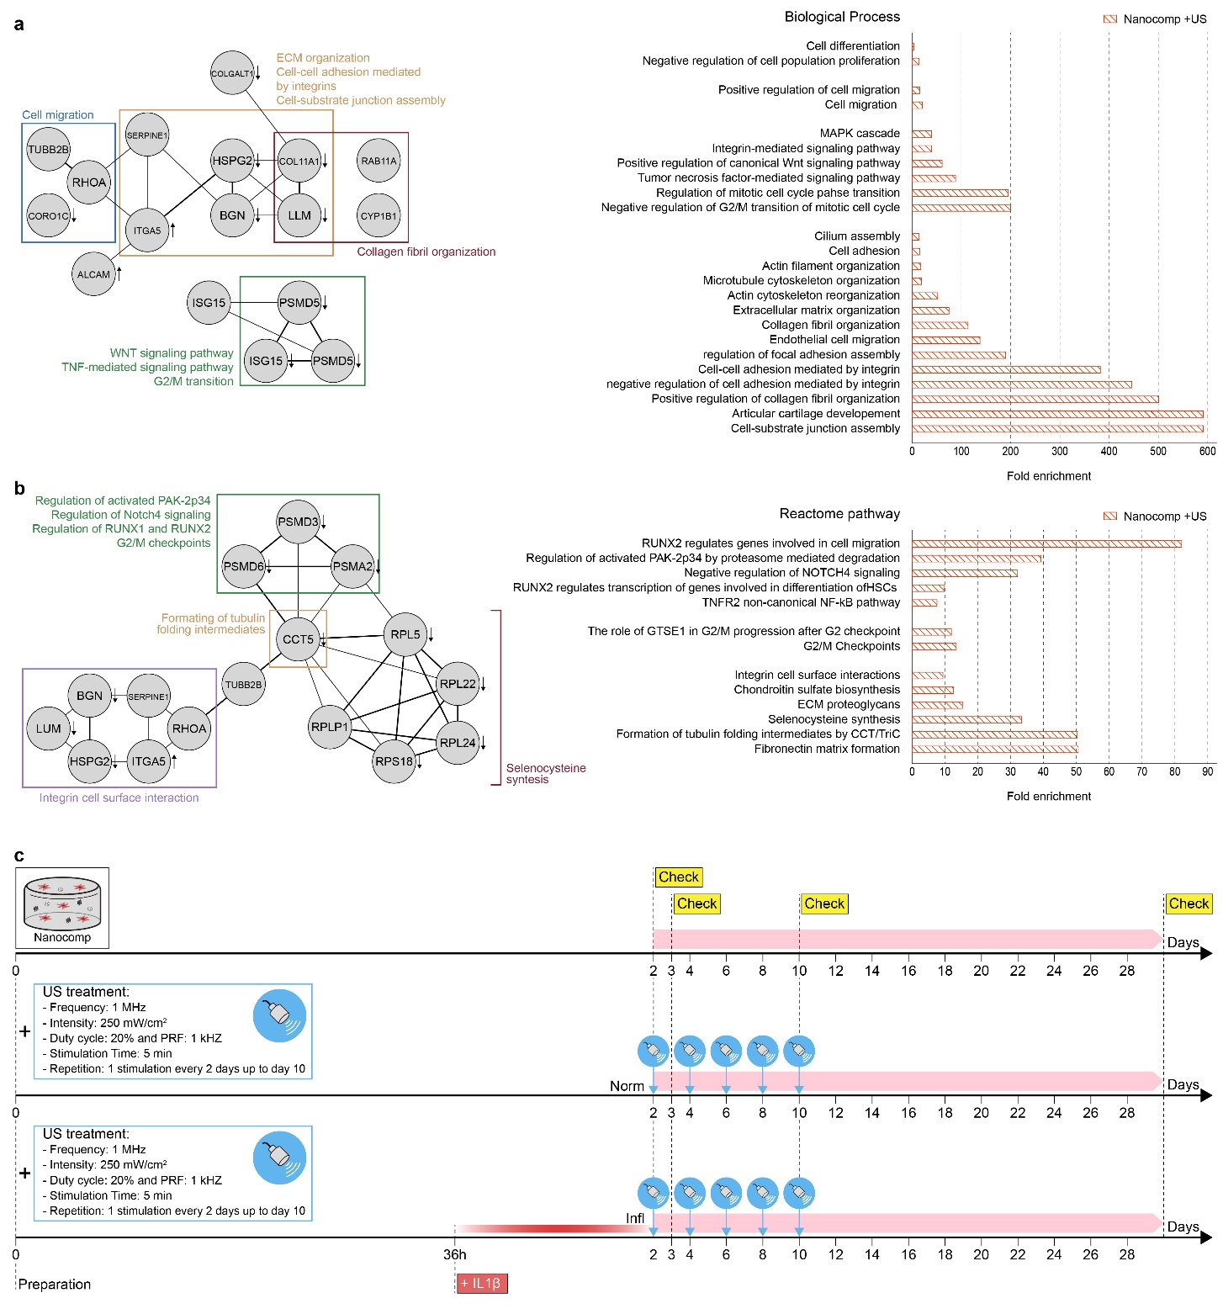
Extended Data Fig. 8. Proteomic analysis and assessment of anti-inflammatory effects. a, String network originated from Nanocomp + US proteins differentially expressed with respect to Nanocomp – US (up or down-regulated) and uniquely identified. Gene Ontology terms for biological processes were interrogated, showing that annotated protein complexes belong to extracellular matrix organization, collagen fibril organization, cell-cell adhesion mediated by integrins, cell-substrate junction assembly and cell migration. Signaling pathways, such as Wnt and TNF-α, were also enriched. Arrows represent up/down regulated proteins resulting from spectral counting analysis. On the right, bars represent the fold enrichment of Gene Ontology terms with respect to the whole human proteome used as a reference background. b, String network in which the curated Reactome pathway was interrogated, showing that annotated protein complexes were enriched for regulation of activated PAK2p34, Notch4 signaling, RUNX1 and RUNX2, formation of tubulin folding intermediates, selenocysteine synthesis and integrin cell surface interactions. Arrows represent up/down regulated proteins resulting from spectral counting analysis. c, Scheme of the experiment for evaluating ASC chondrogenic differentiation in absence and presence of an inflammatory environment.

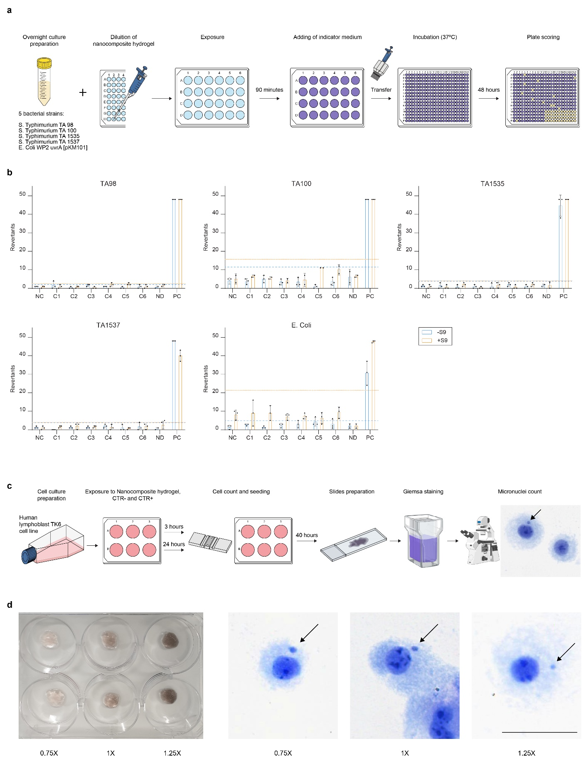
Extended Data Fig. 9. In vitro genotoxicity tests. a, Experimental flow-chart of the Ames test, performed on five different bacterial strains. Six different concentrations of nanocomposite hydrogel (C1-C6), non disgregated (ND) nanocomposite, positive (PC) and negative (NC) controls were run. b, Graphs reporting the results of the Ames test, for each bacterial strain with and without S9 metabolic activation. Dotted (orange) and dashed (blue) lines represent the 2-fold increase of revertant colonies over baseline with or without metabolic activation that identify the threshold for mutagenicity. Data are reported as mean and s.d. c, Depiction of the Micronuclei test performed on TK6 lymphoblasts exposed to three different concentrations of Nanocomp, positive (CTR+) and negative (CTR-) controls for 3 and 24 h. d, Photo (left) of the experimental plate used for the exposure of TK6 cells to three Nanocomp concentrations and representative microscopy images (right) showing micronuclei (highlighted by arrows). Scale bar = 50 µm.

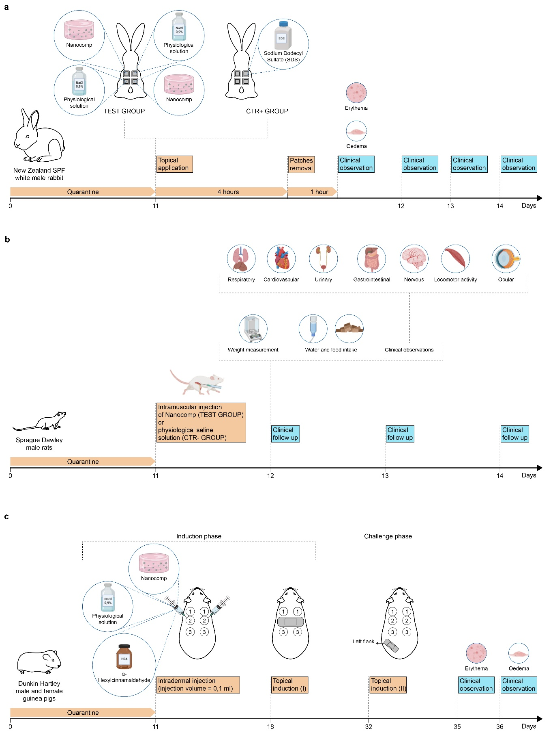
Extended Data Fig. 10. In vivo tests for the assessment of safety and biocompatibility following ISO 10993. a, Scheme of the experiment for evaluating skin irritation in rabbits: Nanocomp and saline solution (negative control, CTR-) were topically applied in two sites of three rabbits for 4 hours, and 0.5 g of a known irritant (positive control, CTR+) were applied in four sites of one animal. Skin responses, such as erythema and oedema were scored starting from day 11, after 1 h, 1, 2 and 3 days from patches removal for the calculation of the Primary Irritation Index. b, Scheme of the experiment for evaluating acute systemic toxicity in rats. In five rats per group, 0.15 mL of Nanocomp or saline solution were i.m. injected in the thigh; clinical follow-up was performed at baseline and daily for 3 days. c, Scheme of the experiment for evaluating delayed type- hypersensitivity in guinea pigs. 0.1 mL of Nanocomp or saline solution (CTR-) or a known sensitizer (CTR+) were injected intradermally, followed by a topical application in the dorsum of 0.5 mL of Nanocomp or controls and a challenge phase by another (0.5 mL) topical application in the animal’s flank. Skin reactions were registered after 24 and 48 h.

