Table I. Details of TC specimens [16].
(a)
Code | YP1 | YW
Powder | ZrO₂-8 mass %Y₂O₃  (HOSP, 11 μm-125 μm) | ZrO₂-8 mass %Y₂O₃  (F&C, 45 μm-106 μm)
Spray process | APS | WPS
Porosity estimated from image (before annealing) | In-plane:  Linear porosity: 3.4 %  Globular porosity: 3.1 %  Cross-plane:  Lamellar porosity(horizontal): 3.6 %  Lamellar porosity(vertical): 1.4 %  Globular porosity: 2.5 % | In-plane:  Linear porosity: 5.7 %  Globular porosity: 1.9 %  Cross-plane:  Lamellar porosity(horizontal): 5.8 %  Lamellar porosity(vertical): 1.9 %  Globular porosity: 2.7 %
Microstructure  (before annealing) | 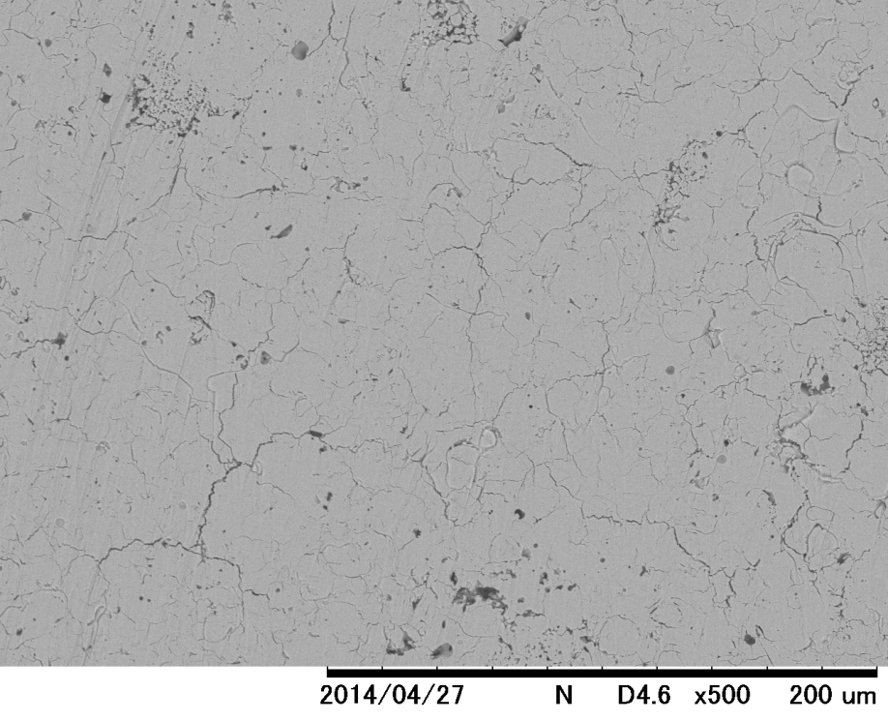  YP1 [cross]  50μm  YP1 [in]  50μm | YW [in]  YW [cross]  50μm  50μm

