A very promising antibiofilm activity against Candida albicans from an in vitro screening for antimicrobial, antibiofilm and antiproliferative activity of new synthesized 4-cinnamamido- and 2-phenoxyacedamido-1H-pyrazol-5-yl)benzamides.
Fabiana Plesciaª, Valentina Catania^{b}, Antonella D’Anneo^{c}, Demetrio Raffa^{*a}, Marianna Lauricella^{d}, and Domenico Schillaciª.

ªDepartment of Biological, Chemical and Pharmaceutical Sciences and Technologies, Medicinal Chemistry and Pharmaceutical Technologies Section - University of Palermo, Via Archirafi 32, 90123 Palermo, Italy
^{b}Department of Earth and Marine Sciences (DiSTeM), University of Palermo, Viale delle Scienze Ed. 16, 90128 Palermo, Italy.
^{c}Department of Biological, Chemical and Pharmaceutical Sciences and Technologies, Laboratory of Biochemistry, University of Palermo, 90127-Palermo, Italy
^{d}Department of Experimental Biomedicine and Clinical Neurosciences, Laboratory of Biochemistry, University of Palermo, 90127-Palermo, Italy

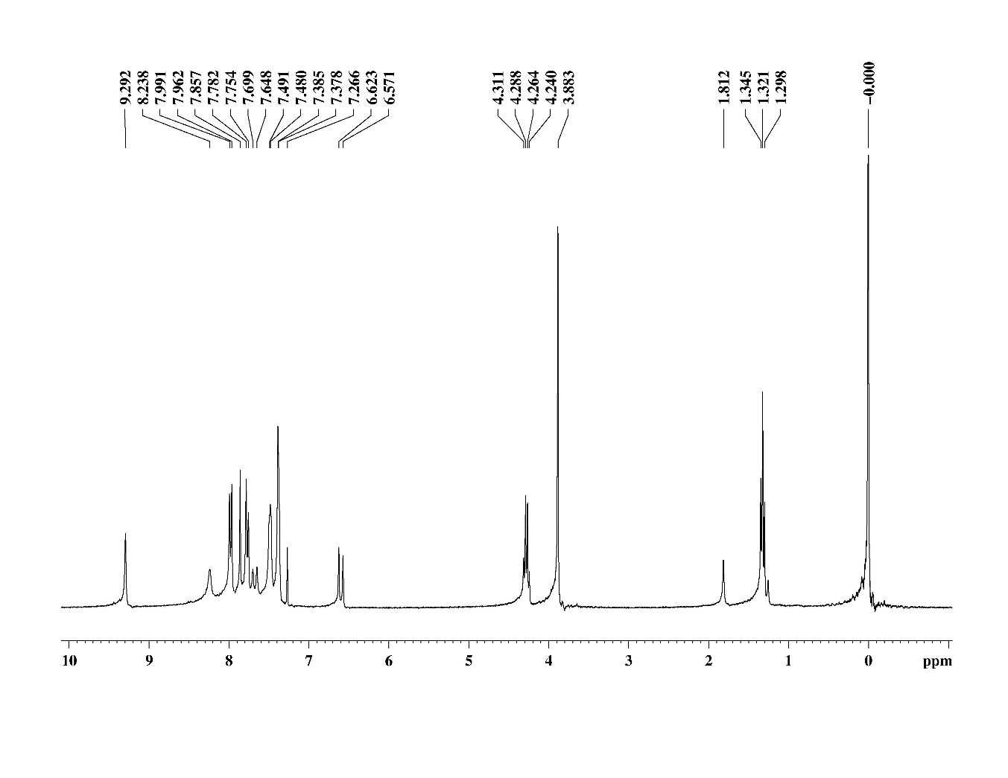Figure S1. Ethyl 5-(4-cinnamamidobenzamido)-1-methyl-1H-pyrazole-4-carboxylate 26a.

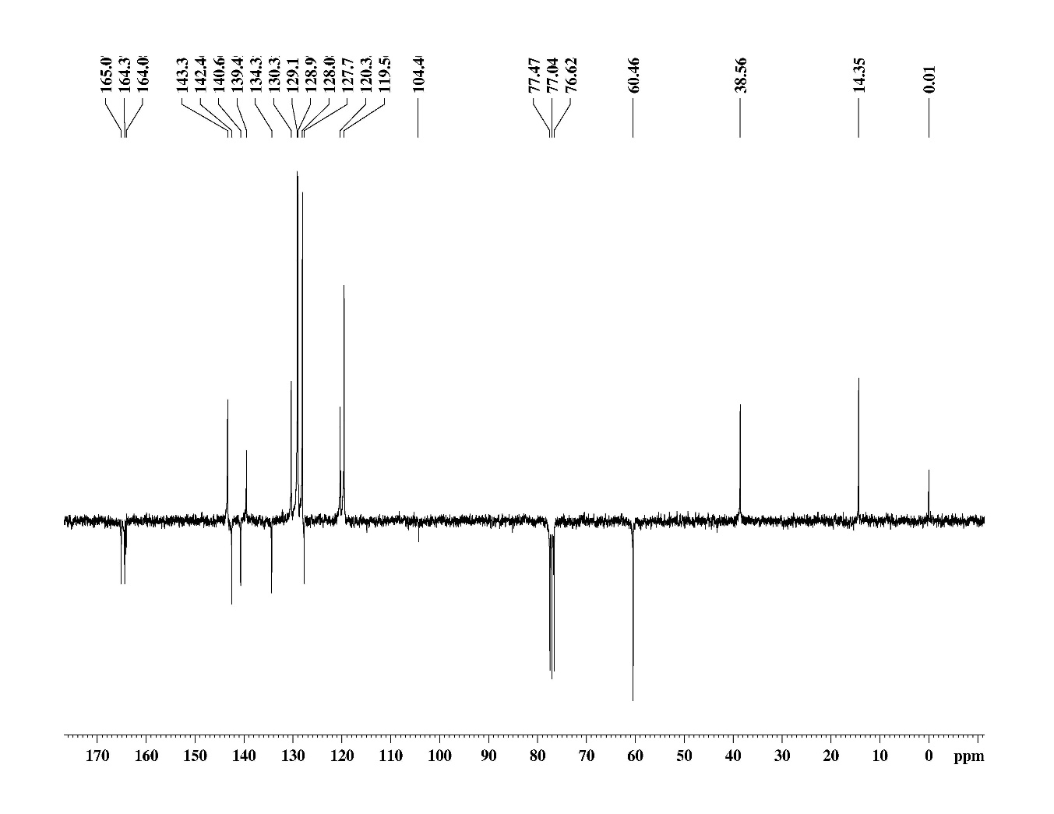
Figure S2. APT of Ethyl 5-(4-cinnamamidobenzamido)-1-methyl-1H-pyrazole-4-carboxylate 26a.

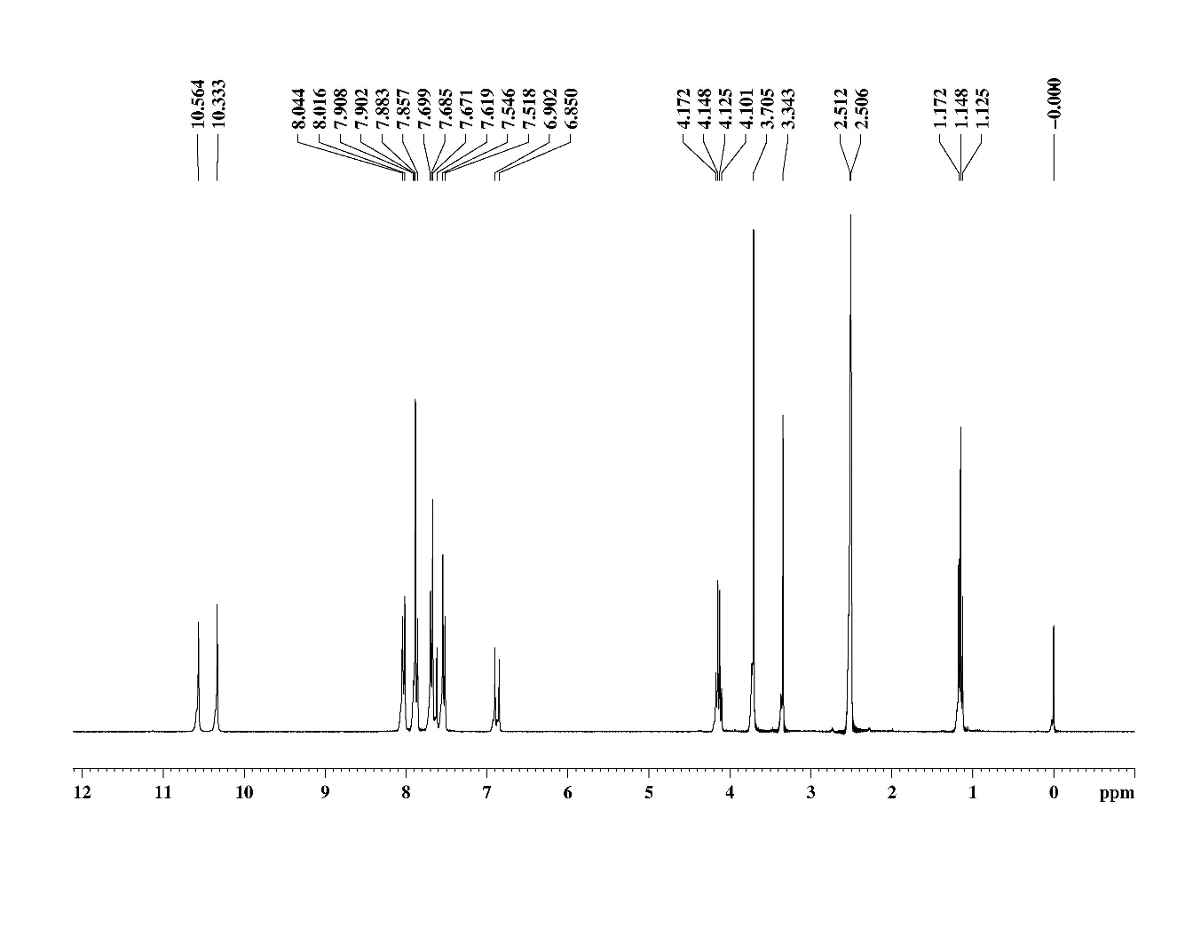
Figure S3. 1H NMR of 5-iodo-2-((1R,2R)-2-phenylcyclopropane-1-carboxamido)benzamide 26c.

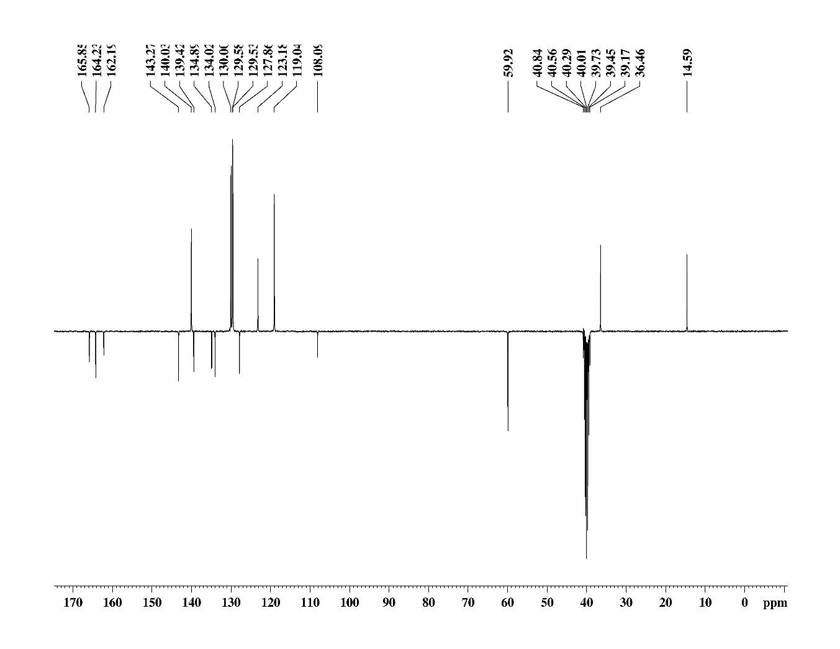
Figure S4. ATP of Ethyl 5-(4-(3-(4-chlorophenyl)acrylamido)benzamido)-1-methyl-1H-pyrazole-4-carboxylate 26c.

Figure S5. Ethyl 5-(4-(3-(4-chlorophenyl)acrylamido)benzamido)-1-phenyl-1H-pyrazole-4-carboxylate 26f.

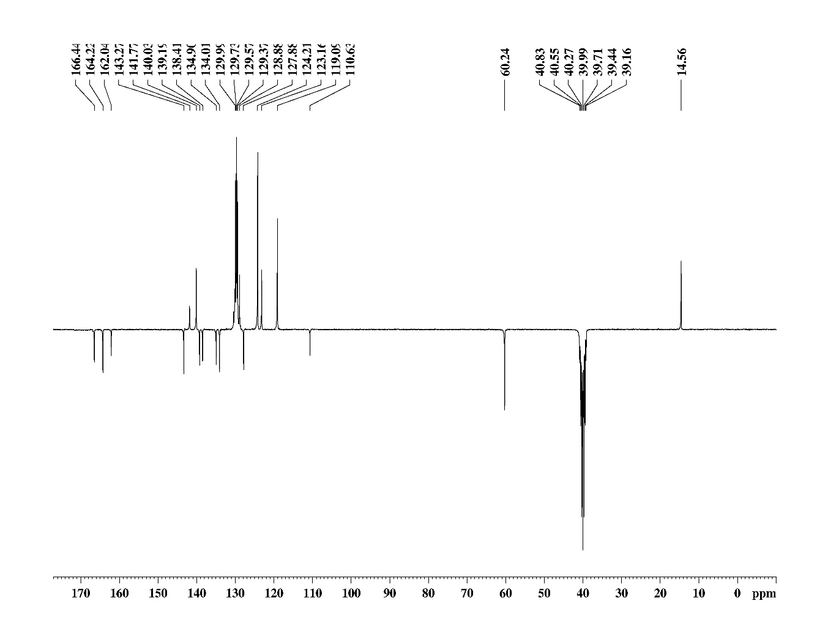
Figure S6. APT of Ethyl 5-(4-(3-(4-chlorophenyl)acrylamido)benzamido)-1-phenyl-1H-pyrazole-4-carboxylate 26f.

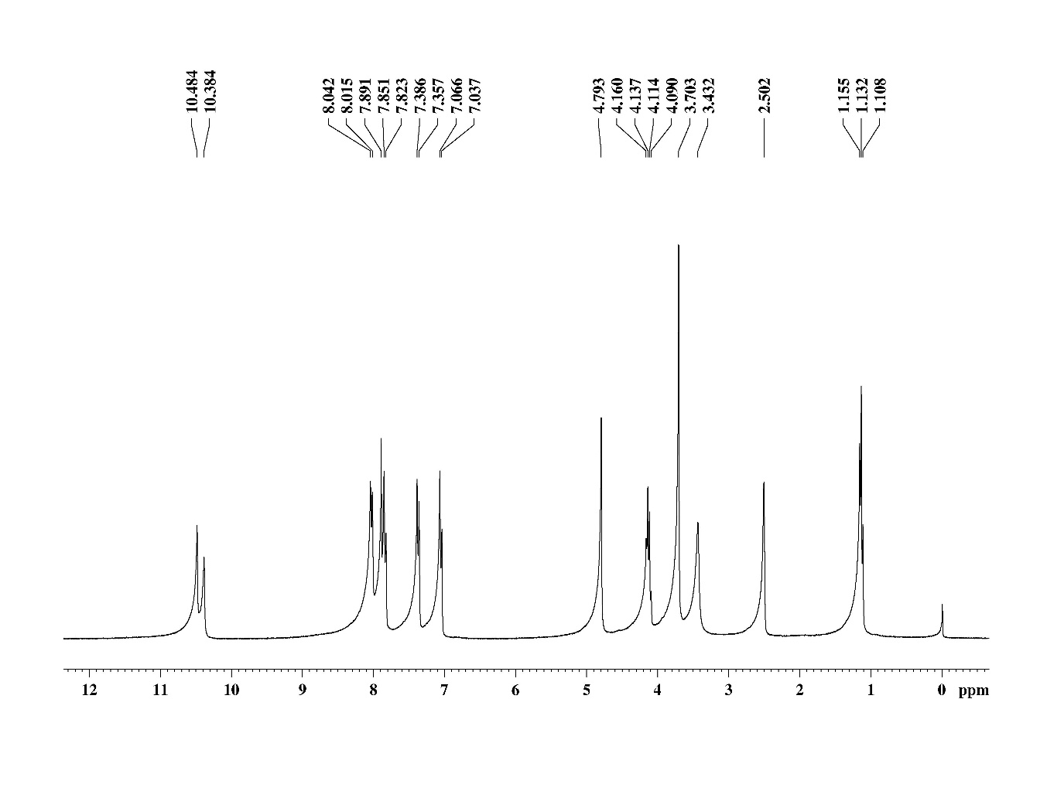
Figure S8. 1H NMR of Ethyl 5-(4-(2-(4-chlorophenoxy)acetamido)benzamido)-1-methyl-1H-pyrazole-4-carboxylate 27c.

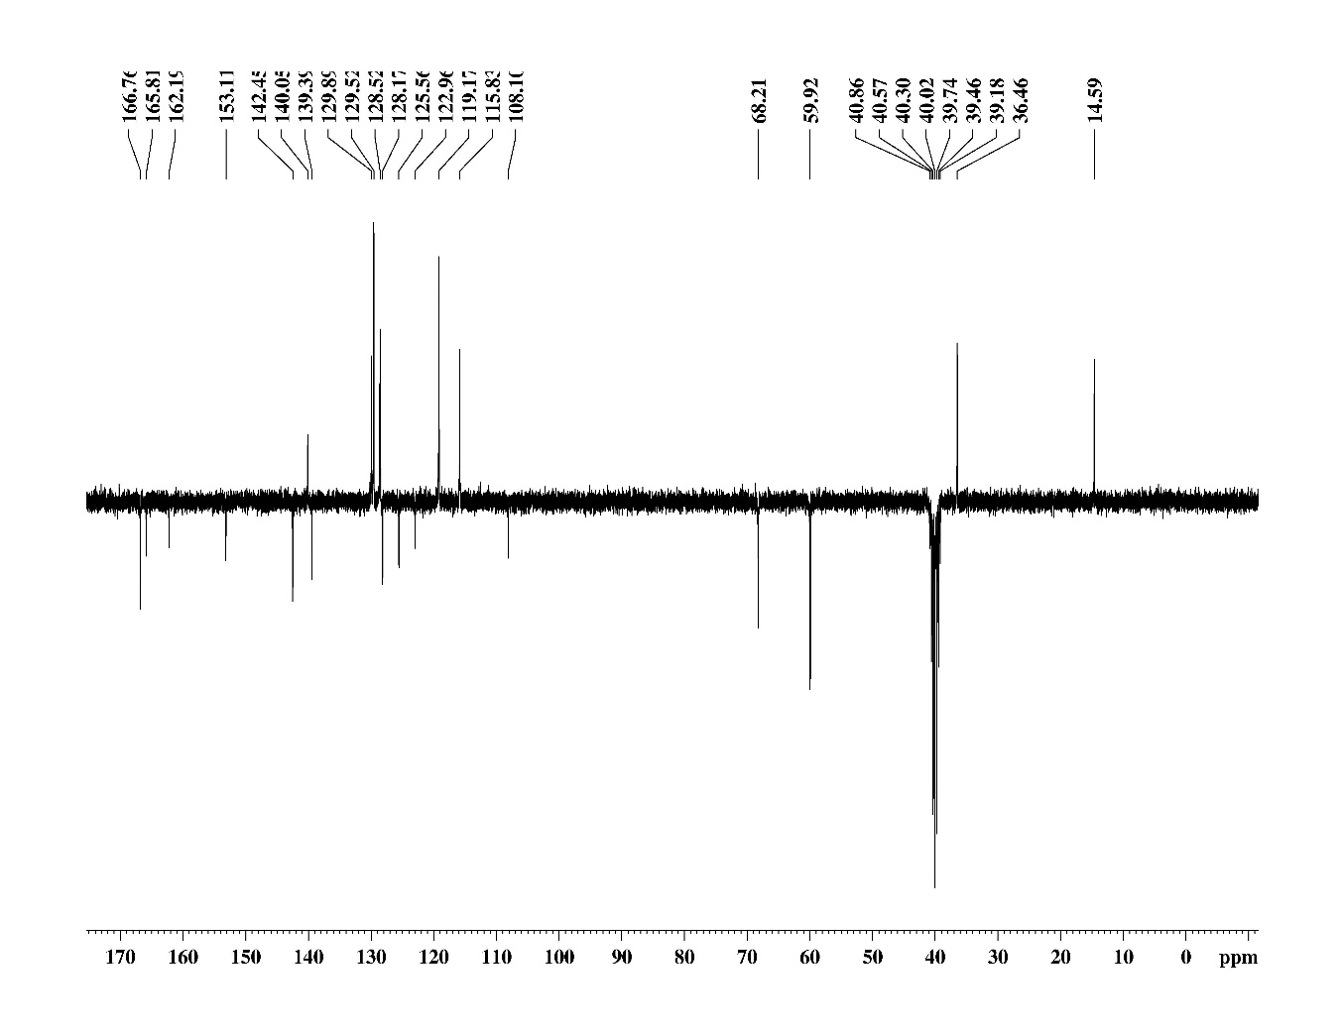
Figure S10. ATP of Ethyl 5-(4-(2-(2,4-dichlorophenoxy)acetamido)benzamido)-1-methyl-1H-pyrazole-4-carboxylate 27d.

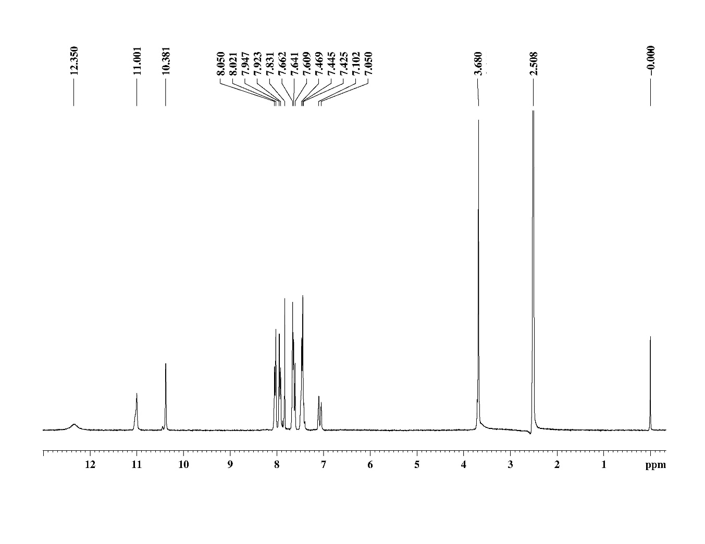
Figure S11. 1H NMR of 5-(4-cinnamamidobenzamido)-1-methyl-1H-pyrazole-4-carboxylic acid 28a.

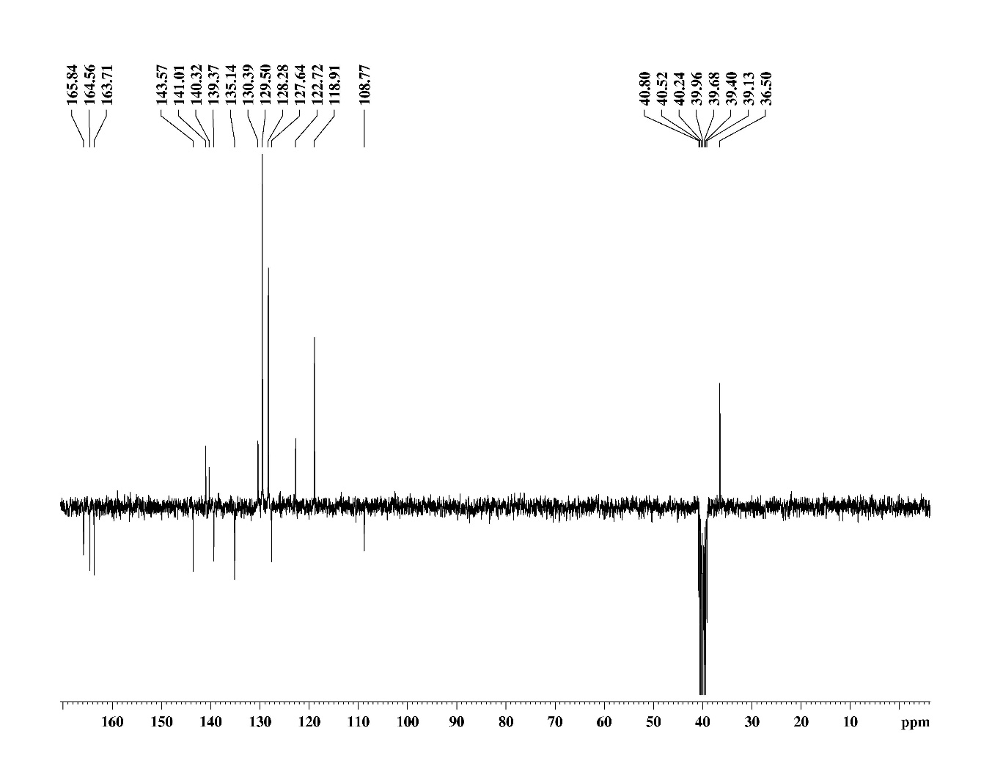
Figure S12. APT of 5-(4-cinnamamidobenzamido)-1-methyl-1H-pyrazole-4-carboxylic acid 28a.

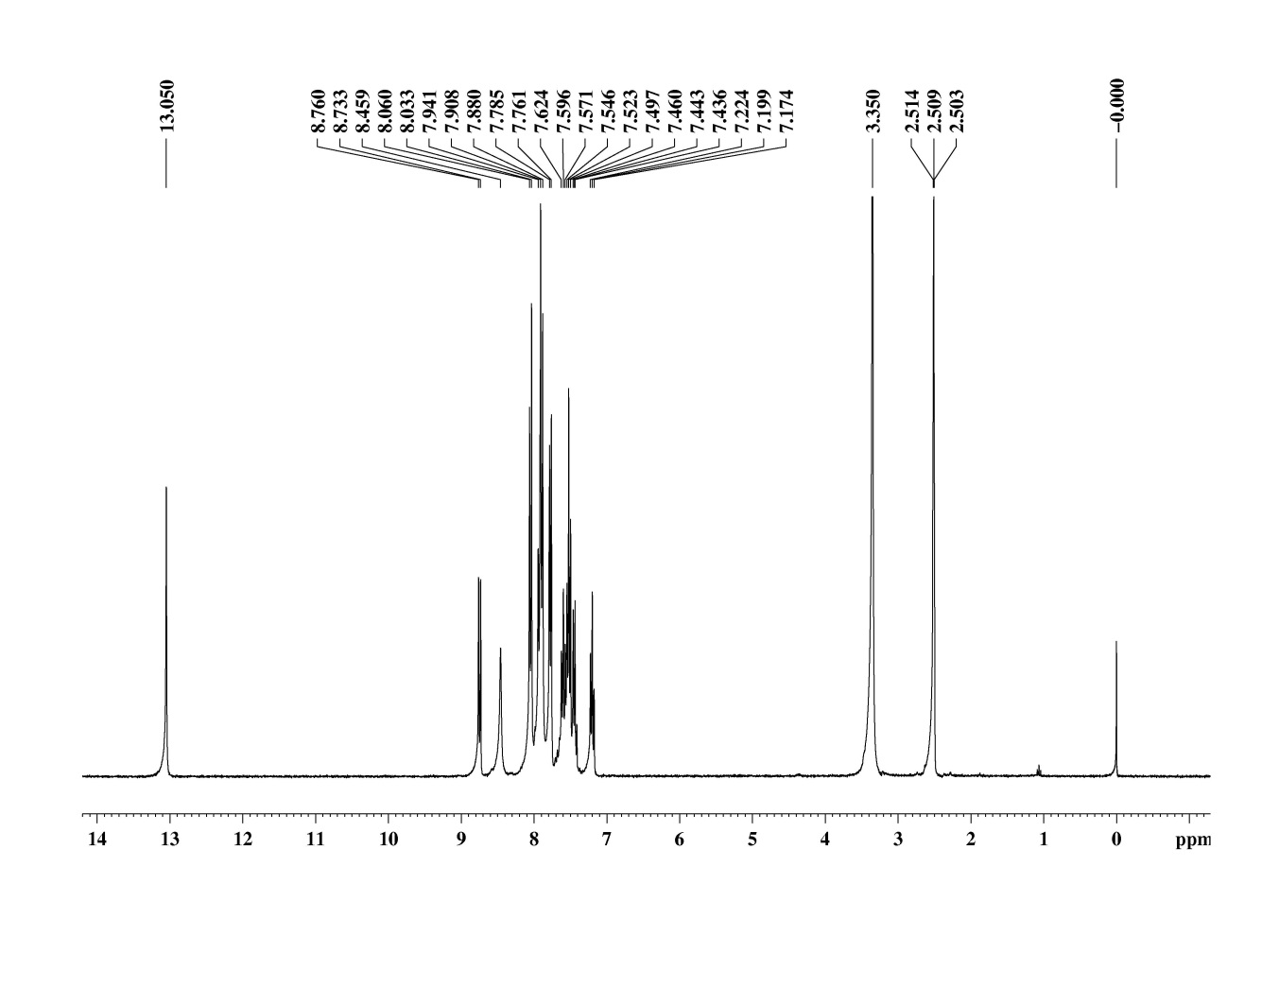
Figure S15. 1H NMR of 5-(4-cinnamamidobenzamido)-1-phenyl-1H-pyrazole-4-carboxylic acid 28f.

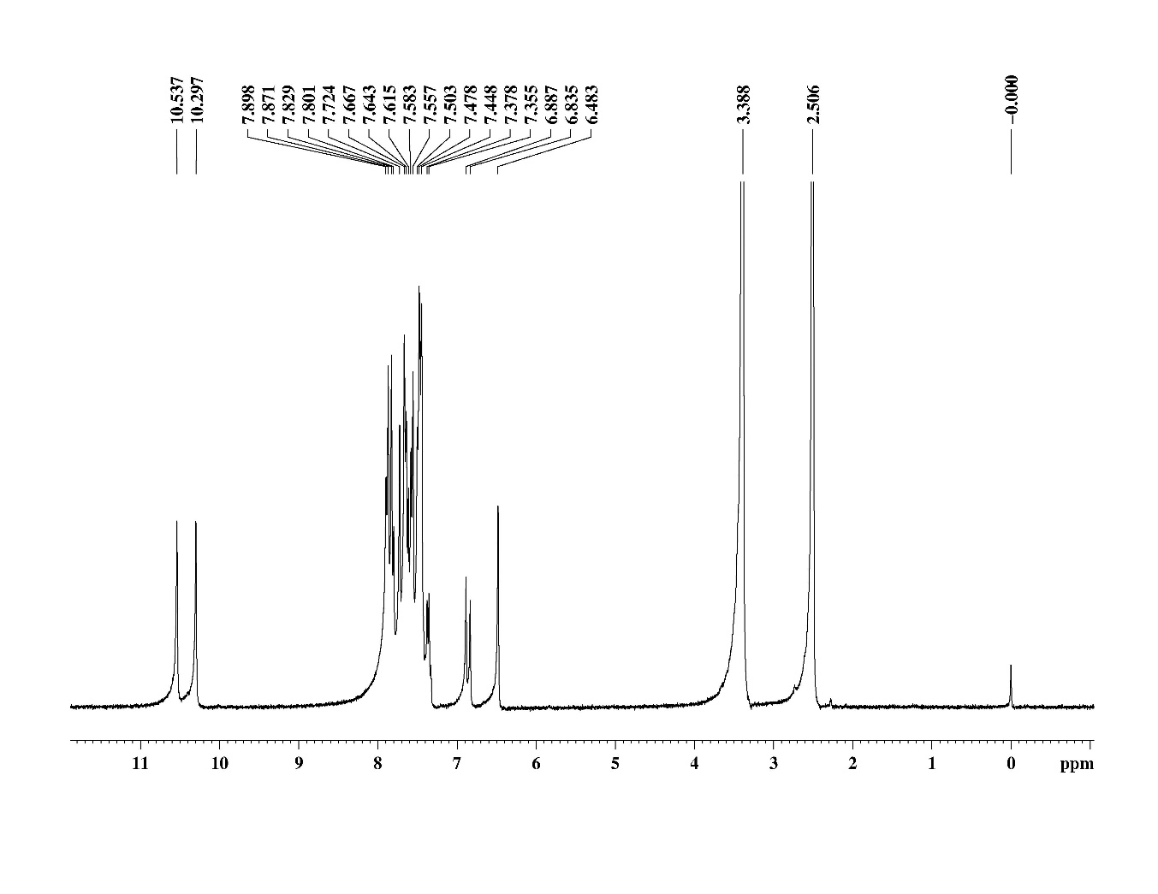
Figure S17. 1H NMR of 4-cinnamamido-N-(1-phenyl-1H-pyrazol-5-yl)benzamide 29a.

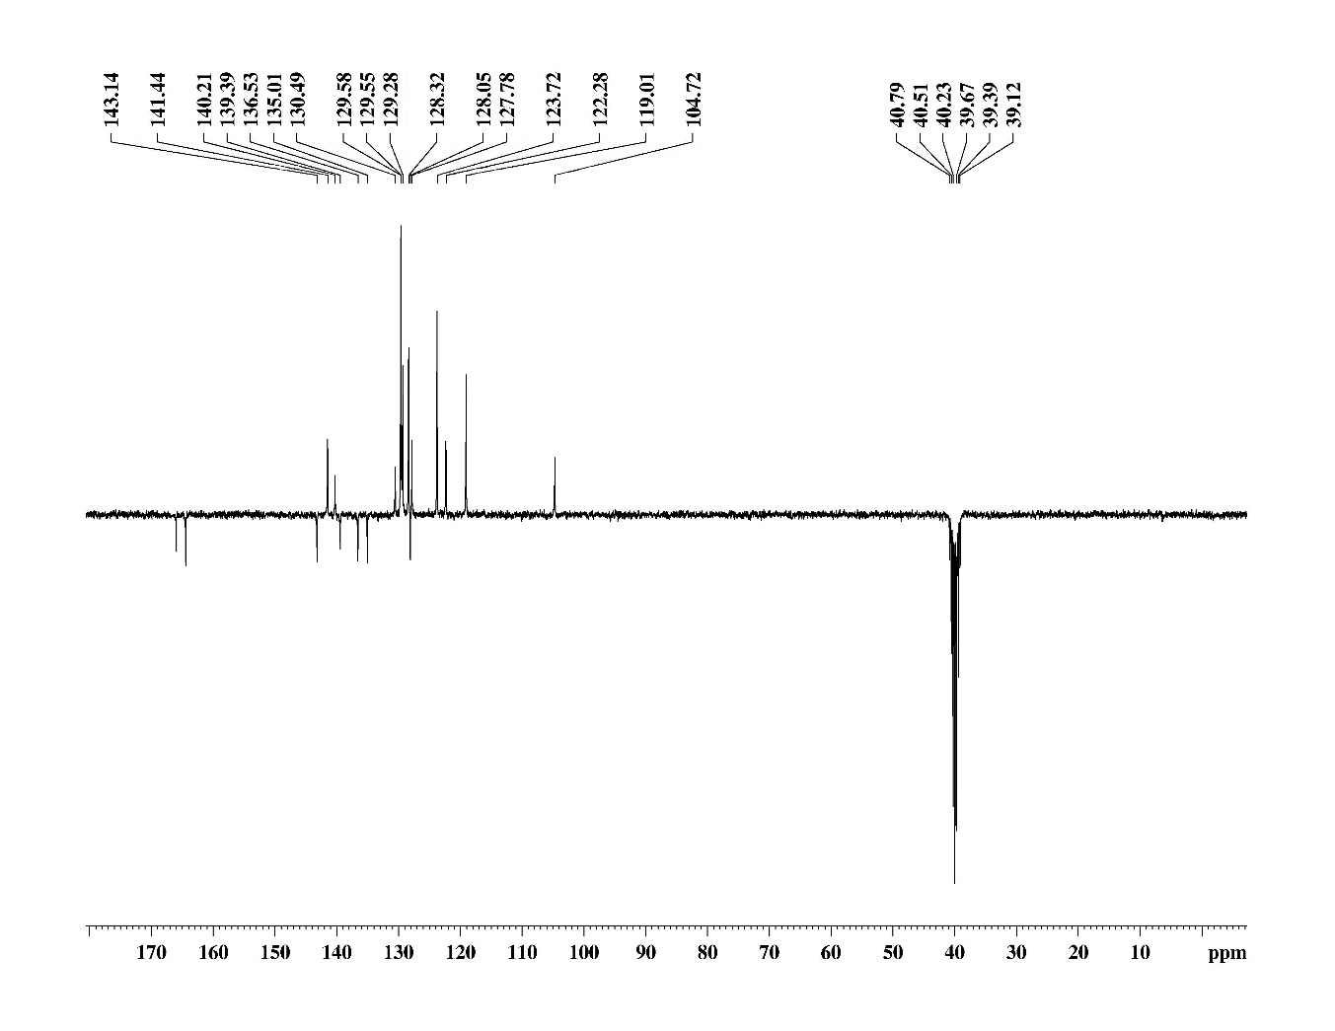
Figure S18. ATP of 4-cinnamamido-N-(1-phenyl-1H-pyrazol-5-yl)benzamide 29a.

