Supplementary Material - Thermal Fractional Diffusion: Experimental Evidence from the Discrepancies in the Amplitude and Phase in Photothermal Technique
A. Somer^{a,∗}, A. Novatskiª, Gerson Kniphoff da Cruzª, Claudia Bonardi Kniphoff da Cruzª, Francisco Carlos Serbenaª, Ervin Kaminski Lenziª
ªDepartamento de Física, Universidade Estadual de Ponta Grossa, Av. Gen. Carlos Cavalcanti 4748, Ponta Grossa 84030-900, PR, Brazil

Results of the fit of experimental data
The best fits by using the classical model for simultaneous (orange) and individual (blue) are shown in figure. The obtained parameters from NonLinearModelfit for the fit shown in figure S1 are presented in Table S1. The A Fit represents the induvial fit for the amplitude of the PA signal, represented by the solid blue line. The $∅$ Fit represents the induvial fit for the phase of the PA signal, represented by the solid blue line. The Classic is the result of the solid orange line, which represents the simultaneous fit of amplitude and phase of the PA signal with the classical model. The comparison between the results of the best simultaneous fit with GCEII (orange) and the Classical result (blue) is shown in Figure S2, and for GCEIII, it is shown in Figure S3. Table S1 provides the fitted parameters. The green lines are the TD and TE contributions for the fractional models.
Table S1 – Parameters obtained from the fit of one set of measurements of each sample for the results presented in Figures S1 and S2. The Classical, GCEII and GCEIII results are obtained from Simultaneous Fit of Amplitude and Phase.
Sample | Fit | C₁  (a. u.) | C₂  (10⁻³ m.s^{1/2}) | $$α_{s}$$  (10⁻⁶ m²/s) | f_{c2}  (Hz) | $$δ_{c3}$$ | $$τ$$  (10⁻⁵ s) | $$γ$$ | R²
A285 | A Fit | 325 | 1.86 | 4.467 | 8.3 | 1.5 | - | - | 0.9998
A285 | $∅$ Fit | 1400 | 1.83 | 3.432 | 35 | 0.75 | - | - | 0.9999
A285 | Classical | 232 | 2.08 | 4.084 | 20 | 0.86 | - | - | 0.9997
A285 | GCEII | 255 | 4.34 | 4.107 | 33 | - | 2.82 | 0.924 | 0.9999
A285 | GCEIII | 250 | 3.05 | 5.005 | 20 | - | 4.09 | 0.999 | 0.9999
A400 | A Fit | 298 | 2.15 | 6.363 | 13 | 2.2 | - | - | 0.9998
A400 | $∅$ Fit | 939 | 1.27 | 4.750 | 30 | 1.20 | - | - | 0.9985
A400 | Classic | 302 | 2.11 | 6.340 | 14 | 1.36 | - | - | 0.9996
A400 | GCEII | 459 | 1.67 | 4.189 | 19 | - | 5.00 | 0.998 | 0.9994
A400 | GCEIII | 401 | 1.92 | 5.250 | 17 | - | 4.98 | 0.999 | 0.9994
A480 | A Fit | 206 | 3.21 | 5.983 | 9.0 | 2.00 | - | - | 0.9998
A480 | $∅$ Fit | 511 | 2.13 | 5.267 | 9.7 | 1.71 | - | - | 0.9998
A480 | Classic | 220 | 3.16 | 5.644 | 10 | 1.44 | - | - | 0.9998
A480 | GCEII | 385 | 1.17 | 4.035 | 13 | - | 6.82 | 0.997 | 0.9998
A480 | GCEIII | 354 | 1.97 | 4.233 | 11 | - | 6.78 | 0.962 | 0.9998
A600 | A Fit | 150 | 4.59 | 7.293 | 8.3 | 2.23 | - | - | 0.9999
A600 | $∅$ Fit | 919 | 2.97 | 6.297 | 6.2 | 1.09 | - | - | 0.9998
A600 | Classic | 167 | 4.50 | 6.615 | 8.5 | 0.77 | - | - | 0.9996
A600 | GCEII | 342 | 2.16 | 4.633 | 15 | - | 4.23 | 0.997 | 0.9996
A600 | GCEIII | 394 | 1.86 | 4.299 | 15 | - | 4.04 | 0.934 | 0.9996
Figure S1 – Experimental data and the curves obtained from the fitted parameters with the classical model of one set of measurements for each sample.
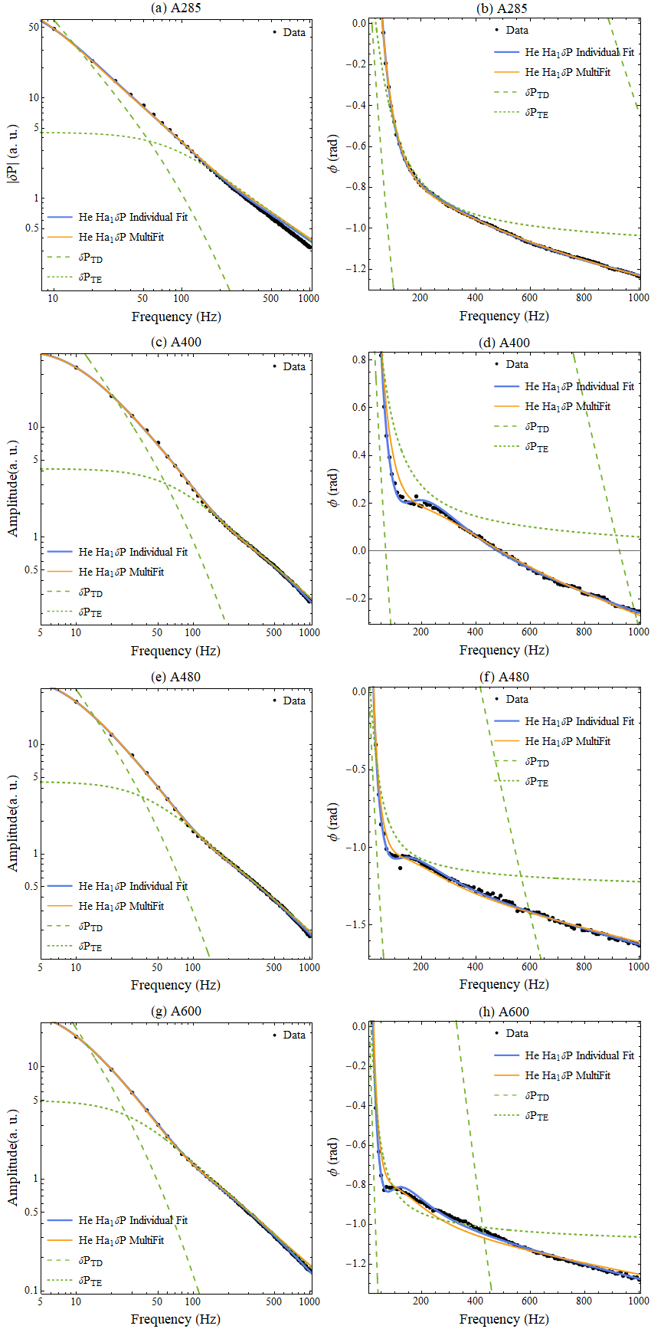
Figure S2 – Experimental data and the curves obtained from the fitted parameters with the fractional GCEII model of one set of measurements for each sample.

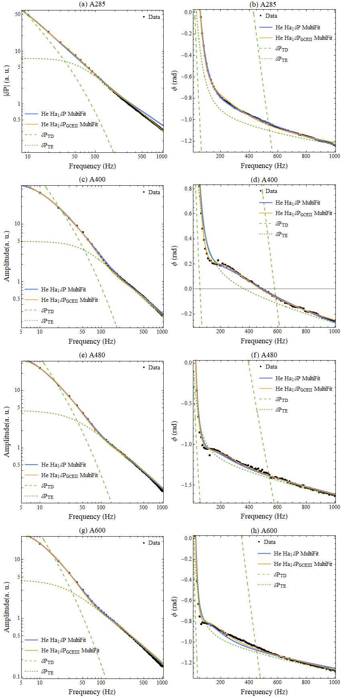
Figure S3 – Experimental data and the curves obtained from the fitted parameters with the fractional GCEIII model of one set of measurements for each sample.

