Research Article

Bile acids induce neurite outgrowth in NSC-34 cells via TGR5 and a distinct transcriptional profile

Hayley Ackerman¹, ² and Glenn S. Gerhard¹

Figure S1. Principal component plot. The PCA plot shows the control basal medium (red) and DCA and CDCA (blue) samples in a three dimensional plot spanned by their first three principal components.

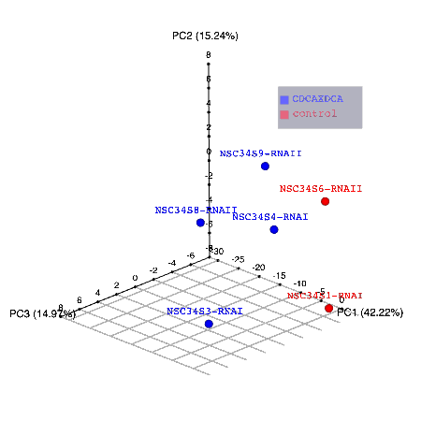

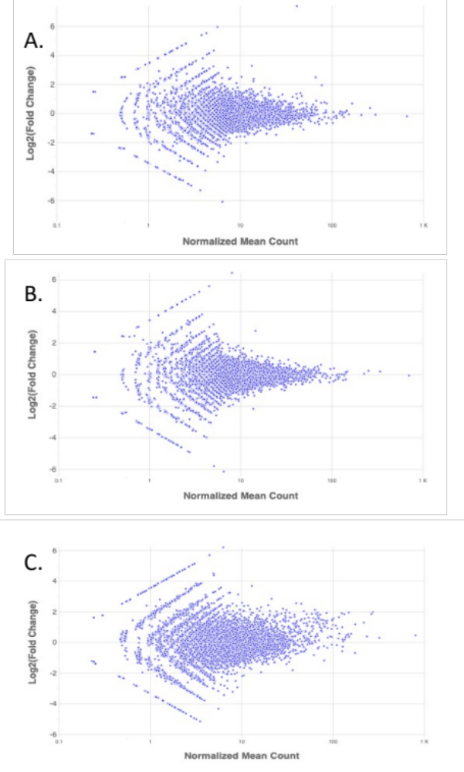

Figure S2. In DESeq2, the function plotMA shows the log2 fold changes attributable to a given transcript over the mean of normalized counts for all the samples A. Plot of RA versus DM. B. Plot of DCA versus DM. C. Plot of CDCA versus DM.

Table S1. Genes whose change in expression level relative to control basal neurite induction media lacking RA met a nominal (P<0.05) level of statistical significance.
GeneName | log2FoldChange | pvalue | BASELINE | 2 HOURS
Dkk3 | 2.50 | 2.26E-13 | 19.92 | 112.97
Ctsb | 1.96 | 4.41E-11 | 31.73 | 123.40
Cyp26b1 | 7.40 | 4.58E-07 | 0.49 | 82.52
Hid1 | 3.29 | 8.21E-05 | 2.48 | 24.24
Alpl | 1.41 | 0.00018 | 24.80 | 65.97
Ubald2 | -6.08 | 0.00040 | 12.59 | 0.19
Adnp | 5.97 | 0.00061 | 0.18 | 11.12
Zbtb18 | 1.35 | 0.00061 | 23.16 | 58.98
Cd9 | 1.21 | 0.00079 | 28.36 | 65.52
Atp1a1 | 0.69 | 0.00084 | 126.90 | 205.38
Zfp445 | 2.22 | 0.0012 | 4.91 | 22.91
Rps2 | -1.11 | 0.0014 | 66.99 | 30.98
Scg2 | 1.78 | 0.0019 | 8.34 | 28.62
Plxnd1 | 1.70 | 0.0020 | 9.84 | 31.85
Ikbip | 5.54 | 0.0023 | 0.18 | 8.36
Lgals1 | -1.46 | 0.0029 | 36.16 | 13.17
Irs2 | 1.31 | 0.0032 | 16.58 | 41.14
Gse1 | 1.14 | 0.0035 | 23.32 | 51.29
Ctsd | 0.78 | 0.0036 | 61.12 | 105.22
Mcam | -5.29 | 0.0049 | 7.16 | 0.18
Ptp4a3 | 2.53 | 0.0050 | 3.05 | 17.59
Tnfsf13b | 3.16 | 0.0057 | 1.47 | 13.16
Txnrd1 | 1.06 | 0.0058 | 27.19 | 56.71
Sdf4 | 2.38 | 0.0058 | 4.52 | 23.53
Hand2 | 0.88 | 0.0072 | 47.57 | 87.54
Wdr75 | -2.02 | 0.0087 | 18.61 | 4.58
Chrna3 | 1.51 | 0.0089 | 8.80 | 25.06
Serinc1 | 0.69 | 0.0089 | 67.35 | 108.96
Stx7 | 1.41 | 0.0092 | 11.20 | 29.72
Tubb5 | -0.67 | 0.0095 | 107.62 | 67.59
Stmn1 | -1.05 | 0.0103 | 50.69 | 24.42
Cdh6 | 4.34 | 0.0109 | 0.48 | 9.82
Arhgap11a | -3.34 | 0.0118 | 10.32 | 1.02
Polr2m | -1.38 | 0.0119 | 27.94 | 10.73
Metrn | 1.68 | 0.0120 | 6.34 | 20.24
Celf4 | 1.29 | 0.0126 | 12.47 | 30.47
Tshz2 | 1.14 | 0.0129 | 16.33 | 35.91
Cenpe | -2.94 | 0.0135 | 11.73 | 1.53
Mki67 | -0.90 | 0.0137 | 59.13 | 31.76
Pum1 | 2.38 | 0.0137 | 2.46 | 12.76
Syt1 | 0.74 | 0.0138 | 57.22 | 95.75
Cerk | 2.44 | 0.0141 | 2.45 | 13.26
Gramd1b | 1.67 | 0.0148 | 5.99 | 19.09
Pcsk6 | -1.42 | 0.0152 | 28.35 | 10.63
Ica1 | -4.96 | 0.0155 | 5.67 | 0.18
Marcksl1 | 1.25 | 0.0161 | 12.16 | 28.97
Gabarapl1 | 4.15 | 0.0171 | 0.49 | 8.68
Fam102a | 2.37 | 0.0174 | 2.45 | 12.65
H19 | 4.15 | 0.0174 | 0.49 | 8.67
Maml3 | 2.79 | 0.0181 | 1.47 | 10.15
Ptma | -0.65 | 0.0182 | 124.95 | 79.62
9330182L06Rik | 2.10 | 0.0203 | 3.44 | 14.76
Vegfa | 1.52 | 0.0203 | 7.16 | 20.53
Dcaf6 | 4.07 | 0.0208 | 0.49 | 8.22
Scd2 | 0.38 | 0.0211 | 227.39 | 295.52
Bmt2 | 2.74 | 0.0214 | 1.46 | 9.74
Fbxo38 | -2.70 | 0.0226 | 10.10 | 1.55
Fyttd1 | -1.43 | 0.0233 | 20.85 | 7.72
Tuba1b | -0.74 | 0.0240 | 90.52 | 54.28
Aurkb | -4.87 | 0.0240 | 5.31 | 0.18
Eif2ak3 | 3.25 | 0.0242 | 0.97 | 9.23
Hace1 | 2.45 | 0.0252 | 1.96 | 10.71
Glrx3 | -4.84 | 0.0256 | 5.19 | 0.18
Ttc39b | 1.57 | 0.0265 | 5.86 | 17.40
Ccndbp1 | 4.82 | 0.0266 | 0.17 | 4.93
Cog2 | 4.82 | 0.0266 | 0.17 | 4.93
Hpcal4 | 4.82 | 0.0266 | 0.17 | 4.93
Kcnn3 | 1.56 | 0.0269 | 5.88 | 17.33
Ephx1 | 1.24 | 0.0271 | 10.29 | 24.40
Kif2c | -3.93 | 0.0278 | 7.80 | 0.51
Prkaca | 1.35 | 0.0278 | 8.81 | 22.45
Chka | 2.66 | 0.0282 | 1.46 | 9.17
Tagln2 | -1.59 | 0.0282 | 16.77 | 5.59
Plk1 | -2.16 | 0.0284 | 11.37 | 2.54
Tmem41b | 2.65 | 0.0286 | 1.47 | 9.23
Hsp90aa1 | -0.65 | 0.0293 | 79.58 | 50.73
Ltbp3 | 1.44 | 0.0296 | 6.92 | 18.75
Rbfox2 | 1.52 | 0.0314 | 5.96 | 17.05
Ccna2 | -1.41 | 0.0315 | 20.42 | 7.66
Ltbr | 3.10 | 0.0318 | 0.96 | 8.23
Mvb12a | 2.61 | 0.0331 | 1.50 | 9.13
Gstm2 | 1.28 | 0.0339 | 8.82 | 21.48
Cyth3 | 0.73 | 0.0345 | 35.72 | 59.16
Hoxd8 | 3.81 | 0.0359 | 0.52 | 7.27
Trove2 | 2.57 | 0.0360 | 1.47 | 8.73
Ski | 1.55 | 0.0364 | 6.06 | 17.74
Vamp4 | -1.57 | 0.0368 | 14.93 | 5.03
Racgap1 | -1.04 | 0.0374 | 29.15 | 14.16
Rrm2 | -2.94 | 0.0376 | 7.85 | 1.02
Nsg2 | 0.88 | 0.0382 | 21.47 | 39.58
Rnf166 | 2.94 | 0.0395 | 0.99 | 7.59
Syncrip | -1.32 | 0.0406 | 21.31 | 8.52
Gprasp2 | 1.45 | 0.0415 | 6.26 | 17.14
Tspan13 | 1.27 | 0.0422 | 8.29 | 19.97
Srp54a | 4.67 | 0.0437 | 0.17 | 4.40
Epb41l2 | -1.11 | 0.0450 | 28.26 | 13.12
Mdm1 | -1.40 | 0.0450 | 17.61 | 6.67
Dlg4 | 1.45 | 0.0454 | 5.90 | 16.15
Prpf19 | 1.35 | 0.0454 | 7.39 | 18.90
Phf12 | -2.30 | 0.0455 | 10.02 | 2.04
Phox2a | 0.84 | 0.0460 | 22.52 | 40.23
Mcm6 | -1.94 | 0.0469 | 11.77 | 3.06
Tiprl | -2.18 | 0.0475 | 9.77 | 2.16
Nckap1l | 2.87 | 0.0483 | 0.98 | 7.16
Fbln1 | -1.62 | 0.0485 | 13.75 | 4.48
Clk2 | 2.46 | 0.0487 | 1.48 | 8.17
Kars | -0.95 | 0.0488 | 31.35 | 16.20
Rnaseh2a | -4.61 | 0.0488 | 4.55 | 0.19
Sun1 | -2.44 | 0.0490 | 8.55 | 1.58
Mmgt1 | -2.18 | 0.0492 | 9.30 | 2.05
Ptprr | 2.43 | 0.0492 | 1.56 | 8.41
Agl | 2.95 | 0.0493 | 0.98 | 7.57

Table S2. Genes whose change in expression level relative to control basal neurite induction media lacking DCA met a nominal (P<0.05) level of statistical significance.
GENE | log2 Fold Change | p-value | BASELINE | 2 HOURS
Sdf4 | 2.78 | 5.25E-05 | 3.70 | 25.37
Dynlt1b | 6.44 | 6.44E-05 | 0.18 | 15.83
Ubald2 | -6.13 | 0.00038 | 12.85 | 0.18
Oaz1 | -5.78 | 0.00098 | 10.00 | 0.18
Adnp | 5.61 | 0.0015 | 0.18 | 8.81
Kdelr2 | -2.16 | 0.0037 | 22.45 | 5.01
Gpsm1 | 5.06 | 0.0143 | 0.18 | 6.00
Ikbip | 4.92 | 0.0173 | 0.18 | 5.40
Sulf2 | -4.90 | 0.0182 | 5.30 | 0.18
Nlk | 3.19 | 0.0184 | 0.99 | 9.05
Gprasp1 | 0.95 | 0.0200 | 22.72 | 44.00
Gm38431 | -4.85 | 0.0238 | 5.10 | 0.18
Kif2c | -3.98 | 0.0239 | 7.96 | 0.50
Nova1 | -2.01 | 0.0240 | 11.76 | 2.92
Bclaf1 | -0.99 | 0.0291 | 40.27 | 20.24
Rab23 | 3.02 | 0.0297 | 0.99 | 8.06
Erlin1 | -2.58 | 0.0298 | 9.23 | 1.54
Adi1 | 4.77 | 0.0298 | 0.18 | 4.85
Mvb12a | 2.59 | 0.0299 | 1.54 | 9.31
Nanos1 | -3.87 | 0.0312 | 7.39 | 0.50
Rbm6 | -3.90 | 0.0319 | 7.48 | 0.50
Ttbk2 | -3.03 | 0.0336 | 8.35 | 1.02
Gas2l3 | -1.98 | 0.0344 | 12.07 | 3.06
Foxm1 | -3.01 | 0.0345 | 7.96 | 0.99
Tprgl | 3.82 | 0.0354 | 0.50 | 7.00
Pcdha8 | 4.76 | 0.0357 | 0.18 | 4.81
Rpl34 | 2.42 | 0.0358 | 1.75 | 9.39
Asf1b | -1.89 | 0.0358 | 12.94 | 3.50
Hdgfl2 | 1.75 | 0.0363 | 4.11 | 13.83
Ube2o | 1.83 | 0.0384 | 4.14 | 14.71
Ctdnep1 | 2.55 | 0.0389 | 1.50 | 8.78
Ubr2 | 2.25 | 0.0389 | 2.00 | 9.52
Eif1 | 1.17 | 0.0400 | 10.47 | 23.56
Plekha1 | 1.10 | 0.0400 | 12.79 | 27.39
Klf13 | 4.63 | 0.0432 | 0.18 | 4.37
Atp8b2 | 1.93 | 0.0433 | 3.01 | 11.48
Man2a1 | 2.04 | 0.0434 | 2.47 | 10.13
Dcun1d2 | 4.62 | 0.0441 | 0.18 | 4.33
Ppib | 3.70 | 0.0449 | 0.50 | 6.49
Tpm2 | -4.60 | 0.0456 | 4.28 | 0.18
Rps12 | 0.63 | 0.0462 | 59.65 | 92.62
2310022A10Rik | 4.65 | 0.0468 | 0.18 | 4.45
Lgals1 | -0.93 | 0.0471 | 36.93 | 19.34
Bysl | 2.60 | 0.0475 | 1.48 | 8.97

Table S3. Genes whose change in expression level relative to control basal neurite induction media lacking CDCA met a nominal (P<0.05) level of statistical significance.
GENE | log2 Fold Change | p-value | BASELINE | 2 HOURS
Fau | 2.53 | 0.0017 | 13.28 | 76.47
Rps26 | 1.99 | 0.0019 | 109.55 | 436.55
Rpl18a | 1.96 | 0.0033 | 60.76 | 237.17
Rps28 | 2.85 | 0.0039 | 5.18 | 37.30
Rpl36 | 2.56 | 0.0040 | 11.49 | 67.54
Rpl41 | 1.86 | 0.0042 | 113.87 | 413.33
Rpl32 | 1.92 | 0.0042 | 35.57 | 134.25
Oraov1 | 3.68 | 0.0046 | 1.86 | 23.90
Uba52 | 1.85 | 0.0051 | 57.68 | 207.98
Rpl35 | 2.13 | 0.0056 | 23.60 | 103.56
Rplp1 | 2.04 | 0.0061 | 18.75 | 77.21
Rpl21 | 1.96 | 0.0065 | 27.85 | 108.27
1700021F05Rik | 5.70 | 0.0067 | 0.17 | 8.70
Rps24 | 1.90 | 0.0068 | 52.74 | 196.67
Rps15 | 1.88 | 0.0086 | 27.75 | 102.29
Rpl10a | 1.82 | 0.0086 | 31.91 | 113.07
Rps17 | 1.77 | 0.0089 | 30.99 | 105.65
Rps3 | 1.57 | 0.0095 | 51.18 | 151.56
Rps12 | 1.66 | 0.0108 | 55.62 | 175.96
Rpl37a | 2.43 | 0.0119 | 6.11 | 32.89
Rpl37 | 1.87 | 0.0123 | 25.23 | 92.31
Mki67 | -1.80 | 0.0125 | 56.19 | 16.09
Rpl38 | 2.20 | 0.0153 | 10.13 | 46.54
Chchd10 | 2.12 | 0.0154 | 11.58 | 50.20
Prph | 1.53 | 0.0156 | 50.41 | 145.98
Rps6 | 1.45 | 0.0172 | 52.83 | 144.07
Rps10 | 1.58 | 0.0191 | 34.91 | 104.67
Rpl14 | 1.54 | 0.0202 | 35.69 | 103.47
Lbr | -3.21 | 0.0206 | 14.37 | 1.55
Zc3h13 | -5.14 | 0.0208 | 6.80 | 0.19
Rps29 | 2.03 | 0.0210 | 9.45 | 38.51
Rps8 | 1.82 | 0.0211 | 16.74 | 58.90
Rpl27a | 1.51 | 0.0211 | 33.65 | 95.65
Crip1 | 3.13 | 0.0213 | 1.88 | 16.38
Rpl18 | 1.62 | 0.0214 | 26.62 | 81.57
Rpl17 | 1.85 | 0.0221 | 22.37 | 80.50
Med23 | -2.92 | 0.0226 | 15.82 | 2.09
Rpl6 | 1.45 | 0.0236 | 52.23 | 142.93
Mrpl20 | 3.23 | 0.0250 | 1.40 | 13.13
Rps11 | 1.94 | 0.0250 | 12.42 | 47.73
Myef2 | -4.31 | 0.0253 | 10.58 | 0.53
Minos1 | 2.06 | 0.0259 | 7.88 | 32.95
Rpl28 | 1.66 | 0.0263 | 33.00 | 104.61
Atp5h | 1.88 | 0.0271 | 11.60 | 42.84
Rpl31 | 1.40 | 0.0274 | 45.71 | 120.33
Tprgl | 4.39 | 0.0276 | 0.45 | 9.49
Aprt | 2.30 | 0.0282 | 5.50 | 27.13
Josd2 | 5.14 | 0.0284 | 0.17 | 5.92
Ftl1 | 1.27 | 0.0287 | 50.10 | 120.54
Rpl4 | 1.30 | 0.0294 | 125.64 | 309.30
Gm1673 | 4.51 | 0.0295 | 0.41 | 9.40
Ikbip | 5.13 | 0.0304 | 0.17 | 5.89
Rpl12 | 1.59 | 0.0305 | 30.32 | 91.26
Cebpb | 5.10 | 0.0307 | 0.17 | 5.73
Gstp1 | 1.85 | 0.0309 | 10.59 | 38.24
Nenf | 3.58 | 0.0309 | 0.91 | 10.86
Rpl19 | 1.48 | 0.0311 | 39.08 | 108.86
Emp1 | -4.93 | 0.0325 | 5.83 | 0.19
Rpl27 | 1.53 | 0.0336 | 23.23 | 67.24
Rpl24 | 1.43 | 0.0336 | 46.65 | 125.75
Ovca2 | 5.07 | 0.0340 | 0.17 | 5.62
Bex3 | 1.94 | 0.0348 | 13.82 | 53.18
Gas2l3 | -3.42 | 0.0349 | 11.72 | 1.09
Naxe | 3.49 | 0.0350 | 0.92 | 10.37
Smc4 | -1.94 | 0.0350 | 25.89 | 6.74
Pgls | 2.20 | 0.0362 | 5.26 | 24.18
Top1 | -2.99 | 0.0366 | 12.39 | 1.56
Uchl1 | 1.47 | 0.0371 | 41.49 | 114.66
Gm15772 | 1.83 | 0.0372 | 11.04 | 39.36
Rpl9 | 1.78 | 0.0372 | 11.13 | 38.21
Acbd6 | 2.38 | 0.0379 | 3.41 | 17.80
Rps4x | 1.32 | 0.0386 | 38.35 | 96.02
Rpsa | 1.19 | 0.0400 | 107.15 | 243.68
Pomp | 2.41 | 0.0406 | 3.72 | 19.74
Ncan | -4.81 | 0.0412 | 5.38 | 0.19
Snx19 | -4.81 | 0.0417 | 5.36 | 0.19
Rps20 | 1.56 | 0.0429 | 24.82 | 73.35
Pfdn5 | 2.07 | 0.0434 | 6.05 | 25.41
Marcksl1 | 1.65 | 0.0437 | 11.19 | 35.11
Ndufa12 | 1.65 | 0.0438 | 16.17 | 50.75
Rps19 | 1.63 | 0.0444 | 16.83 | 52.03
Rps25 | 1.33 | 0.0445 | 38.86 | 97.57
Bnip1 | 4.93 | 0.0447 | 0.17 | 5.08
Snrpd2 | 3.58 | 0.0450 | 0.92 | 10.94
Mpv17l2 | 2.60 | 0.0463 | 2.84 | 17.29
Rps3a1 | 1.27 | 0.0465 | 38.85 | 93.63
Ifi30 | 3.22 | 0.0469 | 1.39 | 12.91
Top2a | -1.41 | 0.0476 | 45.11 | 16.93
Rps18 | 1.75 | 0.0483 | 13.78 | 46.20
Dek | -2.50 | 0.0490 | 14.54 | 2.58
Cox6a1 | 1.68 | 0.0493 | 18.00 | 57.87
Rnf166 | 3.30 | 0.0494 | 0.92 | 9.10
Cfdp1 | 1.84 | 0.0495 | 7.48 | 26.72
Rpl23a | 1.37 | 0.0496 | 30.93 | 79.89

