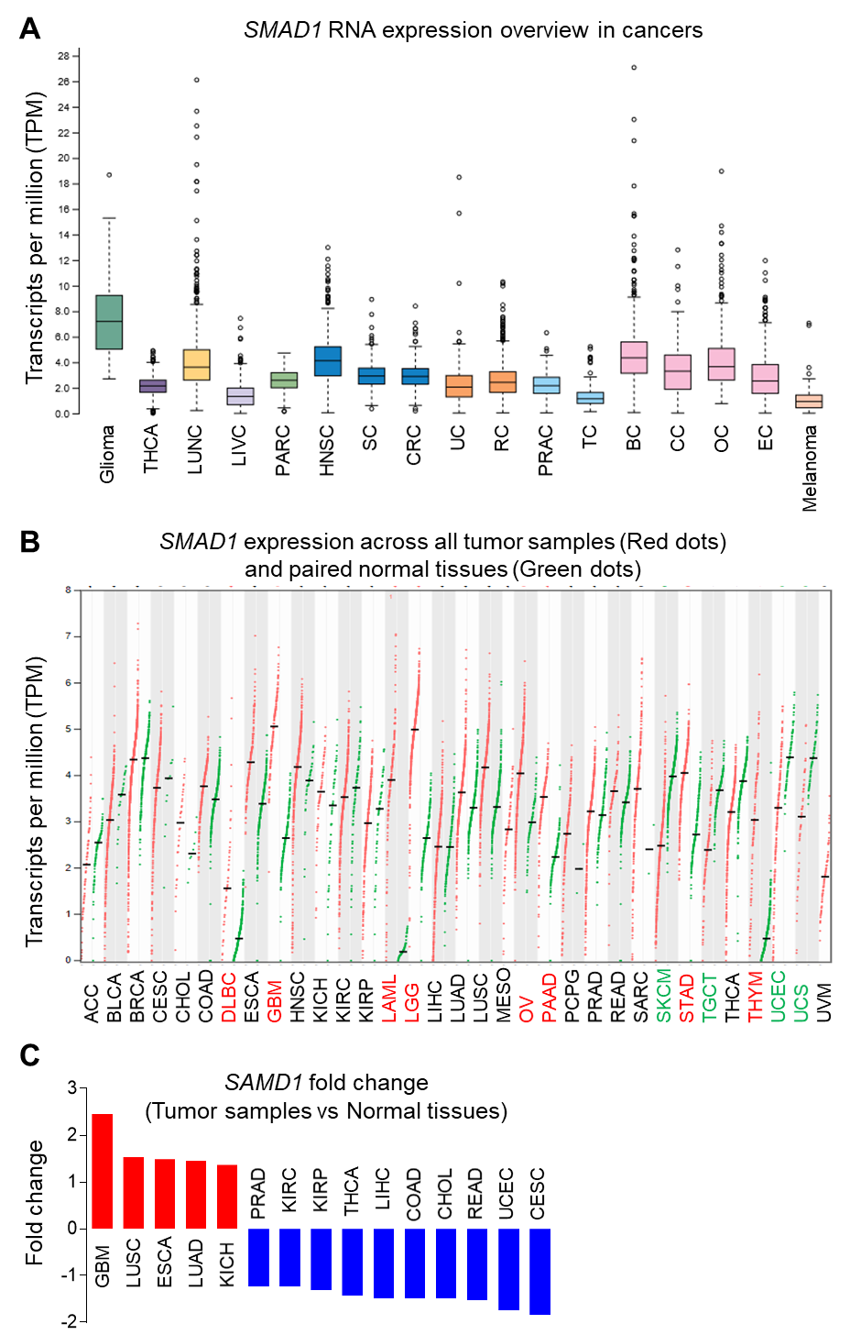
Supplementary Fig.1 SMAD1 is overexpressed in glioblastoma (GBM).
A. RNA expression overview of TCGA RNA-seq data derived from The Human Protein Atlas shows gliomas have the highest SMAD1 expression among cancers.
B. Dot plot from GENEPIA shows SMAD1 expression profile across all tumor samples (Red dots) and paired normal tissues (Green dots). Data includes TCGA normal and GTEx data. Cancers with higher SMAD1 are shown in red and those with lower SMAD1 are shown in green. ANOVA, Log2FC > 1, q value < 0.01.
C. Comparison of SMAD1 transcript levels between tumor samples and normal tissues. Results were derived from GCBI based on RNA-seqV2 datasets. ANOVA, Log2FC > 1, p < 0.05.

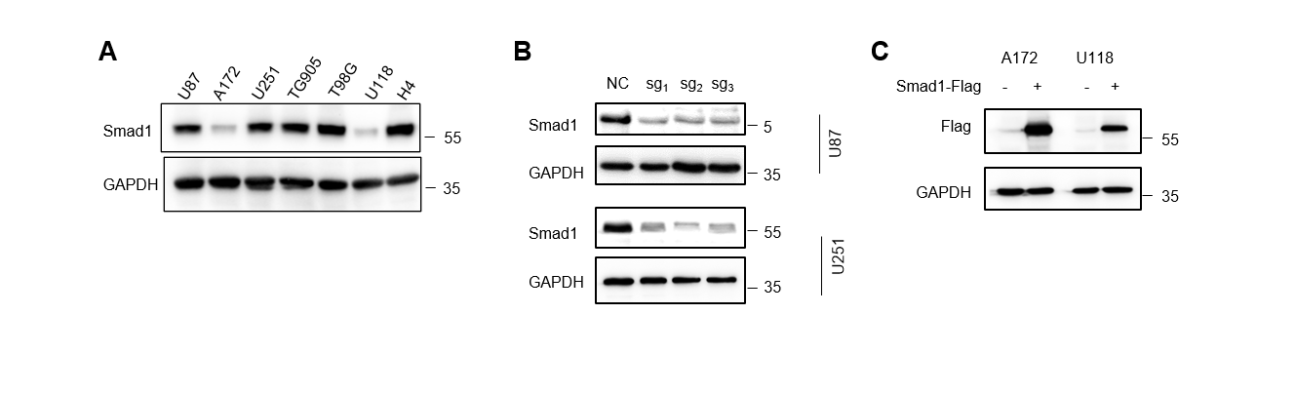

Supplementary Fig.2 Verification of CRISPR/Cas9 mediated SMAD1 knockout and overexpression construction.
A. Western blot analysis showing the expression of Smad1 in various glioma cell lines.
B. Western blot analysis of Smad1 expression in U87 and U251 cells with CRISPR/Cas9-mediated gene depletion. GAPDH served as a loading control.
C. Western blot analysis of ectopic Smad1 expression in A172 and U118 cells using anti-Flag antibody. GAPDH served as a loading control.

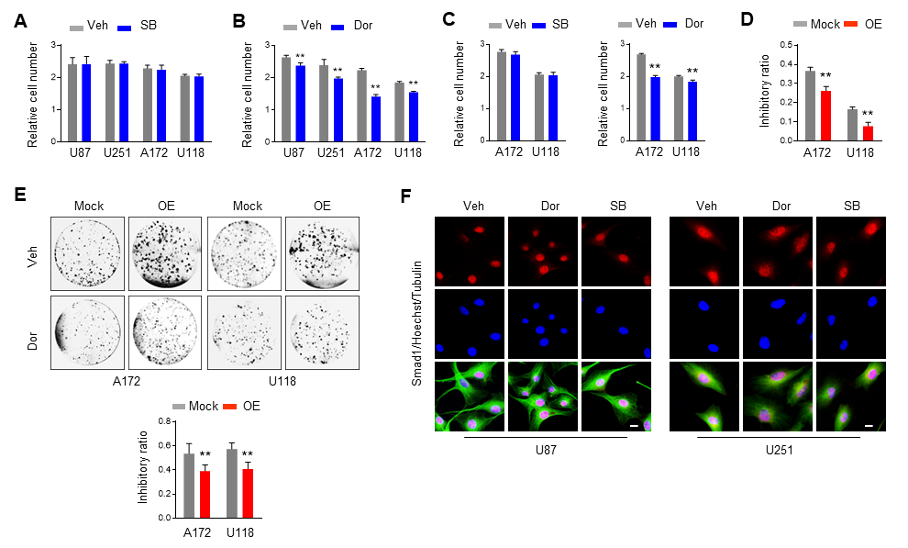
Supplementary Fig.3. Smad1 functions in GBM TGF/BMP independently.
A. Cell growth assay of GBM cell lines treated with SB431542 (SB, 5 μM) for 48 hours. (n = 6)
B. Cell growth assay of GBM cell lines treated with Dorsomorphin (Dor, 2 μM) for 48 hours. (n = 6, **p < 0.01)
C. Cell growth assay of A172 and U118 cells expressing ectopic Smad1 treated with SB (5 μM) or Dor (2 μM) for 48 hours. (n = 6, **p < 0.01)
D. Quantitative analysis of the relative inhibitory ratio of Dor treatment on A172 and U118 cells expressing Mock or ectopic Smad1 (OE). (n=6, **p < 0.01)
E. Representative colony formation (upper panel) of indicated cells treated with Dor. The culture medium was supplemented with Dor and changed every 48 hours. The lower panel shows the quantitation of relative inhibition of colony formation. (n = 6, **p < 0.01).
F. Double immunofluorescence (IF) staining of Smad1 and Tubulin in U87 and U251 cells with the indicated treatment. Hoechst (Hoe) labeled the nuclei. Scale bars, 10 μm.

