Additional information
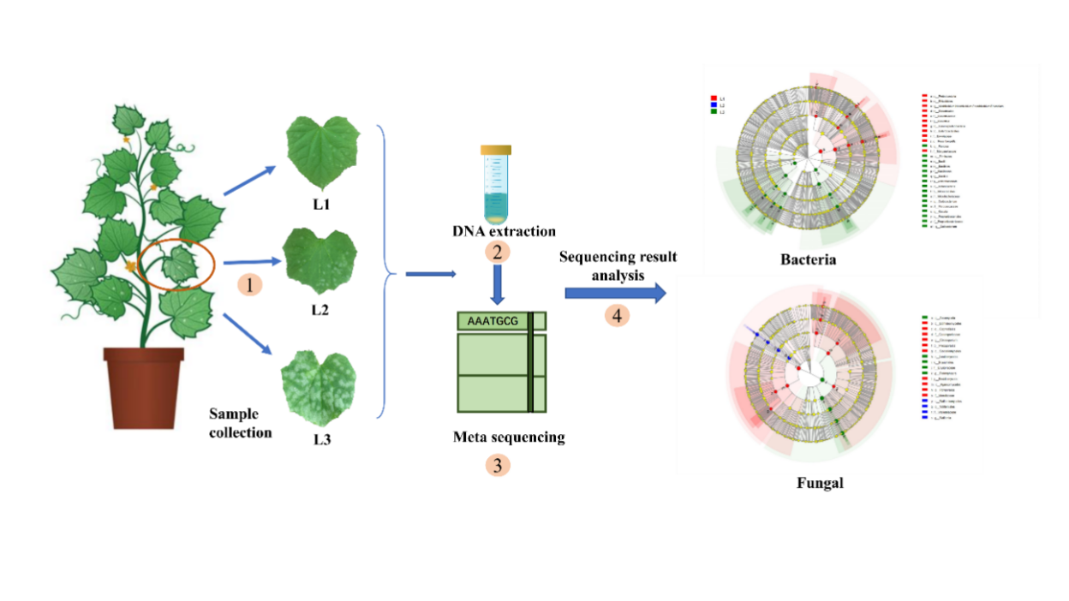
Flow chart of phyllosphere microbial community analysis of cucumber powdery mildew. Cucumber leaves of different incidence grades from the same leaf position were collected for the phyllosphere microbial DNA extraction and sequencing.

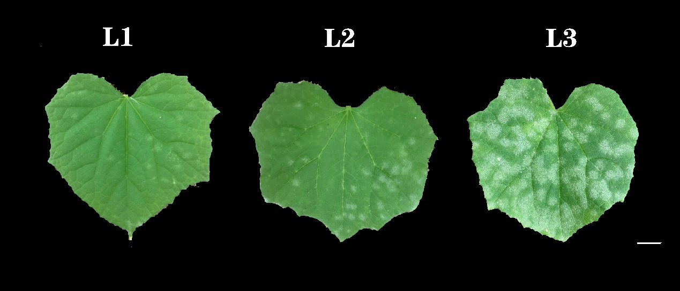
Fig. S1 Cucumber leaves of different disease grades. L1 ≤ 10%, 30% ≤ L2 < 50%, and L3 ≥ 50%. Scaleplate: 1 cm.

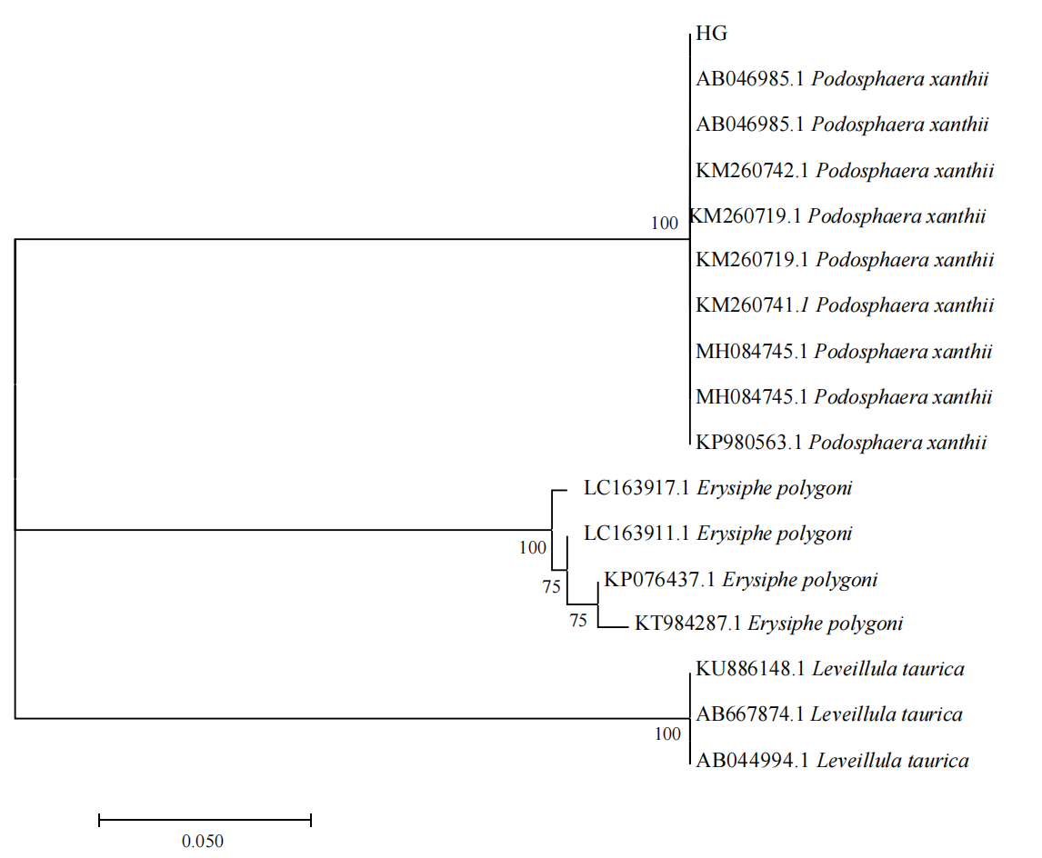
Fig. S2 Phylogenetic tree based on ITSrDNA sequence analysis. HG: cucumber powdery mildew pathogen.

Amplified Region | Samples | Sequences | Bases (bp) | Average Length | Average sequence bar
799F_1193R | 15 | 3600945 | 1360774562 | 377 | 240063
ITS1F_ITS2R | 15 | 3857627 | 925866375 | 240 | 257175
Table S1 Optimize sequence information

Table S2 Statistics of sequencing information
Sample | Bacteria |  | Fungal
Sample | Seq_ number | OTUs number | Seq_ number | OTUs number
L1_1 | 235243 | 766 | 231651 | 424
L1_2 | 241805 | 517 | 229596 | 306
L1_3 | 253207 | 785 | 228567 | 169
L1_4 | 150365 | 524 | 238916 | 547
L1_5 | 329538 | 895 | 283094 | 753
L2_1 | 189536 | 514 | 285343 | 238
L2_2 | 214062 | 541 | 264443 | 368
L2_3 | 236736 | 456 | 248487 | 415
L2_4 | 214204 | 402 | 300387 | 365
L2_5 | 264162 | 750 | 226256 | 467
L3_1 | 257601 | 1285 | 286478 | 383
L3_2 | 271244 | 1118 | 240101 | 341
L3_3 | 262081 | 1176 | 260323 | 351
L3_4 | 262097 | 1021 | 255578 | 321
L3_5 | 219064 | 1134 | 278407 | 369
Total | 3600945 | 3104 | 3857627 | 1454

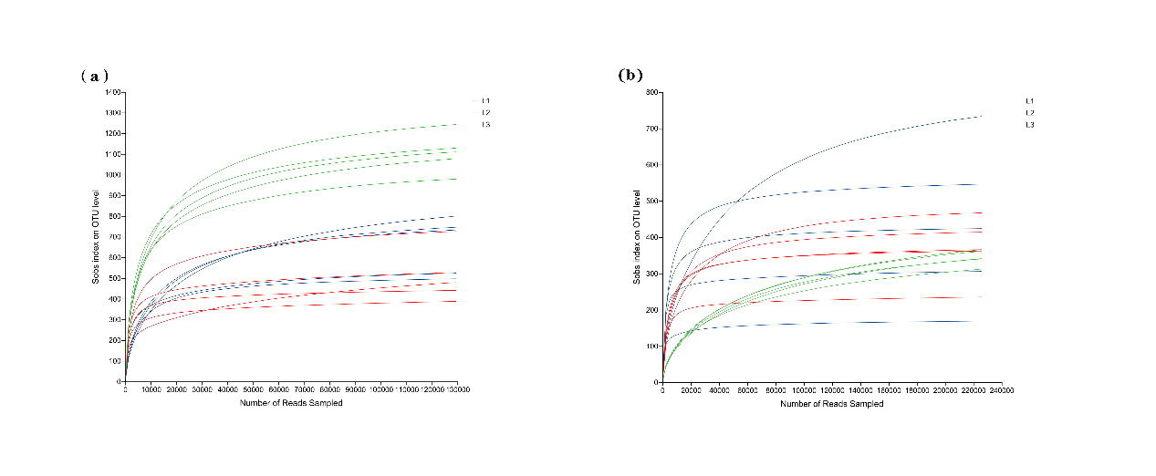
Fig. S3 The Rarefaction curves for samples. (a) Bacteria, (b) Fungal

Table S3 Topological indices of each network in Fig. 8
Network properties | Bacteria |  |  | Fungal
Network properties | L1 | L2 | L3 | L1 | L2 | L3
Number of nodes | 299 | 299 | 299 | 299 | 267 | 299
Number of edges | 4515 | 3984 | 3188 | 4873 | 2534 | 3614
The percentage of positive edges | 76.01 | 77.21 | 51.29 | 93.78 | 71.51 | 81.35
The percentage of negative edges | 23.99 | 22.79 | 48.71 | 6.22 | 28.49 | 18.65
Network diameter | 8 | 7 | 6 | 7 | 7 | 7
Average path length | 3.263 | 3.302 | 3.345 | 3.393 | 3.189 | 3.303
Average degree | 30.201 | 26.649 | 21.324 | 32.595 | 18.981 | 24.174

