Supplementary data
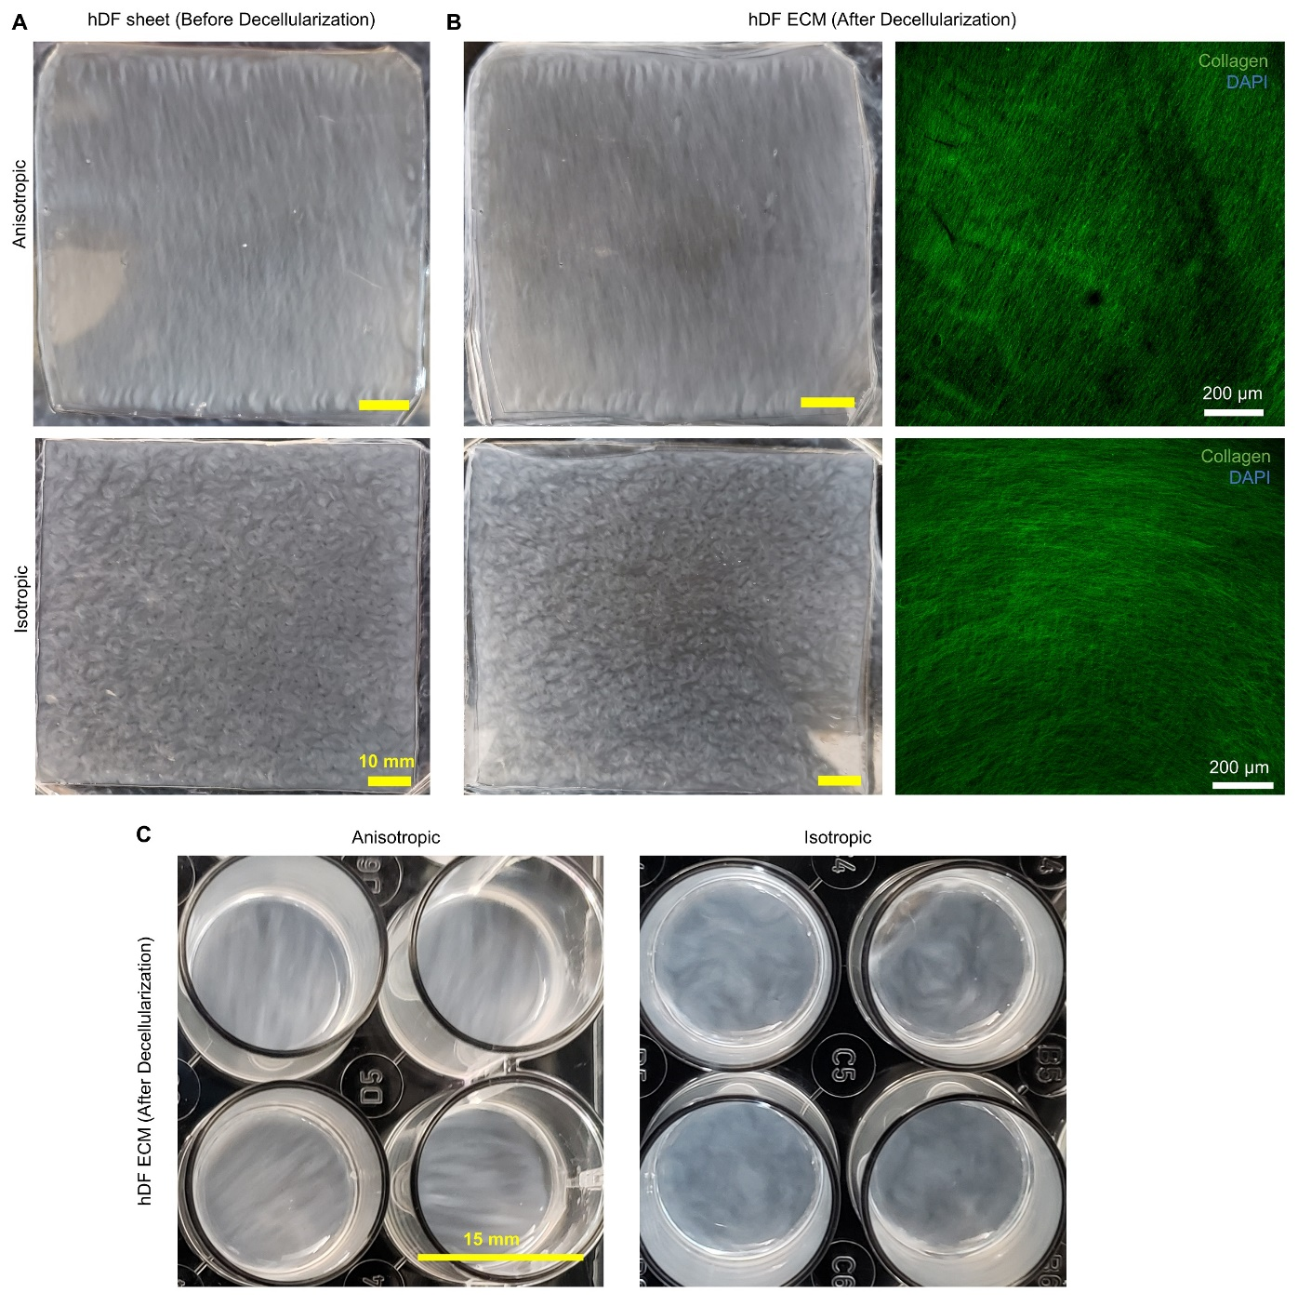
Figure S1 Fabrication of completely biological hDF-ECM scaffolds. (A) Anisotropic or isotropic hDF-sheets developed by growing hDF on micro-pattern or flat PDMS substrates, respectively. (B) hDF-ECM was developed by decellularization of hDF-sheet. IF stating of collagen-I revels nano-fibrous ECM with anisotropic or isotropic fiber orientation. (C) Anisotropic/isotropic hDF-ECM sheets developed on PDMS in 24-well dish and used as a scaffold to develop pre-vascularized constructs (as described in figure 1).
Figure S2: PMA-induced THP-1 differentiation into macrophage. (A) PMA induced THP-1 monocytes differentiated into macrophage and showed distinct cell attachment, increased cell spreading and expression of macrophage specific markers CD11b, CD14, CD68 as observed via IF staining. (Scale bar 20 µm) (B) PMA-induced THP-1 cells displayed significantly increased expression of macrophage specific genes CD14, CD68 and CD80 compared with THP-1 monocytes lacking PMA stimulation. Results displayed as mean ± standard deviation and were considered statistically significant for *p < 0.05, **p < 0.01, ***p < 0.001, ****p < 0.0001. (C) Density and morphology of PMA-stimulated THP-1 macrophage co-cultured on aligned and random hMSC/hDF-ECM scaffolds observed by macrophage specific CD68 marker at day 3 and 7 post macrophage seeding (green). F-actin (red) stains both, macrophage and underlying (aligned and random) hMSC sheets developed on (anisotropic and isotropic) hDF-ECM scaffolds (Scale bar 100 µm)

Figure S3 FAD autofluorescence lifetime metrics of macrophages on aligned and random engineered ECM scaffolds with and without ECs on days 3 and 7 post-cell seeding, (A) Fraction of bound FAD (α₁), (B) bound FAD fluorescence lifetime (τ₁), and (C) free FAD fluorescence lifetime (τ₂). Overall reduction in free FAD mean lifetime was observed in macrophages within all groups overtime from day 3 to day 7. Results displayed as mean ± standard deviation and were considered statistically significant for *p < 0.05, **p < 0.01, ***p < 0.001, ****p < 0.0001.

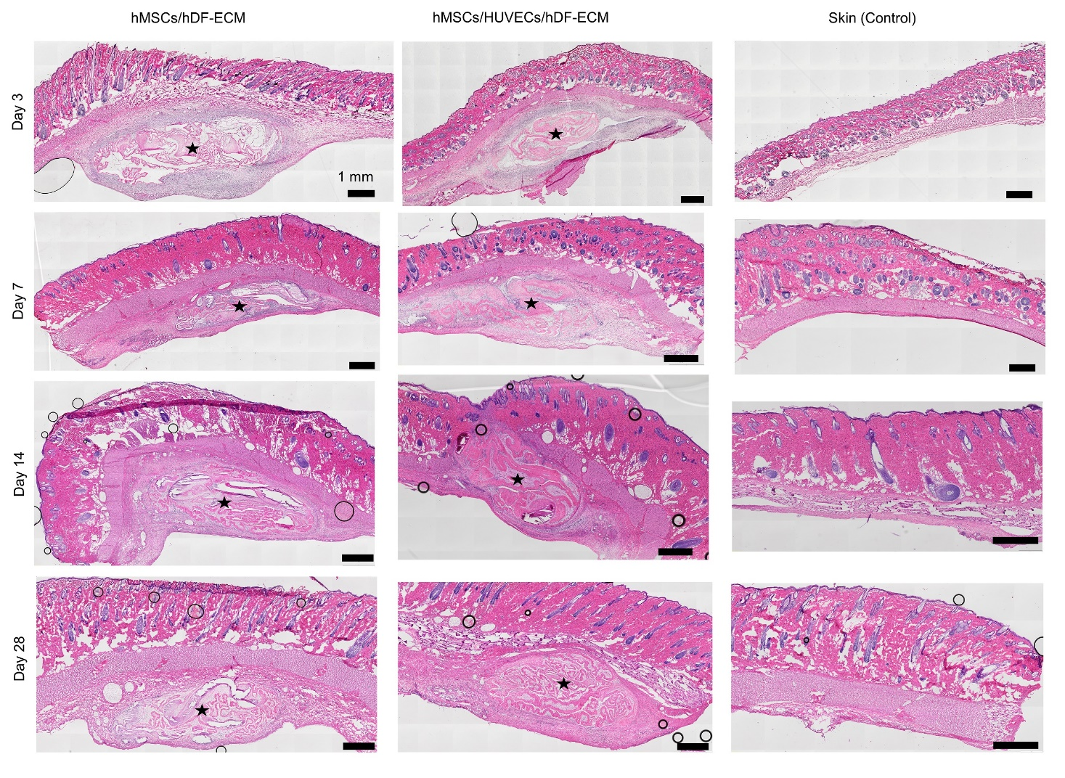
Figure S4. Histological analysis of implanted tissue-constructs in the subcutaneous space of RNU nude rats. H&E staining reveals the morphology of MSC/hDF-ECM and hMSC/EC/hDF-ECM constructs in the subcutaneous space (black star) from day 3 to day 28. Samples harvested from the area other that implant site shows the native architecture of skin, subcutaneous space, and underlying muscle layers over the period of 28 days (third column) (scale bar 1 mm). Overall, increased recruitment of host cells (purple nuclei) surrounding the implant boundary was observed during the first week of implantation, as a typical innate immune response, which was resolved over time. The day 28 implants were well-integrated within subcutaneous space without any signs of ongoing active recruitment of host cells or inflammatory response.
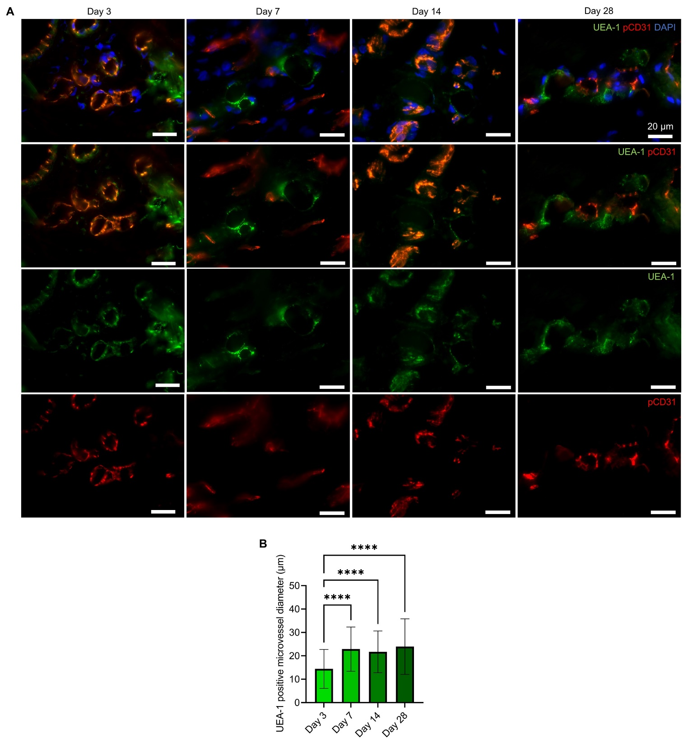
Figure S5 Evaluation of engineered constructs post-subcutaneous implantation in RNU nude rats. (A) Higher magnification images of the UEA-I positive lumen structures (green) found in subcutaneous implant site clearly indicate that the engineered micro-vessels maintained open lumen structure and formed a functional anastomosis with host vessels within one week of implantation (Scale bar 20 µm). (B) Quantification of UEA-1 positive lumen diameter from day 3 to day 28. An increase in micro-vessel diameter from day 3 onwards indicated the active remodeling of engineered micro-vessels in vivo. Results displayed as mean ± standard deviation and were considered statistically significant for *p < 0.05, **p < 0.01, ***p < 0.001, ****p < 0.0001.
Figure S6 Evaluation of macrophage recruitment in vivo at the subcutaneous implant site. Quantification of number of recruited macrophage (CD68, green) surrounding the implants hMSCs/hDF-ECM and hMSC/EC/hDF-ECM and their comparison with control (skin without any implant) at day 3 (A), 7 (B) 14 (C) and 28 (D). Overall, both hMSC/hDF-ECM and pre-vascularized (hMSC/EC/hDF-ECM) groups similarly showed an increased macrophage recruitment during the first week of implantation, which eventually reduced over time and indicated a lack of ongoing active inflammation. Results displayed as mean ± standard deviation and were considered statistically significant for *p < 0.05, **p < 0.01, ***p < 0.001, ****p < 0.0001.

Table S1. List of primer sequences
Gene | Forward sequence | Reverse sequence
CD14 | 5' - GATTCATAAACTGTCAGAGGC | 5' - TCCATGGTCGATAAGTCTTC
CD68 | 5' - GTACTGAACCCCAACAAAAC | 5' - ATGTAGCTCAGGTAGACAAC
CD80 | 5' - AGGAGGAATGAGAGATTGAG | 5' - GACCTTCAGATCTTTTCAGC
GAPDH | 5' - TCGGAGTCAACGGATTG | 5' - CAACAATATCCACTTTACCAGAG

