Supplementary Pages

Total Density Species Richness

Ave. annual temp. [°C] Ave. annual prec.
Ind./m²
160 200 240
Ave. annual temp. [°C]
Ave. annual prec. [mm]

0 2 4 6 8 10
Nr. species
4.4 4.8 5.2
4.4 4.8 5.2
Ave. soil moisture [%]
0 500 1000 1500
Soil pH
170 180
140 200
0 2 4 6 8 10
Ave. soil moisture [%]
Nr. species
4.4 5.0 5.6
0 500 1000 1500
Soil

0 5 10 15 20 25
Ind./m²
160 200
160
4.2 4.6
0 1 2 3 4 5 6 7

0 5 10 15 20 25
0 1 2 3 4 5 6 7

SOM content [%] Soil depth [cm]
Ind./m²
160 175 190
170
Nr. species
4.4 4.6 4.8
4.4 4.6 4.8
SOM content [%]
Soil depth [cm]

0 2 4 6 8 10 12
160
0 5 10 15 20

0 2 4 6 8 10 12
0 5 10 15 20

Clay content [%] Silt content [%]
190
180
Nr. species
4.2 4.8 5.4
Clay content [%]
Silt content [%]

0 10 20 30 40
Ind./m²
160
150
4.4 4.8 5.2
0 20 40 60

0 10 20 30 40
0 20 40 60

Total porosity [vol%] Bulk density [g/cm³]
160 180 200
Total porosity [vol%]
Bulk density [g/cm³]

0 5 10 15 20
Ind./m²
160 180
Nr. species
4.3 4.5 4.7
4.4 4.6 4.8
0.0 0.5 1.0 1.5 2.0 2.5

0 5 10 15 20
0.0 0.5 1.0 1.5 2.0 2.5

Supplementary Fig. 1 Predicted response curves of earthworm total density (left) and species richness (right) to the selected environmental explanatory variables.

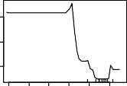
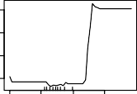
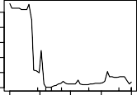
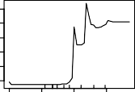
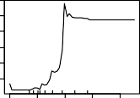
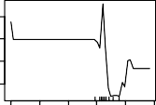
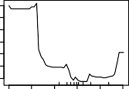
Temp. Prec. Soil depth Clay Silt Porosity Bulk Dens.
0.1
0.1
0.05
0.0
0.0 0.0
0.05
0.04
0.04
0.0
0.04
Soil pH

Soil moisture SOM

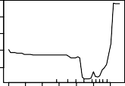

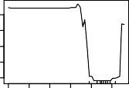
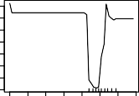
0 2 4 6 8 10
0.0
0.02 0.03
0.0
0.0
0.0
0.03
0.03
0.03
0.0

0 2 4 6 8 10
0.3
0.3 0.3
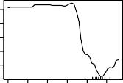
0 2 4 6 8 10

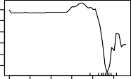
0 2 4 6 8 10
0.29
0.33
0.55 0.65
0.3
0.4
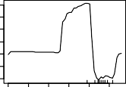
0 2 4 6 8 10
0 500 1000 1500
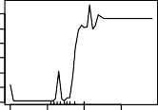
0 500 1000 1500
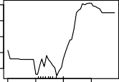
0 500 1000 1500
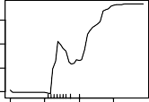
0 500 1000 1500
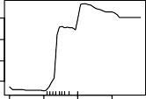
0 500 1000 1500
0 5 10 15 20

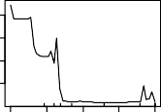
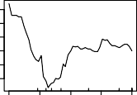
0 5 10 15 20
0.3
0.02 0.03
0.03

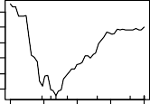
0 5 10 15 20
0.3
0.2
0.3

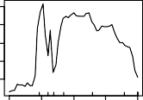
0 5 10 15 20
0.57 0.58 0.59
0.2

0 5 10 15 20
0 10 20 30

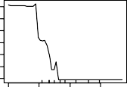
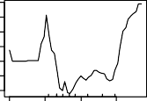
0 10 20 30
0.04
0.08
0.3

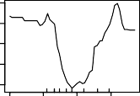
0 10 20 30
0.3
0.3

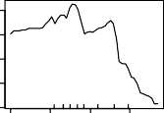
0 10 20 30
0.5 0.6
0.2

0 10 20 30
0 20 40 6

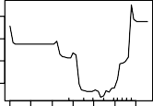
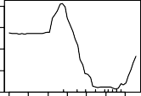
0 20 40 60
0.4
0.02
0.03

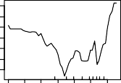
0 20 40 60
0.3
0.3

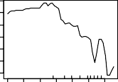
0 20 40 60
0.59
0.3

0 20 40 60
0.55
0 5 10 15 20

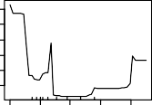
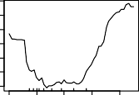
0 5 10 15 20
0.3
0.02
0.04

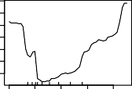
0 5 10 15 20
0.3
0.2

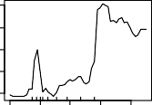
0 5 10 15 20
0.3
0.6

0 5 10 15 20
0.5
0. 1. 2.

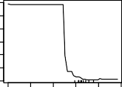
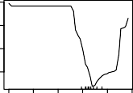
0. 1. 2.
0.4
0.0
0.1

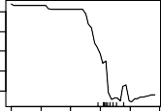
0. 1. 2.
0.3 0.3
0.3

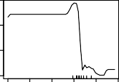
0. 1. 2.
0.3
0.60

0. 1. 2.
0.50
0 1 2 3 4 5 6 7

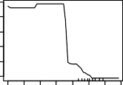
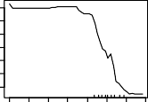
0 1 2 3 4 5 6 7
0.34
0.02
0.06 0.10

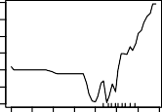
0 1 2 3 4 5 6 7
0.35
0.26

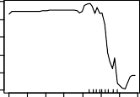
0 1 2 3 4 5 6 7
0.31
0.6

0 1 2 3 4 5 6 7
0.5
0.5
0 5 1 15 2 25
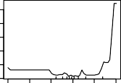
0 5 10 15 2 25

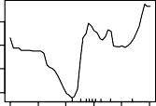
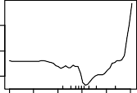
0 5 10 15 20 25
0.3 0.3 0.4
0.2
0.3
0.0 0.0 0.0

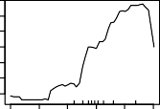
0 5 10 15 20 25
0.60

0 5 10 15 20 25
0.52
0 2 4 6 8 10 12

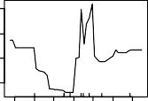
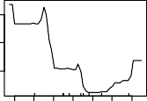
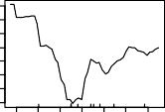
0 2 4 6 8 10 12
0.3
0.02
0.03
0.03

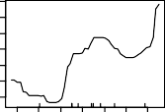
0 2 4 6 8 10 12
0.3
0.3

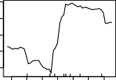
0 2 4 6 8 10 12
0.2
0.5

0 2 4 6 8 10 12
0.5

L.rubellus
0.60 0.68
L.castaneus
D.octaedra
0.25 0.35 0.45
D.attemsi
0.02 0.06 0.10
A.eiseni
Supplementary Fig. 2a Predicted response curves of epigeic species’ occurrence probabilities to quantitative environmental variables.

L.terrestris
Supplementary Fig. 2b Predicted response curves of endogeic
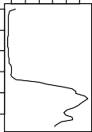
0.4 0.4 0.5
0
2
4
6

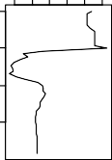
0.5 0.5 0.6
8 10
0
500 1000 1500

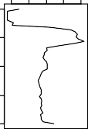
0.5 0.5 0.5
0
5
10

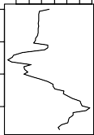
0.53 0.57
15
20
0
( top ) and anecic species’ (below) occurrence probabilities to quantitative environmental variables.

10

20

30

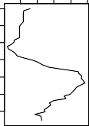
0.50 0.54 0.58
0

20

40

60

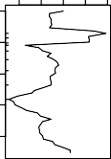
0.5 0.5
0
5
3

10

15

20

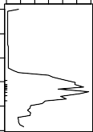
0.49 0.53
0.
1.

L.badensis
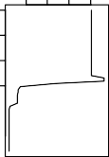
0.0 0.0
0
2
4
6

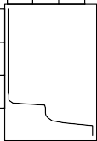
0.00 0.10
8 10
0
500 1000 1500

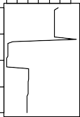
0.0028 0.0034
0
5
10

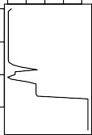
0.003 0.003
15
20
0

10

20

30

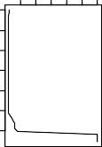
0.00 0.01
0

20

40

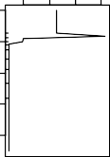
0.0030 0.0040
60
0
5

10

15

20

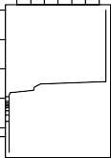
0.01 0.03
0.

A.longa
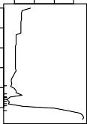
0.16 0.20
0
2
4
6

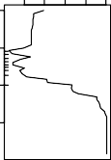
0.1 0.1 0.2
8 1
0
50
1000 1500

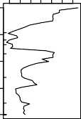
0.14 0.16
0
5
10

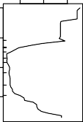
0.1 0.2 0.2
15
20
0

10

20

30

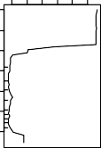
0.15 0.25 0.35
0

20

40

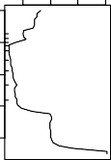
0.1 0.2
60
0
5

10

15

20

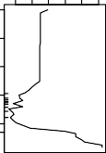
0.14 0.18 0.22
0.
1.

A.rose
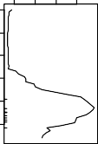
0.54 0.58
0
2
4
6

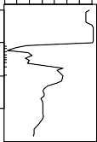
0.5 0.6
8
10
0
500
100 1500

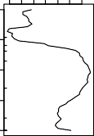
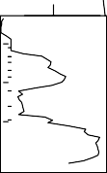
0.56 0.58
0.56 0.60
0
5
10
15
20

10

20

30

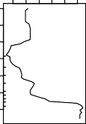
0.5 0.5 0.6
0
0
20

40

60

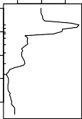
0.55 0.60 0.65
0
5

10

15

20

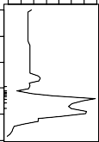
0.5 0.6
0.
1.
1.

A.limicola
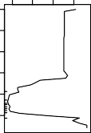
0.06 0.08
0
2
4
6

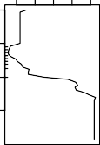
0.06 0.10 0.14
8
10
0
50
1000 1500

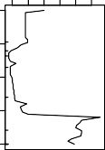
0.05 0.07
0
5
10

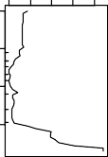
0.06 0.10 0.14
15
20
0

10

20

30

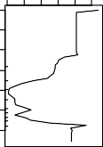
0.06 0.08
0

20

40

60

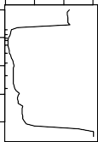
0.05 0.15
0
5

10

15

20

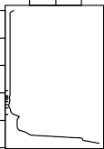
0.10 0.20
0.
1.

A.chlorotica
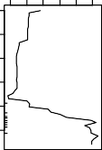
0.2 0.3 0.3
0
2
4
6

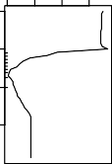
0.3 0.4
8
10
0
500
1000 1500

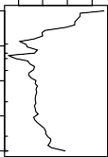
0.33 0.35
0
5
10

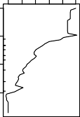
0.30 0.34 0.38
15
20
0
10
20

30

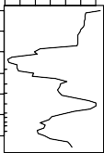
0.33 0.37
0

20

40

60

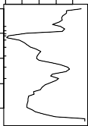
0.3 0.3 0.3
0
5

10

20

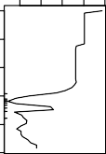
0.33 0.35 0.37
0.
15

A.caliginosa
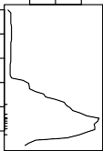
0.6 0.7
Temp.
0
2
4
6

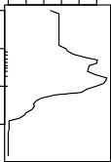
0.6 0.6 0.7
Prec.
8
10
0
50
1000 1500

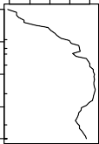
0.66 0.70
Depth
0
5
10

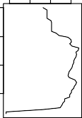
0.5 0.6
Clay
15
20
0
10
20

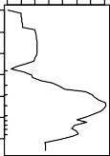
0.68 0.72
Silt
30
0
20

40

60

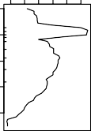
0.6 0.6 0.7
Porosity
0
5

10

15

20

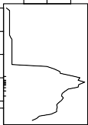
0.60 0.70
Bulk Dens.
0.
1.
1.

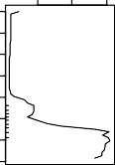
0.5 0.5 0.60
2.
2.
2.
2.
2.
2.
0
1
2 3
4 5 6 7
2.

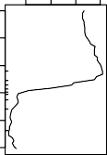
0.5 0.6
0
5

10

15

20

25

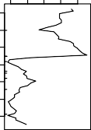
0.5 0.5 0.5

0.0029 0.0030

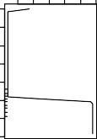
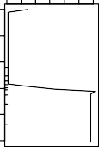
0.0028 0.0029
0
1
2 3
4 5 6 7
0
5
1
1

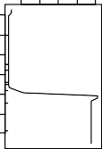
0.00280.0032
2
2

0.15 0.25 0.35

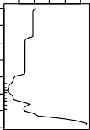
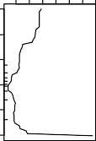
0.15 0.25 0.35
0
1
2
3
4 5 6
7
0
5

10
15

20

25

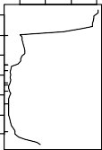
0.1 0.2
0

0.450.50 0.60

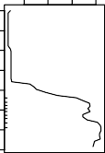
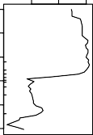
0.5 0.6
0 1
2
3 4 5
6
7
0
5

10

15

20
20

25

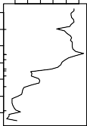
0.5 0.5
0
2
4
6
2 4

0.06 0.07 0.08

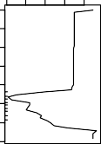
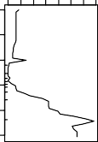
0.0 0.1
0
1
2
3 4 5
6
7
0
5

10

15

25

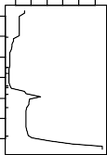
0.06 0.14
0

0.3 0.4

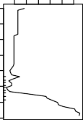
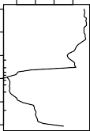
0.3 0.4
0
1
2
3 4 5
6
7
0
5

10

15

20

25

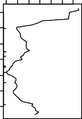
0.3 0.3
0
2
4
6
2
4
6

0.45 0.65

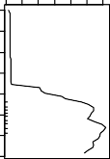
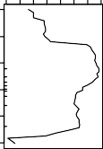
0.64 0.72
pH
Moisture
0
1
2 3 4 5
6
7
0
5

10

15

20

25

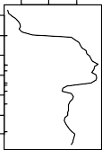
0.6 0.7
SOM
0
2
4
6

0 2 4 6 8 10 12
12
0 2 4 6 8 10
12
6 8 10
12
8 10
12
8 10
12
8 10
8 1 0 12

Supplementary Table 1 Summary description of models algorithms candidates in the study

Model Class | Method | Description | Unique features and  functions
Classical Regression | GLM | Generalized linear regression (GLMs) is a generalization of general linear models (McCullagh & Nelder, 1989). It allows a linear model to be fit between explanatory (predictor) variables and the response variable via a link function (based on the data-distribution type) and provides the magnitude of the variances between the response variables and the  statistical fit to the predictor variables. | Less complex, commonly used and can be fit with all varieties of data (binary, continuous, categorical, count). It is well suited for model extrapolation.
Classical Regression (Smoothing) | GAM | Generalized additive models (GAMs) are non-para - metric extensions of GLMs, thus providing the potential for better fits to heterogeneous data than GLMs (Hastie & Tibshira, 1986). GAMs use data- defined smoothing functions to fit nonlinear species– environment relationships. The smoothing functions are calculated independently for each explanatory variable and then added to build the final model.  Used for fitting non-linear functions. Builds upon the Generalized Linear Model by replacing the linear predictor with an additive predictor (Hastie and Tibshirani, 1986), which is useful for modelling more  complex ecological responses (e.g., Elith et al., 2006). | Can sometimes perform better than GLM when complex species environmental relationships are observed.  Model extrapolation can be equally well done.
Machine Learning (Boosting and Regression) | GBM | Generalized boosting models (GBM), also known as Boosted Regression Trees (BRT), use boosting algorithm which iteratively uses the regression-tree algorithm to construct a combination of trees. in a forward stage wise procedures. It focusses on the weakest parts of the model built so far by fitting each  new tree to the residual of the previously fitted trees (Elith et al., 2006) | Good for solving classification and regression problem with both continuous and categorical data (Elith et al., 2006; Li and Wang, 2012)
Machine Learning (Classification and Regression with Bagging) | RF | Random forest (RF) is an ensemble method that incorporates many different classification (decision) trees, implementing Breiman’s random forest algorithm for choosing the best regression and classification (Breiman, 2001a).  Bagging is a characteristic feature in RF (which makes it different from GBM): it is an ensemble algorithm fitting multiple models with different subsets of a training dataset, and then combining the predictions from all models. The principle behind bagging in RF is to fit several trees to different resampling of the original datasets and then to average from different sub  sample | High predictive performances (Guisan et al., 2017)

