Supplementary Figures and Legends

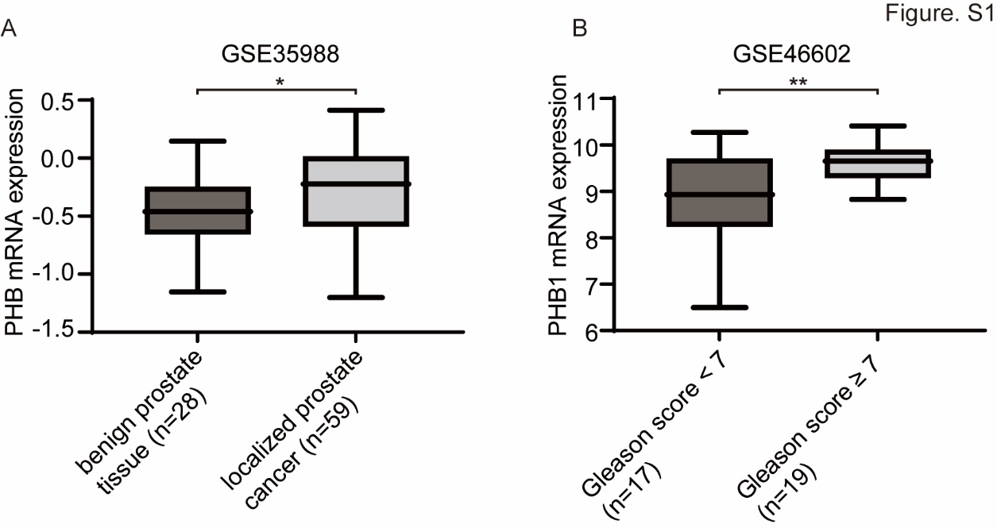
Supplementary Figure S1. PHB1 expression was significantly increased in PCa tissues.
A. Dataset analysis of PHB1 expression levels in benign prostate tissue compared with localized Pca tissue (GSE 35988). B. Dataset analysis of PHB1 expression levels in PCa cases with Gleason score <7 compared with those with Gleason score ≥7 (GSE 46602). *P<0.05, **P<0.01.

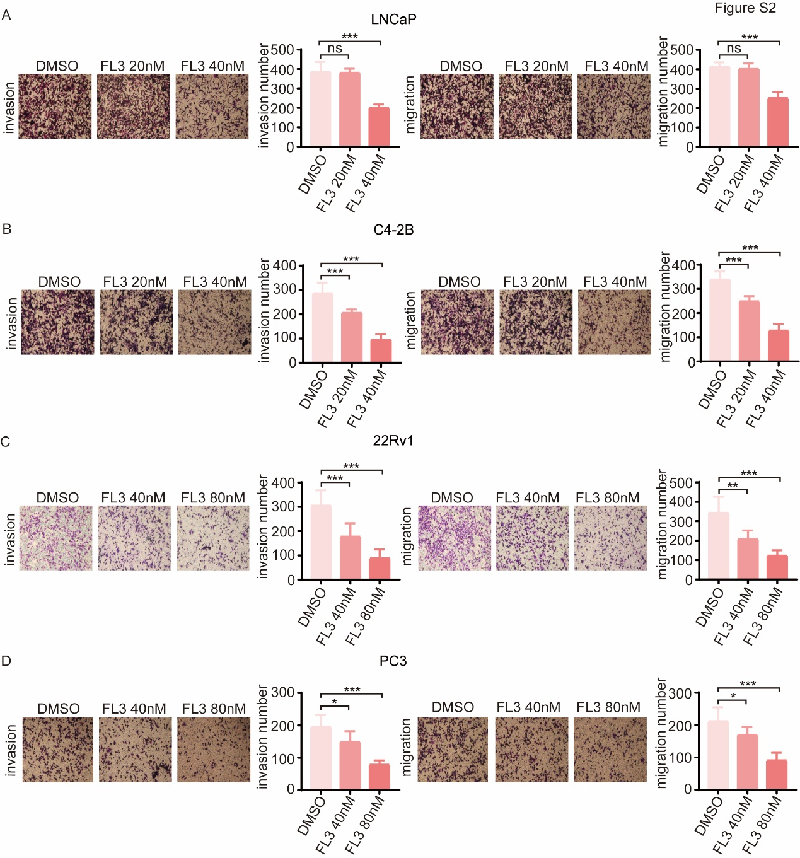
Supplementary Figure S2. FL3 treatment suppresses the invasion and migration ability of PCa cells.
A-D. Transwell assays showing the effect of FL3 on invasion and migration ability of PCa cells. LNCaP(A), C4–2B (B), 22Rv1 (C), and PC3 (D) cells were treated with FL3 in indicated concentrations for 24h. Left: invasion; Right: migrating (magnification, ×40); Bar graphs rate the quantification and statistical analysis of the invasion (left) and migrating (right) assay results. Data are represented as mean ± SD of three independent experiments. *P<0.05, **P<0.01, ***P<0.001.

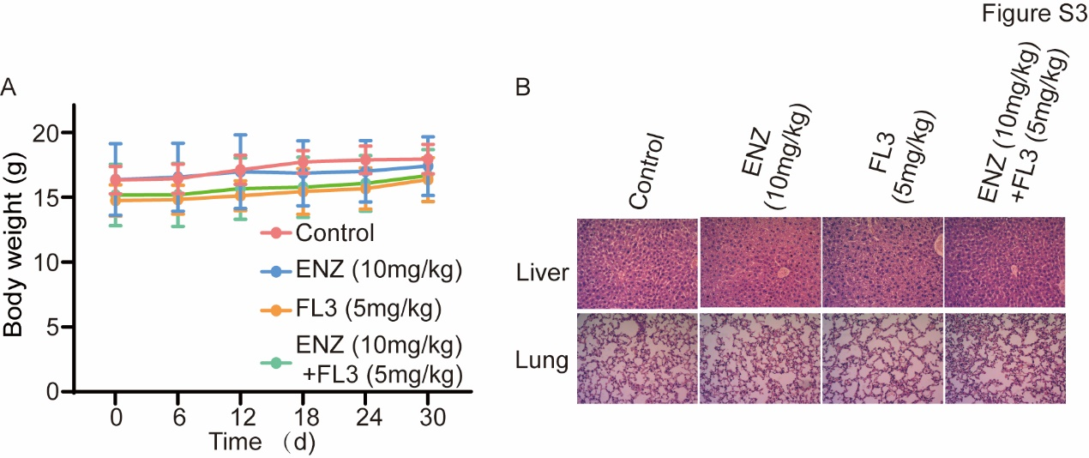
Supplementary Figure S3. FL3 treatment did not cause significant side effects in tested animals.
A. Average body weight of C4-2B tumor-bearing mice in each group within 30 days(n=6). B. Representative histological images for drug toxicity in liver and lung by hematoxylin-eosin staining.

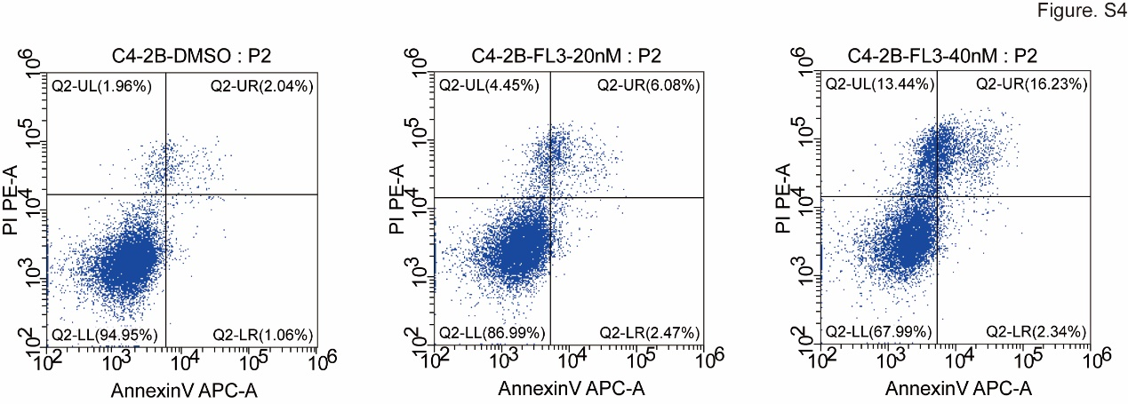
Supplementary Figure S4. FL3 treatment promoted C4-2B cell apoptosis.
Representative flow cytometric plots of C4-2B cells treated with DMSO or FL3 20nM/40nM for 48h. Left: DMSO control; Middle: FL3 20nM; Right: FL3 40nM.

