Supplemental figure

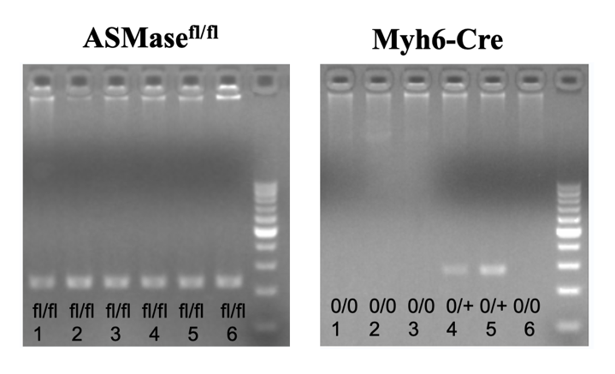
#1,2,3,6: ASMase^{fl/fl}; #4,5: ASMase^{Myh6KO}
Supplemental figure S1. Genotyping of cardiomyocyte-specific ASMase-knockout mice. Representative genotyping results for the ASMase^{Myh6KO} and control littermates. On introduction of cre-recombinase (Myh6-cre), exon 2 of the ASMase gene was excised specifically in cardiomyocytes, allowing for generation of selective ASMase knockout mice (ASMase^{Myh6KO}). In the schematic diagram, pups 1, 2, 3 and 6 were identified as ASMase^{Myh6KO} [ASMase^{fl/fl} with cre recombinase (Cre+/0)], and pups 4 and 5were control littermates [ASMase^{fl/fl} without cre recombinase (Cre0/0)].

