(Supplementary Materials)

Choosing Between Human and Algorithmic Advisors: The Role of Responsibility Sharing
*Lior Gazit (1), Ofer Arazy (1), Uri Hertz (2)
¹Department of Information Systems, University of Haifa, Haifa, Israel
²Department of Cognitive Sciences, University of Haifa, Haifa, Israel
*Corresponding author – Lior Gazit
lgazit01@campus.haifa.ac.il

Department of Information Systems, University of Haifa, Haifa, Israel, 3498838
(+972) 4 6146239
ORCID
Uri Hertz - 0000-0003-4852-3516

Contents
Appendix A – Screen Shots from the Experiment 2
Appendix B – Survey Instrument 8
Appendix C – Descriptive Statistics 10
Appendix D – ANOVA 11
Appendix E – Responsibility Ratings 12
Appendix F – Choice of Advisor 14
Appendix F – Trustworthiness Ratings 16

Appendix A – Screen Shots from the Experiment

Figure S1. Medical domain cancer treatment attitude question screen

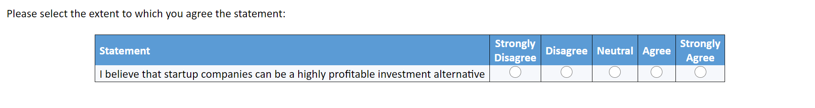
Figure S2. Finance domain startup investments attitude question screen

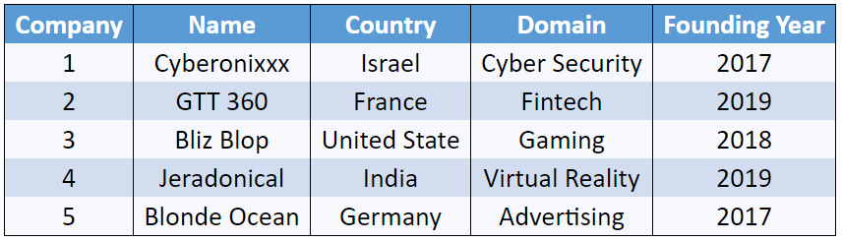
Figure S3. Patients list that was presented at the medical domain

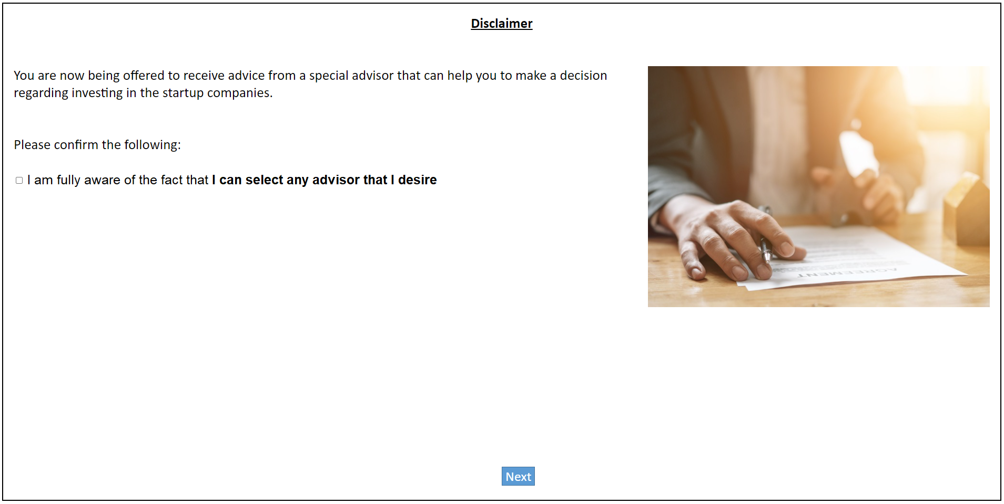
Figure S4. The Neutral disclaimer screen

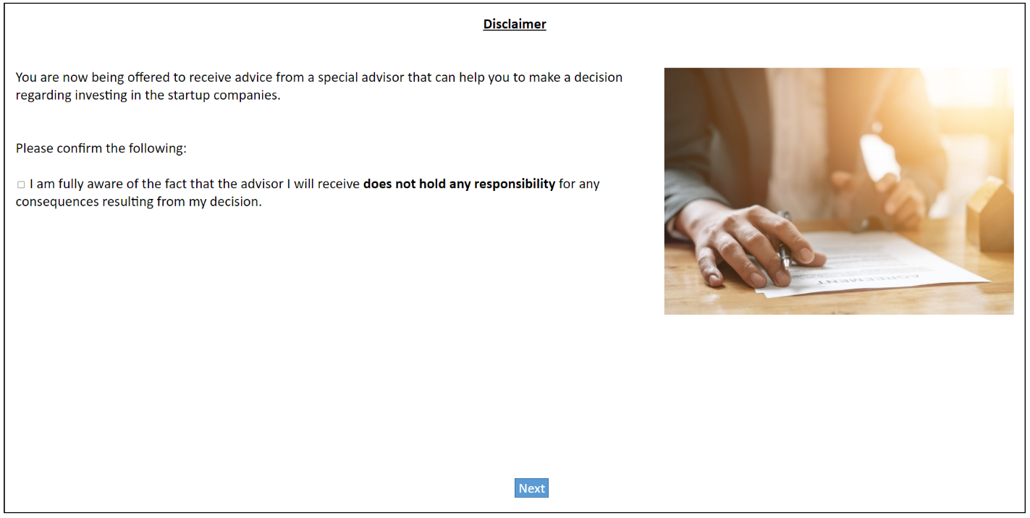
Figure S5. The No Responsibility disclaimer screen

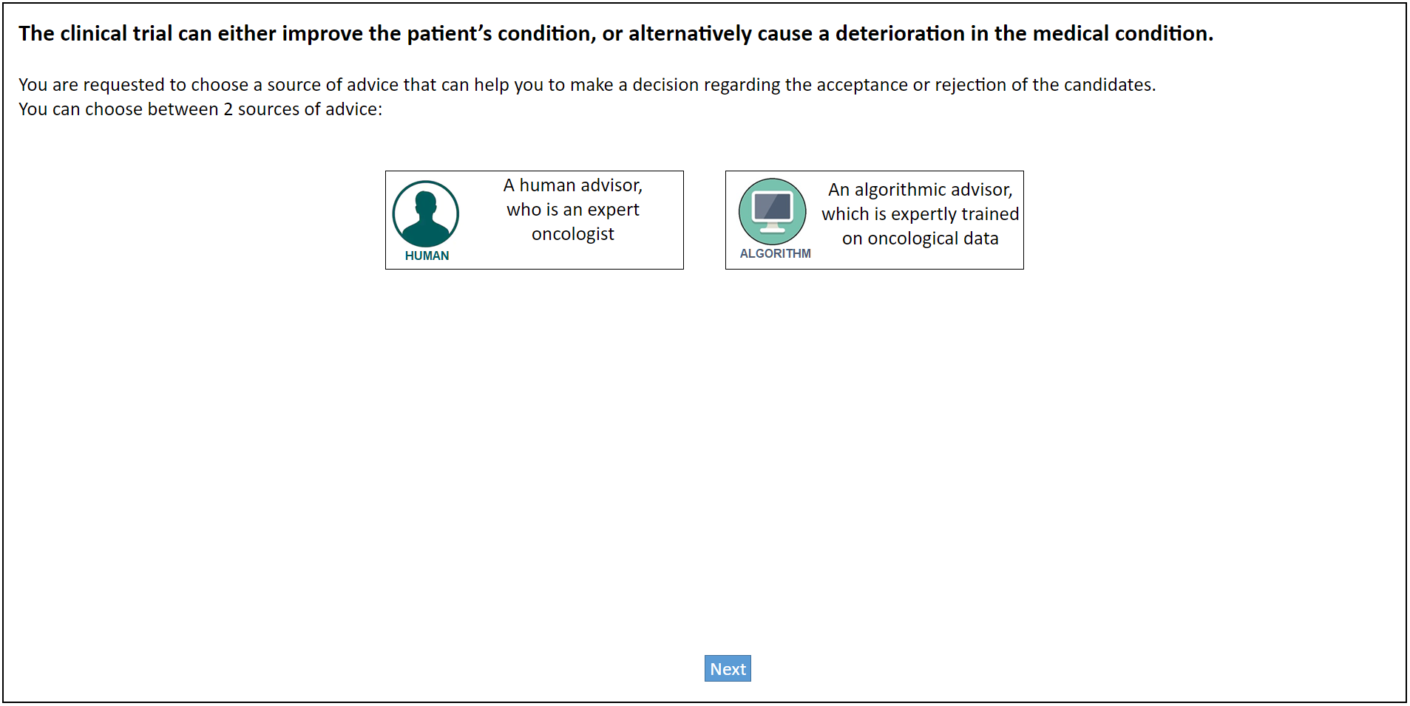
Figure S6. Advisors’ presentation at the medical domain

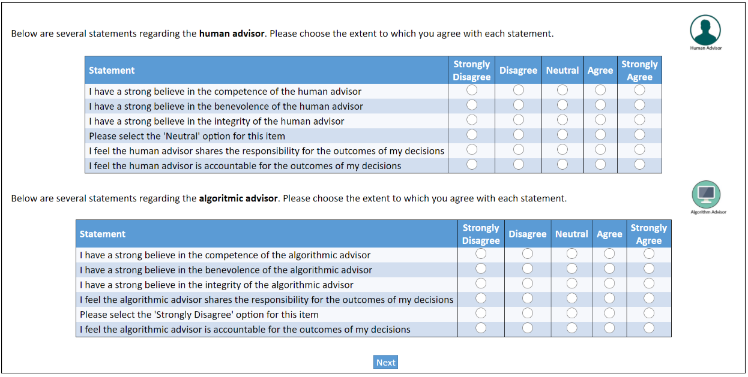
Figure S7. Advisor’s rating Screen

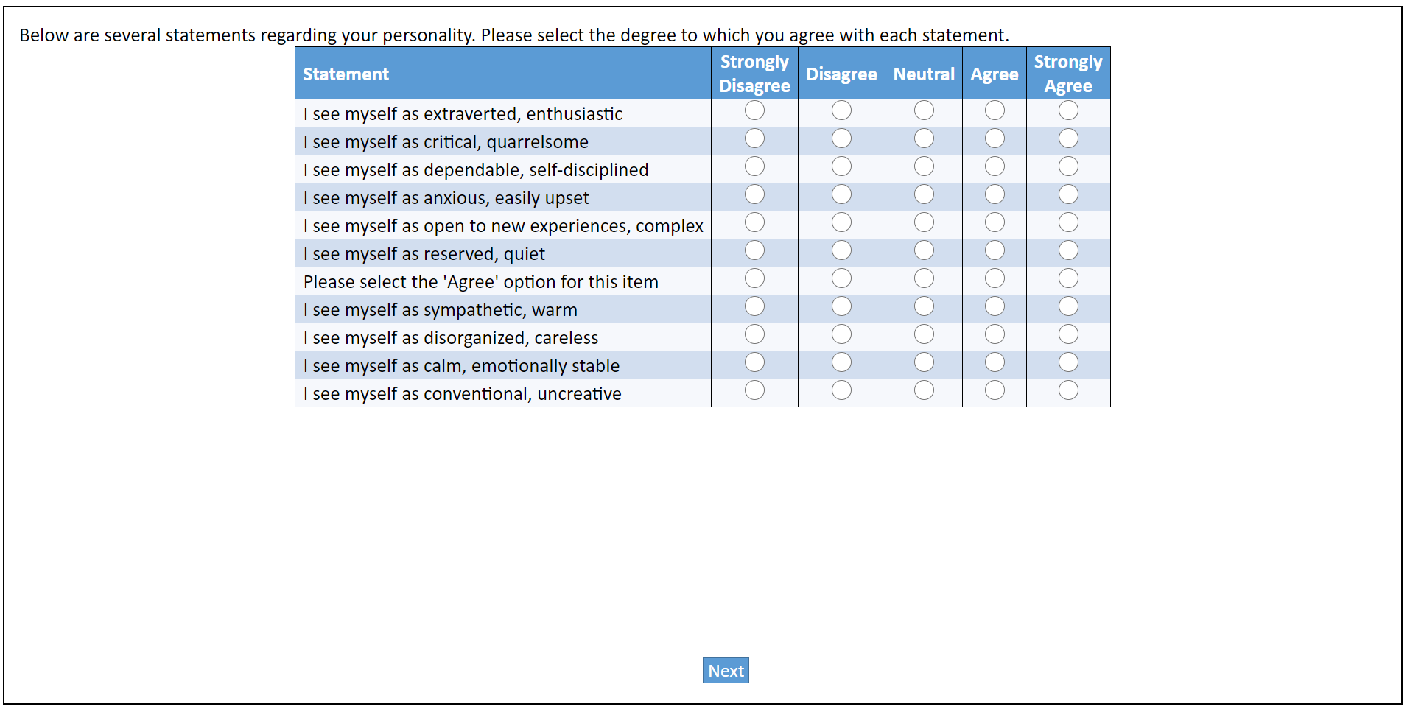
Figure S8. TIPI questionnaire

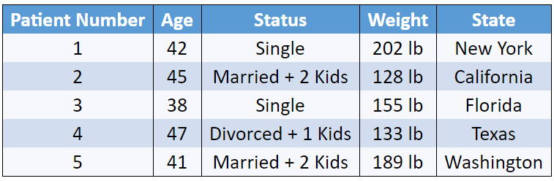
Figure S9. Startup companies list that was presented at the finance domain

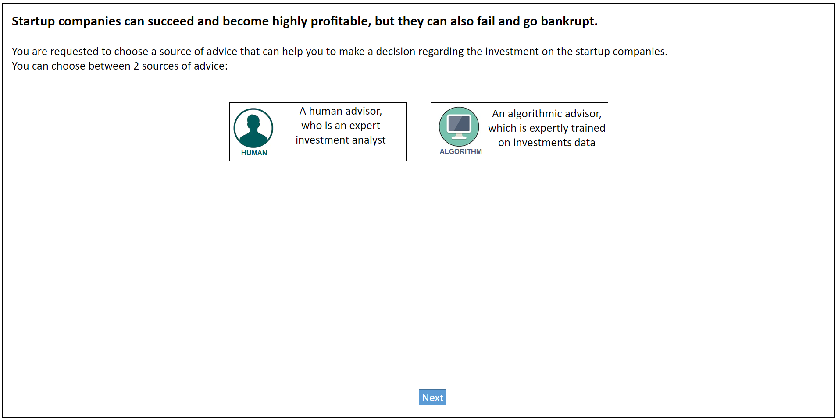
Figure S10. Advisors’ presentation at the finance domain

Appendix B – Survey Instrument
Table S1. Survey Instrument
Construct | Item | Source
Responsibility | I feel the advisor shares the responsibility for the outcome of my decisions | Newly developed
Trustworthiness | I have a strong belief in the competence of the advisor | (Schoorman et al., 2007)
Trustworthiness | I have a strong belief in the benevolence of the advisor | (Schoorman et al., 2007)
Trustworthiness | I have a strong belief in the integrity of the advisor | (Schoorman et al., 2007)
Extraversion | I see myself as extraverted, enthusiastic | (Gosling et al., 2003)
Extraversion | I see myself as reserved, quiet | (Gosling et al., 2003)
Agreeableness | I see myself as critical, quarrelsome | (Gosling et al., 2003)
Agreeableness | I see myself as sympathetic, warm | (Gosling et al., 2003)
Conscientiousness | I see myself as dependable, self-disciplined | (Gosling et al., 2003)
Conscientiousness | I see myself as disorganized, careless | (Gosling et al., 2003)
Emotional Stability | I see myself as anxious, easily upset | (Gosling et al., 2003)
Emotional Stability | I see myself as calm, emotionally stable | (Gosling et al., 2003)
Openness | I see myself as open to new experiences, complex | (Gosling et al., 2003)
Openness | I see myself as conventional, uncreative | (Gosling et al., 2003)
Cancer treatment attitude | I believe that medical treatment can be a highly effective cure for cancer" | Newly developed
Startup Investments attitude | I believe that startup companies can be a highly profitable investment alternative | Newly developed

Appendix C – Descriptive Statistics
Table S2. Descriptive Statistics
 | Finance – Neutral  N=201 |  | Finance – No Responsibility  N=197 |  | Medical – Neutral  N=203 |  | Medical – No Responsibility  N=200
Variant | Mean | SD | Mean | SD | Mean | SD | Mean | SD
Age | 38.43 | 12.93 | 39.85 | 14.36 | 38.10 | 14.36 | 40.18 | 13.77
Domain Attitude | 3.78 | 0.67 | 3.68 | 0.78 | 4.28 | 0.84 | 4.38 | 0.67
Extraversion | 3.50 | 0.82 | 3.57 | 0.86 | 3.63 | 0.76 | 3.55 | 0.77
Agreeableness | 2.69 | 1.01 | 2.57 | 1.01 | 2.68 | 0.97 | 2.60 | 0.95
Conscientiousness | 3.54 | 0.82 | 3.68 | 0.78 | 3.74 | 0.75 | 3.68 | 0.73
Emotional Stability | 3.83 | 0.83 | 3.93 | 0.72 | 3.93 | 0.81 | 3.84 | 0.82
Openness | 3.30 | 0.93 | 3.35 | 0.98 | 3.40 | 0.97 | 3.29 | 0.97
Gender  Male  Female  Other | 86  113  2 |  | 86  109  2 |  | 85  116  2 |  | 78  119  3
Education  High School  Under Graduate  Graduate | 52  71  78 |  | 58  72  67 |  | 58  79  66 |  | 64  73  63

Appendix D – ANOVA
Table S3. ANOVA Anaylsis
Variant |  | DF | Sum Sq | Mean Sq | F value | Pr(>F)
Domain Attitude | Domain | 1 | 72.4 | 72.4 | 129.102 | <2e-16 ***
Domain Attitude | Disclaimer | 1 | 0 | 0 | 0.003 | 0.96
Domain Attitude | Residuals | 798 | 447.5 | 0.56
Extraversion | Domain | 1 | 0.6 | 0.5859 | 0.895 | 0.344
Extraversion | Disclaimer | 1 | 0 | 0.0259 | 0.04 | 0.842
Extraversion | Residuals | 798 | 522.2 | 0.6544
Agreeableness | Domain | 1 | 0 | 0.023 | 0.024 | 0.878
Agreeableness | Disclaimer | 1 | 1.8 | 1.8046 | 1.848 | 0.174
Agreeableness | Residuals | 798 | 779.2 | 0.9765
Conscientiousness | Domain | 1 | 2 | 1.965 | 3.26 | 0.0714
Conscientiousness | Disclaimer | 1 | 0.3 | 0.3041 | 0.504 | 0.4778
Conscientiousness | Residuals | 798 | 481.1 | 0.6028
Emotional Stability | Domain | 1 | 0 | 0.0082 | 0.013 | 0.91
Emotional Stability | Disclaimer | 1 | 0 | 0.0018 | 0.003 | 0.958
Emotional Stability | Residuals | 798 | 514.2 | 0.6443
Openness | Domain | 1 | 0.1 | 0.0967 | 0.103 | 0.749
Openness | Disclaimer | 1 | 0.1 | 0.1281 | 0.136 | 0.712
Openness | Residuals | 798 | 750.8 | 0.9409

Appendix E – Responsibility Ratings
Table S4. linear mixed effect regression results of the responsibility ratings at the medical domain
Variable | Estimate | Std. Error | df | t value | Pr(>|t|) | Standard Coefficient | 95% CI Low | 95% CI High
(Intercept) | 2.73 | 0.43 | 395 | 6.28 | < 0.01 | -0.34 | -0.47 | -0.21
[Control] Age | 0.00 | 0.00 | 391 | 0.01 | 0.99 | 0.00 | -0.07 | 0.07
[Control] Gender (Male) | 0.01 | 0.10 | 391 | 0.10 | 0.91 | 0.01 | -0.14 | 0.16
[Control] Gender (Other) | -0.28 | 0.39 | 391 | -0.71 | 0.48 | -0.22 | -0.85 | 0.4
[Control] Education | 0.00 | 0.05 | 391 | 0.03 | 0.98 | 0.00 | -0.07 | 0.07
[Control] Cancer Treatment Attitude | 0.10 | 0.06 | 391 | 1.71 | 0.09 | 0.06 | -0.01 | 0.13
[Control] Personality (TIPI)
Extraversion | -0.09 | 0.06 | 391 | -1.48 | 0.13 | -0.05 | -0.12 | 0.02
Agreeableness | 0.07 | 0.05 | 391 | 1.59 | 0.11 | 0.06 | -0.01 | 0.13
Conscientiousness | -0.01 | 0.06 | 391 | -0.13 | 0.89 | -0.01 | -0.08 | 0.07
Emotional Stability | -0.03 | 0.06 | 391 | -0.56 | 0.58 | -0.02 | -0.1 | 0.05
Openness | -0.09 | 0.05 | 391 | -1.70 | 0.09 | -0.07 | -0.15 | 0.01
Advisor Type | 1.13 | 0.07 | 402 | 16.53 | < 0.01 | 0.91 | 0.8 | 1.02
Disclaimer | -0.29 | 0.09 | 391 | -3.41 | < 0.01 | -0.24 | -0.37 | -0.1

Analysis formula: Responsibility ~ Advisor + Disclaimer + Age + Gender + Education + Statement + Extraversion + Agreeableness + Conscientiousness + Emotional-Stability + Openness + (1 | id)

Table S5. linear mixed effect regression results of the responsibility ratings at the finance domain
Variable | Estimate | Std. Error | df | t value | Pr(>|t|) | Standard Coefficient | 95% CI Low | 95% CI High
(Intercept) | 2.30 | 0.44 | 390 | 5.26 | < 0.01 | -0.13 | -0.27 | 0.01
[Control] Age | -0.01 | 0.00 | 386 | -1.61 | 0.11 | -0.07 | -0.15 | 0.01
[Control] Gender (Male) | 0.08 | 0.10 | 386 | 0.77 | 0.44 | 0.07 | -0.10 | 0.23
[Control] Gender (Other) | 0.20 | 0.49 | 386 | 0.42 | 0.67 | 0.17 | -0.61 | 0.94
[Control] Education | 0.05 | 0.06 | 386 | 0.77 | 0.44 | 0.03 | -0.05 | 0.11
[Control] Startups Investing Attitude | 0.01 | 0.07 | 386 | 0.15 | 0.87 | 0.00 | -0.07 | 0.09
[Control] Personality (TIPI)
Extraversion | -0.06 | 0.06 | 386 | -0.96 | 0.34 | -0.04 | -0.12 | 0.04
Agreeableness | 0.04 | 0.05 | 386 | 0.77 | 0.44 | 0.03 | -0.05 | 0.12
Conscientiousness | 0.08 | 0.07 | 386 | 1.20 | 0.23 | 0.05 | -0.03 | 0.14
Emotional Stability | 0.08 | 0.07 | 386 | 1.16 | 0.25 | 0.05 | -0.03 | 0.14
Openness | 0.00 | 0.06 | 386 | 0.05 | 0.96 | 0.00 | -0.09 | 0.09
Advisor Type | 0.71 | 0.07 | 397 | 10.81 | < 0.01 | 0.58 | 0.47 | 0.68
Disclaimer | -0.47 | 0.10 | 386 | -4.83 | < 0.01 | -0.38 | -0.54 | -0.23

Analysis formula: Responsibility ~ Advisor + Disclaimer + Age + Gender + Education + Statement + Extraversion + Agreeableness + Conscientiousness + Emotional-Stability + Openness + (1 | id)

Table S6. linear mixed effect regression results of the responsibility ratings at the medical domain
Variable | Estimate | Std. Error | df | t value | Pr(>|t|) | Standard Coefficient | 95% CI Low | 95% CI High
(Intercept) | 2.55 | 0.43 | 400 | 5.85 | < 0.01 | -0.48 | -0.62 | -0.35
[Control] Age | 0.00 | 0.00 | 401 | 0.01 | 0.99 | 0.00 | -0.07 | 0.07
[Control] Gender (Male) | 0.01 | 0.10 | 391 | 0.10 | 0.91 | 0.00 | 0.14 | 0.16
[Control] Gender (Other) | -0.28 | 0.39 | 391 | -0.71 | 0.48 | -0.22 | -0.84 | 0.39
[Control] Education | 0.00 | 0.05 | 391 | 0.03 | 0.98 | 0.00 | -0.07 | 0.07
[Control] Cancer Treatment Attitude | 0.10 | 0.06 | 391 | 1.71 | 0.09 | 0.06 | -0.01 | 0.13
[Control] Personality (TIPI)
Extraversion | -0.09 | 0.06 | 391 | -1.48 | 0.14 | -0.05 | -0.12 | 0.02
Agreeableness | 0.07 | 0.05 | 391 | 1.59 | 0.11 | 0.06 | -0.01 | 0.13
Conscientiousness | -0.01 | 0.06 | 391 | -0.13 | 0.89 | 0.00 | -0.08 | 0.07
Emotional Stability | -0.03 | 0.06 | 391 | 0.56 | 0.58 | -0.02 | -0.10 | 0.05
Openness | -0.09 | 0.05 | 391 | -1.69 | 0.09 | -0.07 | -0.15 | 0.01
Advisor Type | 1.15 | 0.09 | 391 | 16.01 | < 0.01 | 1.20 | 1.05 | 1.35
Disclaimer | 0.07 | 0.10 | 738 | 0.63 | 0.52 | 0.06 | -0.12 | 0.23
Advisor Type X Disclaimer | -0.73 | 0.13 | 401 | -5.48 | < 0.01 | -0.58 | -0.79 | -0.37

Analysis formula: Responsibility ~ Advisor * Disclaimer + Age + Gender + Education + Statement + Extraversion + Agreeableness + Conscientiousness + Emotional-Stability + Openness+(1|id)

Table S7. linear mixed effect regression results of the responsibility ratings at the finance domain
Variable | Estimate | Std. Error | df | t value | Pr(>|t|) | Standard Coefficient | 95% CI Low | 95% CI High
(Intercept) | 2.23 | 0.44 | 394 | 5.09 | < 0.01 | -0.19 | -0.33 | -0.04
[Control] Age | -0.01 | 0.00 | 386 | -1.61 | 0.11 | -0.07 | -0.15 | 0.01
[Control] Gender (Male) | 0.08 | 0.10 | 386 | 0.77 | 0.44 | 0.07 | -0.10 | 0.23
[Control] Gender (Other) | 0.20 | 0.49 | 386 | 0.42 | 0.67 | 0.17 | -0.61 | 0.94
[Control] Education | 0.05 | 0.06 | 386 | 0.77 | 0.44 | 0.03 | -0.05 | 0.11
[Control] Startups Investing Attitude | 0.01 | 0.07 | 386 | 0.15 | 0.88 | < 0.01 | -0.07 | 0.09
[Control] Personality (TIPI)
Extraversion | -0.06 | 0.06 | 386 | -0.96 | 0.34 | -0.04 | -0.12 | 0.04
Agreeableness | 0.04 | 0.05 | 386 | 0.77 | 0.44 | 0.03 | -0.05 | 0.12
Conscientiousness | 0.08 | 0.07 | 386 | 1.20 | 0.23 | 0.05 | -0.03 | 0.14
Emotional Stability | 0.08 | 0.07 | 386 | 1.16 | 0.25 | 0.05 | -0.03 | 0.14
Openness | 0.00 | 0.06 | 386 | 0.05 | 0.96 | < 0.01 | -0.09 | 0.09
Advisor Type | 0.85 | 0.09 | 386 | 9.21 | < 0.01 | 0.69 | 0.54 | 0.83
Disclaimer | -0.33 | 0.11 | 678 | -2.83 | < 0.01 | -0.27 | -0.46 | -0.08
Advisor Type X Disclaimer | -0.28 | 0.13 | 396 | -2.12 | 0.03 | -0.23 | -0.43 | -0.02

Analysis formula: Responsibility ~ Advisor * Disclaimer + Age + Gender + Education + Statement + Extraversion + Agreeableness + Conscientiousness + Emotional-Stability + Openness+(1|id)

Appendix F – Choice of Advisor
Table S8. Multiple logistic regression results of the advisor type selection at the medical domain
Variable | Estimate | Std. Error | z value | Pr(>|z|) | Standard Coefficient | 95% CI Low | 95% CI High
(Intercept) | -0.18 | 1.87 | -0.10 | 0.92 | 2.06 | 1.61 | 2.56
[Control] Age | -0.00 | 0.01 | -0.00 | 1.00 | < 0.01 | -0.32 | 0.32]
[Control] Gender (Male) | 0.19 | 0.34 | 0.56 | 0.58 | 0.19 | -0.47 | 0.86
[Control] Gender (Other) | -0.38 | 1.07 | -0.36 | 0.72 | -0.39 | -2.47 | 1.89
[Control] Education | 0.01 | 0.19 | 0.08 | 0.94 | 0.01 | -0.29 | 0.31
[Control] Cancer Treatment Attitude | -0.01 | 0.21 | -0.05 | 0.96 | < 0.01 | -0.34 | 0.30
[Control] Personality (TIPI)
Extraversion | 0.08 | 0.20 | 0.42 | 0.67 | 0.07 | -0.24 | 0.38
Agreeableness | 0.16 | 0.17 | 0.95 | 0.34 | 0.16 | -0.16 | 0.48
Conscientiousness | 0.36 | 0.22 | 0.74 | 0.46 | 0.12 | -0.20 | 0.45
Emotional Stability | 0.41 | 0.19 | 2.12 | 0.033 | 0.33 | 0.03 | 0.65
Openness | -0.40 | 0.18 | -2.15 | 0.031 | 0.39- | -0.75 | -0.04
[Control] Trustworthiness - Human | 1.09 | 0.30 | 3.62 | < 0.01 | 0.62 | 0.29 | 0.96
[Control] Trustworthiness – Algorithm | -1.58 | 0.26 | -5.98 | < 0.01 | -1.21 | -1.62 | -0.83
[Control] Responsibility - Human | 0.34 | 0.14 | 2.40 | 0.02 | 0.38 | 0.07 | 0.70
[Control] Responsibility - Algorithm | -0.07 | 0.15 | -0.51 | 0.61 | -0.08 | -0.40 | 0.24

Analysis formula: Requested-Advisor ~ Responsibility1 + Responsibility2 + RU1 + TRU2 + Age + Gender + Education + Statement + Extraversion +Agreeableness +Conscientiousness + Emotional-Stability + Openness

Variable | Estimate | Std. Error | z value | Pr(>|z|) | Standard Coefficient | 95% CI Low | 95% CI High
(Intercept) | 0.26 | 1.53 | 0.17 | 0.87 | 1.07 | 0.69 | 1.48
[Control] Age | 0.00 | 0.01 | 0.24 | 0.81 | 0.04 | -0.27 | 0.34
[Control] Gender (Male) | 0.21 | 0.31 | 0.66 | 0.51 | 0.21 | -0.41 | 0.83
[Control] Gender (Other) | 0.27 | 1.25 | 0.22 | 0.82 | 0.28 | -2.57 | 2.70
[Control] Education | -0.07 | 0.18 | -0.36 | 0.72 | -0.05 | -0.34 | 0.24
[Control] Startups Investing Attitude | -0.34 | 0.20 | -1.69 | 0.09 | -0.25 | -0.54 | 0.04
[Control] Personality (TIPI)
Extraversion | -0.16 | 0.19 | -0.84 | 0.40 | -0.13 | -0.44 | 0.17
Agreeableness | -0.12 | 0.15 | -0.81 | 0.42 | -0.13 | -0.44 | 0.18
Conscientiousness | -0.39 | 0.20 | -1.95 | 0.05 | -0.31 | -0.64 | 0.00
Emotional Stability | 0.05 | 0.20 | 0.23 | 0.81 | 0.04 | -0.27 | 0.34
Openness | 0.43 | 0.17 | 2.43 | 0.01 | 0.41 | 0.08 | 0.75
[Control] Trustworthiness - Human | 2.39 | 0.33 | 7.24 | < 0.01 | 1.44 | 1.07 | 1.85
[Control] Trustworthiness – Algorithm | -1.98 | 0.27 | -7.30 | < 0.01 | -1.49 | -1.91 | -1.11
[Control] Responsibility - Human | 0.40 | 0.14 | 2.83 | < 0.01 | 0.49 | 0.15 | 0.83
[Control] Responsibility - Algorithm | -0.35 | 0.15 | -2.36 | 0.02 | -0.40 | -0.74 | -0.07
Table S9. Multiple logistic regression results of the advisor type selection at the finance domain
Analysis formula: Requested-Advisor ~ Responsibility1 + Responsibility2 + RU1 + TRU2 + Age + Gender + Education + Statement + Extraversion +Agreeableness +Conscientiousness + Emotional-Stability + Openness

Variable | Estimate | Std. Error | z value | Pr(>|z|) | Standard Coefficient | 95% CI Low | 95% CI High
(Intercept) | -0.29 | 1.88 | -0.16 | 0.88 | 1.98 | 1.46 | 2.55
[Control] Age | -0.00 | 0.01 | -0.03 | 0.97 | < 0.01 | -0.32 | 0.32
[Control] Gender (Male) | 0.18 | 0.34 | 0.55 | 0.58 | 0.18 | -0.47 | 0.85
[Control] Gender (Other) | -0.40 | 1.08 | -0.37 | 0.71 | -0.40 | -2.48 | 1.90
[Control] Education | 0.01 | 0.19 | 0.07 | 0.94 | 0.01 | -0.29 | 0.31
[Control] Cancer Treatment Attitude | -0.02 | 0.21 | -0.09 | 0.92 | -0.02 | -0.35 | 0.30
[Control] Personality (TIPI)
Extraversion | 0.09 | 0.20 | 0.44 | 0.66 | 0.07 | -0.24 | 0.38
Agreeableness | 0.16 | 0.17 | 0.95 | 0.34 | 0.16 | -0.16 | 0.48
Conscientiousness | 0.16 | 0.22 | 0.73 | 0.46 | 0.12 | -0.20 | 0.45
Emotional Stability | 0.41 | 0.19 | 2.14 | 0.03 | 0.34 | 0.03 | 0.65
Openness | -0.41 | 0.19 | -2.1 | 0.03 | -0.38 | -0.74 | -0.03
[Control] Trustworthiness - Human | 1.10 | 0.30 | 3.64 | < 0.01 | 0.62 | 0.30 | 0.97
[Control] Trustworthiness – Algorithm | -1.59 | 0.27 | -5.97 | < 0.01 | -1.21 | -1.63 | -0.83
[Control] Responsibility - Human | 0.36 | 0.14 | 2.46 | 0.01 | 0.41 | 0.08 | 0.73
[Control] Responsibility - Algorithm | -0.08 | 0.15 | 0.52 | 0.60 | -0.09 | -0.40 | 0.24
Disclaimer | 0.17 | 0.31 | 0.54 | 0.59 | 0.17 | -0.44 | 0.79
Analysis formula: Requested-Advisor ~Disclaimer ~Responsibility1 + Responsibility2 + RU1 + TRU2 + Age + Gender + Education + Statement + Extraversion +Agreeableness +Conscientiousness + Emotional-Stability + Openness
Table S10. Multiple logistic regression results of the advisor type selection at the medical domain
Variable | Estimate | Std. Error | z value | Pr(>|z|) | Standard Coefficient | 95% CI Low | 95% CI High
(Intercept) | 0.26 | 1.54 | 0.17 | 0.86 | 1.08 | 0.61 | 1.57
[Control] Age | 0.00 | 0.01 | 0.24 | 0.81 | 0.04 | -0.27 | 0.34
[Control] Gender (Male) | 0.21 | 0.31 | 0.66 | 0.51 | 0.21 | -0.41 | 0.84
[Control] Gender (Other) | 0.27 | 1.25 | 0.22 | 0.83 | 0.27 | -2.57 | 2.70
[Control] Education | -0.07 | 0.18 | -0.36 | 0.72 | -0.05 | -0.34 | 0.24
[Control] Startups Investing Attitude | -0.34 | 0.20 | -1.69 | 0.09 | -0.25 | -0.54 | 0.04
[Control] Personality (TIPI)
Extraversion | -0.16 | 0.19 | 0.84 | 0.40 | -0.13 | -0.45 | 0.17
Agreeableness | -0.13 | 0.15 | -0.80 | 0.42 | -0.13 | -0.44 | 0.18
Conscientiousness | -0.39 | 0.20 | -1.94 | 0.05 | -0.31 | -0.64 | 0.00
Emotional Stability | 0.05 | 0.20 | 0.24 | 0.81 | 0.04 | -0.27 | 0.35
Openness | 0.42 | 0.17 | 2.43 | 0.01 | 0.41 | 0.08 | 0.75
[Control] Trustworthiness - Human | 2.39 | 0.33 | 7.25 | < 0.01 | 1.44 | 1.07 | 1.85
[Control] Trustworthiness – Algorithm | -1.98 | 0.27 | -7.29 | < 0.01 | -1.49 | -1.91 | -1.11
[Control] Responsibility - Human | 0.40 | 0.14 | 2.77 | < 0.01 | 0.48 | 0.15 | 0.83
[Control] Responsibility - Algorithm | -0.35 | 0.15 | -2.36 | 0.02 | -0.40 | -0.74 | -0.07
Disclaimer | -0.01 | 0.30 | -0.02 | 0.98 | < 0.01 | -0.59 | 0.58
Table S11. Multiple logistic regression results of the advisor type selection at the finance domain
Analysis formula: Requested-Advisor ~Disclaimer ~Responsibility1 + Responsibility2 + RU1 + TRU2 + Age + Gender + Education + Statement + Extraversion +Agreeableness +Conscientiousness + Emotional-Stability + Openness

Appendix G – Trustworthiness Ratings
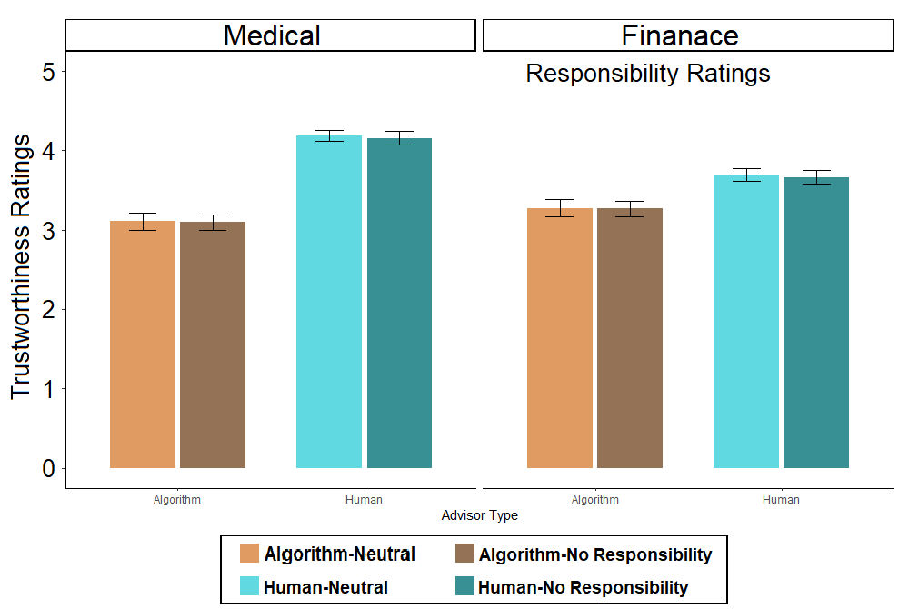
Figure S11. Trustworthiness ratings of the advisors in the two domains: Medical and Finance, and in the two conditions that were tested: Neutral Disclaimer and No-Responsibility Disclaimer. Bars indicate the mean value, and error bars represent 95% confidence interval.

