SUPPLEMENTARY INFORMATION

Hole-type superconducting gatemon qubit based on Ge/Si core/shell nanowires

Enna Zhuo^{1,4,*}, Zhaozheng Lyu^{1,4,*,†}, Xiaopei Sun^{1,4,*}, Ang Li^{2,*}, Bing Li^{1,4}, Zhongqing Ji¹, Jie Fan¹, E.P.A.M. Bakkers³, Xiaodong Han², Xiaohui Song^{1,4,5}, Fanming Qu^{1,4,5,6}, Guangtong Liu^{1,4,5,6}, Jie Shen^{1,4,5}, and Li Lu^{1,4,5,6,†}

¹Beijing National Laboratory for Condensed Matter Physics, Institute of Physics, Chinese Academy of Sciences, Beijing 100190, China
²Beijing Key Laboratory of Microstructure and Property of Advanced Materials, Beijing University of Technology, Beijing 100124, China
³Department of Applied Physics, Eindhoven University of Technology, 5600 MB Eindhoven, The Netherlands
⁴School of Physical Sciences, University of Chinese Academy of Sciences, Beijing 100049, China
⁵Songshan Lake Materials Laboratory, Dongguan, Guangdong 523808, China
⁶Hefei National Laboratory, Hefei 230088, China

_____
*These authors contribute equally to this work.
† Corresponding authors. Zhaozheng Lyu: lyuzhzh@iphy.ac.cn, Li Lu: lilu@iphy.ac.cn
I. Transport measurements of Josephson junctions based on Ge/Si core/shell nanowires
We present the transport measurements of the Josephson junctions (JJs) based on Ge/Si core/shell nanowires with transparent superconducting Al contacts. The JJs are fabricated with the same fabrication process described in the paper.
In the measurement of dc Josephson effect, we observed hysteretic behavior in the $dV/dI-I$ characteristic curve [Fig. S1 (a)] due to dissipative coupling to the environment in an underdamped Josephson junction [1]. Further, we analyzed multiple Andreev reflections (MARs) up to the eleventh order [Fig. S1 (b) and (c)] indicating that quasiparticles can scatter at least eleven times on the interfaces, each time traversing the nanowire channel, and the superconducting gap of the Al electrodes $∆_{Al}=197 μeV$. According to $eI_{exc}R_{n}/∆_{Al}=1.4$ in which the excess current $I_{exc}=128 nA$ and the normal resistance $R_{n}=2.3 kΩ$, this device corresponds to a barrier strength of $Z=0.44$ from the BTK model resulting in a transparency of $84 \%$ [2]. Additionally, we investigate the gate voltage dependence of the critical supercurrent and the normal-state differential conductance. As shown in Fig. S2, when the gate voltage is tuned from $-15$ to $15 V$, the critical supercurrent $I_{c}$ of the JJ ranges from $63$ to $21 nA$ and the differential conductance of the normal state shows several quantized conductance plateaus. These indicate that the extent of the superconductive coupling can be tuned substantially with the change of the density of hole carriers inside the Ge/Si core/shell nanowire by the gate voltage. The plateau feature is associated with quantum ballistic transport through individual 1D subbands in the Ge channel as the channel length of our device is below the scattering mean free path in Ge/Si core/shell nanowires of $70 nm$ [3]. In the measurement of ac Josephson effect, we irradiate our junction with microwaves resulting in Shapiro steps [Fig. S3 (a)]. To figure out the number and heights of Shapiro steps, we show a $V$ biased plot in units of $∆V=hf/2e$ of the same measurement data in Fig. S3 (b). The steps of constant bias voltage $V$ are now visible as peaks in differential conductance $dI/dV$, all aligned with values of $m∆V=mhf/2e$. The demonstrations of both the dc and the ac Josephson effect confirm that our junctions are indeed well behaved JJs with high contact transparency and low disorder.
In order to improve the success rate of the qubit fabrication, we repeat the experiment of JJ to explore the fabrication parameters for stably obtaining high quality JJ with $I_{c}\sim 30 nA$. The critical supercurrent $I_{c}$ of the JJ can be roughly conjectured by the room temperature resistance of the JJ, which can be controlled by the length of thermal annealing duration. As shown in Table S1, when the Ge/Si core/shell nanowires with a diameter of $\sim 30 nm$ were annealed to a room temperature resistance of $\sim 2.6 kΩ$, the expected JJ was obtained and the results were reproducible.

Supporting Figure S1. Dc transport measurement of the Ge/Si nanowire-based JJ. (a) Differential resistance $dV/dI$ as a function of the bias current $I$ showing significant hysteresis. The $I$ was swept from right to left (blue line) and successively from left to right (orange line) denoted by the colored arrows. (b) Differential conductance $dI/dV$ as a function of the bias voltage $V$, same measurement data as (a), showing the MAR peaks up to the eleventh order. The $V$ is obtained by integrating the data (blue line) in (a) for positive bias current. Vertical gray dashed lines denote expected MAR peak positions calculated by $n=2∆_{Al}/eV$ for $n=1\sim 7,9,11$. (c) MAR peak positions versus inverse MAR order $1/n$, extracted from (b). The solid line is a linear fit through zero.

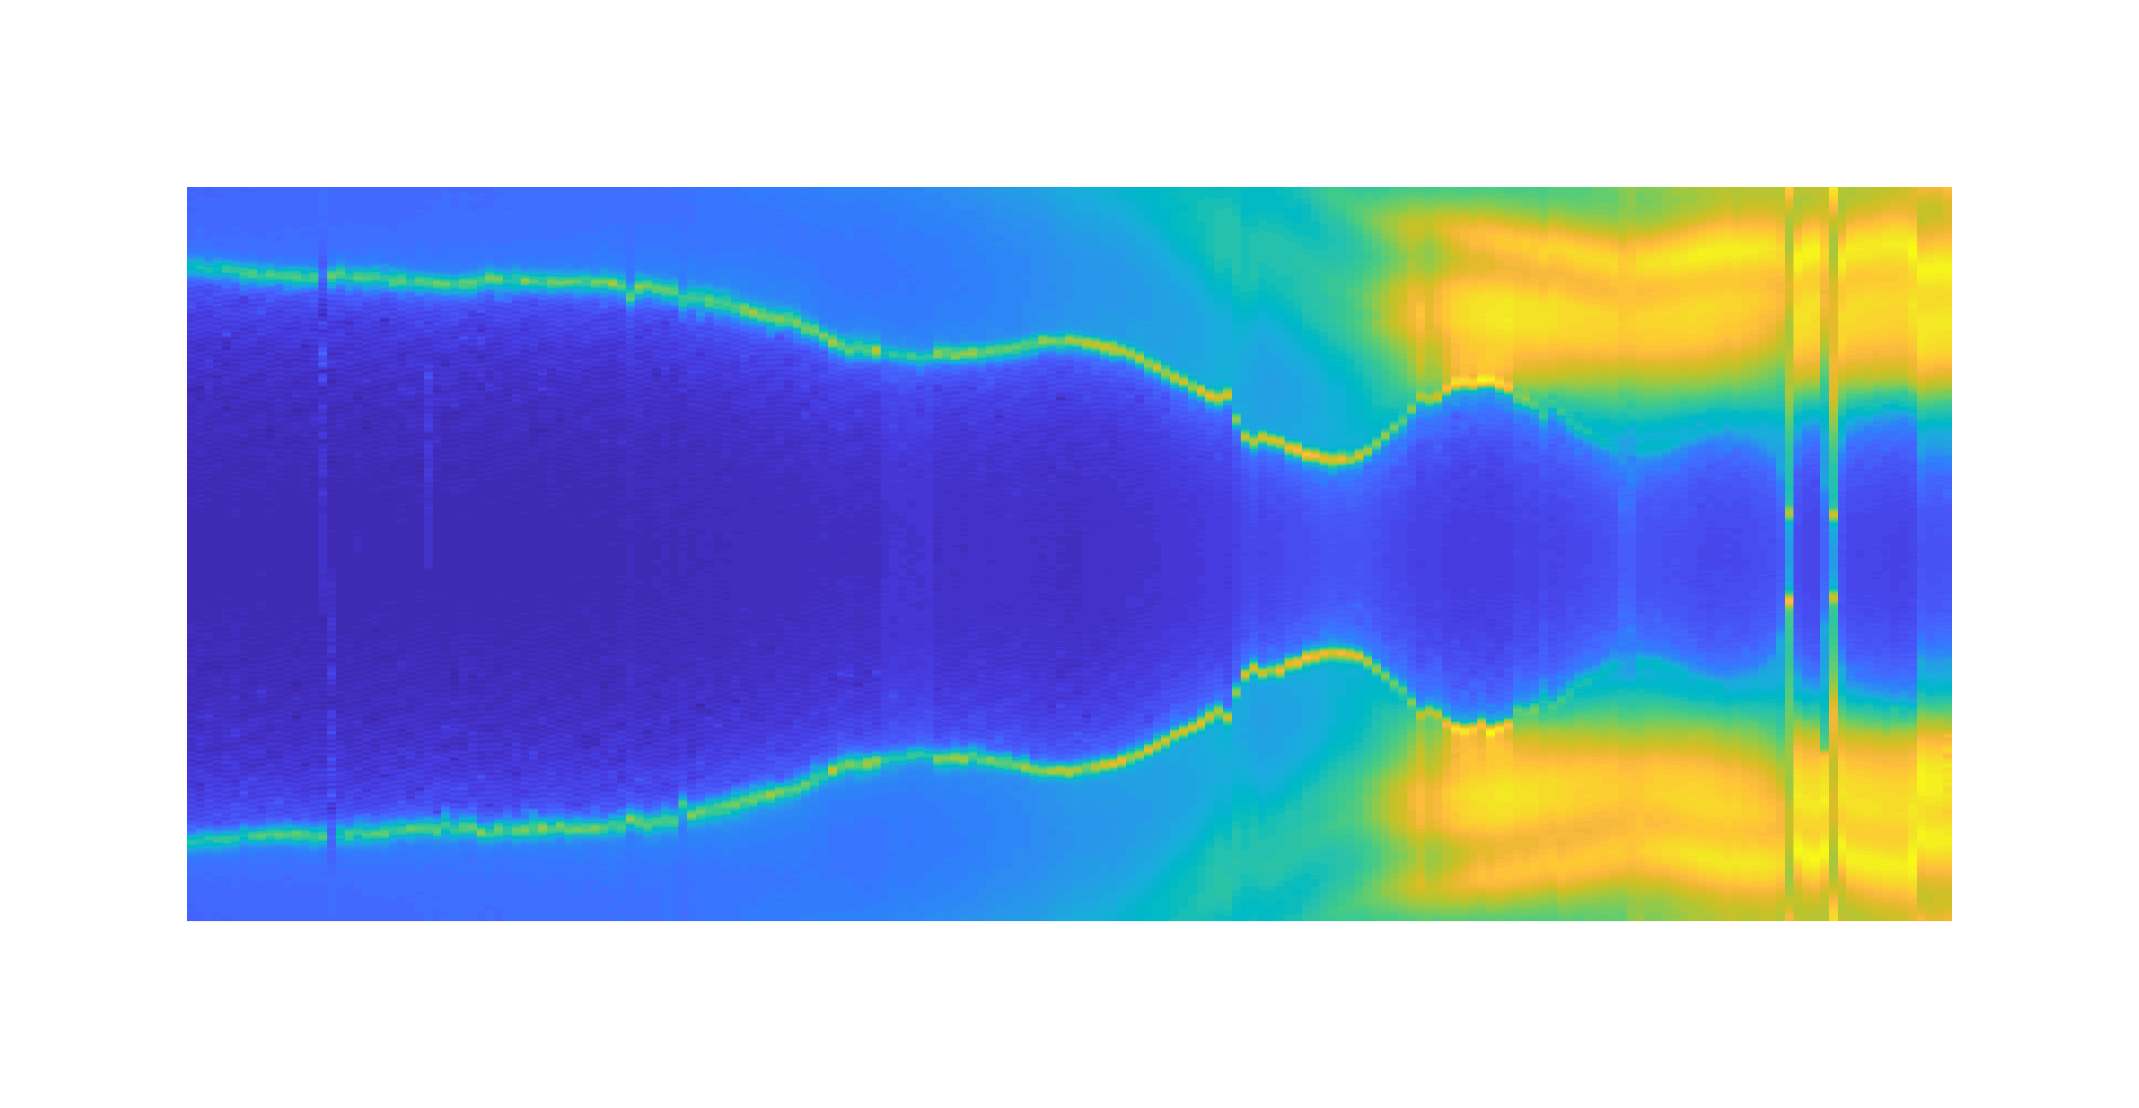
Supporting Figure S2. Gate voltage dependence of the Ge/Si nanowire-based JJ. (a) Differential resistance $dV/dI$ as a function of the bias current $I$ and the gate voltage $V_{g}$. (b) Differential conductance $dI/dV$ as a function of the gate voltage $V_{g}$ for the normal state of the JJ measured at $I=700 nA$.

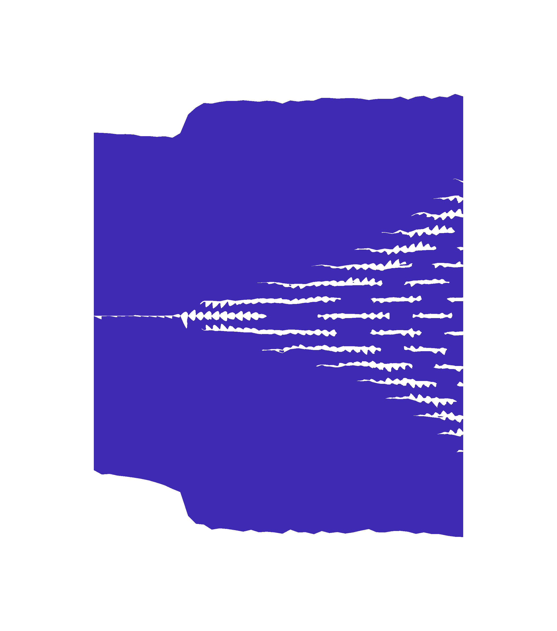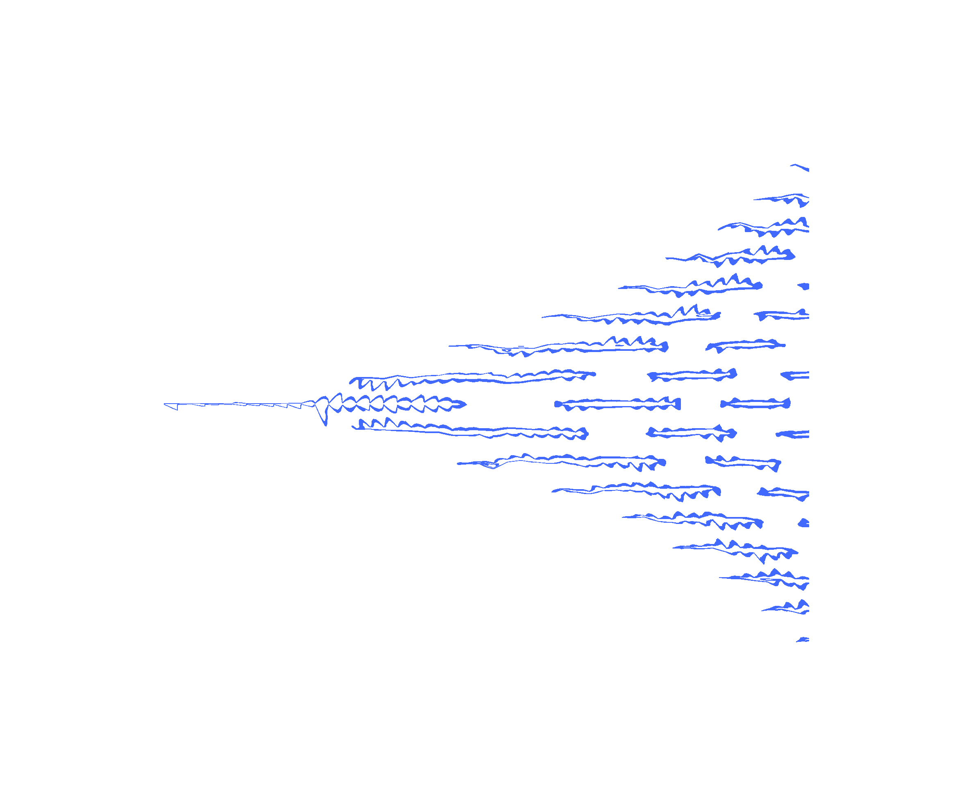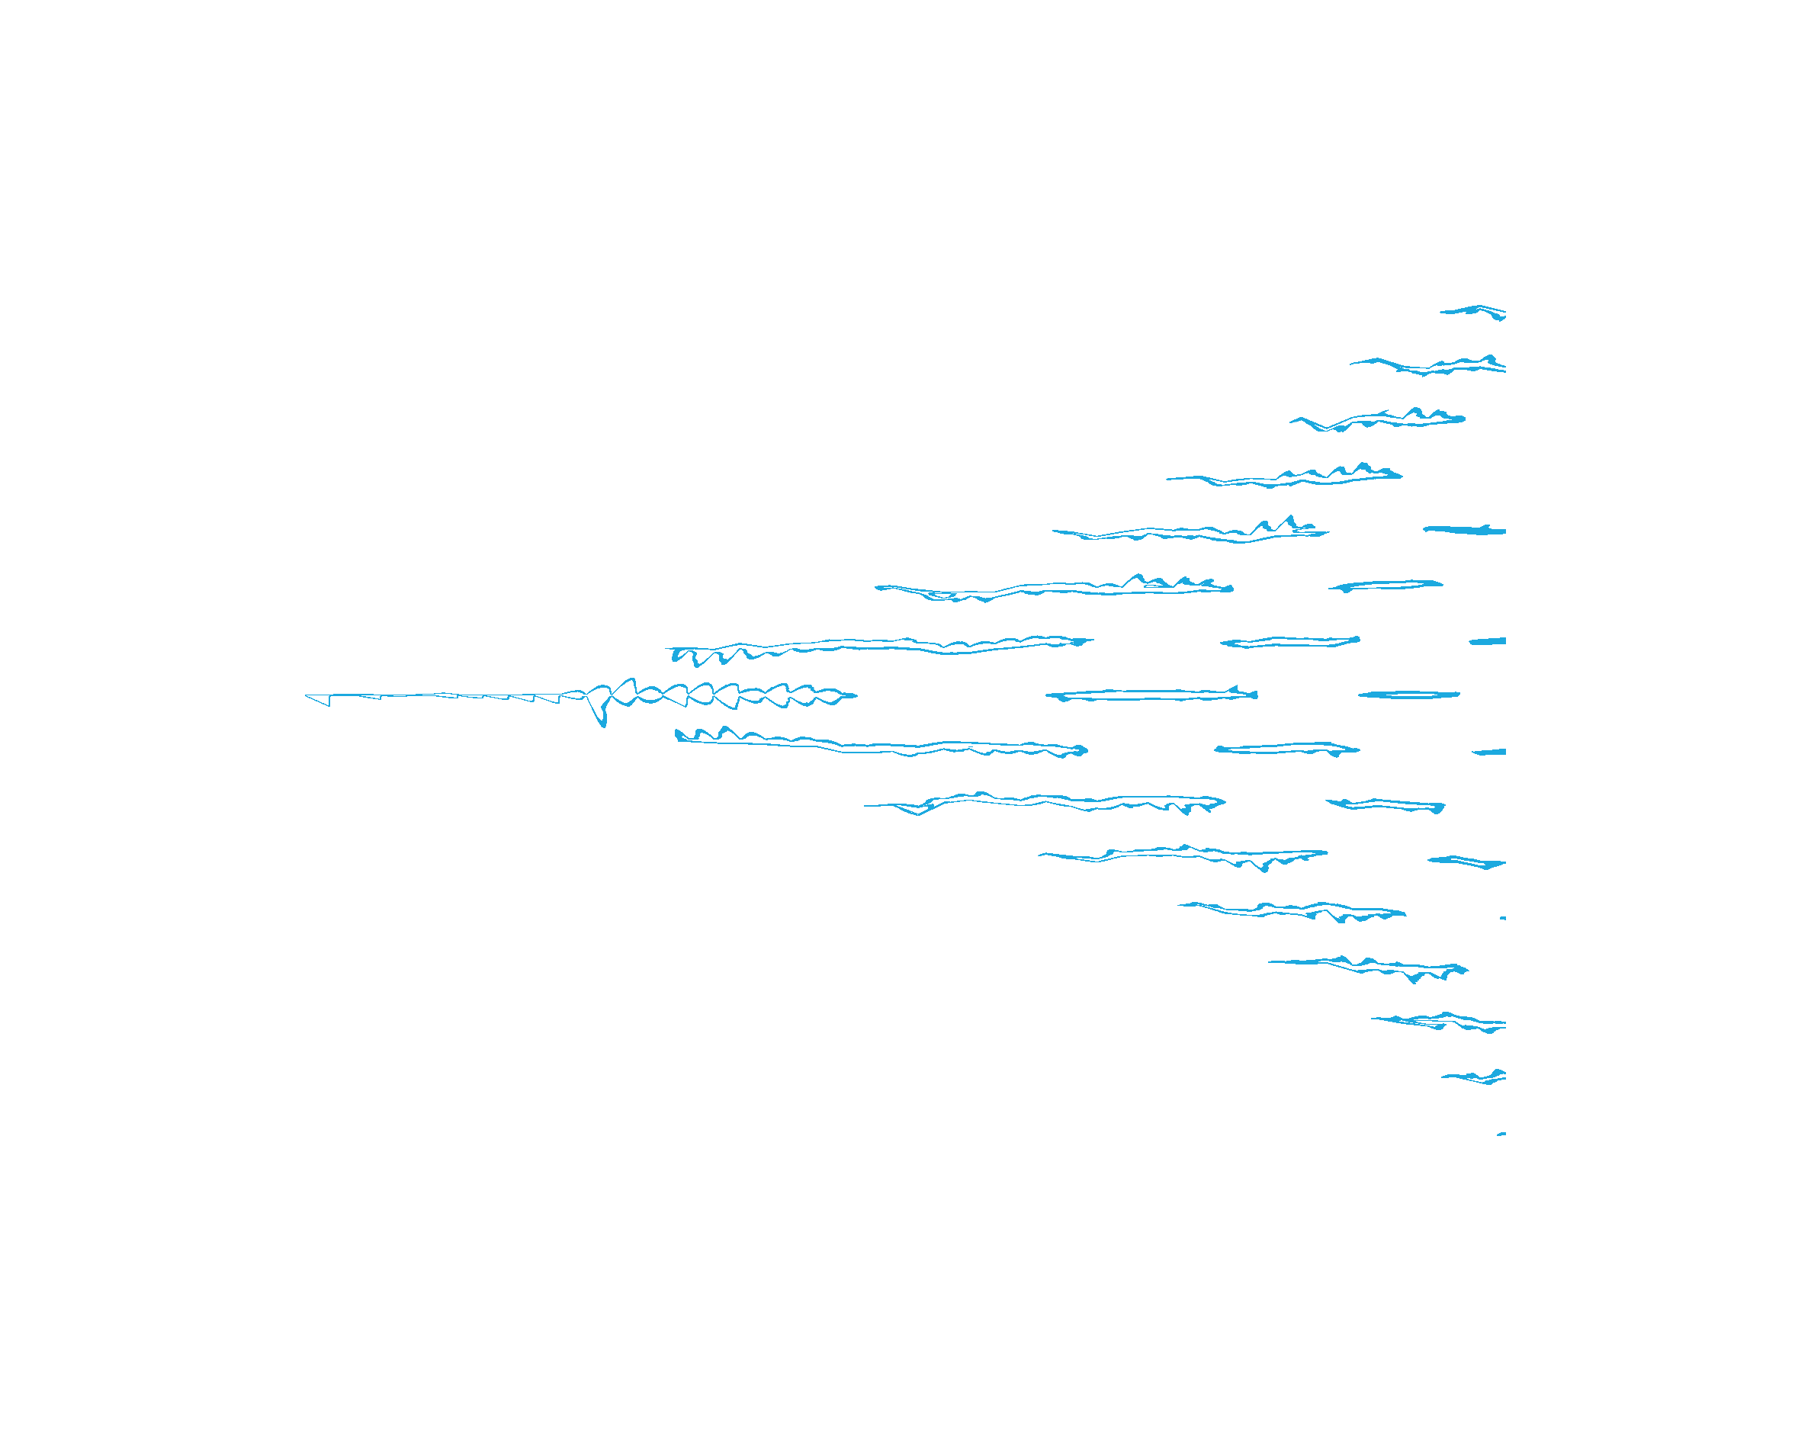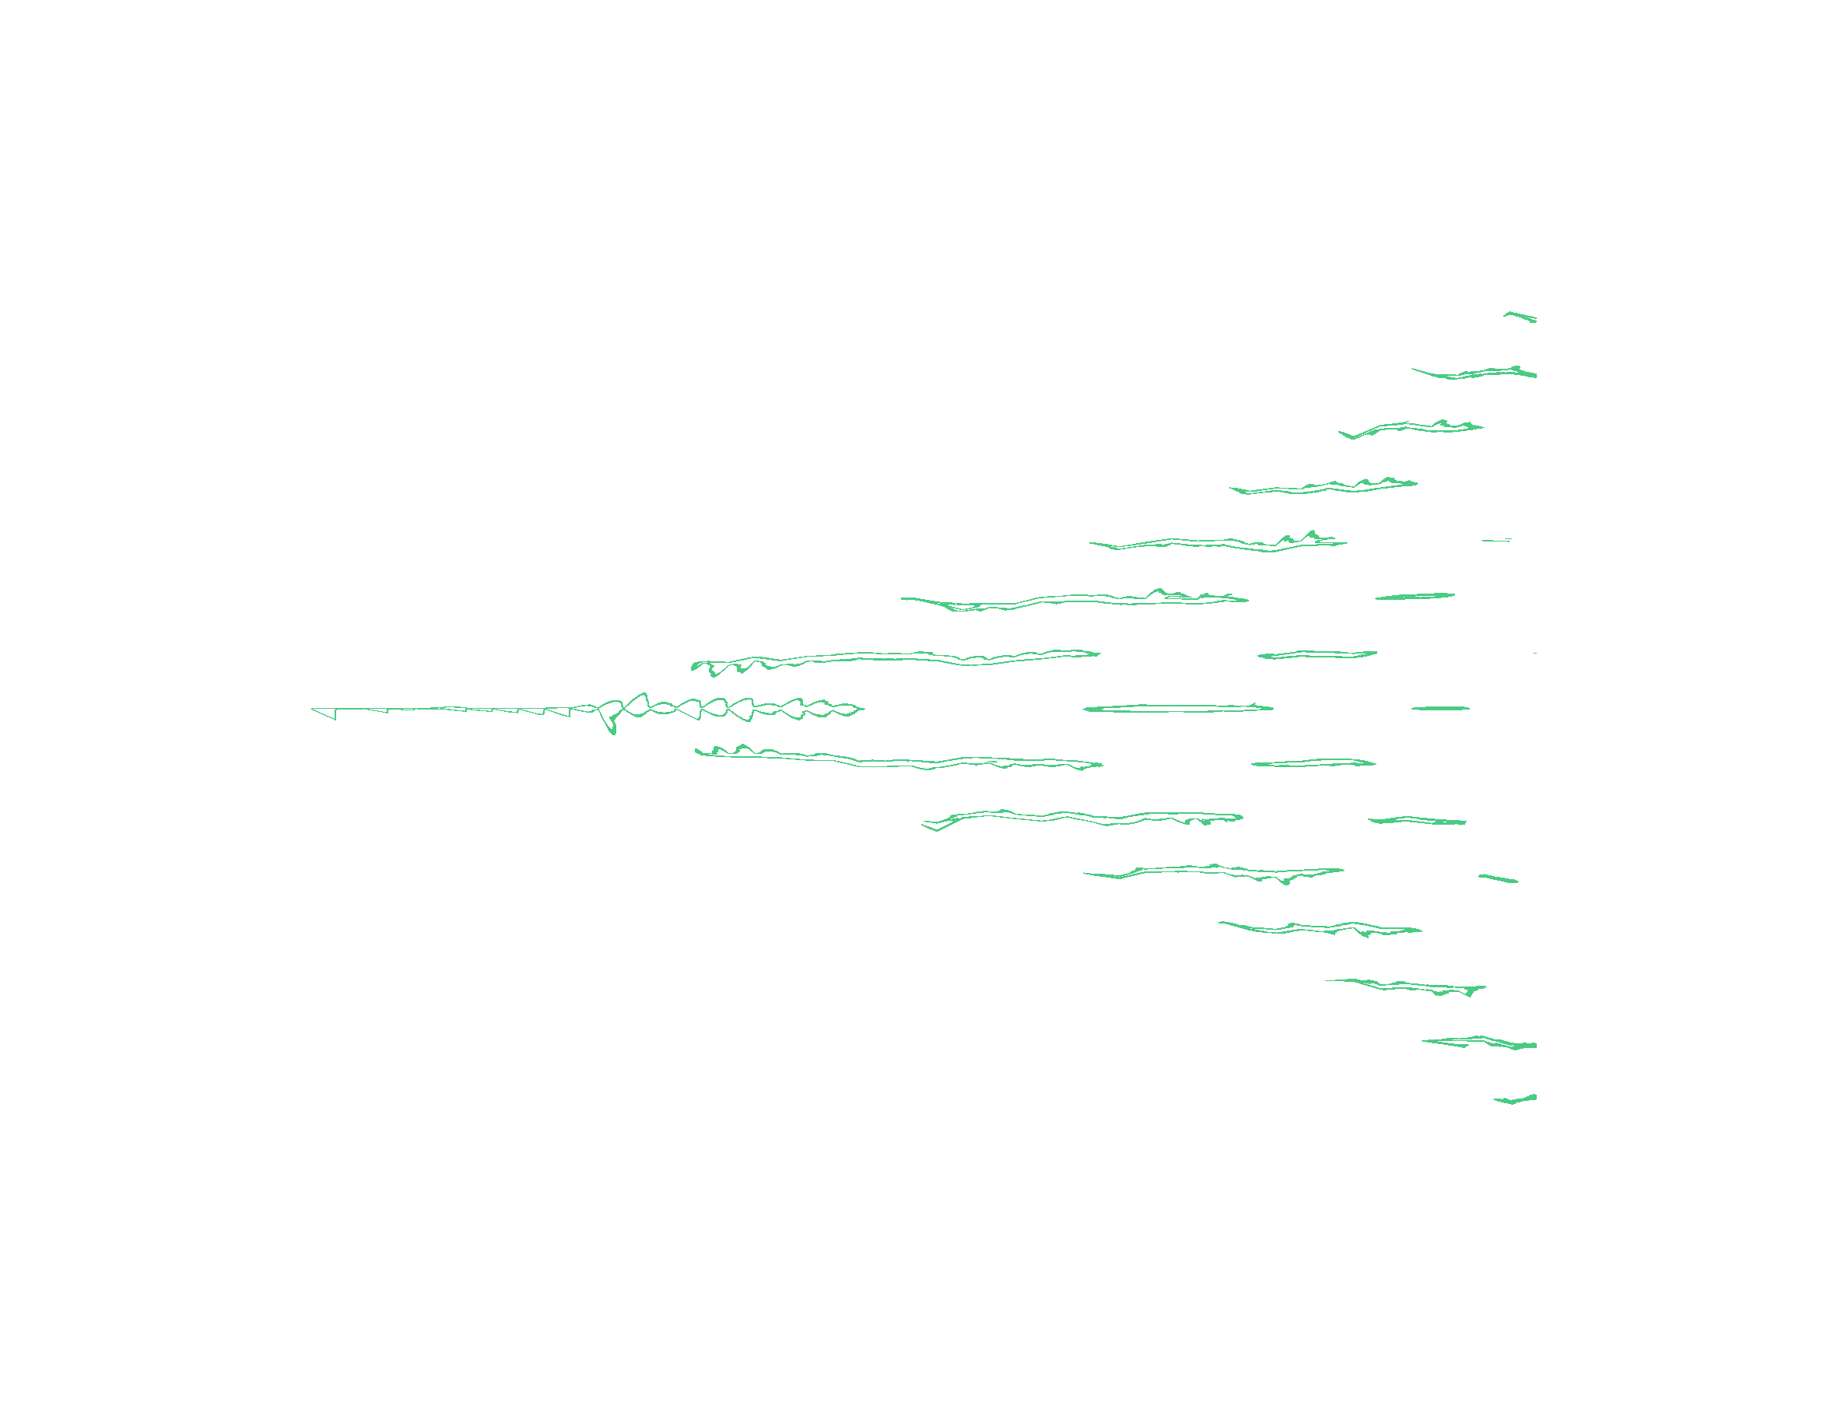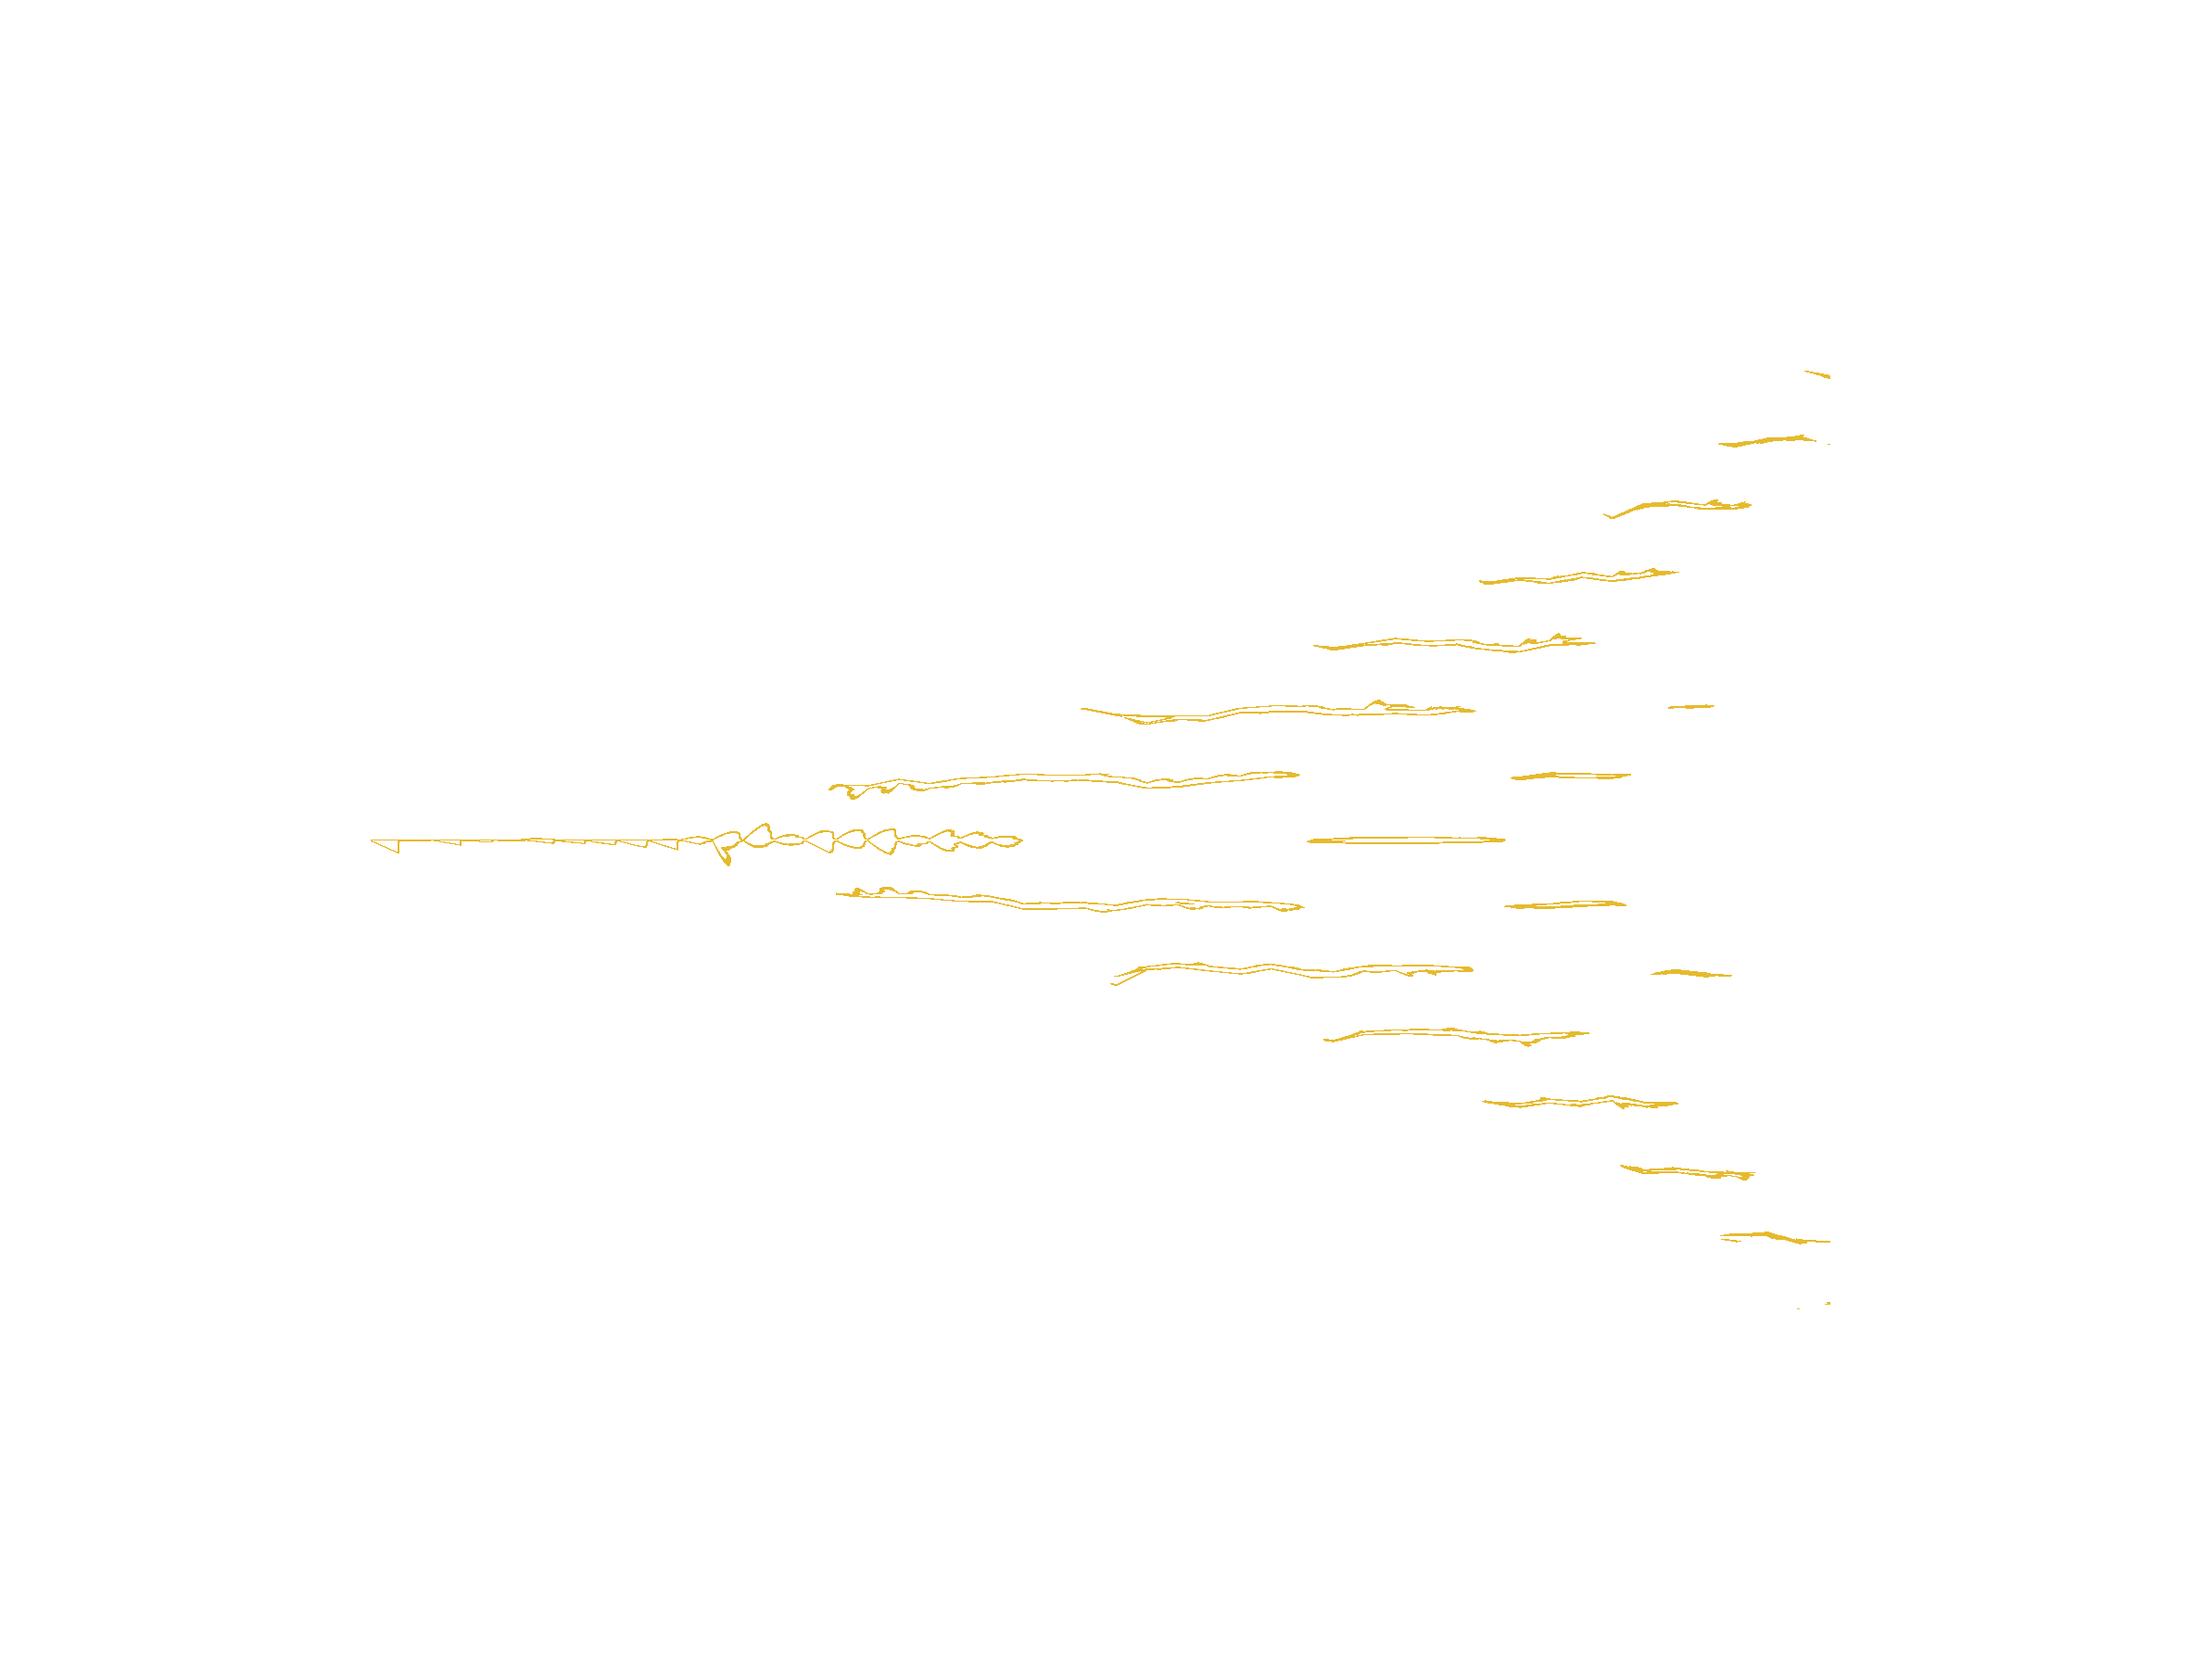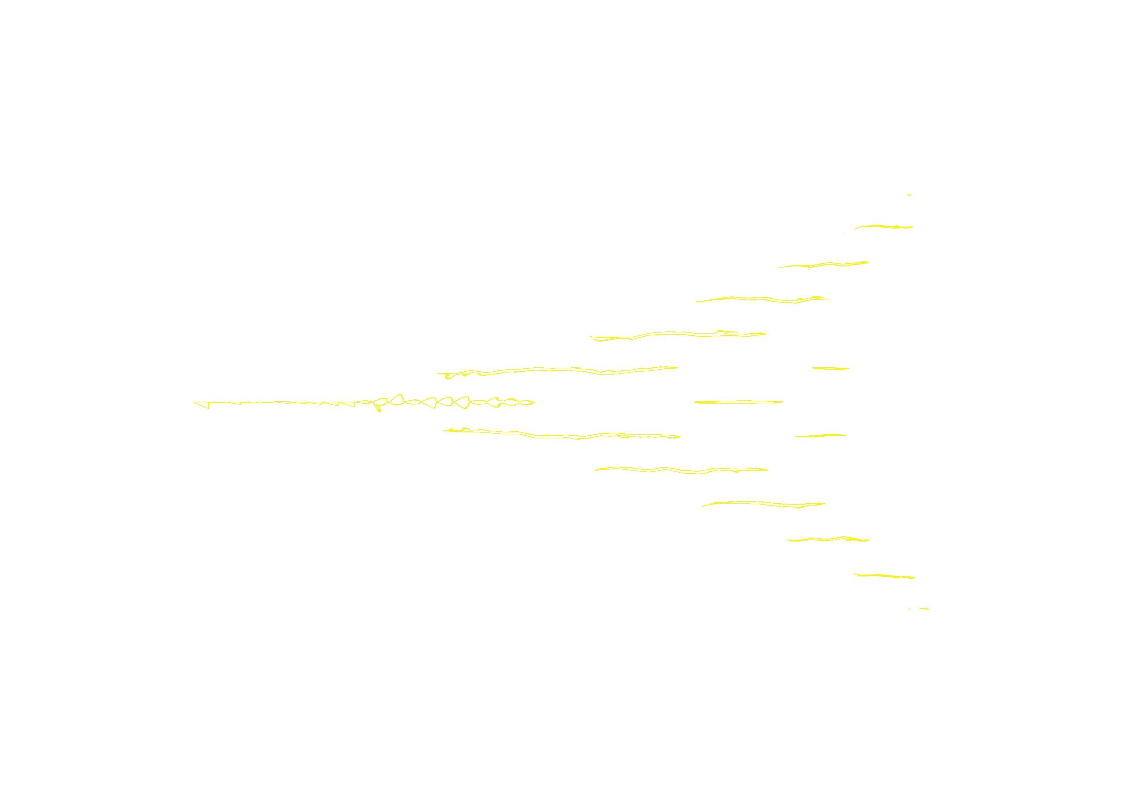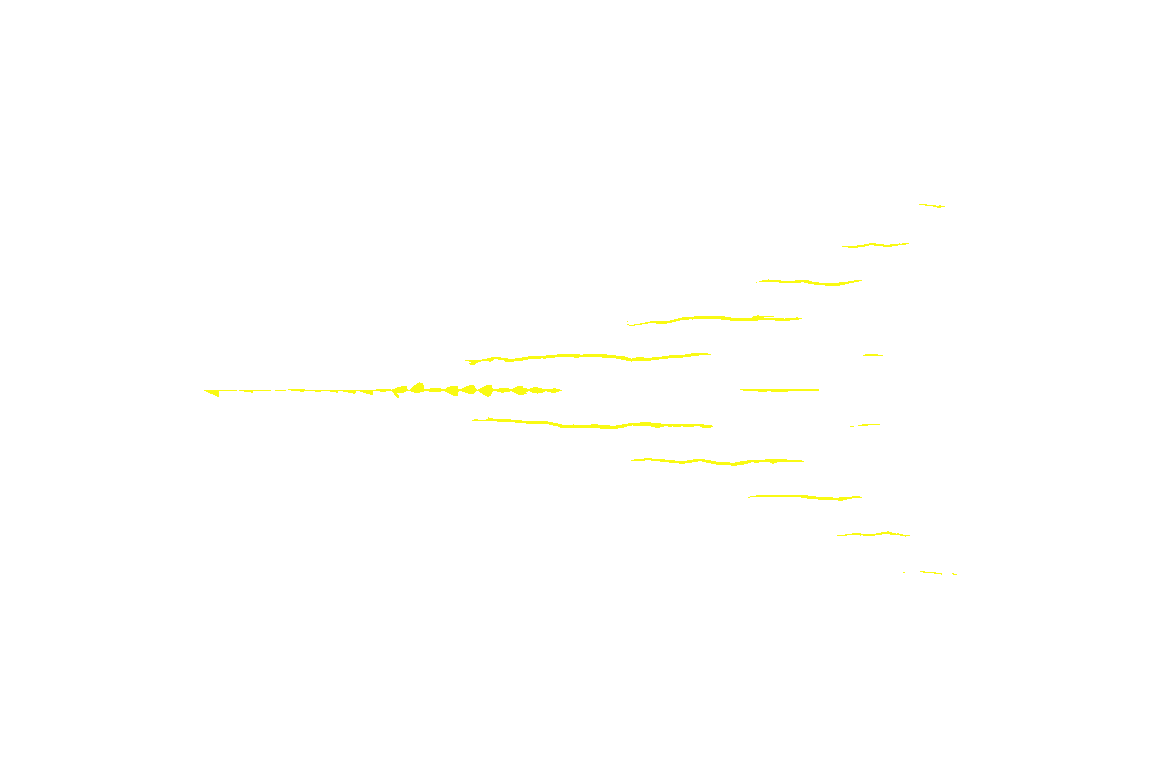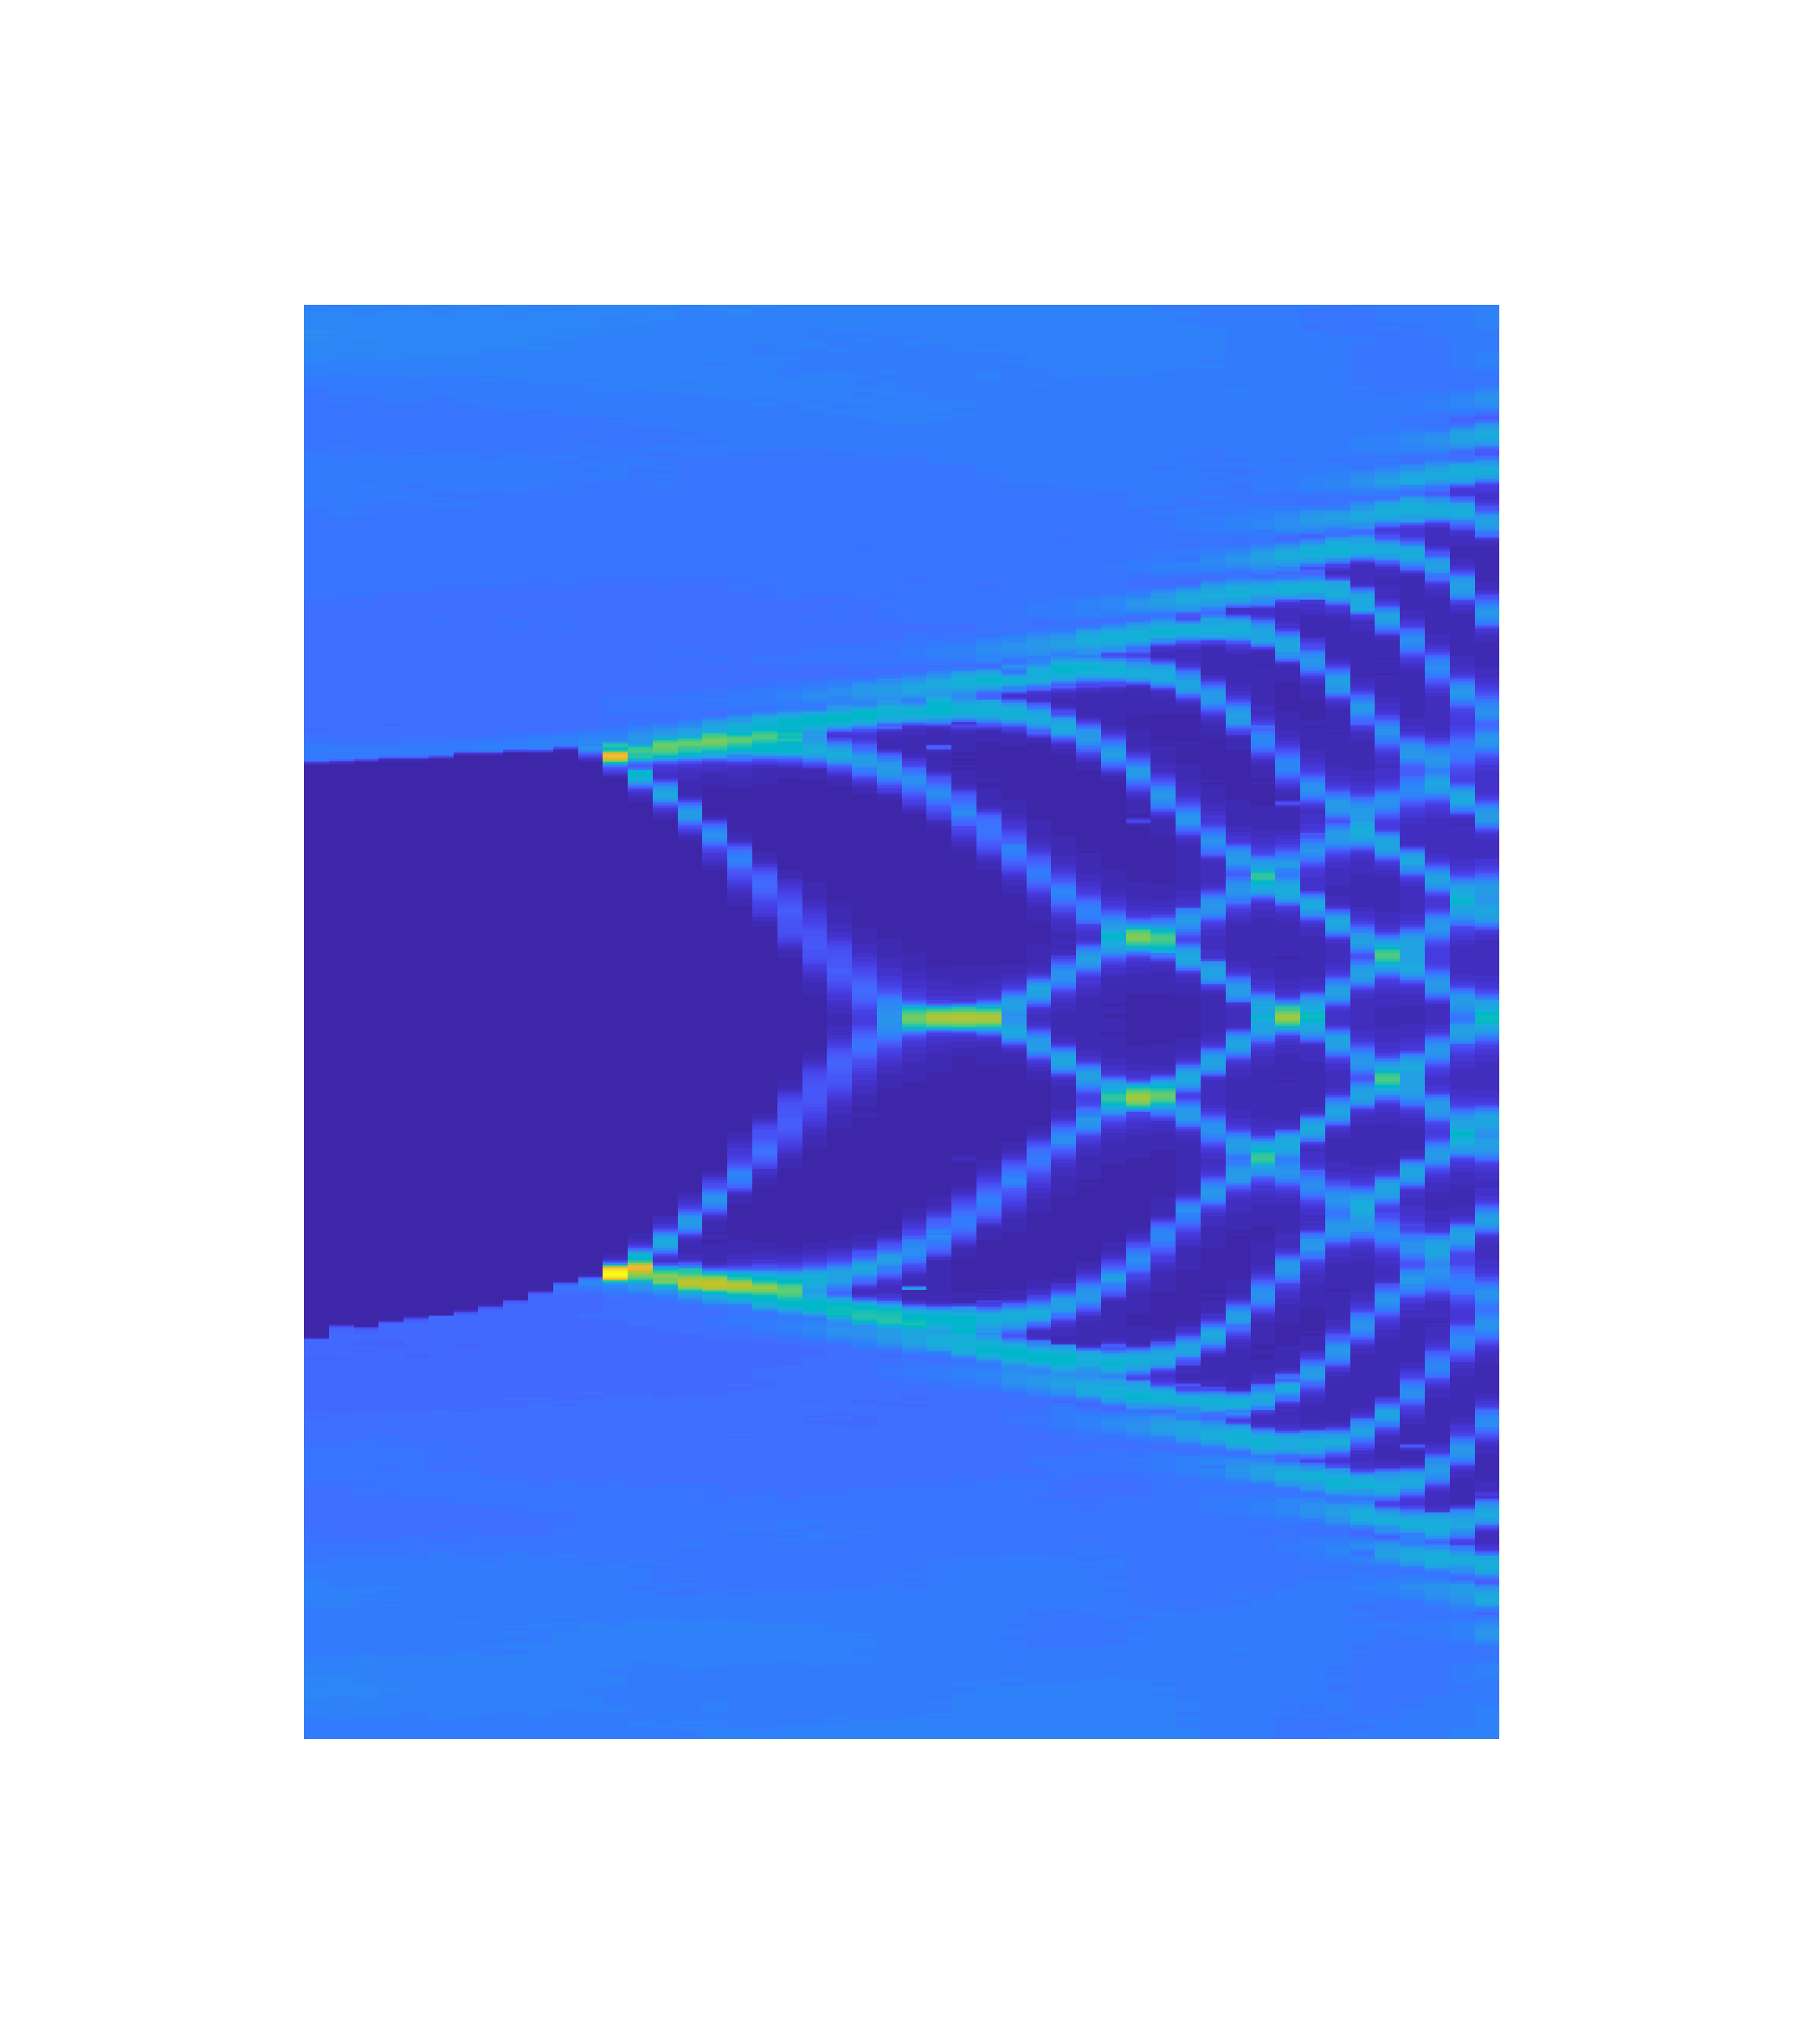
Supporting Figure S3. Ac Josephson effect of the Ge/Si nanowire-based JJ. (a) Differential resistance $dV/dI$ as a function of the bias current $I$ and the microwave power $P_{MW}$ measured at the microwave frequency $f=2.9 GHz$. (b) Differential conductance $dI/dV$ as a function of the bias voltage $V$ and the microwave power $P_{MW}$, same measurement data as (a). The $V$ is obtained by integrating the data in (a), shown in units of the step height $∆V=hf/2e=6 μV$.

Supporting Table S1. Dc transport measurements of the Ge/Si nanowire-based JJs.
Device number | Nanowire diameter (nm) | Room temperature resistance (kΩ) | $I_{c}$ (nA) | Normal state resistance $R_{n}$ (kΩ) | $∆\sim I_{c}R_{n}$ (μV)
16-12 | 32 | 4.7 | 5 | 4.5 | 22.5
16-17 | 28.4 | 2.8 | 26 | 3 | 78
21-1 | 36 | 2.2 | 35 | 1.9 | 66.5
21-5 | 31 | 2.75 | 33 | 2.7 | 89

II. resonator transient response time
In our device, the resonator transient response time $τ_{r}$ with $f_{r}=6.8517 GHz$ is about $300 ns$, as shown in Figure S4, which is related to the coupling capacitance between the resonator and the transmission line.

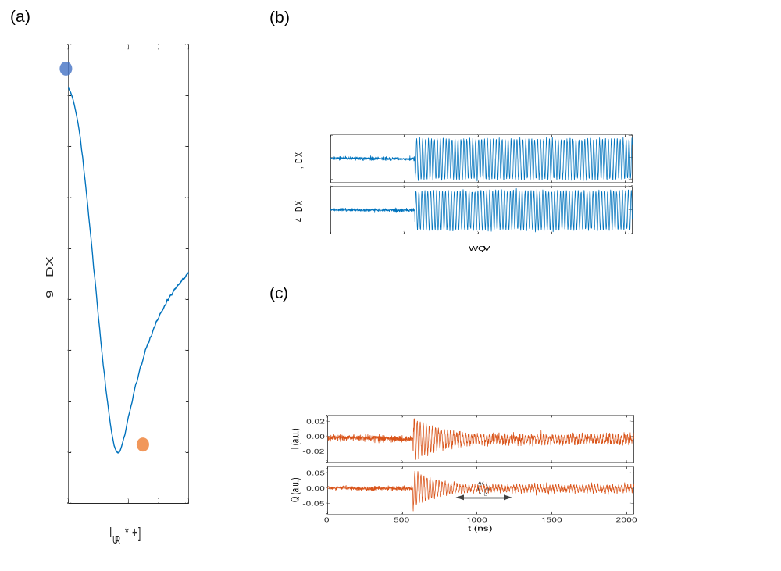
Supporting Figure S4. Resonator transient response time. (a) The response of the resonator with the readout frequency $f_{ro}$ at the resonator resonance frequency $f_{r}=6.8517 GHz$. (b) Real part I (upper panel) and imaginary part Q (lower panel) of the output signal with a frequency of $50 MHz$, demodulated by IQ mixer, as a function of measurement duration $t$, measured at $f_{ro}$ away from the resonator resonance frequency $f_{r}$ (blue point in (a)). (c) Real part I (upper panel) and imaginary part Q (lower panel) of the output signal with a frequency of $50 MHz$, demodulated by IQ mixer, as a function of measurement duration $t$, measured at $f_{ro}=f_{r}$ (orange point in (a)).
III. Supplementary data for $T_{1}$ and $T_{2}$ measurements
The experimental data and fitting results of $T_{1}$ and $T_{2}$ measurements at different $f_{q}$ involved in Figure 4(b) and (c), in the main text, are shown below.


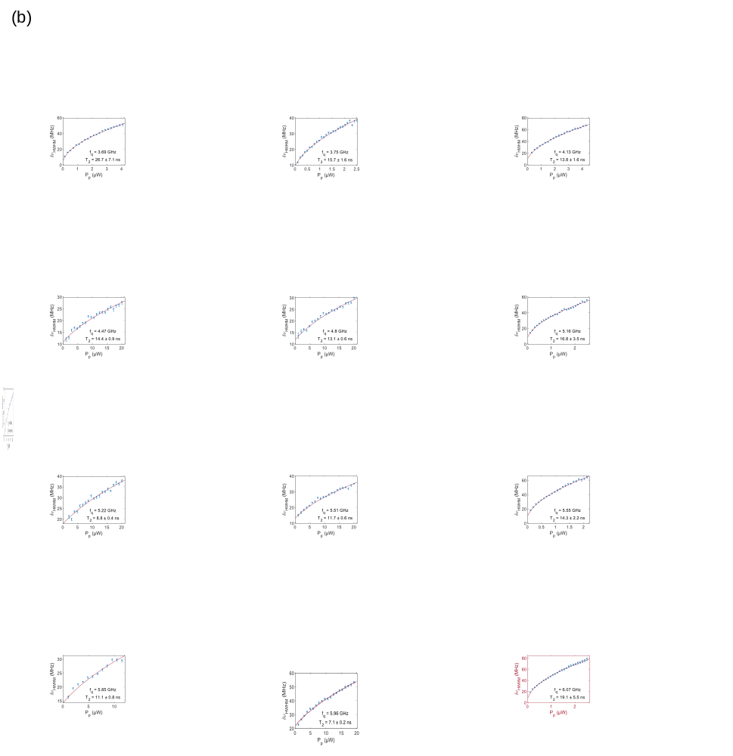
Supporting Figure S5. (a) and (b) are $T_{1}$ and $T_{2}$ measurements at different $f_{q}$, respectively. The points are the experimental data and the solid lines are the fits to the data. The measurements are carried out in the same way as shown in Figure 3. The data that have been shown in Figure 3(d) and (f) in the main text are marked with red boxes.

References
1. Koch, J., et al., Charge-insensitive qubit design derived from the Cooper pair box. Physical Review A, 2007. 76(4): p. 042319.
2. Flensberg, K., J.B. Hansen, and M. Octavio, Subharmonic energy-gap structure in superconducting weak links. Physical Review B, 1988. 38(13): p. 8707-8711.
3. Kotekar-Patil, D., et al., Quasiballistic quantum transport through Ge/Si core/shell nanowires. Nanotechnology, 2017. 28(38): p. 385204.

