Scheme 1. Approaches for the synthesis of silicon-stereogenic monohydrosilanes.
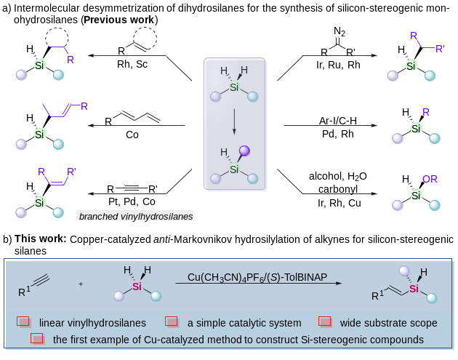

Scheme 2. Exploration of substrate scope.^{a, b, c}
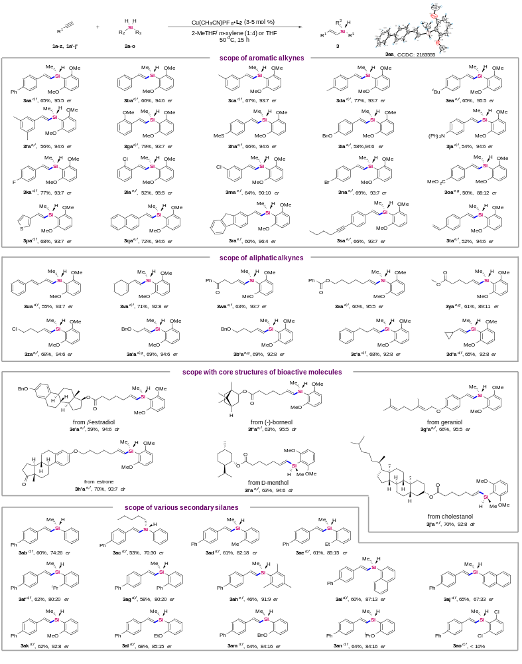
ª Reaction conditions: 1 (0.2 mmol, 1.0 equiv), 2 (0.3 mmol, 1.5 equiv), Cu(CH₃CN)PF₆·L₂ (3-5 mol %) in extra dry solvent (0.2 M) was stirred at 50 ºC for 15 h under argon atmosphere. ^{b} Isolated yield. ^{c} The er value was determined by HPLC. ^{d} 3 mol % catalyst. ^{e} 5 mol % catalyst. ^{f} 2-MeTHF/m-xylene (1:4) as solvent. ^{g} THF as solvent.

Scheme 3. Gram-scale synthesis and transformations of chiral silane products.
a) Gram-scale synthesis.
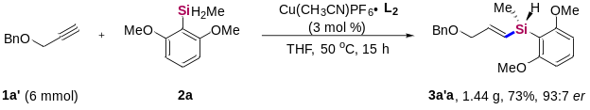
b) Transformations of chiral silane products.
