Jute-integrated copper nanoparticle-embedded PSf membrane as highly efficient dye removal material

Harsh Prajapatiª, Balanagulu Busupalliª*
Department of Chemistry, Pandit Deendayal Energy University (PDEU), Gandhinagar, Gujarat, India-382426

Supporting Information File:

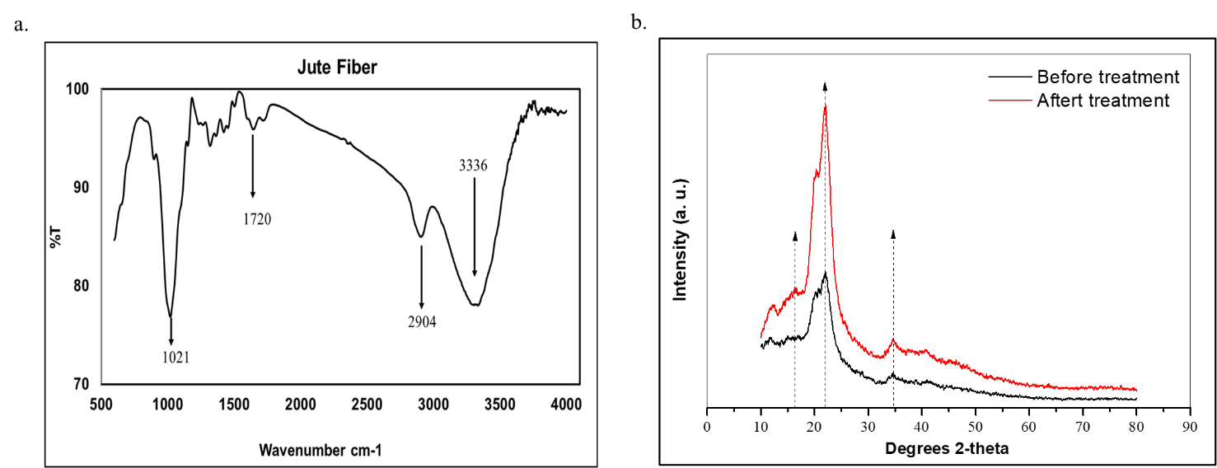

Supplementary Figure S1. a. FT-IR of Jute fibers, b. XRD of Jute fibers

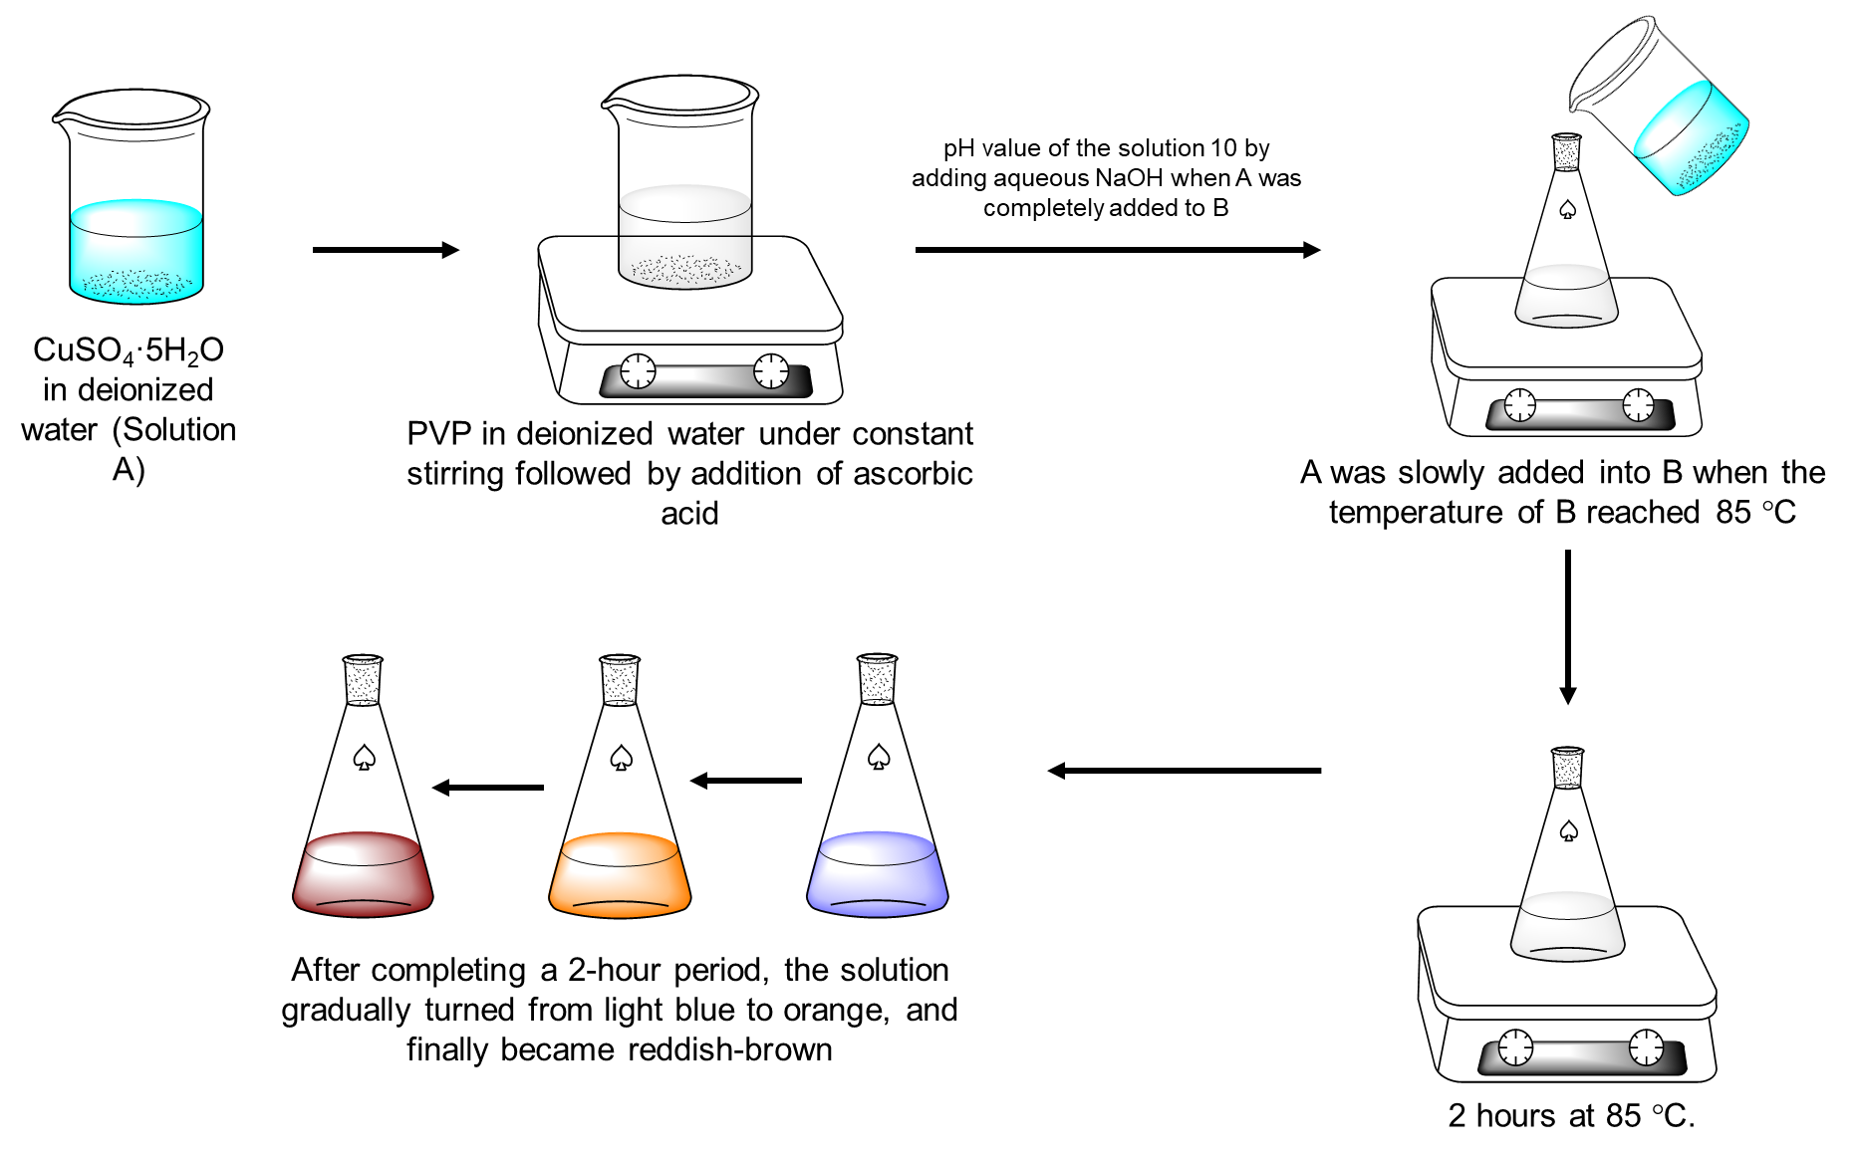
Supplementary Figure S2. Preparation of Copper Nanoparticles

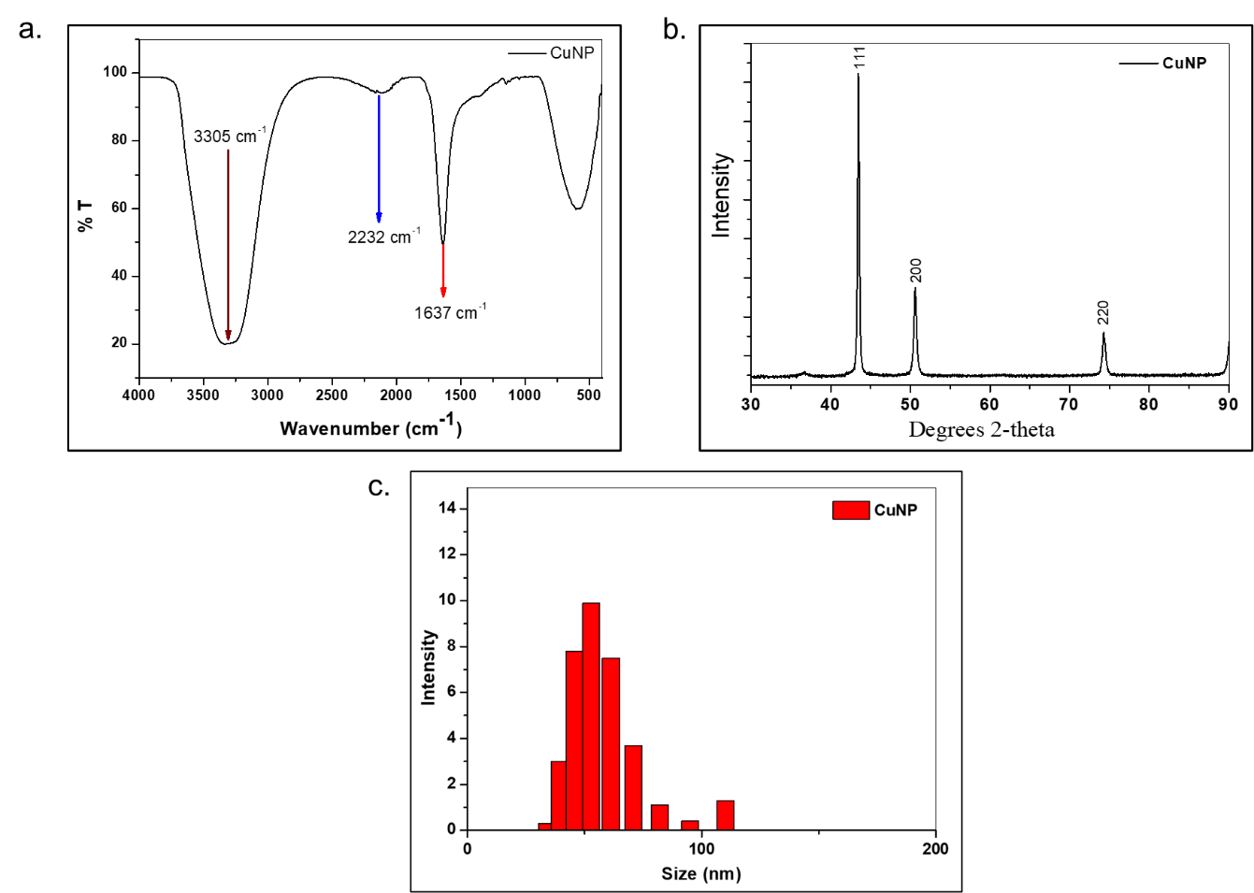
Supplementary Figure S3. a. FT-IR of Copper Nanoparticle, b. XRD of Copper Nanoparticles, c. Particle size analysis of Copper Nanoparticle

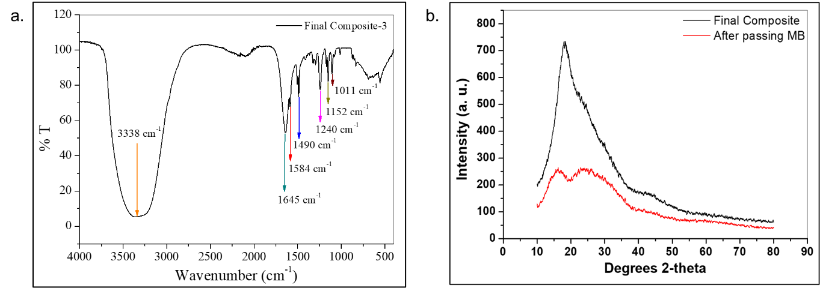
Supplementary Figure S4. a. FT-IR of Final Composite Material, b. XRD of Final composite (Composite 2)

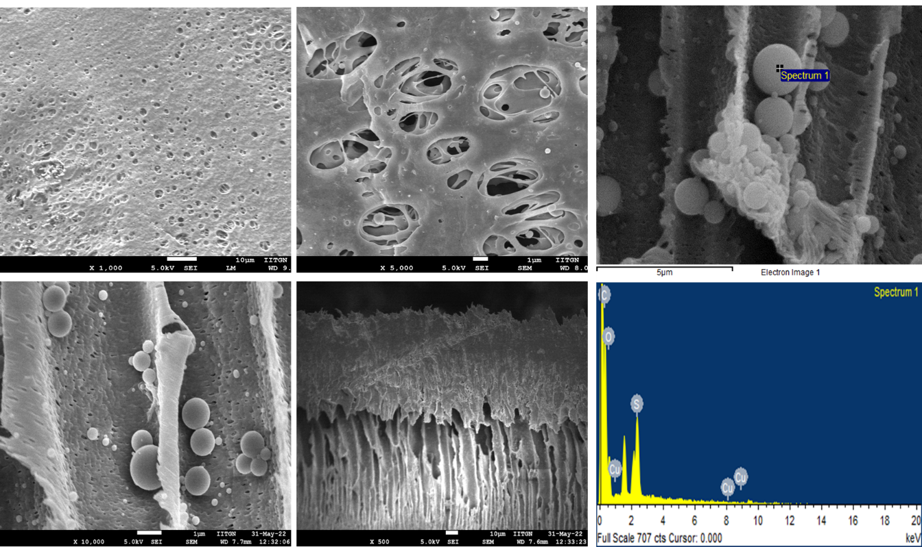

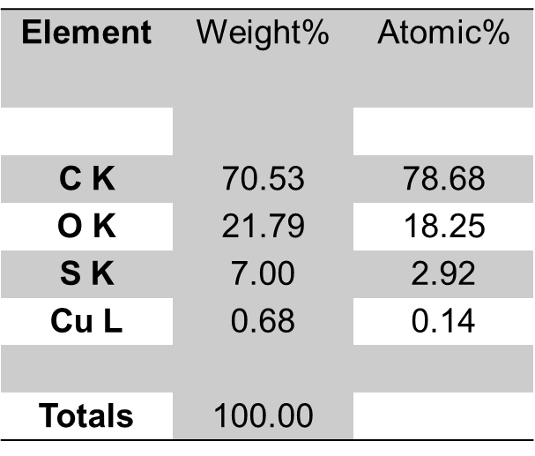

Supplementary Figure S5. SEM of PSF based Final composites (Composite-2) and EDX data

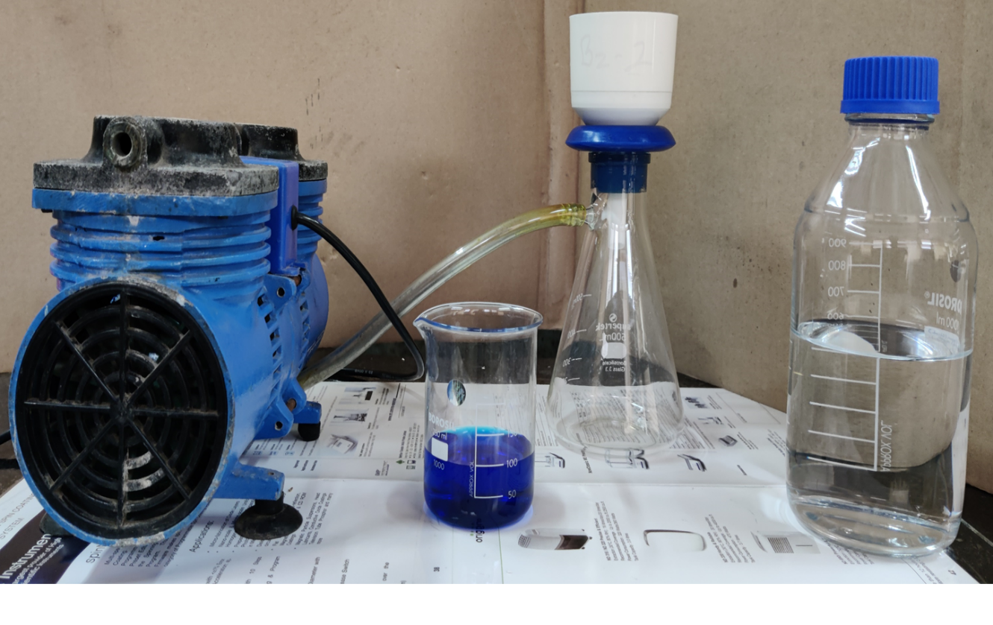
(a)
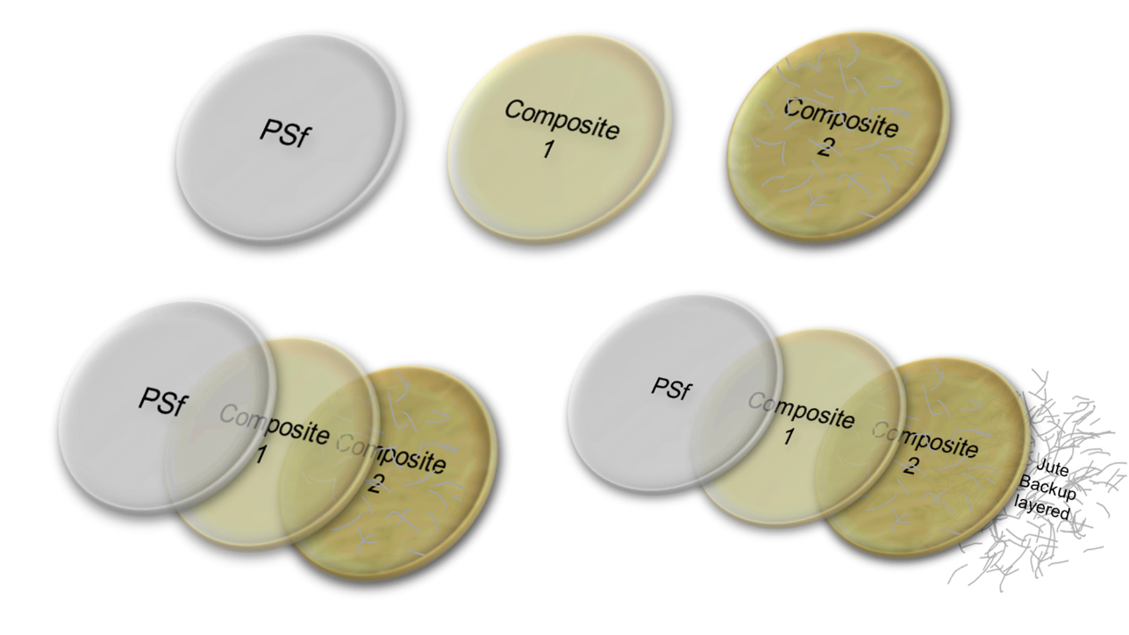
(b)
Supplementary Figure S6. (a). Filtration assembly and (b). Material used for filtration (A. PSf, B. Composite-1, C. Composite-2, D. Multilayered setup (PSf + Com.1 + Com.2), E. Multilayered setup (PSf + Com.1 + Com.2) + Jute backup layered)

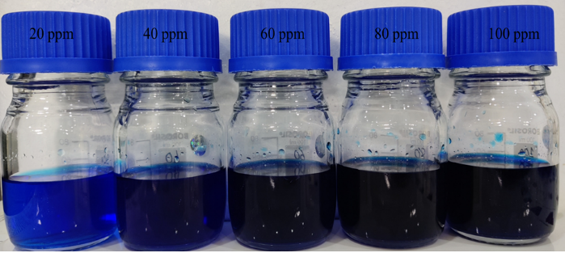

(a)
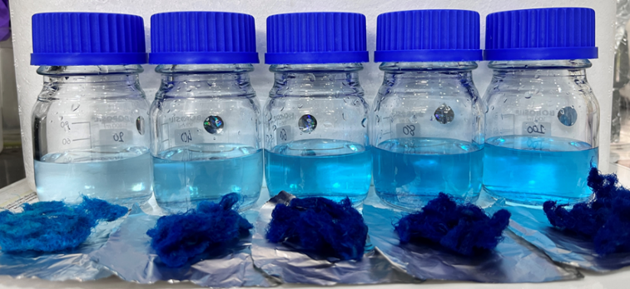

(b)
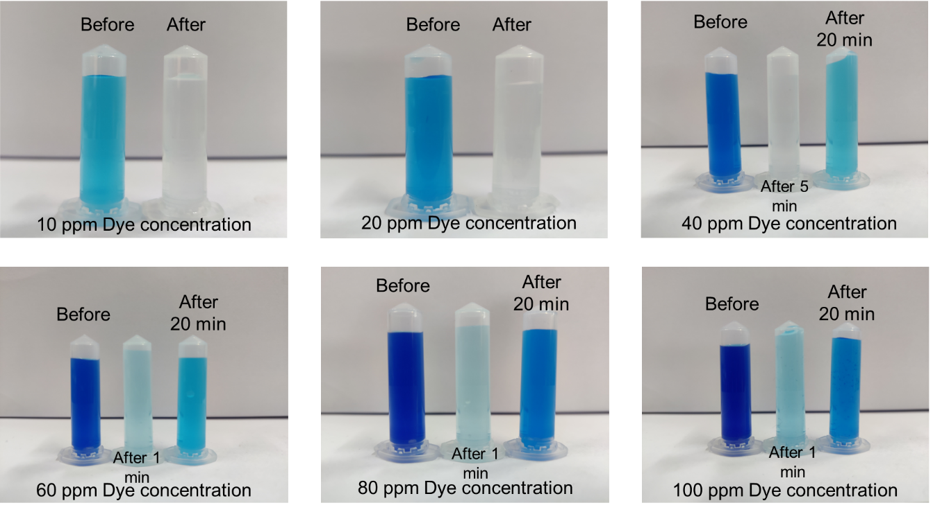
(c)
Supplementary Figure S7. Photographic representation of (a) Initial Dye Concentration, (b) Adsorption and Desorption Study, and (c) Removal of MB using Final Composite 2
In the given Figure S7 we show the initial dye concentration used in our experiment (Figure S7 (a)). Absorption and desorption study carried out for only jute as the adsorbent material (Figure S7 (b)). Here we also show images pertaining to the before and after filtration through the final composite (composite-2) clearly revealing the dye removal from the aqueous solution (Figure S7 (c)).

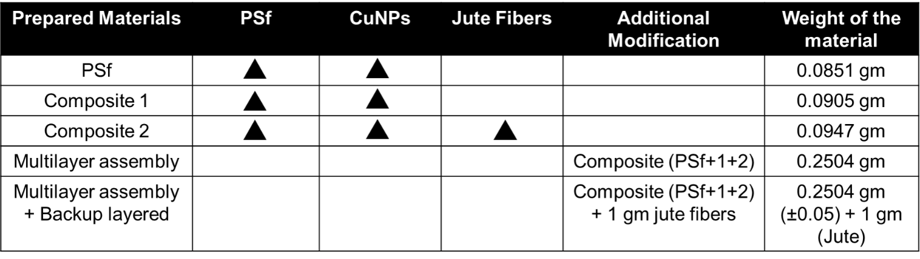
Table 1. Details of prepared composite materials

