Supplementary Information (SI)

Vestibular Compound Action Potentials and Macular Velocity Evoked by Sound and Vibration in the Guinea Pig

Christopher J. Pastras^{1,2*}, Ian S. Curthoys³, Richard D. Rabbitt^{4#}, Daniel J. Brown^{5#}.
Affiliations
¹Faculty of Science and Engineering, School of Engineering, Macquarie University, Sydney, NSW, 2109, Australia.
²School of Medical Sciences, The University of Sydney, Sydney, NSW, 2050, Australia.
³Vestibular Research Laboratory, The University of Sydney, School of Psychology, Sydney, NSW, 2050, Australia
⁴Departments of Biomedical Engineering, Otolaryngology and Neuroscience Program, University of Utah, Salt Lake City, UT, 84112, USA.
⁵School of Pharmacy and Biomedical Sciences, Curtin University, Bentley, Western Australia 6102, Australia

*Correspondence: christopher.pastras@mq.edu.au

Supplementary Note 1. Vestibular Compound Action Potentials were evoked by transient pulses (<1ms) or tone-burst stimuli (e.g., 800Hz). Neural origins of vCAP responses were validated following the perfusion of neurotoxin, Tetrodotoxin (TTX; 100µM in artificial perilymph; Sigma Aldrich, AUS), into the perilymphatic space at the basal epithelium of the utricular macula.

Supplementary Figure 1 (S1). Vestibular striolar primary afferents fire synchronized action potentials at short latencies and precise phase angles relative to input BCV or ACS pulses or train bursts, respectively. A. 0.5ms BCV pulses (0.25ms rise-fall) generate punctate B. ear-bar acceleration transients which evoke robust C. vestibular nerve Compound Action Potentials (vCAPs, averaged; 100 presentations). The neural origin of vCAPs was validated by their chemical ablation following the perfusion of TTX (red line). D. 800Hz sinusoidal BCV results in a E. high-frequency acceleration burst, and a F. volley of extracellular vCAPs, also referred to as the Vestibular Nerve Neurophonic.

Supplementary Note 2. The Laser Doppler Vibrometer was calibrated prior to each experiment. Here, the laser beam from the LDV was focused onto the tri-axial accelerometer, which was vibrated by a Brüel & Kjær minishaker. LDV velocity measurements were made in the same plane as the (in the left-right or x-axis), and accelerometer output was integrated to velocity to validate LDV system output. The LDV carrier delay was corrected programmatically on LabVIEW, and outputs were quantified across frequency using sinusoidal inputs. Code can be made available from the corresponding author upon reasonable request.
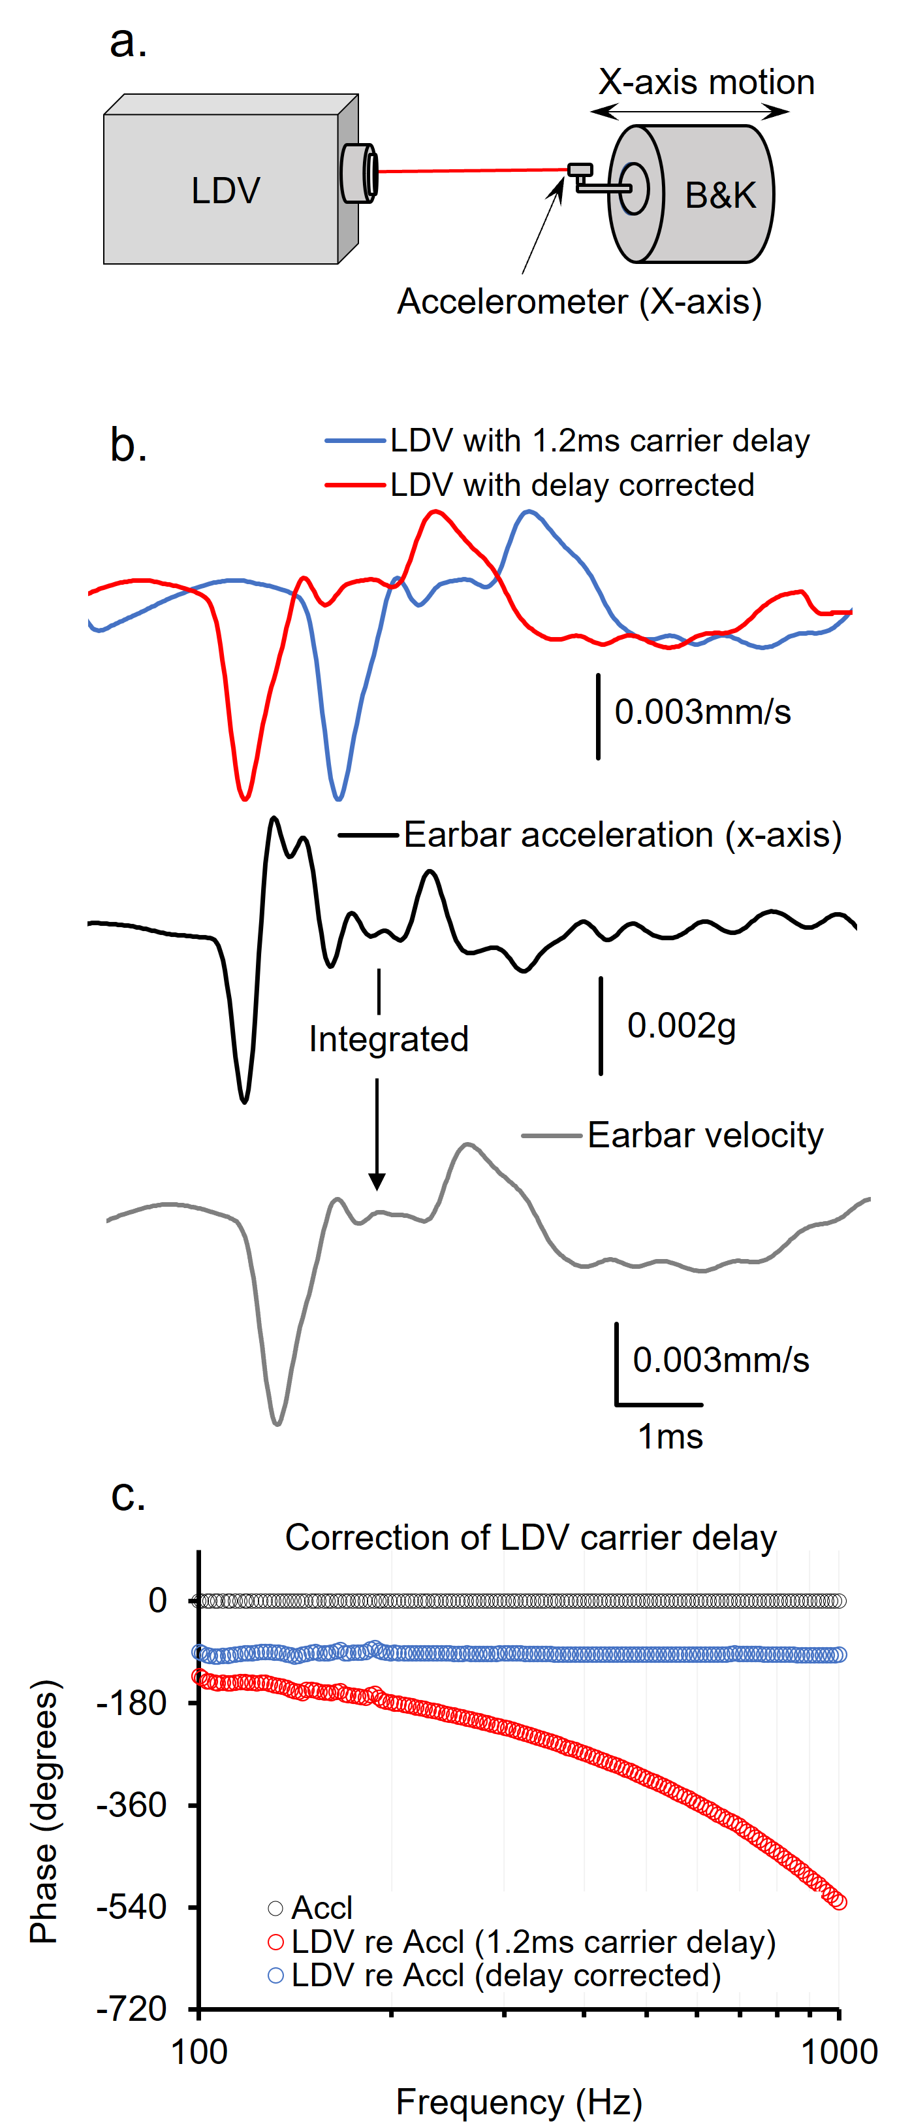
Supplementary Figure 2 (S2). Calibration of Laser Doppler Vibrometry system output. a. Schematic of the experimental setup used to calibrate LDV velocity against accelerometer velocity. b. Representative LDV velocity and earbar acceleration waveforms following Brüel & Kjær (B&K) minishaker stimulation (0.5ms vibration pulse). Accelerometer G integrated to velocity matches the waveshape and magnitude of LDV velocity, suggesting a robust calibration. c. Results of the 1.2ms LDV carrier delay correction across frequency. Supplementary Note 3. When recording vestibular responses, attempts were made to position the bead at the central dark band in the middle of the macula, which corresponds approximately to the striolar zone of the neuroepithelium (Fig. 1 & 3). However, due to the delicate nature of the surgery, and with attempts to avoid contact/damage to the vestibular macula, bead positions varied subtly across animals. Measurements were undertaken to determine the effect of this variation. Recordings of macular vibration at the lateral striolar region revealed minimal to no differences to that of the central ‘striolar’ zone for brief vibration. This suggested that discrepancies in bead placement across animals did not alter mechanical results based on spatial tuning of the macula. Comparisons of temporal bone vibration were also compared to that of the macula, to quantify BCV transmission through the cranium to the macula.

Supplementary Figure 3 (S3). Dynamic response of the macula vs. bone to pulsatile vibration. A. Reflective microbeads were placed on the central (green) and lateral (red) macular region, and bone within the vestibule (blue), for LDV and accelerometer measurements during BCV. B. Representative LDV and accelerometer waveforms corresponding to 0.1V input drive to the minishaker. C. LDV Input-Output functions across BCV input drives corresponding to central and lateral macula and bone positions, for negative (dashed lines) and positive (solid lines) polarity stim. D. LDV response sensitivity relative to ear-bar acceleration in units of µm/s/mG, across input drives associated with different bead positions.

