Supplementary information
Detailed Materials and Methods

1. Animals
RORγt Tg mice generated on a C57BL/6 background in which transgene expression was driven by the CD2 promoter [13, 14] were obtained from Takahashi Laboratory (University of Tsukuba, Tsukuba, Japan). The RORγt Tg mouse line was maintained by backcrossing with C57BL/6 mice. In this study, we used both male WT and RORγt Tg mice at 16W. All animals were housed under standard laboratory conditions (12/12 h light/dark cycle, free access to food and water), and maintained under pathogen-free conditions in the Laboratory Animal Resource Center at the University of Tsukuba. All animals received no treatment (including medication) prior to each experiment.

2. Real-Time PCR
Real-time PCR was performed as previously described [14]. Briefly, colon samples for real-time PCR experiments were obtained from 16W mice. Samples were collected with a Nucleocapsid RNA Kit (Macherey-Nagel, Düren, Germany), and RNA was extracted according to the manufacturer’s instructions. Complementary DNA (cDNA) was generated from the obtained RNA with a High-Capacity RNA-to-cDNA kit (Thermo Fisher Scientific). For real-time PCR, cDNA samples were diluted and mixed with primer pairs for Rorc and IL17A (Supplementary Table 1, Fig. 1A), THUNDERBIRD SYBR qPCR mix, and H₂O. Twenty µL of each sample was placed in a PCR plate and run on an Eco Real-Time PCR System (Illumina, San Diego, CA). Quantification was performed by 2^{−ΔΔCt} analysis. Relative expression levels were calculated with the 2^{−ΔΔCt} method using HPRT as an internal control.

3. Enzyme-Linked Immunosorbent Assay
ELISA was performed as previously described (Tome et al., 2019). Briefly, blood samples (> 0.5 mL) were obtained from the hearts of male mice at 16W. Four mice per group (WT and RORγt Tg) were used for this analysis. The blood was collected in tubes (containing EDTA-2K and CJ-2DK; Terumo, Tokyo, Japan), and centrifuged at 3000 g at 4ºC for 10 min. Serum concentrations of IL-6 and IL-17A were measured using an ELISA system according to the manufacturer's instructions (Fig. 1B).

4. Immunohistochemistry
For histological analysis, mice at 16W were deeply anesthetized with sodium pentobarbital (60 mg/kg body weight, intraperitoneal injection; Somnopentyl; BCM International, Hillsborough, NJ) and transcardially perfused with phosphate buffered saline (PBS), followed by 4% paraformaldehyde in 0.1 M phosphate buffer. Brain tissue sections (40 µm) were prepared with a sliding microtome (REM-710, Yamato-Kohki, Asaka, Japan) and stored at -20°C in cryoprotectant solution (30% glycerol, 30% ethylene glycol, and 40% 0.1 M phosphate buffer) until used in experiments.
Sections were rinsed three times with PBS, submerged in blocking solution (1% bovine serum albumin, 0.3% Triton-X 100, and 0.1% NaN₃ in PBS) for 60 min at room temperature, and then incubated with the following primary antibodies: Iba1 (1:2000, 019-19741, Fujifilm-Wako Pure Chemical, Tokyo, Japan), GFAP (1:1000, Rb-Af800, Frontier Institute), and DCX (1:2000, AB2253, Millipore). Sections were washed three times with PBS before incubating with secondary antibodies in an opaque container for 4 h at room temperature. Secondary antibodies used were goat anti-rabbit Alexa Fluor 488 (1:500, A11070, Thermo Fisher Scientific) and goat anti-guinea pig Alexa Fluor 488 (1:500, 1938425, Thermo Fisher Scientific). Slides were then washed four times with PBS containing 0.05% Tween-20, and mounted with PermaFluor (Thermo Fisher Scientific). Fluorescent images were acquired on an All-in-One Fluorescence Microscope BZX-710 with a 40× objective lens using the Perfect Focus System (Figs. 2A and 2D). Two regions of hippocampus, the DG and CA1, were examined in this study. Fluorescence intensities of Iba1⁺ and GFAP⁺ cells (Figs. 2B and 2E), as well as the density of Iba1⁺, GFAP⁺, and DCX⁺ cells (Figs. 2C, 2F, and 2H) were quantified with the microscope-integrated application. This analysis was carried out under the support of the Open Facility, Research Facility Center for Science and Technology, University of Tsukuba.

5. Western blotting
Hippocampal tissue samples were collected from RORγt Tg and WT mice at 16W. Samples were homogenized and lysed in radioimmunoprecipitation assay buffer. Equal volumes were mixed with Laemmli sample buffer (Bio-Rad, Hercules, CA), boiled, and analyzed on 8%–10% sodium dodecyl sulfate polyacrylamide gels. Proteins were transferred to polyvinylidene difluoride membranes and blocked with 5% skim milk in Tris-buffered saline containing Tween-20 (TBST). Anti-NR2B (rabbit polyclonal, A-6474, 1:500; Thermo Fisher Scientific), anti-NR2A (rabbit polyclonal, 1:500, A-6476, Thermo Fisher Scientific), anti-PSD-95 (mouse monoclonal, 1:2000, ab13552; Abcam), and anti-PSD-93 (rabbit polyclonal, 1:1000, AB_2571834; Frontier Institute) diluted with 1% skim milk in TBST were used as primary antibodies and for overnight incubation. For normalization of proteins in each sample, α-tubulin (1:1000, T9026; Sigma-Aldrich) was used as a control (Fig. 2J). Membranes were washed with TBST and incubated with goat anti-guinea pig secondary antibody conjugated to horseradish peroxidase (HRP) (1:10000, GR3175094-7, Abcam), anti-mouse secondary antibody conjugated to HRP, or anti-rabbit secondary antibody conjugated to HRP (1:10000, 7076 and 7074, respectively; Cell Signaling Technology, Danvers, MA). Membranes were washed in TBST, and protein bands were visualized with Immobilon Western Chemiluminescent HRP Substrate (Millipore) using a LI-COR C-Digit Blot Scanner with Image Studio software.

6. Behavioral analysis
Novel object location testing was performed as previously described with slight modifications [15]. The placement apparatus consisted of an open field arena measuring 47 × 68 × 22 cm, with a black background. Two cylinder blocks were used as objects, and each block was placed in the middle of the designated area to produce a symmetric appearance. The arena was set up under an overhead digital camera, and mice were tracked and recorded with automated tracking software. On Day 1 of the novel object location test, a single mouse was placed in the arena and its behavior was recorded for 10 min. Left and right blocks were placed co-linear to each other. The arena was cleaned with water and dried between each test subject to prevent any odor cues from previous subjects. On Day 2, the task was repeated with the right block placed at a different location (Fig. 3). This behavioral test primarily evaluates spatial learning, which relies on hippocampal activity. Only male mice at 16W were used for this test. Quantitative analysis of the retrieved data was performed using EthoVision XT.

7. Statistical analysis
Differences between the two groups were analyzed with Student’s t-test. All statistical analyses were performed using JMP (SAS Institute, Cary, NC). Probability values < 0.05 were considered significant. All data are expressed as mean ± standard error of the mean.

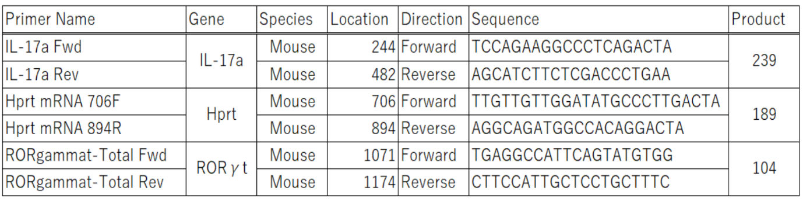
Supplementary Table 1. Primer pairs for real-time PCR.

