Supporting Information
Fabrication and functionality of 3D-printed porous scaffolds composing natural derivatives of duck bones and fish shells and poly(ε-caprolactone)
Dung-Yi Wu¹, Wen-Ling Shih², Shan-Shue Wang³, Chin-San Wu^{3,}*

¹Department of Materials Science and Engineering, Johns Hopkins University, Baltimore, MD 21218, USA
²Department of Biological Science and Technology, National Pingtung University of Science and Technology, Taiwan, Republic of China
³ Department of Cosmetology and Health Care, Kao Yuan University, Kaohsiung County, Taiwan 82101, Republic of China

* Corresponding author. E-mail address: t50008@cc.kyu.edu.tw (C.-S. Wu)

● Number of pages: 11
● Number of table: 2
● Number of figures: 6

Table S1. Formulations of PCL/HA and PCL/MHA composites.

Solution | Component
Solution | PCL (wt%) | HA (wt%) | TAS (phr)
PCL | 100 | - | -
PCL/HA 4 wt% | 96 | 4 | -
PCL/HA 8 wt% | 92 | 8 | -
PCL/HA 12wt% | 88 | 12 | -
 | 84 | 16 | -
  PCL/HA 16 wt% | 95 | - | 9 | -
PCL/MHA 4 wt% | 96 | 4 | 0.8
PCL/MHA 8 wt% | 92 | 8 | 0.8
PCL/MHA 12 wt% | 88 | 12 | 0.8
PCL/MHA 16wt% | 84 | 16 | 0.8
PCL: Polycaprolactone, HA: hydroxyapatite, MHA: HA and Abalone fish shell-derived Ca(OH₂) (TAS) mixed complex.

Table S2
Element content of DB and HA
Element  Temperature | Atomic% |  |  |  |  |  |  | Weight%
Element  Temperature | C | Ca | P | O | Mg | Na | Ca/P |  | C | Ca | P | O | Mg | Na
DB | 40.21 | 11.87 | 5.41 | 41.08 | 0.65 | 0.78 | 2.19 |  | 27.86 | 25.28 | 9.01 | 36.29 | 0.73 | 0.83
HA | - | 21.66 | 13.28 | 63.99 | 0.36 | 0.71 | 1.63 |  | - | 36.63 | 16.21 | 45.91 | 0.44 | 0.81

DB: duck bone
HA: duck bone thermally treated at 1000 ºC

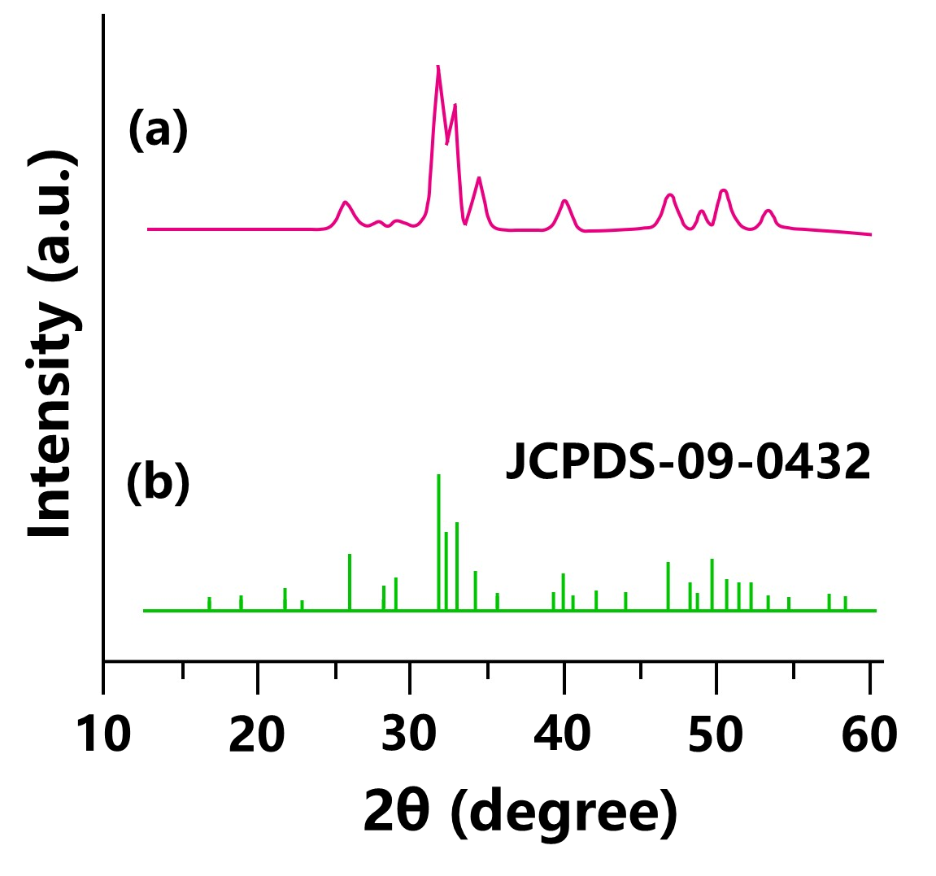

Figure S1. Wide-angle X-ray diffraction (XRD) patterns of (a) Hydroxyapatite (HA)－duckbone-treated thermally at 1000°C, and (b) hydroxyapatite standard JCPDF (09-0432).
The XRD spectrum of duckbone- derived HA and HA standard JCPDF (09-0432) are showed in Figure S1. The HA thermally treated duckbone at 1000°C has 9 absorption peaks that are 25.7°, 31.7°, 32.8°, 34.2°, 39.6°, 46.6°, 49.5°, 50.5° and 53.3°, respectively as shown in Figure S1(a), similar to previous result [1]. Compare to the XRD patterns of the hydroxyapatite standard JCPDF (09-0432) as shown in Figure S2(b), all the observed HA peaks were in good agreement with this standard, indicating that thermally treated duckbone at 1000°C has generated hydroxyapatite [2].

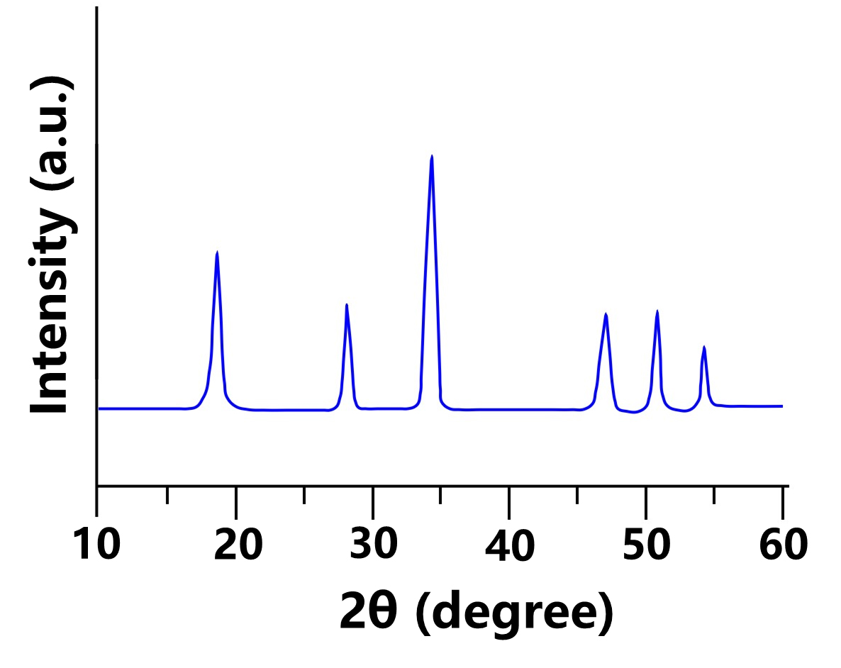
Figure S2. Wide-angle X-ray diffraction (XRD) patterns of calcium hydroxide formed by thermally treated fish (Abalone) shell at 1000°C with hydration.
Figure S2 shows the XRD spectra of Ca(OH)₂ from fish (Abalone) shell calcined at 1000°C and hydration. Six major absorption peaks appear at 18.2°, 28.6°, 34.3, 47.2°, 50.8 and 54.3° [3], respectively.

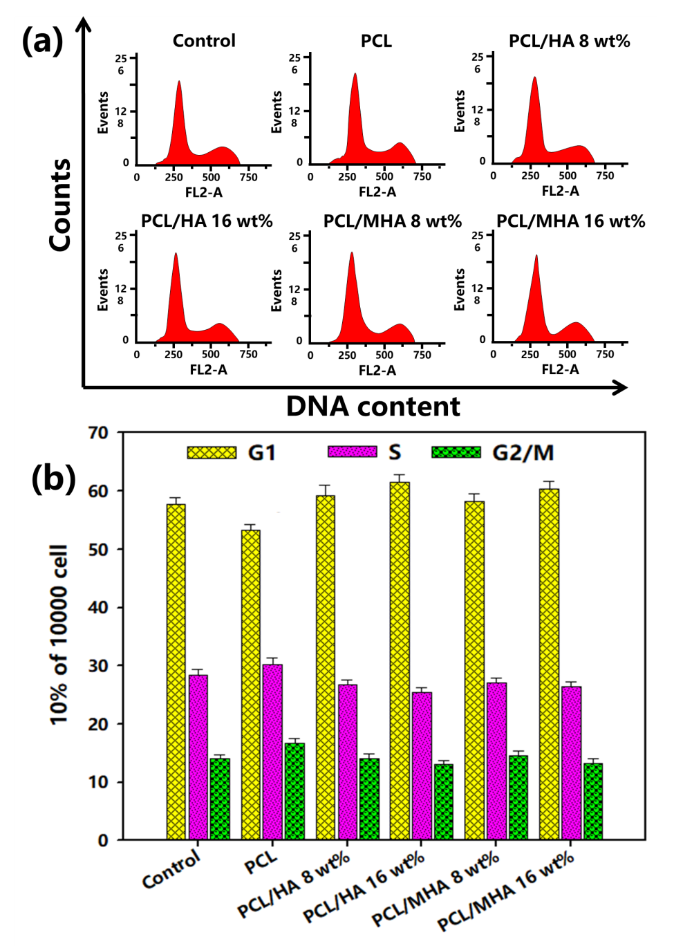

Figure S3. Cell-cycle test results. (a) The horizontal axis (FL2-A) corresponds to the cell DNA content. The vertical axis (event) represents the cell number. (b) Cell-cycle histograms represent the percentage of the total cell population in the different phases.
All data are expressed as means ± SE from at least three separate experiments.

Figure S3
The osteoblast cells were cultured with PCL/HA and PCL/MHA scaffolds for two days. The cells in G1、S and G2/M in cell cycle were examined. The results have shown that PCL/HA and PCL/MHA scaffolds did not influence the cell distribution of G1、S and G2/M population.

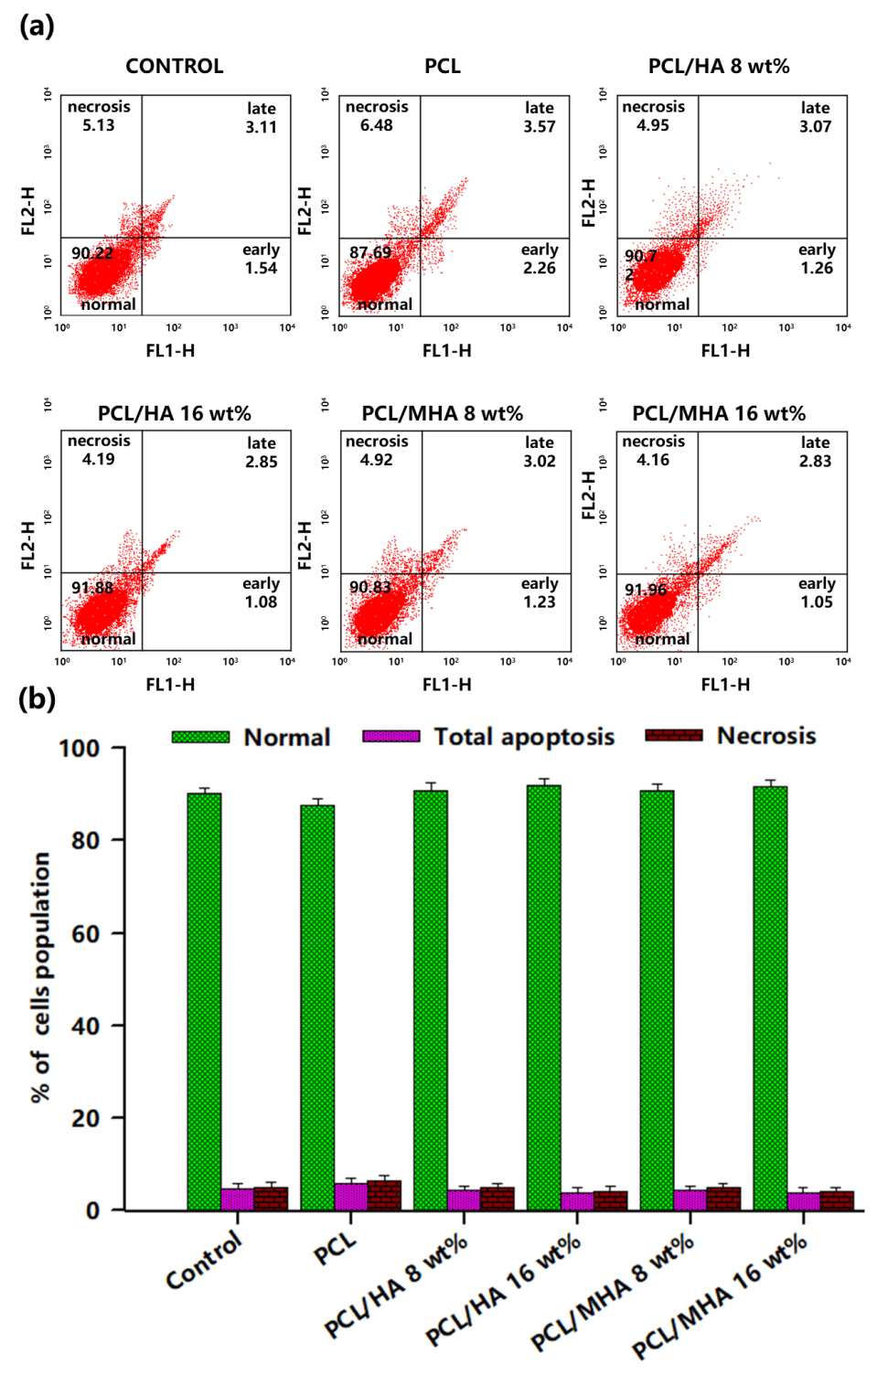

Figure S4. Annexin-V/propidium iodide (PI) staining assays of various ratios of PCL/HA and PCL/MHA scaffolds for (a) FITC-Annexin V (FL1-H) vis PI (FL2-H) via two-color flow cytometry. (b) Apoptosis histograms show the percentage of the total cell population in the different phases. All data are expressed as means ± SE from at least three separate experiments.

Figure S4
The osteoblast cells were cultured with PCL/HA or PCL/MHA scaffolds for one days, stained with the Annexin V–FITC (Fluorescein isothiocyanate) and PI Staining solution and counted the populations of normal, total apoptotic (early-and late-stage) and necrotic osteoblast cells. The normal cell population is no difference among control, PCL/HA and PCL/MHA scaffolds.

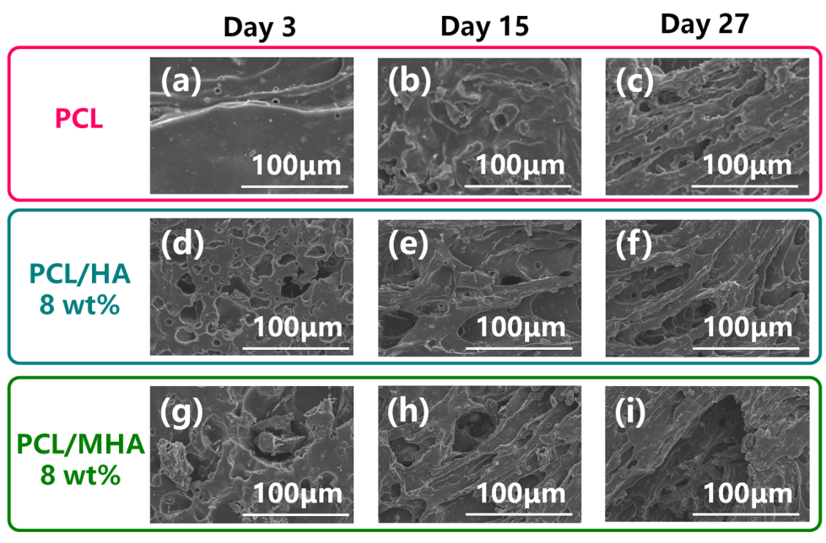

Figure S5. SEM images of degradation of PCL, PCL/HA and PCL/MHA scaffolds at different period in the PBS buffer solution: PCL (a) 0, (b) 15, and (c) 27 days; PCL/HA (8 wt%) (d) 0, (e) 15, and (f) 27 days; and PCL/MHA (8 wt%) (g) 0, (h) 15, and (i) 27 days.
Figure S5 shows the SEM morphology of the PCL, PCL/HA (8 wt%), and PCL/MHA (8 wt%) scaffolds soaked in PBS buffer at different period. The surface decomposition increased as the duration increased. Figure S5 (a, d, g) shows the surface morphology before the scaffolds were soaked in PBS buffer was intact and uncracked. After 15 and 27 days in the PBS buffer, the decomposition and hole size of the PCL, PCL/HA, and PCL/MHA scaffolds became markedly increased, which was in the order of PCL/MHA (8 wt%) > PCL/HA (8 wt%) > PCL.

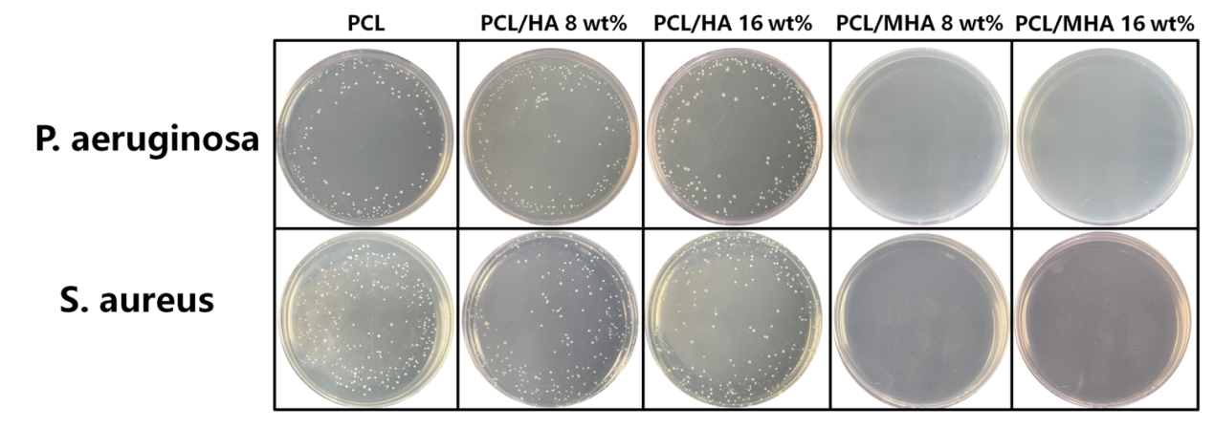
Fig. S6. Photography of the Pseudomonas aeruginosa or Staphylococcus aureus were grown in agar medium containing PCL/HA and PCL/MHA scaffolds, respectively.

References
- Y.W. Sari, A. Saputra, A. Bahtiar, N.A .Nuzulia, Effects of microwave processing parameters on the properties of nanohydroxyapatite: Structural, spectroscopic, hardness, and toxicity studies, Ceram. Int. 47 (2021) 30061–30070.
- P.V. Nam, N.V. Hoa, T.S. Trung, Properties of hydroxyapatites prepared from different fish bones: A comparative study, Ceram. Int. 45 (2019) 20141–20147.
- S. Tanpure, V. Ghanwat, B. Shinde, K. Tanpure, S. Lawande, The eggshell waste transformed green and efficient synthesis of K-Ca(OH)2 catalyst for room temperature synthesis of chalcones, Polycycl. Aromat. Compd. 42(4) (2022) 1322–1340.

