Supplementary Information

PRDM16 deficiency triggered by TGF-β signaling aggravated renal fibrosis by promoting tubular mitochondrial dysfunction

Qian Yuan, Ben Tang, Chao Wan, Yaru Xie, Yajuan Xie, Yuting Zhu, Hua Su, Chun Zhang

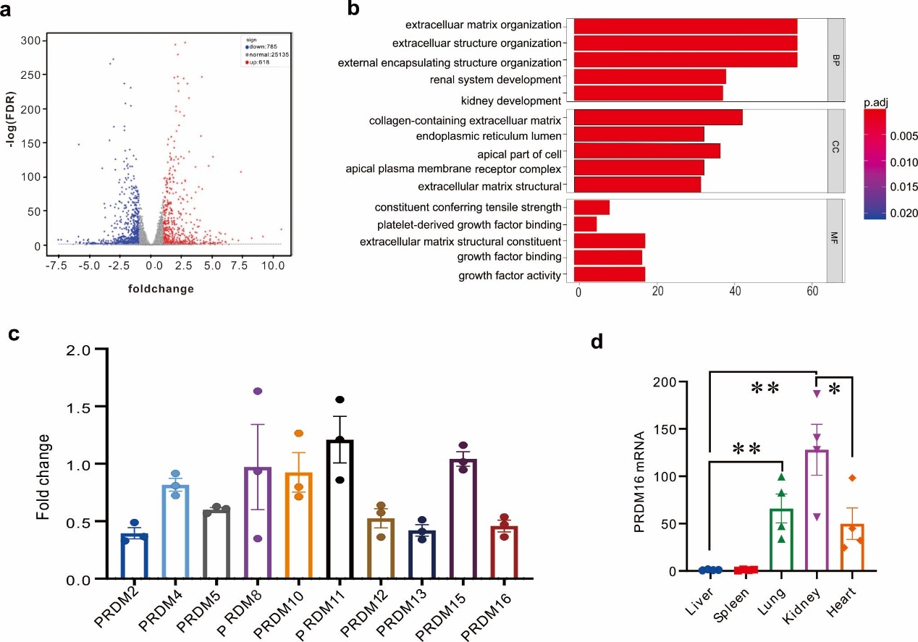
Fig. S1. The screening of PRDM family.
(a) HK-2 cells were treated with TGF-β for 24 hours. The total RNA was extracted and conducted RNA sequence. Volcano plot of RNA-sequencing. (b) GO analysis of RNA-sequencing showed that the expression of the extracellular matrix changed a lot after TGF-β treatment. (c) The mRNA fold change of the PRDM family in UUO kidneys compared to sham kidneys was revealed by qRT-PCR (n=3). (d) The mRNA level of PRDM16 in different organs was revealed by qRT-PCR (n=4). Data are mean ± SEM. n.s. p＞0.05, *p < 0.05, **p < 0.01, Two-tailed Student’s unpaired t-test analysis (c, d).

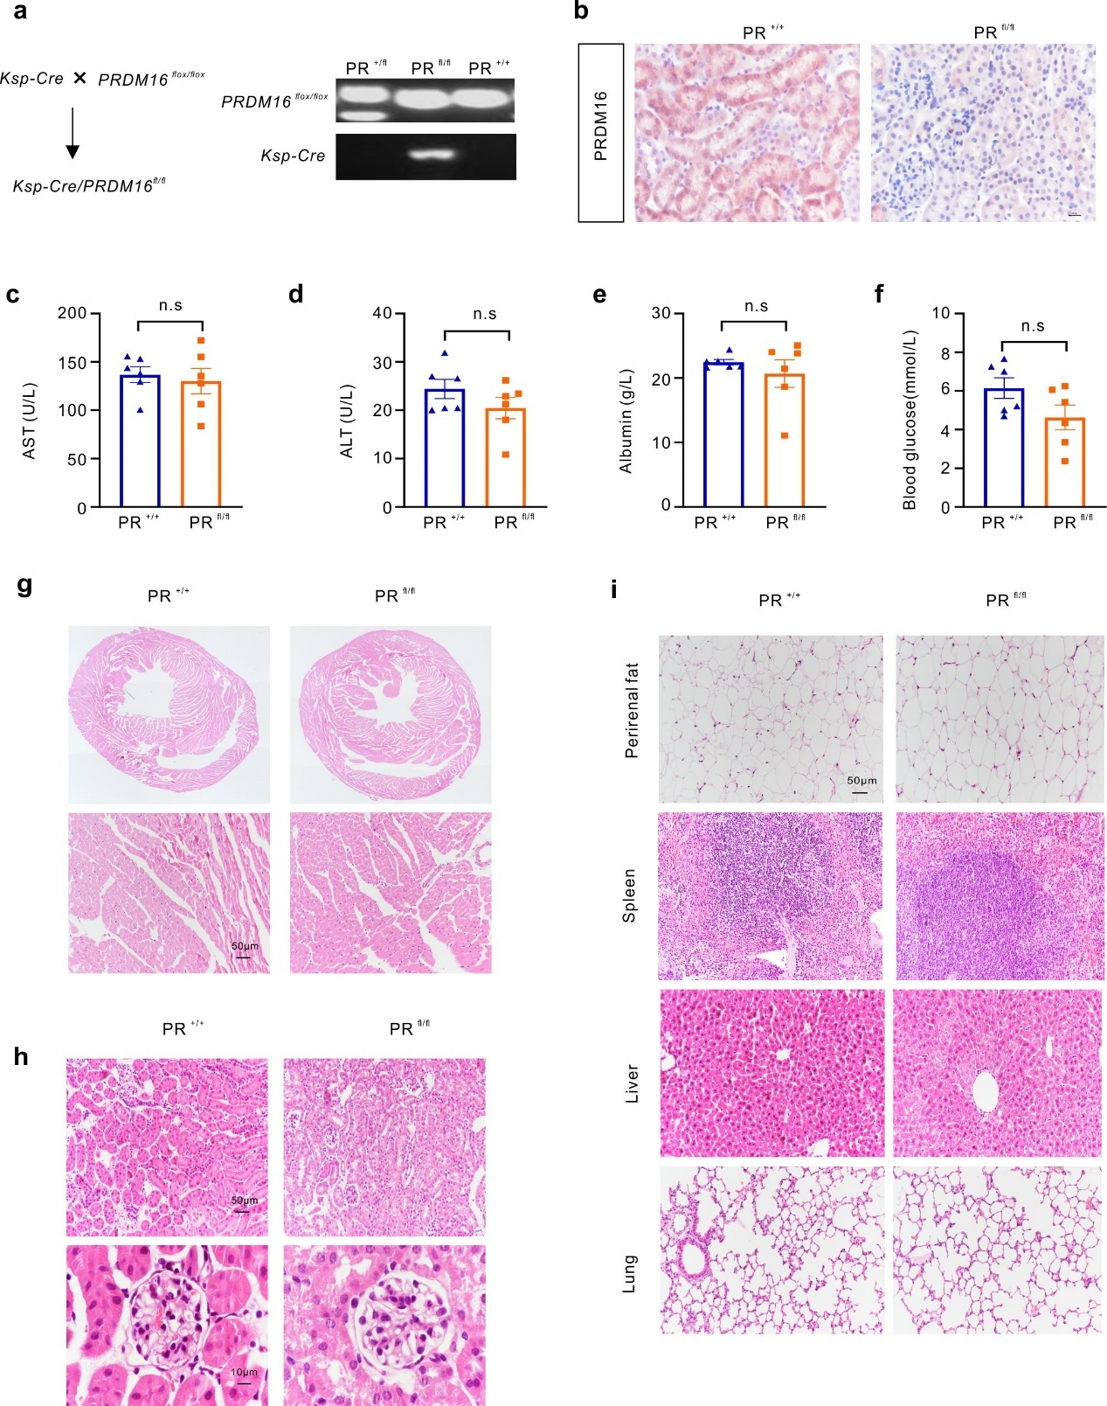
Fig. S2. Tubular-specific knockout PRDM16 mice were healthy at 8 weeks of age.
(a) Ksp-cre mice were cross-bred with PRDM16^{flox/flox} mice to generate Ksp-cre/ PRDM16^{flox/flox} mice. PCR results of mice genotyping with genomic DNA isolated from mouse tails. (b) Immunohistochemical staining of PRDM16 showed that PRDM16 expressed in tubular epithelial cells was knockout. Scale Bar: 20μm. (c-f) Clinical serum parameters of PRDM16^{flox/flox} mice (PR^{+/+}) and Ksp-cre/PRDM16^{flox/flox} mice (PR^{fl/fl}). (n=6). Data are mean ± SEM. n.s., p＞0.05. (g) HE staining showed cardiac chambers were not enlarged and myocardial cells were not hypertrophy. Scale Bar: 50μm. (h) HE staining of the kidney showed tubules and glomerulus were normal in both two groups. Scale Bar: 50μm for tubules. Scale Bar: 10μm for glomerulus. (i) HE staining of the perirenal fat, spleen, liver, and lung. Scale Bar: 50μm.

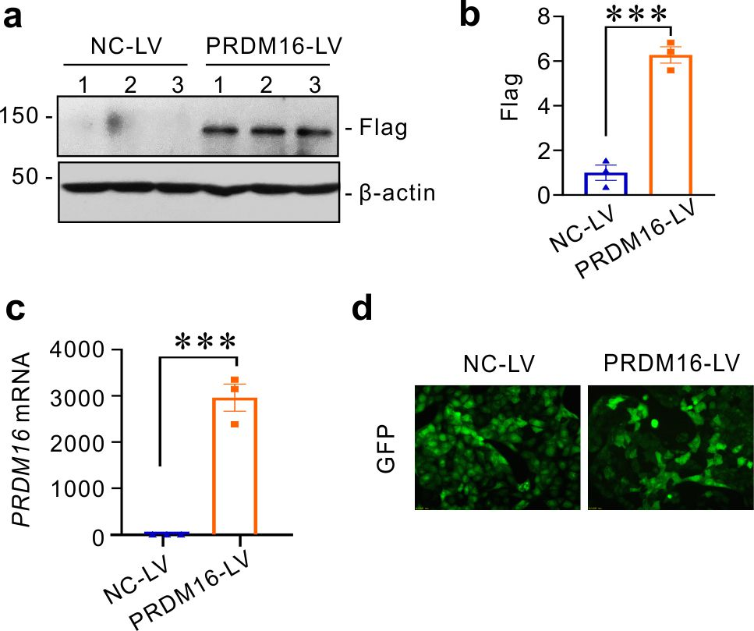

Fig. S3. Identification of PRDM16 stably overexpression HK-2 cell line.
(a-b) Representative Western blotting (a) (n = 3 blots in total) and quantification of Flag (b) in HK-2 cells transfected with PRDM16 lentivirus (PRDM16-LV) and negative control virus (NC-LV). (c) Relative mRNA level of PRDM16 (n=3). (d) Representative images of the expression of GFP. Data are mean ± SEM. ***p < 0.001, Two-tailed Student’s unpaired t-test analysis (b, c).

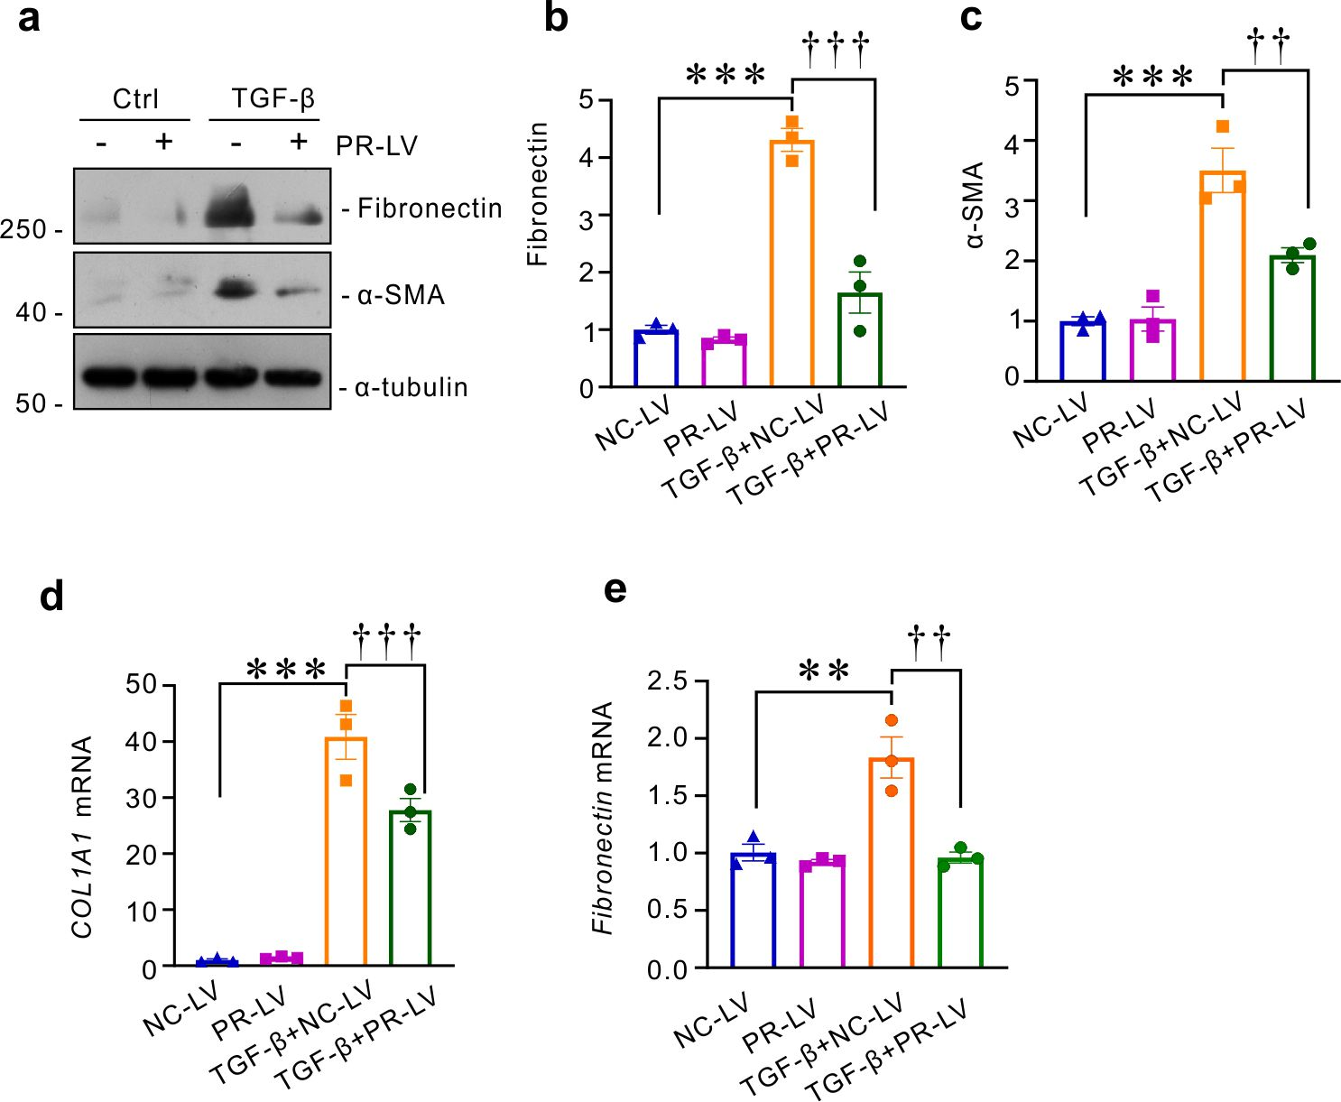
Fig. S4. PRDM16 inhibited partial EMT of tubular epithelial cells.
(a-c) Stably transfected HK-2 cells were treated with 5ng/ml TGF-β for 24 hours. Representative Western blotting (a) (n = 3 blots in total) and quantification of Fibronectin (b) and α- SMA (c). (d-e) Relative mRNA level of COL1A1 and Fibronectin in stably transfected HK-2 cells treated with 5ng/ml TGF-β (n=3) for 24 hours. Data are mean ± SEM. **p < 0.01, ***p < 0.001; †p < 0.05, ††p < 0.01, †††p < 0.001; One-way ANOVA followed by Tukey’s post-test (b-e).

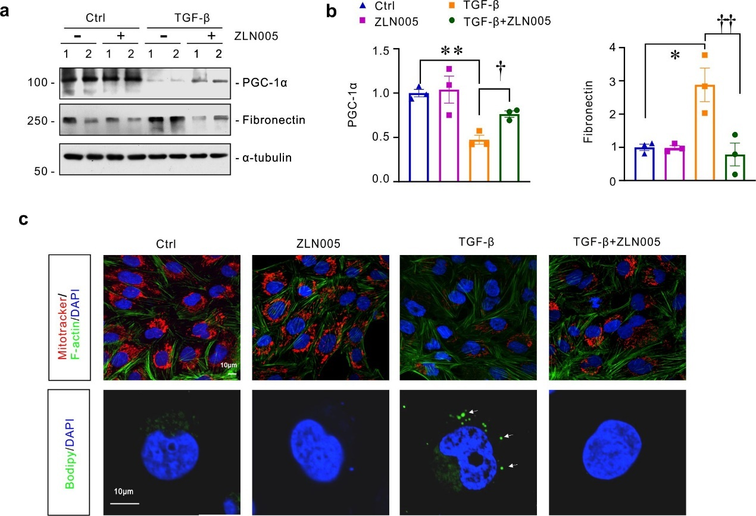

Fig. S5. PGC-1α activator, ZLN005 inhibited TGF-β induced mitochondrial injury.
(a-b) HK-2 cells were treated with 5ng/ml TGF-β and 5μmol/L ZLN005 for 24 hours. Representative Western blotting (a) (n = 3 blots in total) and quantification (b) of PGC-1α and Fibronectin. (c) Representative images of mitotracker staining and Bodipy Staining in HK-2 cells treated with 5ng/ml TGF-β and ZLN005. Scale Bar: 10μm. White Arrow pointed to positive lipid drops. Data are mean ± SEM. *p < 0.05, **p < 0.01; †p < 0.05, ††p < 0.01; One-way ANOVA followed by Tukey’s post-test (b).

Table S1 Clinical data, and the ratio of PRDM16 and PGC-1α positive area of control and IgA patients
Number | Stage | Age | sex | BUN (mmol/L) | Scr(  umol/L) | CysC  (mg/L) | eGFR (ml/  (min/1.73^2)) | UPE  (mg/24h) | PRDM16  (%) | PGC-1α (%)
1 | T2 | 47 | male | 12.5 | 309.5 | 2.7 | 19.61 | 6299 | 7.123 | 8.983
2 | T2 | 50 | male | / | / | / | / | / | 2.039 | 5.157
3 | T2 | 52 | female | 5.7 | 120 | 1.61 | 44.51 | 6920 | 4.67 | 6.746
4 | T2 | 52 | male | 4.6 | 108.3 | 1.34 | 67.4 | 3710 | 9.016 | 10.033
5 | T1 | 48 | female | 9.3 | 124.4 | 1.56 | 44.18 | 1301 | 7.252 | 2.975
6 | T1 | 44 | male | 5.2 | 145.9 | 1.93 | 49.73 | 1514 | 13.297 | 11.264
7 | T1 | 44 | female | 5.7 | 83.9 | 1.36 | 73.16 | 1406 | 5.268 | 2.871
8 | T1 | 47 | female | 6.92 | 79.5 | 0.78 | 76.46 | 1336 | 6.841 | 9.304
9 | T0 | 48 | male | 4.4 | 76.5 | 1.02 | 102.28 | 265 | 15.099 | 5.197
10 | T0 | 48 | female | 4.3 | 69.9 | 0.64 | 88.7 | 966 | 21.304 | 18.126
11 | T0 | 44 | female | 3.1 | 75.4 | 1.19 | 83.25 | 882 | 11.304 | 2.971
12 | T0 | 44 | male | 3.71 | 84.7 | 1.07 | 95.97 | 4165 | 9.696 | 3.081
13 | control | 64 | female | 3.67 | 79.6 | 1.44 | 72.59 | / | 31.741 | 33.852
14 | control | 62 | female | 4.03 | 54.6 | 1.43 | 58.65 | / | 26.012 | 29.187
15 | control | 47 | female | 3.75 | 68.9 | 0.78 | 115.98 | / | 26.58 | 25.368

Table S2 Primers for real-time RT-PCR.
Species | gene | Forward (5' to 3') | Reverse (5' to 3')
Mouse | β-actin | CAGCTGAGAGGGAAATCGTG | CGTTGCCAATAGTGATGACC
Mouse | PRDM16 | CAGCACGGTGAAGCCATTC | GCGTGCATCCGCTTGTG
Mouse | Ppargc1a | CACCAAACCCACAGAAAACAG | GGGTCAGAGGAAGAGATAAAGTTG
Mouse | Vimentin | GATCGATGTGGACGTTTCCAA | ATACTGCTGGCGCACATCAC
Mouse | Fibronectin | GATGAGCTTCCCCAACTGGT | CTGGGTTGTTGGTGGGATGT
Mouse | Col1a1 | ATCTCCTGGTGCTGATGGAC | ACCTTGTTTGCCAGGTTCAC
Mouse | Acox2 | ATAACCGAGTCGTTCTGCCAAT | TTTCAGAGCATTGGCCATAGAA
Mouse | Col3a | ACAGCTGGTGAACCTGGAAG | ACCAGGAGATCCATCTCGAC
Mouse | Tfam | GAGCAGCTAACTCCAAGTCAG | GAGCCGAATCATCCTTTGCCT
Mouse | Cpt1a | GGTCTTCTCGGGTCGAAAGC | TCCTCCCACCAGTCACTCAC
Mouse | H-Ras | AGGAAGGAAAGAGGCGGGAAGG | CACAGGAGCAAGGCAGATGATGG
Mouse | PRDM2 | TTTGGGGTGGATGTGCATTG | CTGCTATCTCGGGGTTGTCT
Mouse | PRDM4 | AGTACCATCTCACTCGCCAC | ATGTGTGTTCCGTCCAAAGC
Mouse | PRDM5 | CCGATGTGAGCTGTGCAATA | TGTGCATCTTCAGTCCGTCA
Mouse | PRDM8 | CGGGTCGTCTCCTTACACAT | CTGTTGCTCTTTACCACCGC
Mouse | PRDM10 | CCCTTGCATCCCATCCCTAA | ATCTTTCAGCTCCGATCCCC
Mouse | PRDM11 | CTCACCATTCCTCAGGGCAT | TCAGCCATGAGAAGAAGCCA
Mouse | PRDM12 | GGGCAGATTGAGAGTGGAGT | GGATGGAAGTGAGAGTGCCT
Mouse | PRDM13 | CAACAAGCACATCCGACTCC | ACATCACTGTCCTCGCTCTT
Mouse | PRDM15 | GGGGACAAGAAGTTTGCCTG | GCTTGTTCATGTTGCTCCGA
Human | β-actin | CTCACCATGGATGATGATATCGC | AGGAATCCTTCTGACCCATGC
Human | PRDM16 | CGAGGCCCCTGTCTACATTC | GCTCCCATCCGAAGTCTGTC
Human | PPARGC1A | AAAGGATGCGCTCTCGTTCA | GGAATATGGTGATCGGGAACA
Human | Fibronectin | AGCAAGCCCGGTTGTTATGA | CCCACTCGGTAAGTGTTCCC
Human | TFAM | CGCTCCCCCTTCAGTTTTGT | CCAACGCTGGGCAATTCTTC
Human | COL1A1 | GAGGGCCAAGACGAAGACATC | CAGATCACGTCATCGCACAAC
Human | ACOX2 | TCTTCTACCAACCAGCCCTG | CTCTCTATGTCGGGGTGCAT
Human | H-Ras | CGGAAGCAGGTGGTCATTGATGG | GCAGCCAGGTCACACTTGTTCC
Human | ChIP Primer1 | TTCTCTAGGCGACACTCACC | TGCTCAGATTCGAACCCAGA
Human | ChIP Primer2 | GGTGGGTAAAGGGGTCGATA | TCCCTGCTCAGATTCGAACC
Human | ChIP Primer3 | ATGTGCGAAGGTGTCCAAAC | GCGGAATCTCTCTCCTCCTC

Table S3 Key resources table.
REAGENT or RESOURCE | SOURCE | IDENTIFIER
Antibodies
Rabbit polyclonal anti-PRDM16(1:1000 For WB; 1:50 For IHC) | Abcam | Cat#ab106410
Rabbit monoclonal anti-PGC-1α (1:1000 For WB; 1:50 For IHC) | Boster | Cat#BM4898
Rabbit polyclonal anti-α- SMA(1:1000 For WB;1:50 For IHC) | ProteinTech | Cat#14395-1-AP
Rabbit polyclonal anti-Fibronectin (1:10000 For WB; 1:100 For IHC and IF) | Sigma | Cat#F3648
Rabbit polyclonal anti-H-RAS (1:1000 For WB) | ProteinTech | Cat#18295-1-AP
Rabbit polyclonal anti-Phospho-Smad3(1:1000 For WB) | Santa Cruz | Cat#sc-130218
Rabbit monoclonal anti-Phospho-Smad3(1:1000 For WB; 1:50 For IHC,1ug for Co-IP, 3ug for ChIP) | CST | Cat#9520T
Mouse monoclonal anti-FLAG (1:1000 For WB) | Sigma | Cat#F1804
Rabbit monoclonal anti-PPAR-γ (1:1000 For WBC) | CST | Cat#2435s
Rabbit polyclonal anti-CPT1A (1:2000 For WB) | ProteinTech | Cat#15184-1-AP
Rabbit polyclonal anti-GAPDH (1:10000 For WB) | ProteinTech | Cat No.60004-1-Ig
Mouse monoclonal anti-β-Actin(1:10000 For WB) | Santa Cruz | Cat#sc-47778
HRP-conjugated mouse monoclonal anti- α-Tubulin （1:10000 For WB） | ProteinTech | Cat No.HRP-66031
Donkey polyclonal Secondary Antibody to Rabbit IgG - H&L (Alexa Fluor® 594-AffiniPure) | Jackson | Cat#711-585-152
Biotin-SP (long spacer) AffiniPure Donkey Anti-Rabbit IgG (H+L) | Jackson | Cat#711-065-152
Rabbit IgG | Beyotime Biotechnology | Cat#A7016
Chemicals, Peptides, and Recombinant Proteins
ProDots Recombinant Human TGF-beta 1 Protein | RnD | Cat#PRD240-01
SIS3 | MCE | Cat#HY-13013
ZLN005 | MCE | Cat#HY-17538
Oil Red O | Sigma-Aldrich | Cat# O0625
mitotracker | Invitrogen | Cat#M22425
Bodipy | AbMole | Cat#M9850
Phosphatase Inhibitor Cocktail | Servicebio | Cat#G2006
100mM PMSF | Beyotime Biotechnology | Cat# ST506-2
Lipofectamine 2000 transfection reagent | Invitrogen | Cat# 11668500
Actin-Tracker Green | Beyotime Biotechnology | Cat#C1033
DAPI | Servicebio | Cat#G1012
Critical Commercial Assays
Immobilon Western Chemiluminescent HRP substrate | Applygen | Cat#P1010
Co-IP Kit | Beyotime Biotechnology | Cat#P2197
ChIP Kit | Beyotime Biotechnology | Cat#P2078
creatine assay kit | bioassay systems | Cat#DICT-500
Deposited Data
RNA-sequencing data | This paper | N/A
Experimental Models: Cell Lines
Homo Sapiens：HK-2 | ATCC | N/A
Experimental Models: Organisms/Strains
Mouse: PRDM16 flox/flox (C57BL/6J;129) | Shanghai Southern Model Biotechnology Development Co., Ltd. | N/A
Mouse: C57BL/6J;129 | Vital River Laboratory Animal Technology Co. Ltd. | N/A
Mouse: PRDM16^{+/+}and PRDM16 ^{fl/fl} (C57BL/6J;129) | bred by Shulaibao (Wuhan) Biotechnology Co., Ltd | N/A
Mouse: Ksp-cre | Cyagen Biosciences Co. Ltd. | N/A
PRDM16 siRNA | RIBOBIO | Cat#U0128
NC-siRNA | RIBOBIO | Cat#S1012
H-Ras siRNA | RIBOBIO | Cat#N0704
Recombinant DNA
GV703-PRDM16 | Shanghai Genechem Co.,Ltd. | N/A
GV141-PRDM16 | Shanghai Genechem Co.,Ltd. | N/A
GV238-PRDM16-luc | Shanghai Genechem Co.,Ltd. | N/A
Software and Algorithms
ImageJ | National Institutes of Health | https://imagej.nih.gov/ij/
GraphPad Prism 8.0 | GraphPad | https://www.graphpad.com/
Corel Draw X8 | Corel Draw | https://www.corel.com/cn/
Adobe Photoshop CS6 | Adobe | https://www.adobe.com/cn

